AICTE | IBM SkillsBuild
Data Analytics with AI Internship Program 2026 — BharatCares
PROJECT REPORT
AI-Powered Loan Approval & Credit Risk Analytics
From data cleaning and KPIs to risk segmentation and machine-learning-based decision support
Submitted by
Sakshi Jaiswal
September 2026
Tools: Python · pandas · scikit-learn · matplotlib · seaborn · Jupyter

Contents
1. Abstract
2. Introduction
3. Dataset Description
4. Methodology
5. Data Cleaning and Preparation
6. Key Performance Indicators
7. Exploratory Data Analysis
8. Risk Segmentation
9. AI / Machine-Learning Model
10. Insights, Risks, Opportunities and Recommendations
11. Limitations and Ethical Considerations
12. Conclusion and Future Scope
13. Tools, References and Project Files

1. Abstract
Lending decisions depend on many applicant and loan characteristics. This project analyses 4,269 loan applications to understand what drives approval, which applicant segments carry higher risk, and how machine learning can support faster, more consistent decisions. The workflow covers data cleaning, feature engineering, KPI computation, exploratory analysis, a transparent risk-scoring framework and a comparison of three classification models (Logistic Regression, Decision Tree and Random Forest).
The overall approval rate is 57.5%. Credit score is by far the dominant factor: approval rises from 10.7% in the Poor CIBIL band to 99.8% in the Excellent band. The tuned Random Forest reaches 92.4% accuracy and a ROC-AUC of 0.974 on unseen data. The findings are converted into risks, opportunities and concrete recommended actions for a lender.
Keywords: loan approval, credit risk, CIBIL score, exploratory data analysis, Random Forest, decision support.

2. Introduction

2.1 Background
Banks and NBFCs receive large volumes of loan applications. Each application combines financial information (income, assets, requested amount), credit history (bureau score) and demographic details. Reviewing these manually is slow and can be inconsistent. Data analytics helps lenders see patterns in past decisions, and machine learning can score new applications to prioritise the review queue.

2.2 Problem Statement
Financial institutions receive loan applications from customers with different financial, demographic and credit-related characteristics. Analysing these factors can help identify patterns in loan approvals and potential risk segments. This project analyses historical loan application data, identifies the key factors associated with approval and risk, visualises important trends and KPIs, and develops an AI-based analytical model to support data-driven lending decisions.

2.3 Objectives
- Clean and validate the loan-application data and engineer meaningful affordability and asset features.
- Compute KPIs that describe application volume, approval performance and applicant profile.
- Identify the factors associated with approval through visual and statistical exploration.
- Segment applications into Low, Medium and High risk tiers using a transparent scoring framework.
- Build and compare machine-learning models that predict the historical approval outcome.
- Translate findings into risks, opportunities and recommended actions.

2.4 Scope
This is an academic analytics project. It shows how data can support decision-making; it is not designed to approve or reject real borrowers automatically.

3. Dataset Description
The analysis uses a loan-application table with 4,269 records and 13 columns, following the structure of the public Kaggle “Loan Approval Prediction Dataset”. Monetary values are in Indian Rupees (INR). The target variable is loan_status (Approved / Rejected).
Column | Description | Type
loan_id | Unique application identifier | ID
no_of_dependents | Number of dependents (0–5) | Numeric
education | Graduate / Not Graduate | Categorical
self_employed | Yes / No | Categorical
income_annum | Annual income (INR) | Numeric
loan_amount | Loan amount requested (INR) | Numeric
loan_term | Loan tenure in years | Numeric
cibil_score | Credit score (300–900) | Numeric
residential / commercial / luxury_assets_value, bank_asset_value | Value of applicant assets (INR) | Numeric
loan_status | Approved or Rejected (target) | Categorical

3.1 Note on the data used in this report
Important: the figures, tables and results in this report were generated from a synthetic dataset created with the same columns and value ranges as the Kaggle dataset. The notebook automatically uses the real Kaggle file (loan_approval_dataset.csv) if it is placed in the same folder, and every result can be reproduced by re-running it. The relationships reported here (for example the dominance of credit score) are illustrative of the modelling approach and should be re-validated on the real file before drawing business conclusions.

4. Methodology
The project follows a standard analytics pipeline, implemented end-to-end in a single Jupyter notebook:
Stage | What was done
1. Data loading | Read the CSV, inspect shape, types and summary statistics
2. Cleaning | Standardise names and text, remove duplicates, handle missing and invalid values, flag outliers
3. Feature engineering | Total assets, loan-to-income ratio, asset coverage, CIBIL / income / loan-size bands
4. KPIs | Volume, approval and rejection rates, average loan and income, low-credit share, approved loan value
5. EDA | Distributions, approval rates by segment, correlation matrix, two-factor heatmap
6. Risk segmentation | Rule-based risk score → Low / Medium / High tiers
7. Machine learning | 80/20 stratified split, 5-fold CV, three models, grid-search tuning, evaluation
8. Insights | Key findings → risks and opportunities → recommended actions

5. Data Cleaning and Preparation
Quality checks were run before any analysis so that conclusions rest on reliable data.
Check | Result
Records (raw → clean) | 4,269 → 4,269
Duplicate rows removed | 0
Missing values found | 0
Negative asset values corrected | 0
IQR outliers (income / loan / CIBIL) | 0 / 0 / 0 — flagged, not removed
Range validation | CIBIL within 300–900; income and loan amount > 0 (assertions passed)

Column names and text values were stripped of stray whitespace (a common issue in this dataset’s raw file). Missing numeric values would be filled with the median and categorical values with the mode. Outliers were flagged but kept, because high-income or large-loan applicants are genuine cases in lending.

5.1 Engineered features
- loan_to_income = loan amount ÷ annual income (years of income the loan represents).
- total_assets = sum of residential, commercial, luxury and bank assets.
- asset_coverage = total assets ÷ loan amount (assets held per rupee borrowed).
- cibil_band: Poor (300–549), Fair (550–649), Good (650–749), Excellent (750–900); income_band and loan_size_band are quartiles; lti_band: ≤2x, 2–3x, 3–4x, >4x.

6. Key Performance Indicators
Eight KPIs summarise the portfolio. They were chosen because each answers a question a credit manager would ask.
KPI | Value
Total applications | 4,269
Approval rate | 57.5%
Rejection rate | 42.5%
Average loan amount | INR 147.9 lakh (1.48 crore)
Average annual income | INR 50.4 lakh
Average CIBIL score | 595.8
Applicants with CIBIL < 550 | 42.4%
Total approved loan value | INR 3,566.7 crore

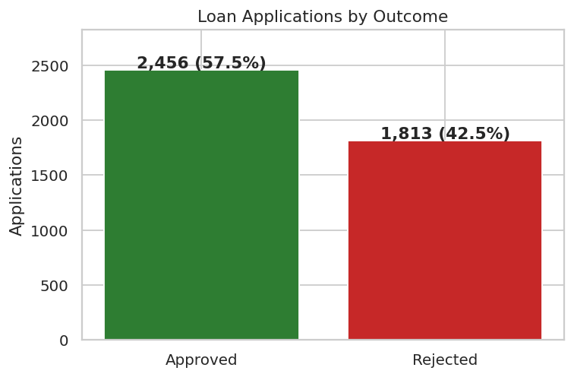
Figure 1: Loan applications by outcome

7. Exploratory Data Analysis

7.1 Income and loan-amount distributions
Income and requested loan amounts are spread widely, with no extreme skew, reflecting a broad applicant base. The typical applicant asks for a loan of roughly three times annual income.
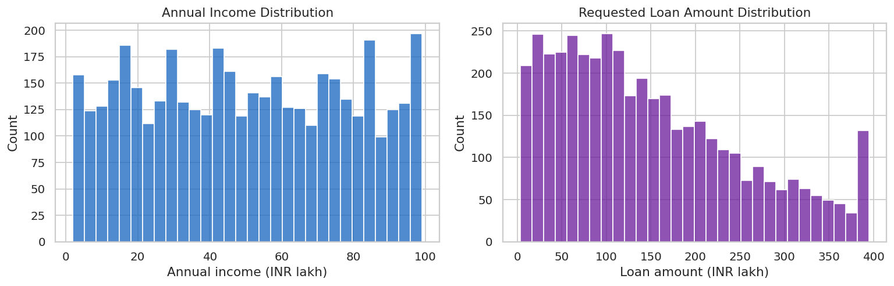
Figure 2: Distribution of annual income and requested loan amount

7.2 Credit score is the strongest signal
Rejected applications cluster at low CIBIL scores and approved ones at high scores, with a transition zone around 550–650. Approval rate climbs steeply by band: Poor 10.7% → Fair 75.6% → Good 97.0% → Excellent 99.8%. The correlation between CIBIL score and approval is 0.81, far larger than any other variable.
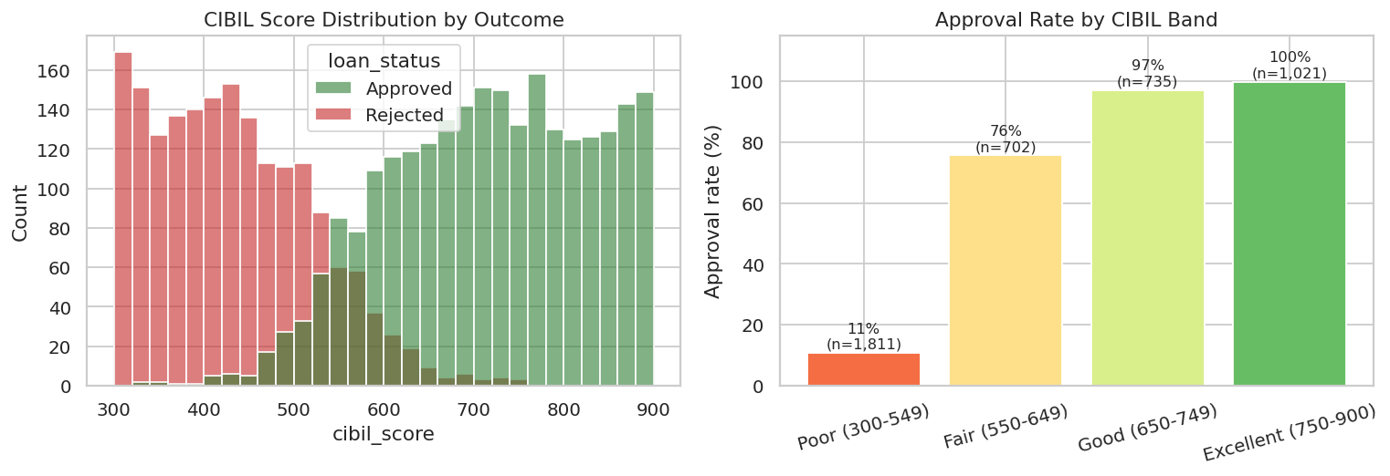
Figure 3: CIBIL score distribution by outcome and approval rate by CIBIL band

7.3 Applicant profile
Income, education, self-employment and number of dependents show only small differences in approval rate compared with credit score. Approval by income quartile ranges from 55.0% (Low) to 58.9% (High); Graduates are approved at 58.9% versus 56.2% for Non-graduates; self-employed and salaried applicants are almost identical (57.3% vs 57.7%). Dependents show no consistent pattern.
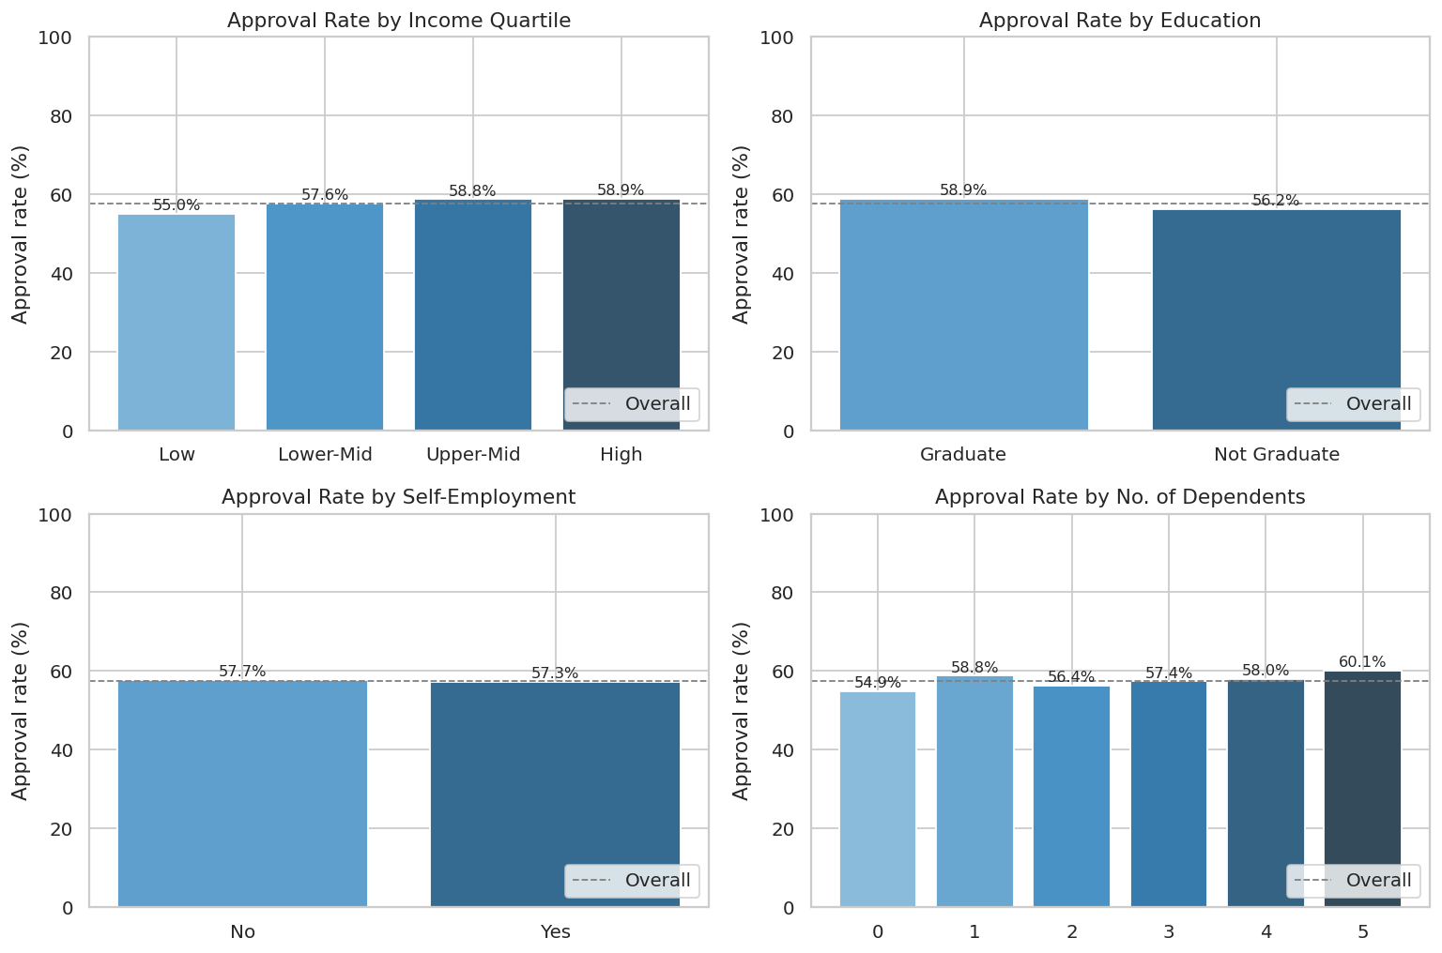
Figure 4: Approval rate by income quartile, education, self-employment and dependents

7.4 Loan characteristics and affordability
Affordability matters at the margin: approval falls from 64.1% for loans up to 2x income to 51.1% for loans above 4x income. Loan size and tenure have a weaker effect once affordability is considered.
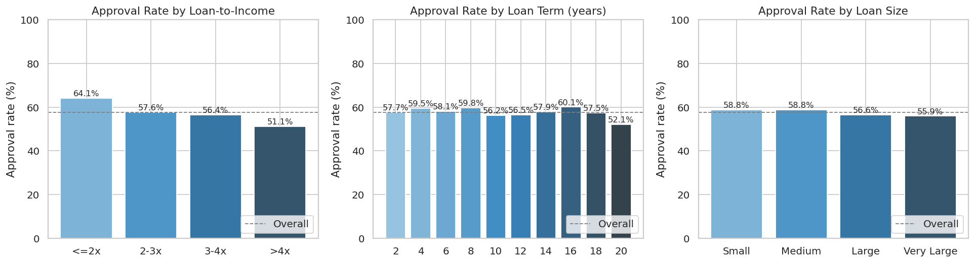
Figure 5: Approval rate by loan-to-income band, loan term and loan size

7.5 Correlation analysis
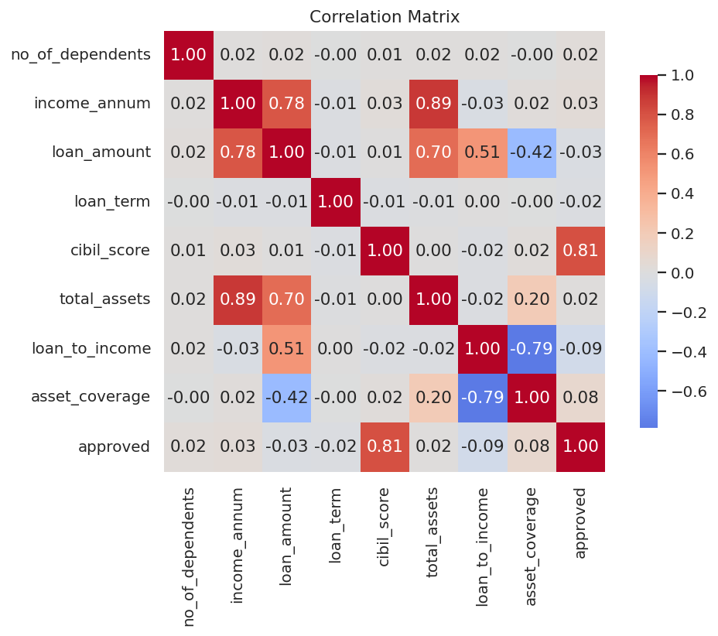
Figure 6: Correlation matrix of numeric variables
Apart from CIBIL score, correlations with approval are small (|r| < 0.10). Income, loan amount and total assets are strongly correlated with one another, which is expected because larger earners request and hold more.

7.6 Credit score and affordability together
Combining the two strongest factors shows where the decision boundary sits: Poor-credit applicants are mostly rejected regardless of loan size, while in the Fair band, approval is sensitive to how large the loan is relative to income.
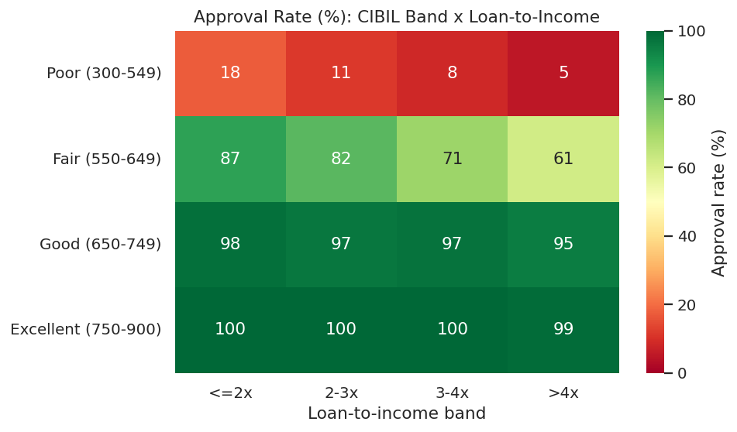
Figure 7: Approval rate (%) by CIBIL band and loan-to-income band

8. Risk Segmentation
The dataset does not contain repayment or default information, so a true default-risk model is not possible. Instead, each application receives a transparent risk score built from lender-relevant factors:
Factor | Points
CIBIL score | < 550 → 3; 550–649 → 2; 650–749 → 1; ≥ 750 → 0
Loan-to-income | > 4x → 2; 3–4x → 1; otherwise 0
Asset coverage < 0.5 | +1

Applications scoring 0–1 points are Low risk, 2–3 Medium, and 4 or more High.
Risk tier | Applications | Share | Approval rate | Avg loan (lakh) | Requested (crore) | Approved (crore)
Low | 1,165 | 27.3% | 99.1% | 118.1 | 1375.9 | 1364.4
Medium | 2,050 | 48.0% | 55.6% | 137.9 | 2827.7 | 1845.5
High | 1,054 | 24.7% | 15.3% | 200.0 | 2108.2 | 356.7

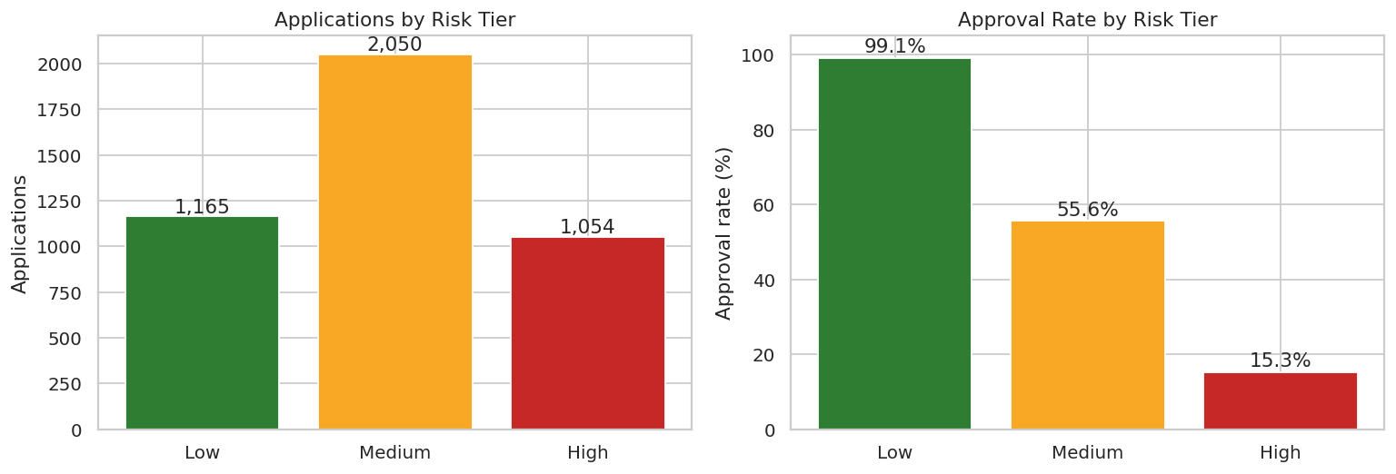
Figure 8: Applications and approval rate by risk tier
The High tier accounts for 24.7% of applications and carries the largest average requests (INR 200.0 lakh) but only 15.3% are approved. The Medium tier (48.0% of applications, 55.6% approval) is where manual review has the most impact.

9. AI / Machine-Learning Model

9.1 Setup
The task is binary classification: predict whether an application is Approved (1) or Rejected (0). Thirteen features were used: the raw numeric fields, the engineered ratios (loan-to-income, asset coverage) and encoded education and self-employment flags. The data were split 80/20 with stratification, and models were compared using 5-fold cross-validated ROC-AUC on the training set and a held-out test set.

9.2 Models compared
- Logistic Regression (with feature scaling) — simple, interpretable baseline.
- Decision Tree (depth 5) — rule-based and easy to explain.
- Random Forest — ensemble of trees; tuned with grid search over trees, depth and leaf size (best: max_depth=6, min_samples_leaf=5, n_estimators=400).

9.3 Results
Model | CV AUC | Accuracy | Precision | Recall | F1 | Test AUC
Logistic Regression | 0.972 | 0.925 | 0.950 | 0.918 | 0.934 | 0.979
Decision Tree | 0.963 | 0.924 | 0.942 | 0.925 | 0.933 | 0.977
Random Forest | 0.965 | 0.926 | 0.937 | 0.935 | 0.936 | 0.974
Random Forest (Tuned) | 0.966 | 0.924 | 0.929 | 0.939 | 0.934 | 0.974

All models perform very similarly (accuracy about 92.5%–92.4%), which is consistent with the finding that one variable (CIBIL score) explains most of the outcome. The simple Logistic Regression is competitive with the tree ensembles, so interpretability need not be sacrificed. The tuned Random Forest is used for the confusion matrix and importance analysis: of 854 test applications, 461 approvals and 328 rejections were predicted correctly, with 35 false approvals and 30 false rejections.
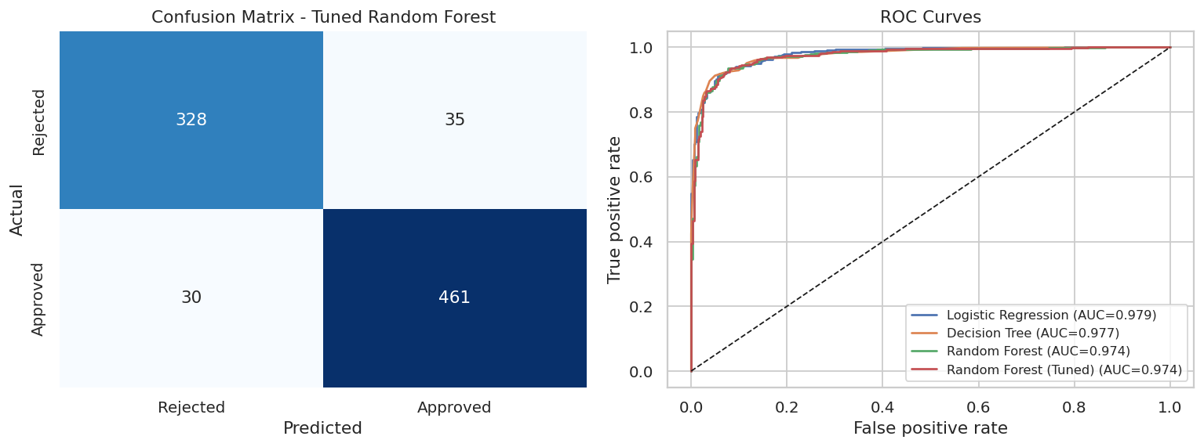
Figure 9: Confusion matrix (tuned Random Forest) and ROC curves for all models

9.4 What drives the predictions?
Permutation importance confirms the EDA: cibil_score (0.4634), loan_to_income (0.0058), asset_coverage (0.0011). CIBIL score accounts for nearly all of the predictive power; affordability and asset cover contribute marginally, and demographic fields add essentially nothing.
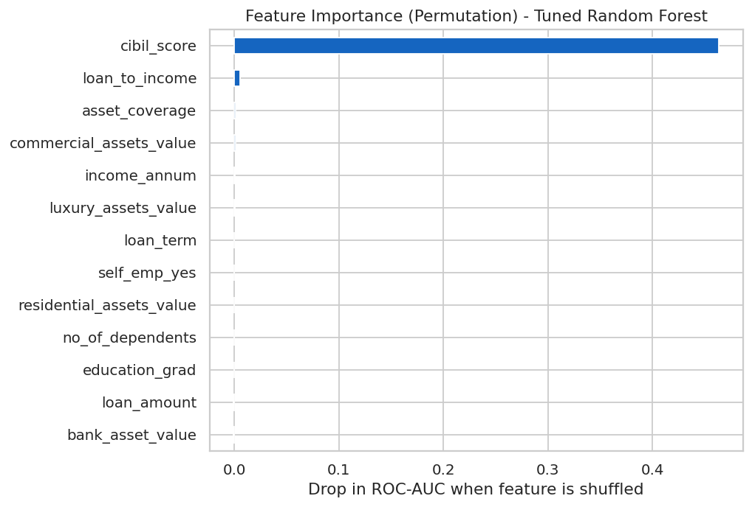
Figure 10: Permutation feature importance (drop in ROC-AUC)

9.5 Are the probabilities trustworthy?
Predicted approval probability | Test applications | Actual approval rate
0-20% | 244 | 2.5%
20-40% | 102 | 20.6%
40-60% | 33 | 42.4%
60-80% | 70 | 77.1%
80-100% | 405 | 97.8%

Actual approval rates rise in step with predicted probability, so the score can be used to rank and triage applications, not just to classify them.
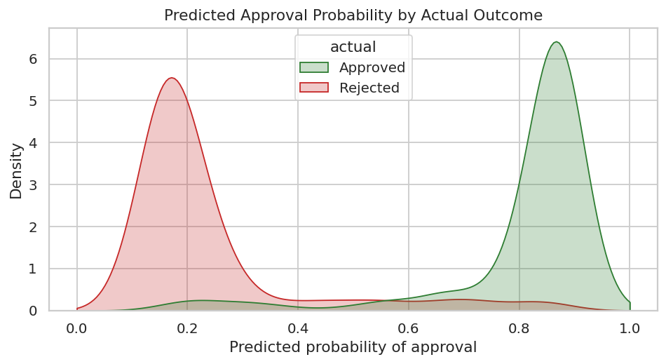
Figure 11: Predicted approval probability by actual outcome

10. Insights, Risks, Opportunities and Recommendations

10.1 Key insights
- Approval is overwhelmingly a credit-score decision: 10.7% approval for Poor scores versus 99.8% for Excellent.
- 42.4% of all applicants have CIBIL below 550, so a large share of application effort is spent on cases that are very likely to be rejected.
- Affordability is a secondary factor: loans above 4x income are approved 51.1% of the time versus 64.1% at 2x or below.
- Education, employment type, number of dependents and income level show only small differences once credit score is considered.
- A model using only application data predicts historical decisions with about 92.4% accuracy.

10.2 Risks to monitor
- Single-factor dependence: decisions hinge on one bureau score; errors or thin credit files can exclude creditworthy applicants.
- Over-leveraged requests: high loan-to-income with weak asset cover forms the riskiest segment.
- Model risk: the model learns historical decisions, including any historical bias; it does not measure repayment behaviour.
- Borderline zone: Fair-band applicants sit near the decision boundary, where errors are most likely.

10.3 Opportunities
- Secured lending or co-applicant / guarantor structures for Fair-band applicants with strong assets.
- Fast-track processing for Low-tier applications (27.3% of volume, 99.1% approval) to cut turnaround time.
- Use predicted probability to prioritise the review queue and shorten time-to-decision.
- Pre-application guidance for likely rejections, improving customer experience and reducing wasted processing.

10.4 Recommended actions
# | Action | Why
1 | Use risk tier + model probability for triage, with human sign-off on borderline cases | Speeds up clear cases; keeps judgement where it matters
2 | Set loan-to-income guardrails (manual review above 4x) | Affordability is the second strongest driver
3 | Offer credit-improvement guidance and right-sized loan suggestions to likely rejections | Turns rejections into future customers
4 | Explore secured / co-applicant options for Fair-band applicants | Largest pool of recoverable business
5 | Audit approval rates by group (education, employment, dependents) regularly | Guards against unfair bias
6 | Collect repayment / default data | Enables true credit-risk modelling

11. Limitations and Ethical Considerations
- The target is the historical approval decision, not repayment. The model therefore imitates past decisions rather than measuring true credit risk.
- The risk-tier score is rule-based and illustrative; its weights were not calibrated against default outcomes.
- The results in this report come from synthetic data with the same schema as the public dataset. They demonstrate the method and must be re-validated on real data.
- Very high model accuracy is largely explained by one dominant variable; a production system would need richer data (repayment history, employment stability, liabilities).
- Fairness: automated scoring can reproduce historical bias. Any real deployment needs bias testing, explainability and human oversight in line with responsible-lending rules.

12. Conclusion and Future Scope
This project took loan-application data from raw records to decision-ready insight. Credit score emerged as the dominant driver of approval, with loan-to-income as a meaningful secondary factor, and demographic attributes played a minor role. A tuned Random Forest predicted historical outcomes with 92.4% accuracy and a ROC-AUC of 0.974, while the risk-tier framework gives a simple way to segment applications for triage. Together these provide a practical decision-support view rather than an automated decision-maker.

Future scope
- Train on repayment / default outcomes to build a genuine probability-of-default model.
- Add explainability (SHAP) and fairness metrics across demographic groups.
- Deploy an interactive dashboard (Power BI, Streamlit or IBM Cognos) with an Executive Overview, Applicant Analysis and Risk & AI Insights page.
- Test gradient-boosting models and cost-sensitive thresholds that reflect the higher cost of a bad approval versus a lost good customer.

13. Tools, References and Project Files

Tools and libraries
Python 3, pandas, NumPy, matplotlib, seaborn, scikit-learn, Jupyter Notebook.

Project files
File | Purpose
SakshiJaiswal_LoanApproval_CreditRisk_Analytics.ipynb | Complete, executed analysis notebook
requirements.txt | Python dependencies
README.md | Overview, dataset link and run instructions
loan_approval_dataset_synthetic.csv | Dataset used to generate this report
loan_data_cleaned.csv, results_summary.json, figures/ | Notebook outputs

References
- Kaggle — Loan Approval Prediction Dataset (Archit Sharma): https://www.kaggle.com/datasets/architsharma01/loan-approval-prediction-dataset
- scikit-learn documentation: https://scikit-learn.org/stable/
- TransUnion CIBIL — credit score ranges and interpretation.
- IBM SkillsBuild — Data Analytics with AI internship masterclass material.

