WEEK 3 TASK
STATISTICAL ANALYSIS AND PREDICTIVE MODELING USING R
Telco Customer Churn Prediction using Logistic Regression

1. Objective
The objective of this analysis is to investigate customer churn using statistical analysis and develop a predictive classification model in R. The analysis includes hypothesis testing, distribution and normality assessment, correlation analysis, logistic regression, cross-validation, threshold evaluation, model diagnostics, and ROC-AUC analysis.

2. Dataset Identification
The publicly available Telco Customer Churn dataset was selected because it contains customer-level demographic, service, tenure, billing, and churn information. The binary churn variable makes the dataset suitable for classification and predictive modeling.
The working data contained 7,043 observations and 22 variables before the train/test split. The training data contained 5,634 observations and the test data contained 1,409 observations.

3. Hypothesis Formulation
The analysis tested whether important numerical customer variables were statistically related.
- H0: There is no significant linear correlation between the selected numerical variables.
- H1: There is a significant linear correlation between the selected numerical variables.

4. Exploratory Statistical Analysis

4.1 Distribution Analysis
Histograms were generated for Monthly Charges, Tenure, and Total Charges. Monthly Charges show variation across the customer base, while Tenure is concentrated among newer customers and Total Charges are strongly right-skewed, with many customers having relatively low cumulative charges.
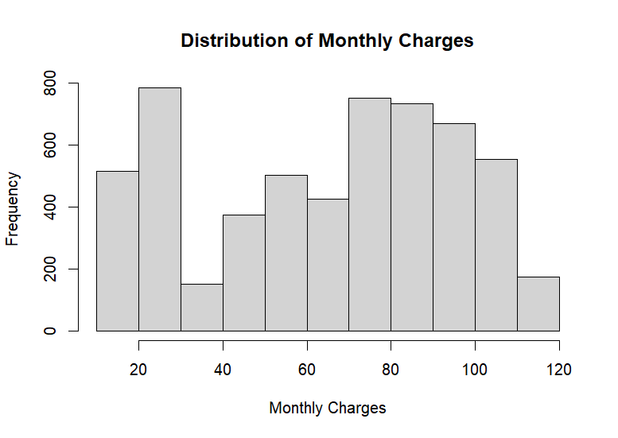
Figure 1. Distribution of Monthly Charges
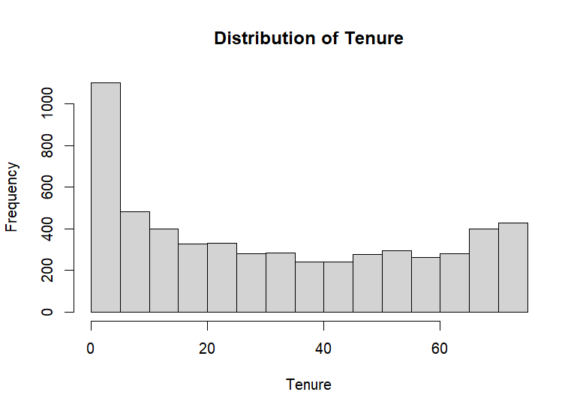
Figure 2. Distribution of Tenure
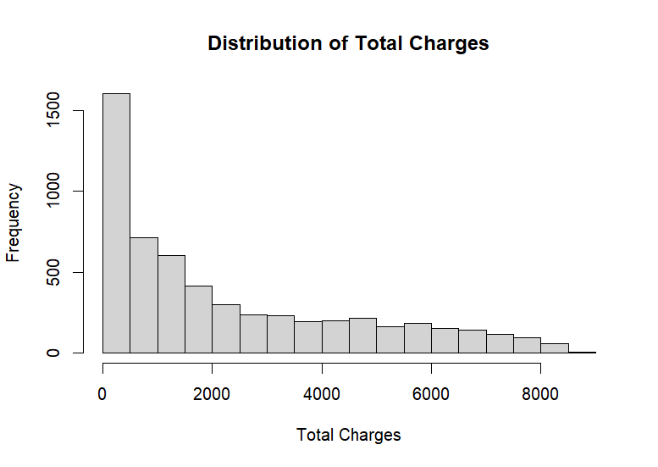
Figure 3. Distribution of Total Charges

4.2 Normality Assessment
Q-Q plots were used to assess whether Monthly Charges, Tenure, and Total Charges followed a normal distribution. The plots show noticeable departures from the reference line, indicating that these variables are not normally distributed. This supports using correlation testing without assuming normality of the raw variables.
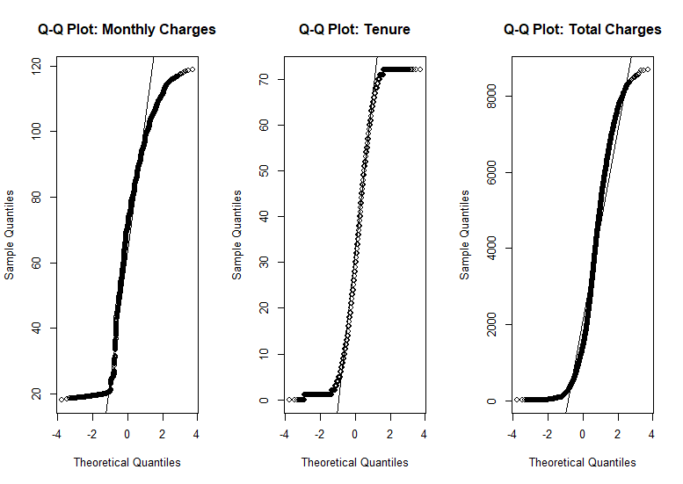
Figure 4. Q-Q Plots for Monthly Charges, Tenure, and Total Charges

4.3 Correlation Analysis
Variable Pair | Pearson r | p-value | Interpretation
Monthly Charges – Total Charges | 0.6511 | < 2.2e-16 | Moderate-to-strong positive relationship
Monthly Charges – Tenure | 0.2546 | < 2.2e-16 | Weak positive relationship
Tenure – Total Charges | 0.8297 | < 2.2e-16 | Strong positive relationship
All three correlations are statistically significant. Tenure has the strongest relationship with Total Charges, which is reasonable because customers who remain longer generally accumulate more charges.

5. Predictive Model: Logistic Regression
A logistic regression model was developed to predict the binary customer churn outcome. Logistic regression was selected because the target variable represents two classes: churn and non-churn.
The dataset was divided into training and testing data. Cross-validation was also used during model assessment to reduce dependence on a single train/test split and provide a more robust estimate of model performance.

6. Cross-Validation and Performance
The cross-validation results at the default classification threshold produced an accuracy of approximately 80.40%, with sensitivity of approximately 45.58% and specificity of approximately 91.96%. The difference between sensitivity and specificity indicates that the default threshold is conservative in identifying churners.

7. ROC Curve and AUC
The ROC curve evaluates model discrimination across classification thresholds. The area under the curve (AUC) was 0.831, indicating good ability to distinguish between customers who churn and customers who do not churn.
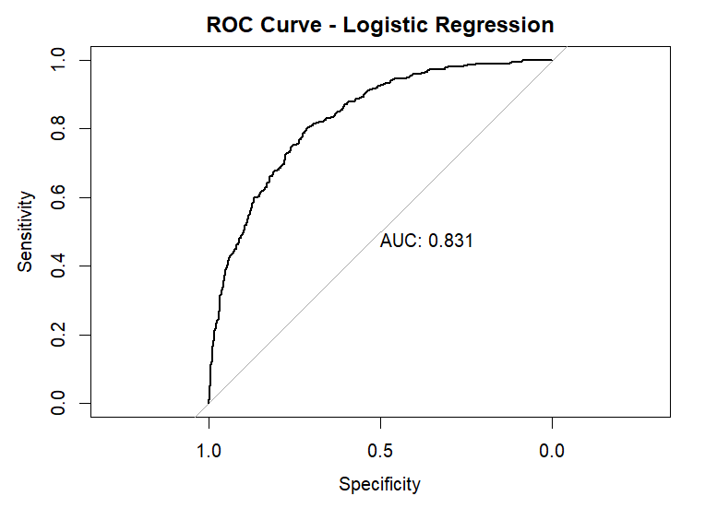
Figure 5. ROC Curve for Logistic Regression (AUC = 0.831)

8. Threshold Analysis
Three classification thresholds were compared to understand the trade-off between sensitivity and specificity.
Threshold | Accuracy | Sensitivity | Specificity
0.3 | 75.85% | 72.93% | 76.82%
0.4 | 78.55% | 62.11% | 84.01%
0.5 | 80.40% | 45.58% | 91.96%
A threshold of 0.3 was selected for the final evaluation because it substantially improves sensitivity while retaining reasonable specificity. This is useful in churn analysis because missing actual churners can be costly for customer-retention activities.

9. Final Confusion Matrix and Metrics
Actual / Predicted | 0 | 1
0 | 812 (TN) | 245 (FP)
1 | 95 (FN) | 256 (TP)

Metric | Value
Accuracy | 75.85%
Sensitivity | 72.93%
Specificity | 76.82%
ROC-AUC | 0.831
At the selected threshold of 0.3, the model correctly classified 812 non-churn customers and 256 churn customers. It produced 245 false positives and 95 false negatives. The sensitivity of 72.93% indicates that the model identifies a substantial proportion of actual churners, while specificity of 76.82% indicates reasonable identification of non-churn customers.

10. Model Diagnostics
Diagnostic plots were examined to assess model behavior and identify potential outliers, influential observations, and patterns in residuals. The diagnostic plots show some structure and extreme observations, indicating that the model could potentially be improved through feature engineering, treatment of influential observations, or alternative classification methods.
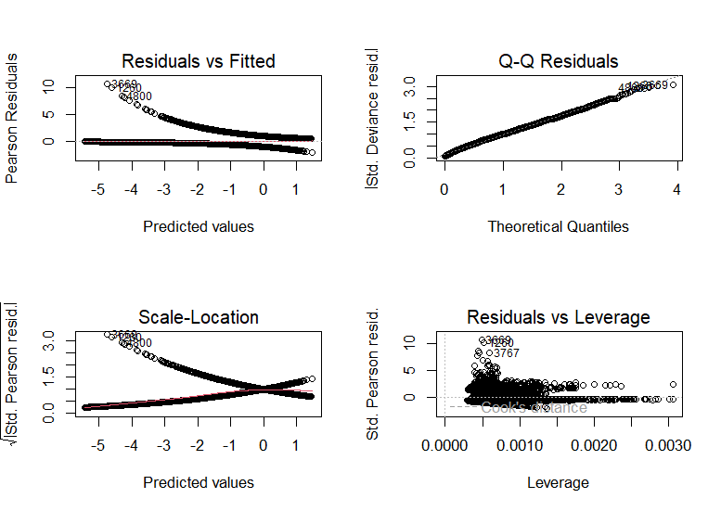
Figure 6. Logistic Regression Model Diagnostics

11. Key Findings
- Tenure and Total Charges have a strong positive correlation (r = 0.8297).
- Monthly Charges and Total Charges have a moderate-to-strong positive correlation (r = 0.6511).
- The logistic regression model achieved an ROC-AUC of 0.831, indicating good discrimination.
- Lowering the classification threshold from 0.5 to 0.3 increased sensitivity from 45.58% to 72.93%.
- The selected threshold of 0.3 provides a more balanced sensitivity-specificity trade-off for churn detection.

12. Potential Improvements
- Test additional classification algorithms such as random forest, gradient boosting, or other tree-based methods.
- Perform feature selection and engineering to reduce redundancy and improve predictive power.
- Tune the classification threshold based on the business cost of false positives and false negatives.
- Use stratified cross-validation and hyperparameter tuning for more robust model comparison.
- Investigate influential observations and potential non-linear relationships.

13. R Code Excerpts
# Correlation
cor.test(train_data$MonthlyCharges, train_data$TotalCharges, use="complete.obs")
# Logistic regression
logit_model <- glm(Churn_Binary ~ ., data=train_data, family=binomial)
# ROC and AUC
roc_curve <- roc(test_data$Churn_Binary, test_data$predicted_prob)
auc_value <- auc(roc_curve)
# Threshold-based prediction
test_data$predicted_churn_30 <- ifelse(test_data$predicted_prob >= 0.3, 1, 0)
# Confusion matrix
final_cm_30 <- table(
Actual = test_data$Churn_Binary,
Predicted = test_data$predicted_churn_30
)

14. Conclusion
This analysis demonstrated a complete statistical and predictive modeling workflow in R for customer churn. The exploratory analysis identified significant relationships among customer billing and tenure variables. The logistic regression model showed good discrimination with an AUC of 0.831. Although the default threshold provided higher overall accuracy, a threshold of 0.3 was selected to improve churn detection, resulting in 72.93% sensitivity and 76.82% specificity. The model provides a useful baseline for customer-retention prediction and can be further improved through feature engineering, model comparison, and threshold optimization.

