WEEK 4 FINAL REPORT
Telco Customer Churn
Comprehensive Data Analysis, Statistical Modeling and Reporting
YuvaIntern Virtual R Data Analyst Internship
Prepared by: Sakshi Lal
Tools: R / RStudio
Dataset: Telco Customer Churn
Final Week – Comprehensive Integration of Weeks 1–3

Executive Summary
This final report consolidates the four-week Telco Customer Churn analysis into one coherent, data-driven narrative. The work progressed from data inspection and preprocessing, through exploratory visualization and statistical analysis, to logistic-regression-based churn prediction. The final objective was not only to build a predictive baseline, but also to translate the analytical results into practical customer-retention insights.
The dataset contains 7,043 telecom customer records. The overall churn rate is approximately 26.54%, with 1,869 customers classified as churned and 5,174 as non-churned. Exploratory analysis identified particularly high churn among month-to-month customers, newer customers, electronic-check users, and fiber-optic customers. Tenure and cumulative charges also showed a strong positive relationship.
The predictive stage used logistic regression. The model achieved an ROC-AUC of 0.831, indicating good discrimination. A probability threshold of 0.30 was selected for the final evaluation because it improved sensitivity for identifying likely churners. At this threshold, accuracy was 75.85%, sensitivity was 72.93%, and specificity was 76.82%.

Key Results at a Glance
Metric / Finding | Result | Interpretation
Dataset size | 7,043 customers | Large enough for exploratory and baseline predictive analysis
Overall churn | 26.54% | About one in four customers churned
Highest contract churn | Month-to-month: 42.71% | Short commitment is strongly associated with churn
Highest tenure-group churn | 0–12 months: 47.44% | Early customer lifecycle is a major retention risk
Highest payment-method churn | Electronic check: 45.29% | Requires investigation of billing/payment experience
Highest internet-service churn | Fiber optic: 41.89% | Potential pricing, service or experience issue
Tenure ↔ Total Charges | r = 0.8297 | Strong positive relationship
Monthly Charges ↔ Total Charges | r = 0.6511 | Moderate-to-strong positive relationship
Logistic regression AUC | 0.831 | Good classification discrimination
Final threshold | 0.30 | Chosen to improve churn detection
Final accuracy | 75.85% | Overall classification correctness
Final sensitivity | 72.93% | Churners identified reasonably well
Final specificity | 76.82% | Non-churners identified reasonably well

Report Structure
- 1. Introduction and Business Objective
- 2. Dataset and Data Preparation
- 3. Exploratory Data Analysis and Visualization
- 4. Statistical Analysis
- 5. Predictive Modeling
- 6. Model Evaluation and Diagnostics
- 7. Integrated Business Insights
- 8. Recommendations
- 9. Challenges and Lessons Learned
- 10. Future Scope
- 11. Conclusion
- 12. Appendix: Selected R Code

1. Introduction and Business Objective
Customer churn is a major business concern in subscription-based telecommunications because losing an existing customer can require significant effort and cost to replace that customer. The purpose of this project was to use customer-level data to understand which characteristics are associated with churn and to develop a baseline model capable of identifying customers who may be at higher risk.
The analysis was completed progressively across the internship. Week 1 focused on data quality and preliminary analysis. Week 2 converted the exploratory findings into visual business insights. Week 3 added statistical testing and predictive modeling. Week 4 integrates those outputs into a final report designed for a non-technical as well as technical audience.

Objectives
- Inspect and prepare the Telco Customer Churn dataset.
- Understand the distribution of important numerical variables.
- Identify customer segments associated with higher churn.
- Measure statistical relationships among tenure and charge variables.
- Build and evaluate a logistic regression churn model.
- Compare classification thresholds and select a business-relevant threshold.
- Translate analytical findings into customer-retention recommendations.

2. Dataset and Data Preparation

2.1 Dataset Overview
The Telco Customer Churn dataset contains 7,043 customer observations and customer-level demographic, service, contract, billing, tenure and churn information. The working analysis used variables such as tenure, MonthlyCharges, TotalCharges, Contract, PaymentMethod, InternetService, SeniorCitizen and Churn.
Area | Variables / Examples | Purpose
Customer profile | Gender, SeniorCitizen, Partner, Dependents | Understand demographic and household context
Service usage | PhoneService, InternetService, Online services | Measure service characteristics
Relationship | Tenure, Contract | Capture customer lifecycle and commitment
Billing | PaymentMethod, MonthlyCharges, TotalCharges | Capture revenue and payment behavior
Target | Churn | Binary outcome for churn analysis and modeling

2.2 Data Quality Checks
The source dataset used during visualization contained 11 blank values in TotalCharges. The cleaned working dataset used for Week 1 analysis was subsequently checked and contained no remaining missing values in the variables used for that stage. Duplicate-row checks returned zero duplicates. These checks were important because missing or duplicated observations can distort descriptive statistics and model results.

2.3 Preprocessing
- Numerical variables such as Tenure, MonthlyCharges and TotalCharges were inspected using summary statistics.
- Boxplots were used to screen MonthlyCharges and TotalCharges for observations flagged by the default boxplot rule; no values were flagged for removal.
- Min-max normalization was demonstrated for MonthlyCharges and TotalCharges, producing values on a 0–1 scale.
- Selected binary categorical variables were encoded numerically for analytical/modeling use.
- The churn target was represented as a binary outcome for logistic regression.
# Basic data-quality checks
summary(telco)
colSums(is.na(telco))
sum(duplicated(telco))
# Min-max normalization
telco$MonthlyCharges_Normalized <-
(telco$MonthlyCharges - min(telco$MonthlyCharges)) /
(max(telco$MonthlyCharges) - min(telco$MonthlyCharges))

3. Exploratory Data Analysis and Visualization
Week 2 focused on communicating patterns visually. Base R graphics were used to compare churn rates across customer groups and to understand the distributions and relationships of key numerical variables. The visual analysis is descriptive: it identifies associations and high-risk segments but does not by itself establish causation.

3.1 Overall Churn
There are 1,869 churned customers and 5,174 non-churned customers, corresponding to an overall churn rate of approximately 26.54%. The class imbalance is important when interpreting model accuracy because a model can achieve apparently strong accuracy while still missing a meaningful number of churners.

3.2 Numerical Distributions
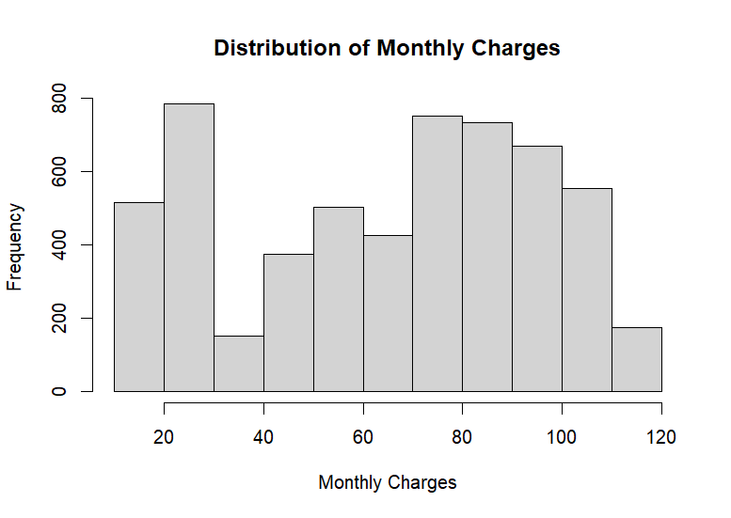
Figure 1. Distribution of Monthly Charges
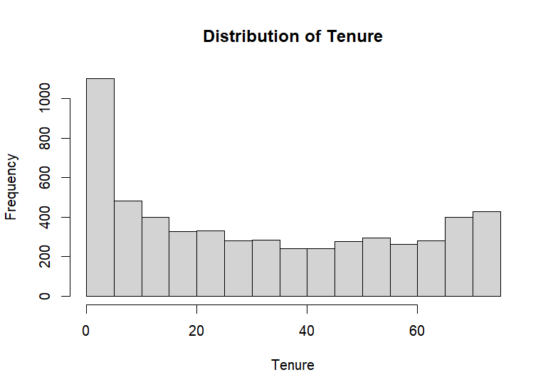
Figure 2. Distribution of Tenure
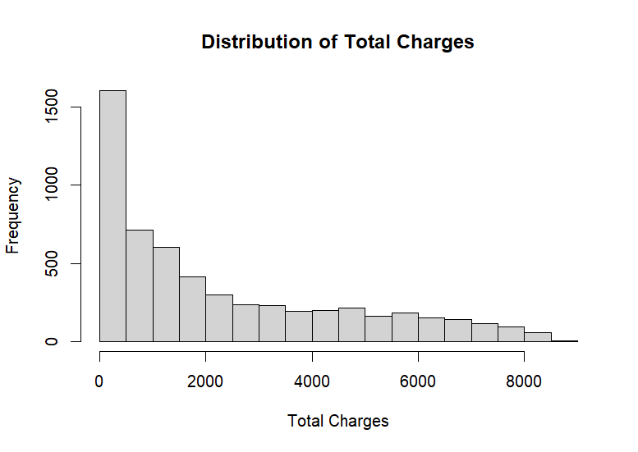
Figure 3. Distribution of Total Charges
Monthly Charges show substantial variation across customers. Tenure is concentrated among newer customers, while Total Charges are strongly right-skewed, reflecting the accumulation of charges over time. These distributions also explain why normality assumptions should not be taken for granted in the raw numerical variables.

3.3 High-Risk Customer Segments
Customer segment | Observed churn rate | Business meaning
Month-to-month contract | 42.71% | Low commitment creates a major retention risk
0–12 months tenure | 47.44% | Early lifecycle is the most vulnerable period
Electronic check | 45.29% | Potential billing/payment-experience issue
Fiber-optic internet | 41.89% | Requires investigation of price/service experience
Two-year contract | 2.83% | Long commitment is strongly associated with retention
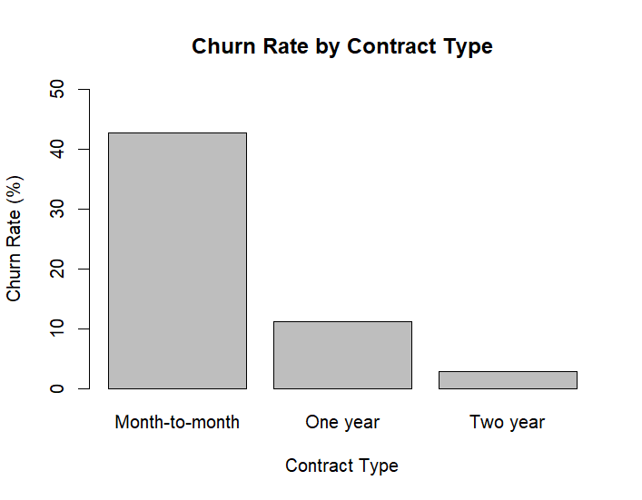
Figure 4. Churn Rate by Contract Type
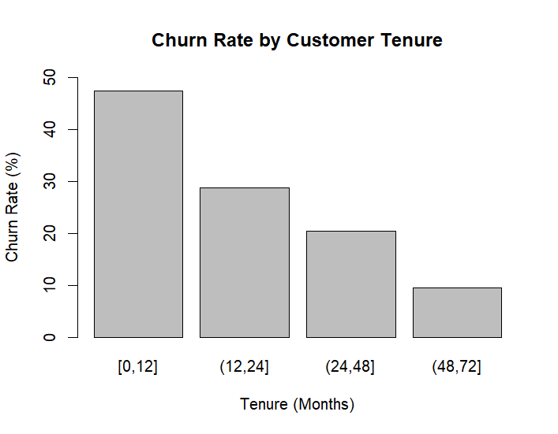
Figure 5. Churn Rate by Customer Tenure
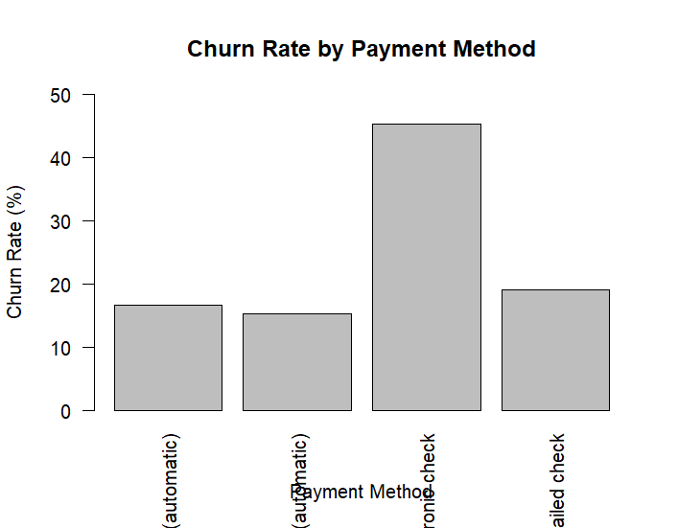
Figure 6. Churn Rate by Payment Method
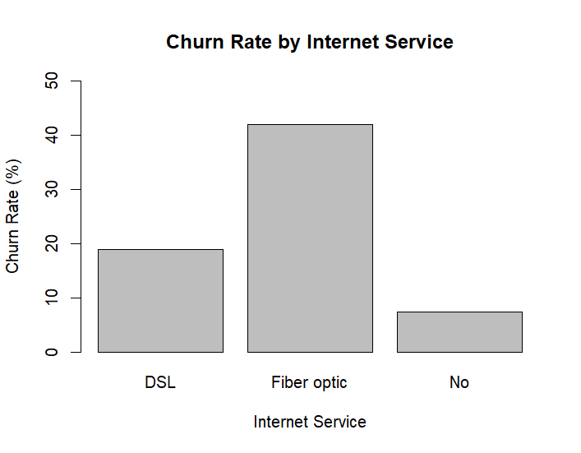
Figure 7. Churn Rate by Internet Service

3.4 Key Visualization Interpretation
- Month-to-month customers are substantially more likely to churn than customers on one- or two-year contracts.
- The first 12 months represent the most vulnerable stage of the customer lifecycle.
- Electronic-check customers form a high-risk segment and deserve targeted investigation.
- Fiber-optic customers have unusually high churn and should be studied for pricing, service quality, technical support and competitive pressure.
- Gender shows comparatively little separation and should not be treated as a primary churn driver based on this exploratory analysis.

4. Statistical Analysis
Week 3 extended the exploratory work with distribution assessment, Q-Q plots, Pearson correlation tests and significance testing. The goal was to quantify relationships suggested by the earlier charts.

4.1 Normality Assessment
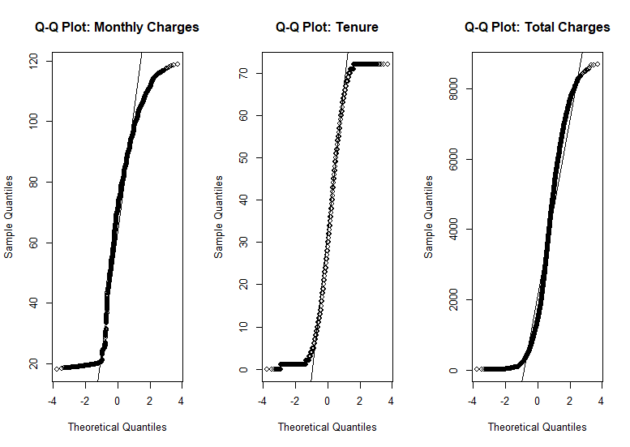
Figure 8. Q-Q Plots for Monthly Charges, Tenure and Total Charges
The Q-Q plots show clear departures from the reference line, particularly in the tails. This indicates that MonthlyCharges, Tenure and TotalCharges are not well described by a normal distribution. The result supports careful interpretation of distribution-based assumptions and motivated the use of correlation tests and logistic regression rather than relying on normality of the raw variables.

4.2 Correlation Analysis
Variable pair | Pearson r | 95% CI | Interpretation
MonthlyCharges – TotalCharges | 0.6511 | 0.6358 to 0.6659 | Moderate-to-strong positive relationship
MonthlyCharges – Tenure | 0.2546 | 0.2300 to 0.2788 | Weak-to-moderate positive relationship
Tenure – TotalCharges | 0.8297 | 0.8214 to 0.8377 | Strong positive relationship
All three relationships were statistically significant (p < 2.2e-16 in the reported tests). The strongest relationship is between Tenure and TotalCharges, which is intuitively reasonable: customers who remain longer with the provider have more time to accumulate total charges. The correlation between MonthlyCharges and TotalCharges is also substantial because monthly billing contributes directly to cumulative billing.
# Pearson correlation tests
cor.test(train_data$MonthlyCharges,
train_data$TotalCharges,
use = "complete.obs")
cor.test(train_data$MonthlyCharges,
train_data$tenure,
use = "complete.obs")
cor.test(train_data$tenure,
train_data$TotalCharges,
use = "complete.obs")

5. Predictive Modeling

5.1 Logistic Regression
Logistic regression was selected because Churn is a binary outcome. The model estimates the probability that a customer belongs to the churn class based on the available predictors. The data were split into training and testing sets, with 5,634 observations in training and 1,409 observations in testing.
# Logistic regression
logit_model <- glm(
Churn_Binary ~ .,
data = train_data,
family = binomial
)

5.2 Cross-Validation and Default Threshold
The cross-validation/default-threshold evaluation produced approximately 80.40% accuracy, 45.58% sensitivity and 91.96% specificity. This shows the classic trade-off of a conservative threshold: the model was strong at identifying non-churners but missed many actual churners.

5.3 ROC Curve and AUC
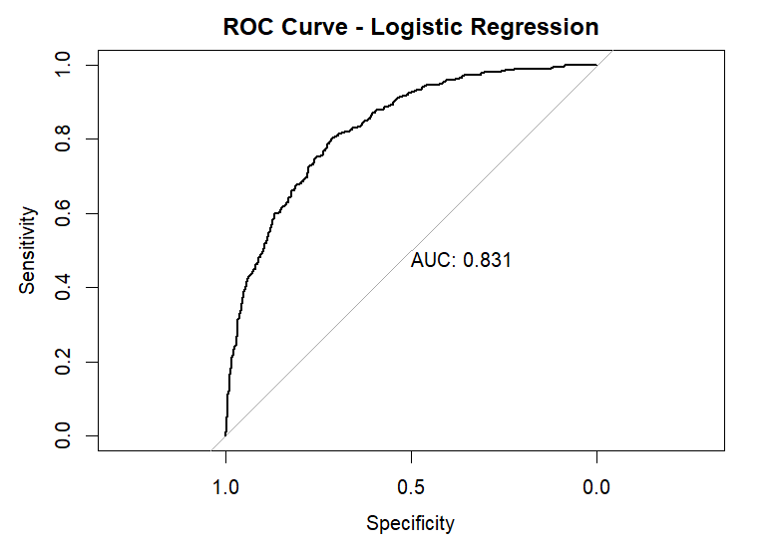
Figure 9. ROC Curve for Logistic Regression (AUC = 0.831)
The ROC curve summarizes model discrimination across possible probability thresholds. The AUC of 0.831 indicates good separation between churners and non-churners. The model therefore provides a useful baseline for ranking customers by churn risk.

5.4 Threshold Selection
Threshold | Accuracy | Sensitivity | Specificity | Comment
0.30 | 75.85% | 72.93% | 76.82% | Selected final threshold; stronger churn detection
0.40 | 78.55% | 62.11% | 84.01% | More conservative; misses more churners
0.50 | 80.40% | 45.58% | 91.96% | Highest accuracy of the tested thresholds but low sensitivity
A threshold of 0.30 was selected because churn-retention use cases typically place meaningful value on identifying potential churners. Reducing the threshold increases the number of customers flagged for retention activity, improving sensitivity while accepting more false positives.

6. Model Evaluation and Diagnostics

6.1 Final Confusion Matrix
 | Predicted 0 | Predicted 1
Actual 0 | 812 (TN) | 245 (FP)
Actual 1 | 95 (FN) | 256 (TP)
At the 0.30 threshold, the model correctly classified 812 non-churn customers and 256 churn customers. There were 245 false positives and 95 false negatives. The resulting sensitivity of 72.93% means that roughly three quarters of actual churners were detected by the model.

6.2 Final Performance Metrics
Metric | Value | Business interpretation
Accuracy | 75.85% | Overall proportion of correct classifications
Sensitivity | 72.93% | Ability to identify customers who actually churn
Specificity | 76.82% | Ability to identify customers who do not churn
AUC | 0.831 | Overall ranking/discrimination ability across thresholds

6.3 Logistic Regression Diagnostics
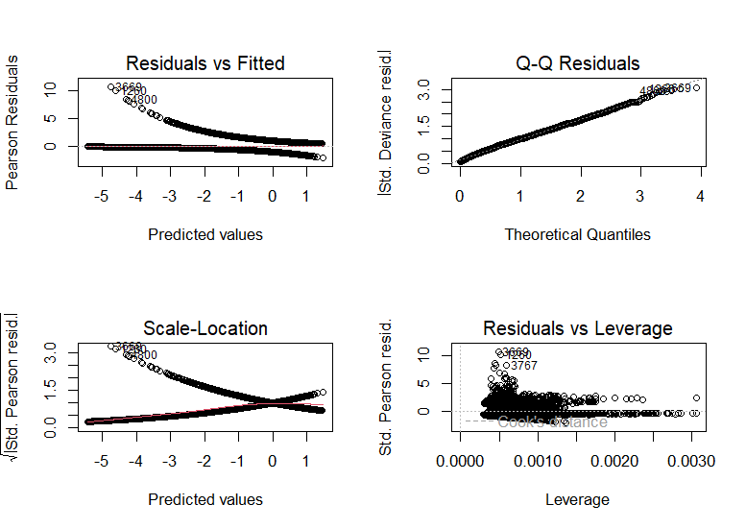
Figure 10. Logistic Regression Diagnostic Plots
The diagnostic plots show some structured residual behavior and several observations with comparatively large residual values. These patterns do not invalidate the baseline model, but they suggest opportunities for improvement through feature engineering, alternative algorithms, treatment of influential observations, and investigation of non-linear relationships.

7. Integrated Business Insights
Combining the descriptive, statistical and predictive stages provides a more useful business story than looking at any single chart or metric in isolation.
- Customer lifecycle matters: the 0–12 month segment has the highest observed churn, indicating that onboarding, early engagement and first-year service experience are critical.
- Commitment matters: month-to-month contracts have much higher churn than longer contracts, suggesting that customers with weak contractual commitment should receive proactive retention attention.
- Billing experience matters: electronic-check customers have unusually high churn. The segment should be examined for payment friction, failed payments, billing confusion or customer-profile differences.
- Service type matters: fiber-optic customers show elevated churn. This should be investigated rather than assuming that the technology itself causes churn.
- Tenure and cumulative charges are strongly related (r = 0.8297). This is useful for understanding customer value but also means that highly correlated predictors should be interpreted carefully in a predictive model.
- The predictive model is useful for prioritization rather than perfect prediction. An AUC of 0.831 indicates good discrimination, while the 0.30 threshold provides a practical balance between finding churners and limiting unnecessary interventions.

8. Recommendations
Recommendation | Action
Strengthen first-year retention | Create onboarding journeys, early satisfaction checks and targeted support during the first 12 months.
Target month-to-month customers | Offer suitable incentives, contract education or loyalty benefits to customers with high churn probability.
Investigate electronic-check churn | Review billing friction, payment failures, customer support contacts and alternative payment adoption.
Investigate fiber-optic churn | Compare price, service quality, outage history, support experience and competitor pressure for this segment.
Use churn scores for prioritization | Use the logistic model as a risk-ranking tool and focus retention resources on customers above the selected threshold.
Measure intervention outcomes | Track retention campaigns using controlled comparisons so that future decisions are based on incremental impact rather than association alone.

9. Challenges and Lessons Learned
- Data preparation must be completed before interpretation; missing-value checks and duplicate checks can materially affect downstream analysis.
- Exploratory charts are most useful when each visual answers a specific business question rather than simply displaying a variable.
- Statistical significance does not automatically mean business importance; effect size and practical context must also be considered.
- Classification accuracy alone is not sufficient for churn prediction. Sensitivity, specificity and AUC provide a more complete picture.
- Threshold selection should reflect business costs. In a retention setting, missing a true churner can be more costly than contacting a customer who would not have churned.
- Model diagnostics are important because they reveal patterns that may not be visible from a single accuracy number.

10. Future Scope
- Compare logistic regression with random forest, gradient boosting and other tree-based classifiers.
- Use stratified cross-validation and hyperparameter tuning for more robust model comparison.
- Perform feature selection and feature engineering, including interaction terms such as Contract × Tenure.
- Optimize the classification threshold using explicit business costs for false positives and false negatives.
- Investigate influential observations and possible non-linear effects.
- Build a monitoring framework so that churn scores and retention outcomes can be tracked over time.

11. Conclusion
The four-week Telco Customer Churn project demonstrates a complete analytical workflow using R: data inspection and preparation, exploratory visualization, statistical analysis, predictive modeling, and business interpretation. The analysis identified clear high-risk groups, including early-tenure and month-to-month customers, while also highlighting electronic-check and fiber-optic segments for further investigation.
The statistical stage confirmed meaningful relationships among tenure and charge variables, with Tenure and TotalCharges showing the strongest relationship at r = 0.8297. The logistic regression model achieved an AUC of 0.831, demonstrating good discrimination. Selecting a 0.30 probability threshold improved churn detection to 72.93% sensitivity while retaining 76.82% specificity.
Overall, the analysis provides a practical baseline for data-driven customer retention. The most valuable next step is not simply to increase model accuracy, but to connect churn predictions to targeted retention actions and measure whether those actions reduce actual customer loss.

12. Appendix: Selected R Code

12.1 Exploratory Visualization
# Overall churn
table(WA_Fn_UseC_Telco_Customer_Churn$Churn, useNA="ifany")
prop.table(table(WA_Fn_UseC_Telco_Customer_Churn$Churn)) * 100
# Contract churn
contract_churn <- prop.table(
table(WA_Fn_UseC_Telco_Customer_Churn$Contract,
WA_Fn_UseC_Telco_Customer_Churn$Churn),
margin = 1
) * 100
barplot(contract_churn[, "Yes"],
main="Churn Rate by Contract Type",
xlab="Contract Type",
ylab="Churn Rate (%)")

12.2 Correlation and Modeling
# Correlation
cor.test(train_data$MonthlyCharges,
train_data$TotalCharges,
use="complete.obs")
# Logistic regression
logit_model <- glm(
Churn_Binary ~ .,
data=train_data,
family=binomial
)
# ROC and AUC
roc_curve <- roc(
test_data$Churn_Binary,
test_data$predicted_prob
)
auc_value <- auc(roc_curve)
# Threshold-based prediction
test_data$predicted_churn_30 <-
ifelse(test_data$predicted_prob >= 0.3, 1, 0)
# Confusion matrix
final_cm_30 <- table(
Actual = test_data$Churn_Binary,
Predicted = test_data$predicted_churn_30
)

12.3 Source Repository
Project repository: https://github.com/Sakshilal/virtual-r-data-analyst-intern
The repository contains the Week 1, Week 2 and Week 3 reports and the Week 2 R visualization script. This final Week 4 report consolidates those analyses into a single comprehensive submission.

