WEEK 2 PROJECT REPORT
Data Visualization and Insight Communication using R
Telecom Customer Churn Analysis
Dataset: WA_Fn_UseC_Telco_Customer_Churn.csv
Tool: R / RStudio
Visualization system: Base R

1. Executive Summary
This Week 2 project uses the Telco Customer Churn dataset to communicate customer-retention patterns through visualizations created in R. The dataset contains 7,043 customer records and 21 variables covering demographics, services, contracts, billing, charges, and churn.
The churn outcome contains 5,174 customers who did not churn and 1,869 who churned. This corresponds to approximately 73.46% non-churn and 26.54% churn.
The strongest differences appear across contract type, customer tenure, payment method, internet service, and senior-citizen status. Gender shows comparatively little separation.

2. Dataset Overview
Variable | Type | Purpose
customerID | Character | Unique customer identifier
gender | Categorical | Customer gender
SeniorCitizen | Binary | Senior-citizen status
Partner / Dependents | Categorical | Household characteristics
tenure | Numeric | Months with the company
PhoneService / MultipleLines | Categorical | Phone service details
InternetService | Categorical | Internet service type
OnlineSecurity / OnlineBackup | Categorical | Online service add-ons
DeviceProtection / TechSupport | Categorical | Protection and support services
StreamingTV / StreamingMovies | Categorical | Streaming services
Contract | Categorical | Contract duration
PaperlessBilling | Categorical | Billing preference
PaymentMethod | Categorical | Payment method
MonthlyCharges | Numeric | Current monthly charge
TotalCharges | Numeric | Accumulated charges
Churn | Categorical | Target outcome: Yes / No
A summary check identified 11 missing values in TotalCharges. The Churn variable contained no blank values.

3. Visualization Methodology
Base R graphics were used. Bar charts compare churn rates within customer groups, the histogram shows the distribution of MonthlyCharges, and the scatter plot examines the relationship between MonthlyCharges and TotalCharges. For categorical variables, row-wise percentages were calculated so each group's churn rate could be compared fairly.

4. Overall Churn Distribution
There are 1,869 churned customers and 5,174 non-churned customers. The overall churn rate is approximately 26.54%.
table(WA_Fn_UseC_Telco_Customer_Churn$Churn, useNA = "ifany")
prop.table(table(WA_Fn_UseC_Telco_Customer_Churn$Churn)) * 100

5. Churn Rate by Contract Type
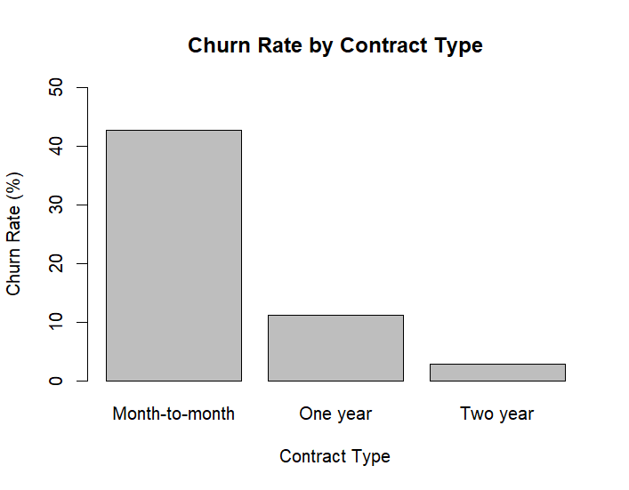
Interpretation: Month-to-month customers have the highest churn rate at about 42.71%. One-year contracts are about 11.27%, while two-year contracts are only about 2.83%. Longer commitment is strongly associated with retention.
R code used:
contract_churn <- prop.table(
table(WA_Fn_UseC_Telco_Customer_Churn$Contract,
WA_Fn_UseC_Telco_Customer_Churn$Churn), margin=1) * 100
barplot(contract_churn[, "Yes"], main="Churn Rate by Contract Type",
xlab="Contract Type", ylab="Churn Rate (%)", ylim=c(0,50))

6. Churn Rate by Customer Tenure
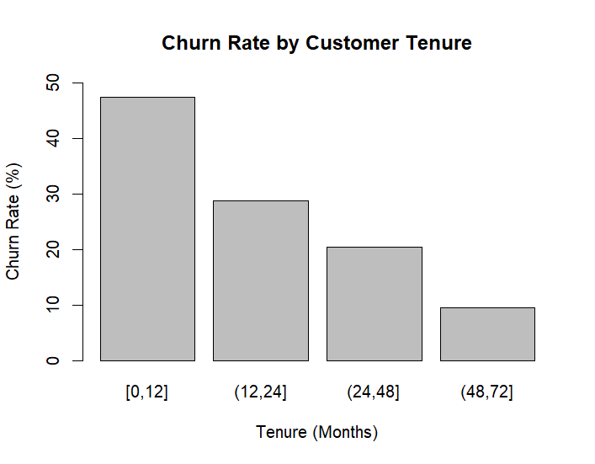
Interpretation: Customers with 0–12 months of tenure have the highest churn rate at about 47.44%. The rate declines to about 28.71%, 20.39%, and 9.51% as tenure increases.
R code used:
tenure_churn <- prop.table(
table(cut(WA_Fn_UseC_Telco_Customer_Churn$tenure,
breaks=c(0,12,24,48,72), include.lowest=TRUE),
WA_Fn_UseC_Telco_Customer_Churn$Churn), margin=1) * 100
barplot(tenure_churn[, "Yes"], main="Churn Rate by Customer Tenure",
xlab="Tenure (Months)", ylab="Churn Rate (%)", ylim=c(0,50))

7. Churn Rate by Payment Method
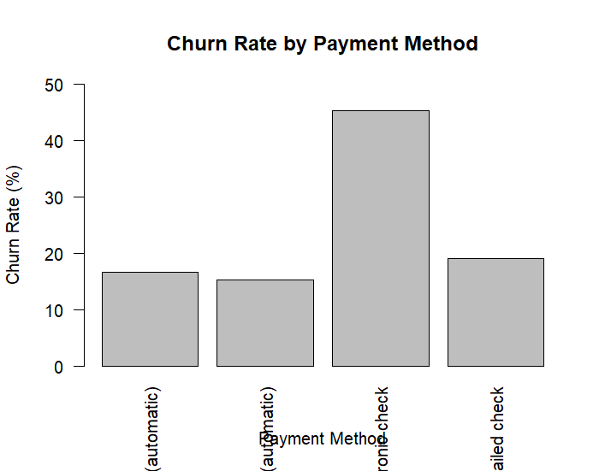
Interpretation: Electronic check customers show the highest churn rate at about 45.29%. The other payment groups are much lower, making this segment useful for further retention investigation.
R code used:
payment_churn <- prop.table(
table(WA_Fn_UseC_Telco_Customer_Churn$PaymentMethod,
WA_Fn_UseC_Telco_Customer_Churn$Churn), margin=1) * 100
barplot(payment_churn[, "Yes"], main="Churn Rate by Payment Method",
xlab="Payment Method", ylab="Churn Rate (%)", ylim=c(0,50), las=2)

8. Churn Rate by Internet Service
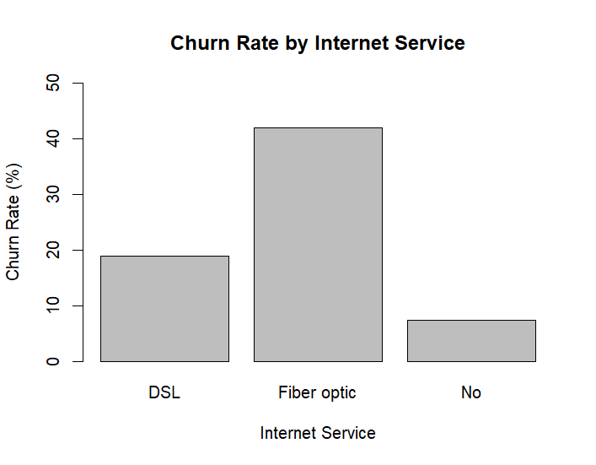
Interpretation: Fiber-optic customers have about 41.89% churn, compared with about 18.96% for DSL and 7.40% for customers without internet service. The fiber segment deserves further investigation.
R code used:
internet_churn <- prop.table(
table(WA_Fn_UseC_Telco_Customer_Churn$InternetService,
WA_Fn_UseC_Telco_Customer_Churn$Churn), margin=1) * 100
barplot(internet_churn[, "Yes"], main="Churn Rate by Internet Service",
xlab="Internet Service", ylab="Churn Rate (%)", ylim=c(0,50))

9. Churn Rate by Senior Citizen Status
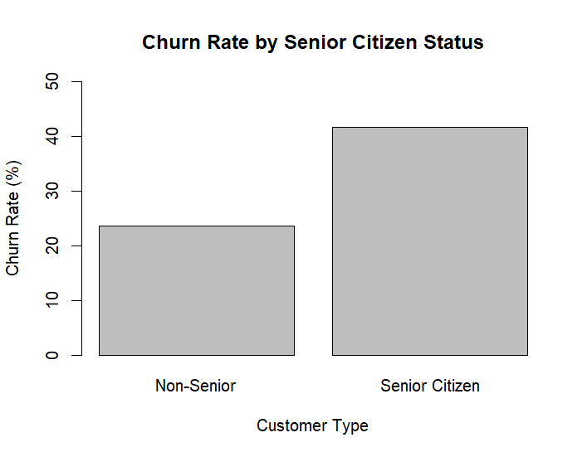
Interpretation: Senior citizens show a noticeably higher churn rate than non-senior customers. This is an association and should not be interpreted as proof that age status causes churn.
R code used:
senior_churn <- prop.table(
table(WA_Fn_UseC_Telco_Customer_Churn$SeniorCitizen,
WA_Fn_UseC_Telco_Customer_Churn$Churn), margin=1) * 100
barplot(senior_churn[, "Yes"],
names.arg=c("Non-Senior","Senior Citizen"),
main="Churn Rate by Senior Citizen Status",
xlab="Customer Type", ylab="Churn Rate (%)", ylim=c(0,50))

10. Churn Rate by Gender
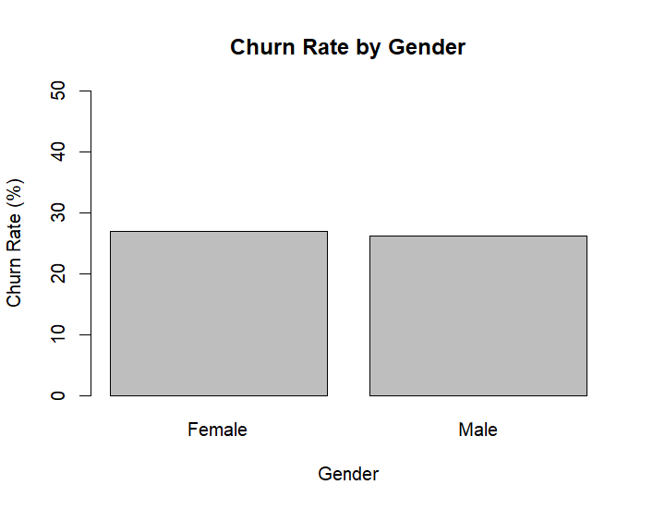
Interpretation: Female and male customers have very similar churn rates, both around 26–27%. Gender therefore shows less separation than contract, tenure, payment method, or internet service.
R code used:
gender_churn <- prop.table(
table(WA_Fn_UseC_Telco_Customer_Churn$gender,
WA_Fn_UseC_Telco_Customer_Churn$Churn), margin=1) * 100
barplot(gender_churn[, "Yes"], names.arg=c("Female","Male"),
main="Churn Rate by Gender", xlab="Gender",
ylab="Churn Rate (%)", ylim=c(0,50))

11. Distribution of Monthly Charges
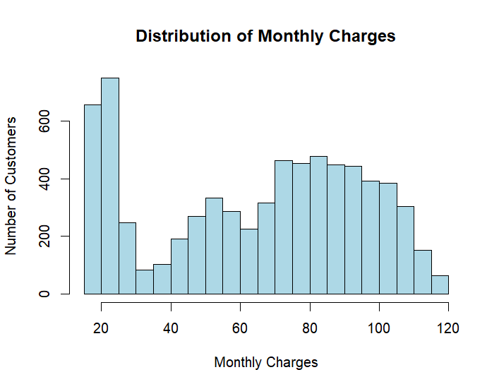
Interpretation: Monthly charges range roughly from 18 to 119. The histogram shows substantial customer volume at lower charge levels and a broad concentration across higher charge levels, reflecting different service bundles.
R code used:
hist(WA_Fn_UseC_Telco_Customer_Churn$MonthlyCharges,
main="Distribution of Monthly Charges",
xlab="Monthly Charges", ylab="Number of Customers",
breaks=20)

12. Monthly Charges vs Total Charges
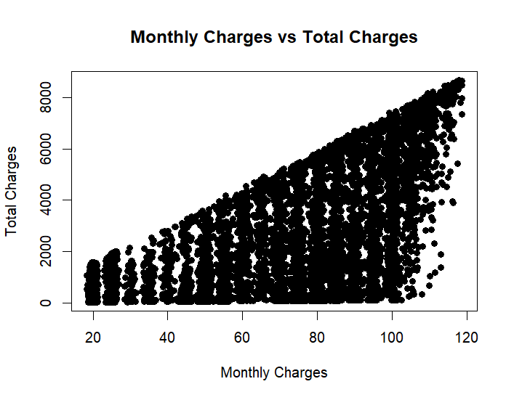
Interpretation: The plot shows a clear positive relationship: customers with higher monthly charges generally accumulate higher total charges. The spread also reflects differences in customer tenure. The 11 missing TotalCharges values were not imputed for this exploratory plot.
R code used:
plot(WA_Fn_UseC_Telco_Customer_Churn$MonthlyCharges,
WA_Fn_UseC_Telco_Customer_Churn$TotalCharges,
main="Monthly Charges vs Total Charges",
xlab="Monthly Charges", ylab="Total Charges", pch=19)

13. Key Findings and Business Insights
- Early-tenure customers are the highest-risk group. The 0–12 month segment has about 47.44% churn, making onboarding and first-year engagement important retention opportunities.
- Contract commitment is strongly associated with retention. Month-to-month customers churn at about 42.71%, versus about 2.83% for two-year contracts.
- Electronic check users show unusually high churn. This segment has about 45.29% churn and could be investigated for billing friction, payment convenience, or customer-profile differences.
- Fiber-optic customers require attention. The segment has about 41.89% churn and warrants further analysis of pricing, service experience, technical support, and competition.
- Senior citizens show higher churn. The senior-citizen group has a noticeably higher churn rate and may benefit from targeted support.
- Gender is not a strong differentiator. Male and female churn rates are close, so gender alone provides limited insight in this exploratory analysis.

14. Limitations and Next Steps
This is an exploratory visualization project. The charts show associations rather than causation. A next step would be multivariable analysis or a classification model to determine whether the strongest relationships remain after controlling for other customer characteristics. Useful follow-up comparisons include contract × tenure, internet service × payment method, and monthly charges × contract.

15. Conclusion
The Week 2 exercise demonstrates how R can turn customer-level data into clear business insights. Month-to-month customers, newer customers, electronic-check users, fiber-optic customers, and senior citizens emerge as important groups for further retention analysis, while longer-tenure and longer-contract customers show substantially lower churn.

16. R Code Appendix
# Overall churn
table(WA_Fn_UseC_Telco_Customer_Churn$Churn, useNA="ifany")
prop.table(table(WA_Fn_UseC_Telco_Customer_Churn$Churn)) * 100
# Dataset summary
summary(WA_Fn_UseC_Telco_Customer_Churn)
# Histogram
hist(WA_Fn_UseC_Telco_Customer_Churn$MonthlyCharges,
main="Distribution of Monthly Charges",
xlab="Monthly Charges", ylab="Number of Customers",
breaks=20)
# Scatter plot
plot(WA_Fn_UseC_Telco_Customer_Churn$MonthlyCharges,
WA_Fn_UseC_Telco_Customer_Churn$TotalCharges,
main="Monthly Charges vs Total Charges",
xlab="Monthly Charges", ylab="Total Charges", pch=19)

