Containers recap

What is Kubernetes

Kubernetes Architecture

Components of Kubernetes cluster

Pod

Kube-apiserver

KubeControllerManager

Kube scheduler

Kubelet

Hands-on

Pod replication

Deployments

Create custom image with required contents (optional)

Namespace

Resource limit on Pod

Resource limit on namespace

Services in Kubernetes

ClusterIP

NodePort

LoadBalancer

Services summarized

Lab setup

Minikube installation on Fedora OS

Install kubectl

Multi node kubernetes setup

Resources:

### Containers recap

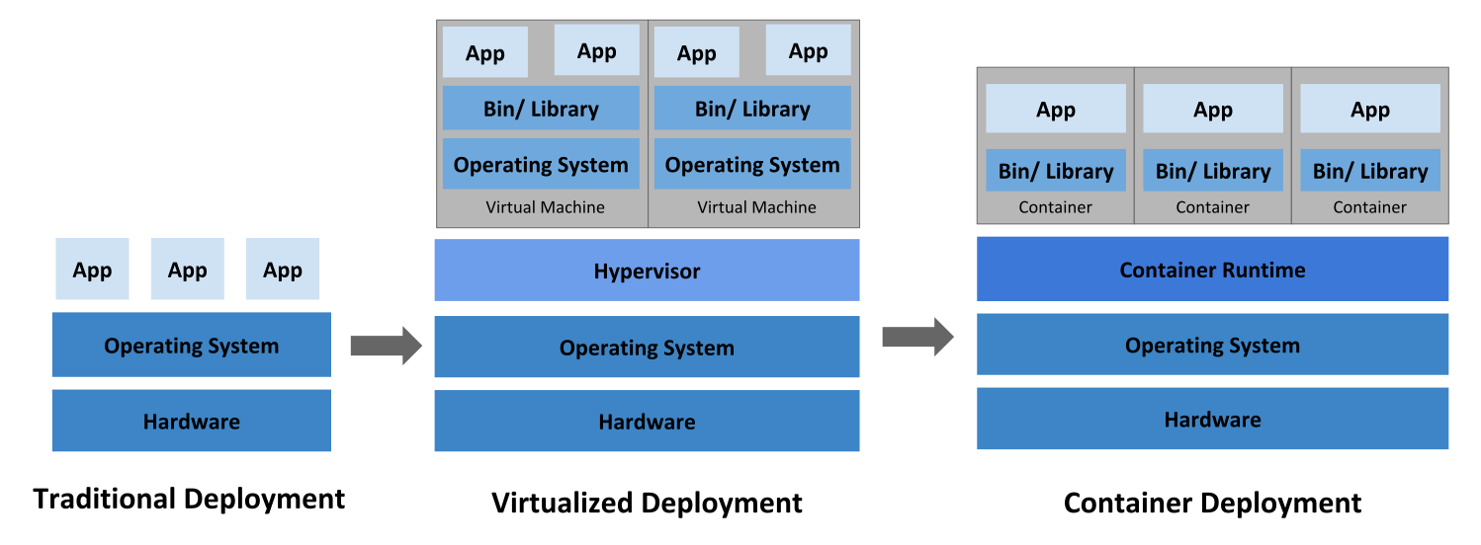

### What is Kubernetes

Kubernetes (also known as k8s or “kube”) is anopen source container orchestration platform that automates many of the manual processes involved in deploying, managing, and scaling containerized applications.

Kubernetes is a portable, extensible, open source platform for managing containerized workloads and services, that facilitates both declarative configuration and automation.

It’s based on Google’s internal project - Borg.

### Kubernetes Architecture

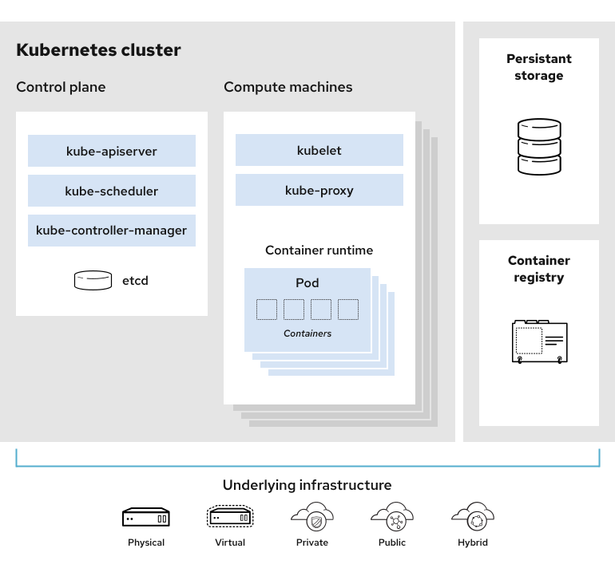

* Control plane (master nodes)

Manages the workload

* Compute plane (worker nodes)

Runs the workload

### Components of Kubernetes cluster

**Master node - manages the cluster setup**

* Etcd

Etcd is a key-value store database. Configuration data and information about the state of the cluster lives in etcd,

Fault-tolerant and distributed, etcd is designed to be the ultimate source of truth about your cluster.

* kube-scheduler

The scheduler considers the resource needs of a pod, such as CPU or memory, along with the health of the cluster. Then it schedules the pod to an appropriate compute node.

* Controller manager

Controllers take care of actually running the cluster, and the Kubernetes controller-manager contains several controller functions. For Example:

* + Node controller - Manages node related tasks like onboarding nodes, managing node failures, etc
  + Replication controller - Manages container. Make sure the desired number of containers run all the time.
* Kube-apiserver

Facilitates the interaction with the Kubernetes cluster.

Theis the front end of the Kubernetes control plane, handling internal and external requests. The API server determines if a request is valid and, if it is, processes it. You can access the API through REST calls, through the kubectl command-line interface, or through other command-line tools such as kubeadm.

**Worker node - Rus the container workload in the cluster setup**

* Container runtime Engine

To run the containers, each compute node has a container runtime engine.Docker is one example, but Kubernetes supports other Open Container Initiative-compliant runtimes as well, For example:

* + Docker
  + Containerd
  + Rocket
  + CRI-O
* Kubelet

Each compute node contains a kubelet, a tiny application that communicates with the control plane. The kublet makes sure containers are running in a pod. When the control plane needs something to happen in a node, the kubelet executes the action.

* Kube-proxy

Each compute node also contains kube-proxy, a network proxy for facilitating Kubernetes networking services. The kube-proxy handles network communications inside or outside of your cluster—relying either on your operating system’s packet filtering layer, or forwarding the traffic itself.

### Pod

Pod is the atomic unit of scheduling in kubernetes cluster

Pod is a group of containers. Normally one container is run in one pod.

When two applications are tightly coupled, then only two containers may run in a single pod.

Usually it is avoided to run more than one container in one pod.

Pod is a wrapper to distribute the container.

Consider running multiple containers with port mapping from host:

docker run -d -p 80:80 httpd

docker run -d -p 80:80 httpd

The second run fails as port 80 on the host is already occupied with the earlier container. Hence another container needs to be run with different port mapping on host.

docker run -d -p 81:80 httpd

We need to manually track the free ports.

Container abstraction helps to handle this.

Pod gets it’s own network namespace and virtual ethernet connection to connect underlying infrastructure. (We will look actual hands-on with this using kubernetes later)

Basic operations to run a workload in Kbernetes:

Package application as container

Wrap it in the pod

Deploy it using manifest file

Pods help for abstraction of container engine.

With use of pods as basic atomic unit, the underlying container engine can be easily changed.

### Kube-apiserver



Consider any kuectl get command

1. **kubectl** generates authentication request to **kube-apiserver**
2. **Kube-apiserver** validates the request
3. **kube-apiserver** retrieve data from **etcd**
4. Data is displayed on the console by **kubectl**

APIs can also be invoked directly by sending HTTP request instead of running the kubectl command because api-server uses HTTP protocol for all communication

During the request for creating pod:

1. **kubectl** generates authentication request to **kube-apiserver**
2. **Kube-apiserver** validates the request
3. **kube-apiserver** creates a pod object without assigning it to a node
4. **kube-apiserver** updates the pod info in **etcd** database
5. **Kube-apiserver** updates the user that pod has been created
6. **kube-scheduler** continuously monitors the **kube-apiserver** and realizes there is new pod with no node assigned
7. **kube-scheduler** identifies the right node for the pod and communicated that back to **kube-apiserver**
8. **kube-apiserver** updates the info in **etcd**
9. **kube-apiserver** passes that info to the **kubelet** in the appropriate worker node
10. **kubelet** creates the pod in the node and instructs the container runtime engine to deploy the application image
11. once done **kubelet** updates the status back to the **kube-apiserver**
12. **kube-apiserver** updates the data back in the **etcd**

kube-apiserver at the center of all the tasks that need to be performed on the cluster.

### KubeControllerManager

Manages various controllers in the setup.

Continuously monitors the status of different components on the cluster

In case of any failure, it takes corrective actions to bring the cluster back to its desired state.

For Example:

node-controller continuously monitors the status of the nodes via kube-apiserver

Heartbeat is sent every 5 seconds to monitor the health of the node

If the heartbeat is missed, the controller waits for 40 seconds before marking the node unreachable.

After the node is marked unreachable, the controller waits for another 5 mins to see if the node is coming back.

If a node does not come up after 5 mins, the controller manager moves the pods assigned to the broken node to the healthy nodes.

There are many controllers in a kubernetes cluster e.g. node-controller, replication controller, namespace controller, deployment controller, etc. All these controllers are packaged in to single kube-controller-manager process

### Kube scheduler

Kube scheduler does not create the pod on the worker node.

Kube scheduler just decides which pod goes on which node. Kubelet creates the pod on the node.

Scheduler tries to identify the best node for the pod based on:

resource requirements

Taints

Affinity rules

Etc

### Kubelet

Kubelet in the worker node registers the node with the cluster

When kube-apiserver sends request to load a container it sends request to container runtime engine e.g. docker to run the instance

Kubelet then regularly monitors that status of the pods and reports the status to kube-apiserver

Kubelet is the sole point of contact on the worker node for the master node.

Load or unload the pods, send status

### Hands-on

kubectl get pods

kubectl get pods -A

kubectl run --image IMAGE_NAME POD_NAME

kubectl run --image nginx nginx

kubect create deployment NAME --image=IMAGE

kubectl create -f definition.yml

kubectl create -f definition.yml

kubectl delete pod NAME

kubectl deete deployment NAME

kubectl run NAME --image=NAME --dry-run=client -o yaml

kubectl edit pod NAME

kubectl apply -f file.yml

kubectl describe pod PODNAME

kubectl logs PODNAME

kubectl logs PODNAME CONTAINERNAME

pod.yml:

apiVersion: v1

kind: Pod

metadata:

name: myapp

labels:

app: myapp

type: prod

spec:

containers:

- name: container-1

image: redis

- name: container-2

image: nginx

### Pod replication

Replication controller helps create multiple instances of a pod to provide high availability.

It also helps with scaling of application workload using load balancing.

What is Scale up (vertical scaling) VS scale out (horizontal scaling)?

Labels and Selectors are used to identify and use the pods in a specific replica set.

This can be used for pods outside of the replica set definition file as well.

apiVersion: apps/v1

kind: ReplicaSet

metadata:

name: myapp-ha

labels:

app: myapp

type: front-end

spec:

template:

metadata:

name: myapp

labels:

app: myapp

type: frontend

spec:

containers:

- name: container-1

image: redis

replicas: 3

selector:

matchLabels:

type: frontend

Kubectl create -f file.yml

Kubectl explain replicaset

Kubectl get replicaset

Kubectl get pods

Kubectl delete pod NAME

Kubectl get pods

Kubectl describe replicaset myapp-ha

Scale by changing the replicas number in aove config and then use below command

kubectl replace -f file.yml

Alternate options:

Kubectl scale –replicas=4 -f file.yml

Kubectl scal –replcas=5 replicaset myapp-ha

### Deployments

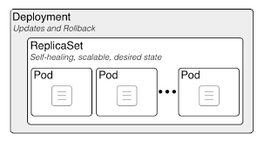

Typical requirements form any production application:

* Replications - for high availability
* Seamless upgrade
* Rolling updates - updates one after other for seamless user experience
* Rollback updates - in case of failure, updates can be rolled back
* Pause - update resume capability

Same config as replicaset except

kind: Deployment

Kubectl explain deployment

Generate the sample config file using:

Kubectl create deployment –image=nginx nginx –dry-run=client -o yaml

apiVersion: apps/v1

kind: Deployment

metadata:

name: nginx-deployment

labels:

app: nginx

spec:

replicas: 3

selector:

matchLabels:

app: nginx

template:

metadata:

labels:

app: nginx

spec:

containers:

- name: nginx

image: nginx:1.22

Kubectl apply -f file.yml

Kubectl get deployments

Kubectl get replicaset

Kubectl get pods

Kubectl get all

Kubectl describe deployment NAME

Kubectl describe pod name

Watch “kubectl get all”

kubectl set image deployment.v1.apps/nginx-deployment nginx=nginx:1.16.1

Kubectl describe pod name

<https://hub.docker.com/_/nginx/tags>

Edit file and change to the newer version

Kubectl apply -f file.yml

Kubectl describe pod name

kubectl rollout status deployment nginx-deployment

kubectl rollout history deployment nginx-deployment

kubectl rollout undo deployment nginx-deployment --to-revision 1

### Create custom image with required contents (optional)

1. Create a program (tobe used in custom image) which will consume system memory:

cat mem.c

/*

* https://stackoverflow.com/a/1865536

*/

#include <stdio.h>

#include <stdlib.h>

#include <string.h>

int main()

{

while(1)

{

printf ("\nAllocating...");

void *m = malloc(1024*1024);

memset(m,0,1024*1024);

printf("done");

printf ("\nPress any key to continue...");

//sleep(2);

getchar();

}

return 0;

}

$ gcc mem.c -o mem

1. Create a Dockerfile to generate a custom container with required packages and tools.

cat Dockerfile

from fedora

run dnf -y install iputils iproute

copy mem /usr/local/bin/mem

CMD sleep 100000

1. Create docker image and test is by running docker container

docker build -t my-fedora .

docker run --rm -ti --name new-fedora my-fedora bash

1. Login to <https://hub.docker.com/> with your credentials and create a public repo with tag
2. Back to the system: tag newly created custom image and push it to docker hub:

$ docker login

$ docker image tag my-fedora:latest ashishkshah/my-fedora:test

$ docker push ashishkshah/my-fedora:test

1. Create kubernetes pod using this new image:

$ kubectl run --image ashishkshah/my-fedora:test mypod

1. Connect to the pod with bash shell and verify the tools embedded in it:

kubectl exec --stdin --tty mypod -- /bin/bash

$ mem

$ ping

$ ip

### Namespace

kubectl create namespace myspace

kubectl get pods --namespace=myspace

kubectl create -f file.yml --namespace=myspace

kubectl get ns

kubectl get pods --all-namespaces

kubectl config current-context

kubectl config set-context kubernetes-admin@kubernetes --namespace=myspace

cat namespace.yml

apiVersion: v1

kind: Namespace

metadata:

creationTimestamp: null

name: myspace

spec:

status: {}

### 

### Resource limit on Pod

1. Run the pod with custom image

cat pod-limits.yml

---

apiVersion: v1

kind: Pod

metadata:

name: testpod

spec:

containers:

- name: app

image: ashishkshah/myrepo:test

resources:

requests:

memory: "8Mi"

limits:

memory: "16Mi"

1. Connect to the pod via bash shell (two sessions) and execute memory consumption utility /usr/local/bin/mem
2. Keep increasing the program's memory consumption and observe it in another session.

$ watch “ps aux | grep mem | grep -v mem”

1. Watch the program getting terminated upon hitting limit

A request is the amount of that resource that the system will guarantee for the container, and Kubernetes will use this value to decide on which node to place the pod.

A limit is the maximum amount of resources that Kubernetes will allow the container to use.

### Resource limit on namespace

cat resource-quota.yml

apiVersion: v1

kind: ResourceQuota

metadata:

name: quota

spec:

hard:

cpu: "2"

memory: "32Mi"

pods: "4"

replicationcontrollers: "2"

resourcequotas: "1"

services: "3"

kubectl describe quota

kubectl --namespace=myspace describe quota

# kubectl apply -f resource-quota.yml --namespace=myspace

kubectl --namespace=myspace describe quota

kubectl config set-context minikube --namespace=myspace

kubectl config get-contexts

kubectl describe quota

cat pod-limits-nginx.yml

---

apiVersion: v1

kind: Pod

metadata:

name: testpod

spec:

containers:

- name: app

image: nginx

resources:

requests:

memory: "8Mi"

cpu: 2

limits:

memory: "16Mi"

cpu: 2

### Services in Kubernetes

In kubernetes, services are different mechanisms available for accessing pods.

By Default, pods created on kubernetes cluster are not accessible outside of the cluster and they can not communicate among themselves as well.

kubectl run --image nginx nginx --port 80

kubectl describe pod nginx | grep 'Node\|IP'

curl IP

curl IP <-- from node

kubectl port-forward pod-nginx 30005:80 --address 0.0.0.0

NOTE: port-forwarding is used throughout this hands-on activity for the demonstration purpose only. This is not a recommended way to expose any service from kubernetes cluster.

There are different types of services available in kubernetes cluster which enables the communication among the pods and communication outside the cluster.

1. ClusterIP
2. NodePort
3. LoadBalancer

#### ClusterIP

ClusterIP is the default service type.

This is used for inter service communication within the cluster.

Consider two deployment sets, front-end and back-end.

Communication between these two deployment sets is established using clusterip service.

Why do we need it? or why do we prefer this for inter pod communication within the cluster?

If we are using a pod's ip address for communication among the pods, when any pod is deleted or crashed due to some reason, the deployment set or replica set will spawn another pod to maintain the replica count.

The new pod spawned will have different ip addresses and hence it will not be easy to maintain the communication among the pods with new pods running with different ips.

To resolve this, we are creating a clusterip service which attaches itself to pods or replicas or daemonsets using labels and selectors.

In our example we will have two clusterip services for frontend and backend each.

The IP address of clusterip service is now being used for communication among the services instead of pods ip address.

Now even if the pods in replicasets fail and new pods are spawned with a new ip address, communication between the two services is not broken as it is done using clusterip service.

Kubernetes assigns a cluster-internal IP address to ClusterIP service.

Due to this the service is only reachable within the cluster.

The IP address of ClusterIP service can not be accessed from outside the cluster.

### clusterip service enable connictivity between group of pods

kubectl create -f pod-client.yml

### Try to access pod ip using curl

kubectl get all -o wide

### Note the node where pod is runnning

### From the node try to access service using curl

cat deployment-nginx.yml

apiVersion: apps/v1

kind: Deployment

metadata:

name: nginx-server-dep

labels:

app: nginx-server

spec:

template:

metadata:

labels:

app: nginx-server

spec:

containers:

- name: frontend

image: nginx

replicas: 3

selector:

matchLabels:

app: nginx-server

cat cip-service-nginx-dep.yml

apiVersion: v1

kind: Service

metadata:

labels:

app: cip-nginx-server-dep

name: cip-nginx-server-dep

spec:

ports:

- name: "80"

port: 80

protocol: TCP

targetPort: 80

selector:

app: nginx-server

type: ClusterIP

kubectl apply -f deployment-nginx.yml

kubectl apply -f cip-service-nginx-dep.yml

kubectl port-forward services/cip-nginx-server-dep 30005:80 --address 0.0.0.0

curl kubemaster:30005

### Kill the pods one by one and make sure service is accessible via service ip

#### NodePort

NodePort service is an extension of ClusterIP service.

It exposes the service outside of the cluster by adding a cluster-wide port on top of ClusterIP.

Limitation of clusterip service was it can not be used for communication outside the cluster.

Noteport service can be used for enabling access to the service outside of the cluster.

As the name may suggest, the NodePort service exposes the service(port) on each Node’s IP.

The service can be accessed from outside the the cluster using nodeip:port

Port configured to listen on the node is mapped to the service port and it is further mapped to the port on the pod.

Node port must be in the range of 30000–32767. The ports can be allocated manually or kubernetes will take care of it if they are not manually assigned.

cat np-service-nginx-server.yml

apiVersion: v1

kind: Service

metadata:

labels:

app: np-service-server

name: np-service-server

spec:

ports:

- name: "80"

port: 80

protocol: TCP

targetPort: 80

nodePort: 30009

selector:

app: nginx-server

type: NodePort

kubectl apply -f np-service-nginx-server.yml

kubectl describe service np-service-server

Check the node where pod is provisioned

run curl kubeworker1:30005 from outside

#### LoadBalancer

The nodeport service has enabled external connectivity for the service. But still there is one problem with it.

The service is listening on the specified port on node's ip. That means if the pods in your replicaset are distributed among different nodes, all the nodes ip addresses will listen on the nodeport. Hence there will be a number of IP:PORT combinations available to access your service.

Needless to say there is no server side distribution of the traffic with this approach of accessing service. This approach is not practically used

for providing external access to the service but is used as an intermediate step.

LoadBalancer service is an extension of NodePort service.

Loadbalancer integrates NodePort with cloud-based load balancers and provides a single ip:port combination for accessing service from external networks.

The load is then distributed by load balancer service to different nodes underneath.

Usually cloud-provide's load balancer service offering is used to exposes this service externally.

Each cloud provider like e.g. AWS, Azure, GCP, etc has its own native load balancer implementation.

This type of service is heavily dependent on the cloud provider.

Load Balancer created by cloud provider routes the incoming requests to kubernetes services which sends the traffic further to backend pods.

#### Services summarized

Function:

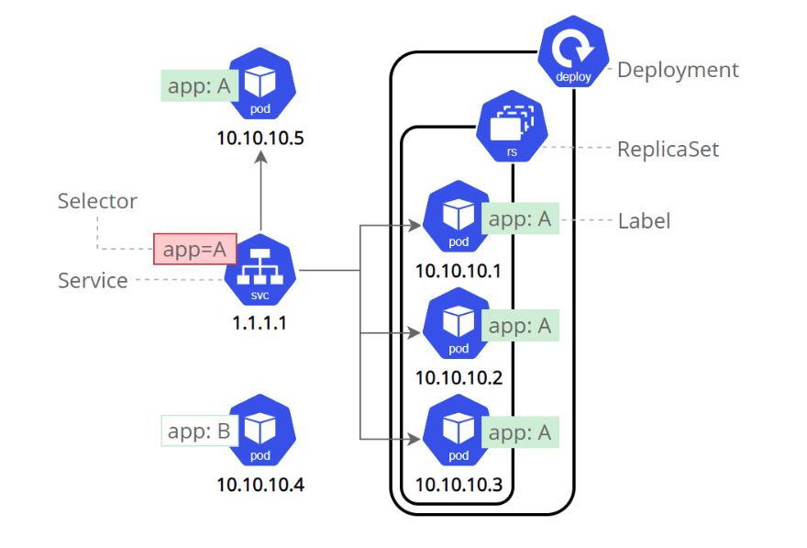

Implementation:



### 

### Lab setup

#### Minikube installation on Fedora OS

curl -LO https://storage.googleapis.com/minikube/releases/latest/minikube-latest.x86_64.rpm

sudo rpm -Uvh minikube-latest.x86_64.rpm

dnf install docker

systemctl enable docker.service --now

Useradd kube

Passwd kube

usermod -aG docker $USER && newgrp docker

echo -e " kube ALL=(ALL) ALL" >> /etc/sudoers

Su - kube

$ minikube start --driver=docker

#### Install kubectl

cat <<EOF | sudo tee /etc/yum.repos.d/kubernetes.repo

[kubernetes]

name=Kubernetes

baseurl=https://packages.cloud.google.com/yum/repos/kubernetes-el7-\$basearch

enabled=1

gpgcheck=1

gpgkey=https://packages.cloud.google.com/yum/doc/yum-key.gpg https://packages.cloud.google.com/yum/doc/rpm-package-key.gpg

EOF

sudo yum install -y kubectl

kubectl get pods -A

**Bash auto completion:**

kubectl completion bash | sudo tee /etc/bash_completion.d/kubectl > /dev/null

source /usr/share/bash-completion/bash_completion

Kubectl <tab> <tab>

#### Multi node kubernetes setup

Execute steps 1 to 6 on all the nodes

1. Set static ip, gateway and dns configuration:

nmcli connection show

nmcli

sudo nmcli con modify NAME ifname NAME ipv4.method manual ipv4.addresses 192.168.122.10/24 gw4 192.168.122.1

sudo nmcli con mod NAME ipv4.dns 192.168.122.1

nmcli con down NAME

nmcli con up NAME

sudo hostnamectl set-hostname master-node

reboot

1. Disable swap

rpm -e zram-generator-defaults zram-generator

swapoff -a

free

1. Configure repo

cat <<EOF > /etc/yum.repos.d/kubernetes.repo

[kubernetes]

name=Kubernetes

baseurl=https://packages.cloud.google.com/yum/repos/kubernetes-el7-x86_64

enabled=1

gpgcheck=1

repo_gpgcheck=1

gpgkey=https://packages.cloud.google.com/yum/doc/yum-key.gpg https://packages.cloud.google.com/yum/doc/rpm-package-key.gpg

EOF

1. Install packages and enable service

yum install -y docker kubelet kubeadm kubectl crio

systemctl enable docker --now

systemctl enable kubelet --now

systemctl enable crio --now

1. Configure firewall rules

sudo firewall-cmd --permanent --add-port=6443/tcp

sudo firewall-cmd --permanent --add-port=2379-2380/tcp

sudo firewall-cmd --permanent --add-port=10250/tcp

sudo firewall-cmd --permanent --add-port=10251/tcp

sudo firewall-cmd --permanent --add-port=10252/tcp

sudo firewall-cmd --permanent --add-port=10255/tcp

sudo firewall-cmd --reload

1. Enable bridge-nf-call-iptables in sysctl config file

cat <<EOF > /etc/sysctl.d/k8s.conf

net.bridge.bridge-nf-call-ip6tables = 1

net.bridge.bridge-nf-call-iptables = 1

EOF

sysctl --system

1. Execute steps 1 to 6 on Mster node and then run below command:

sudo kubeadm init --pod-network-cidr=10.244.0.0/16

mkdir -p $HOME/.kube

sudo cp -i /etc/kubernetes/admin.conf $HOME/.kube/config

sudo chown $(id -u):$(id -g) $HOME/.kube/config

sudo kubectl apply -f https://raw.githubusercontent.com/coreos/flannel/master/Documentation/kube-flannel.yml

1. Run steps 1 to 6 on worker node and then join the node to master

kubeadm join 192.168.122.10:6443 --token fm2fjd.940uvjc3tqi6pgjx --discovery-token-ca-cert-hash sha256:a8989efa29ec4e6f4c343d104b3f66f84da855992d795ddc9082522bc39b9346

### Resources:

<https://kubernetes.io/docs/concepts/>

<https://www.redhat.com/en/topics/containers/what-is-kubernetes>

<https://www.redhat.com/en/topics/containers/kubernetes-architecture>

<https://minikube.sigs.k8s.io/docs/start/>

<https://kubernetes.io/docs/tasks/tools/install-kubectl-linux/#install-using-native-package-management>

<https://kubernetes.io/docs/tasks/tools/included/optional-kubectl-configs-bash-linux/>

<https://phoenixnap.com/kb/how-to-install-kubernetes-on-centos>