1. **Get the value for column place for student with id 1 using the column key word .**

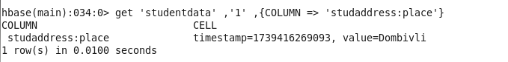

1. **Retrieve all column values for student with id 1**

1. **Get the records for student with id 2 , 3 , and 4**

1. **Get all the column values for column family student address for student with id=1 without using columns keyword**

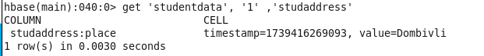

1. **Change the lastname for studentid 1 from original to Kelar and then check the record to see if the changes are done**

**Perform the following processes on the student table**

1. **Count the number of records**

1. **Disable the table**

1. **Verify if the table is disabled**

1. **Enable the table again and scan the table**

1. **Delete the column middle name for student with id 4**



1. Delete all the column families and columns for record 4

1. Q

1. Q

1. Q

