# Data Model Diagram

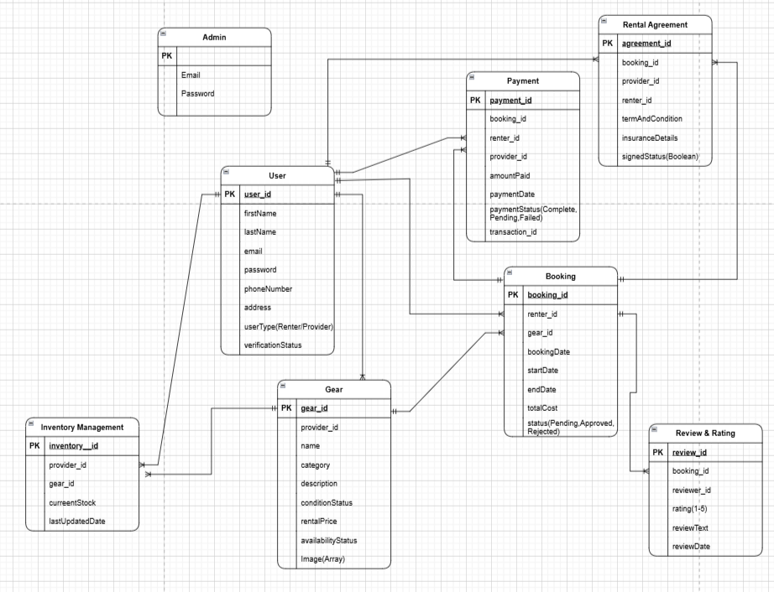

# Use Case

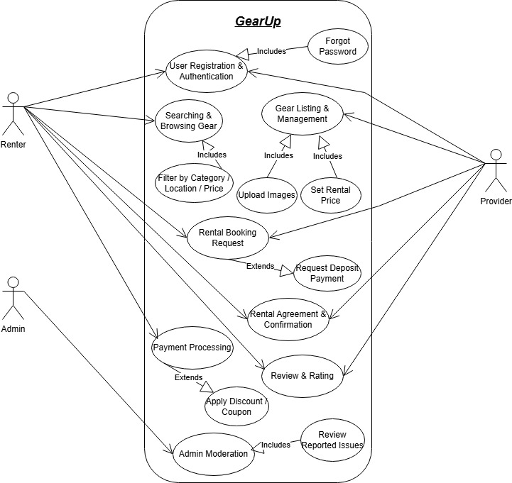

# UI Design

**Login Screen**

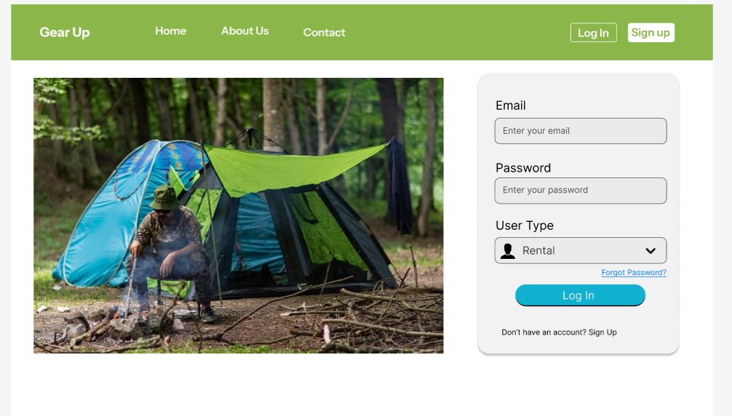

Entering credentials—such as email and password—the login page lets users access their accounts. It may also include a "Forgot Password" tool for account recovery and enable social network login choices.

**Register Screen**

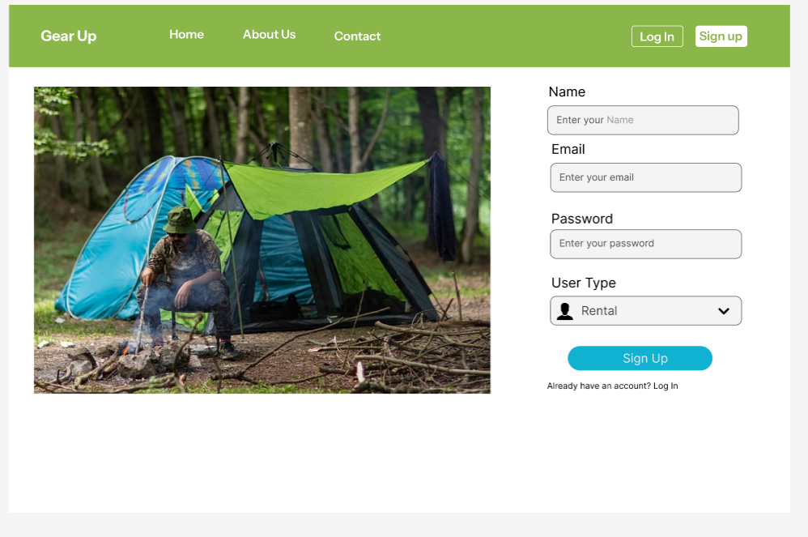

By entering their basic information—name, email, password, and role—renter or provider—the registration page lets new users join up. It can contain emails confirming account activation and validation tests

**Home & Search Page**

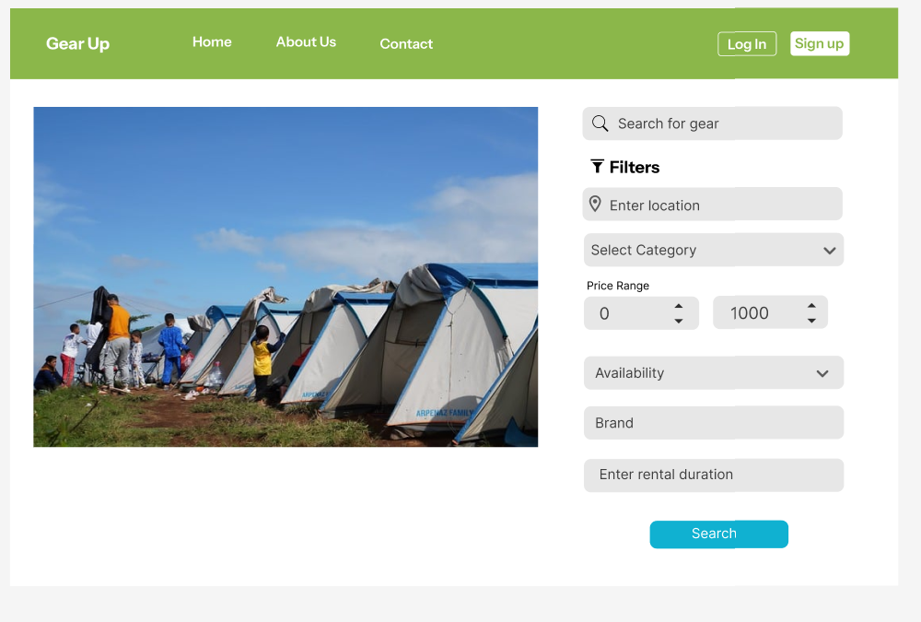

Users browse gear listings, search by location, category, price, and availability. Personalized recommendations based on past searches and geo-based suggestions help renters find suitable gear quickly.

**Search Gear Screen**

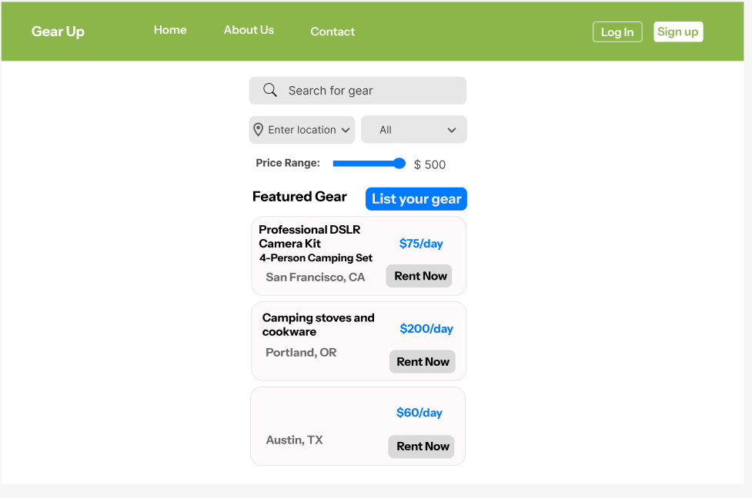

Based on several factors like location, category, availability, and price, users may narrow their search for gear rentals. Modern filtering and sorting choices might be offered to assist identify the greatest fit quickly.

**Gear Listing Page (For Providers)**

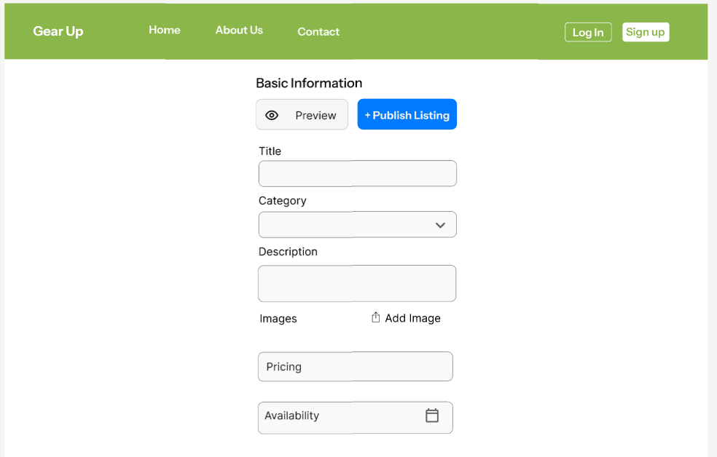

Providers add, edit, or remove gear listings with images, descriptions, pricing, and availability. A calendar-based scheduler manages inventory, and a preview feature allows providers to see how listings appear to renters.

**Payment Detail Screen**

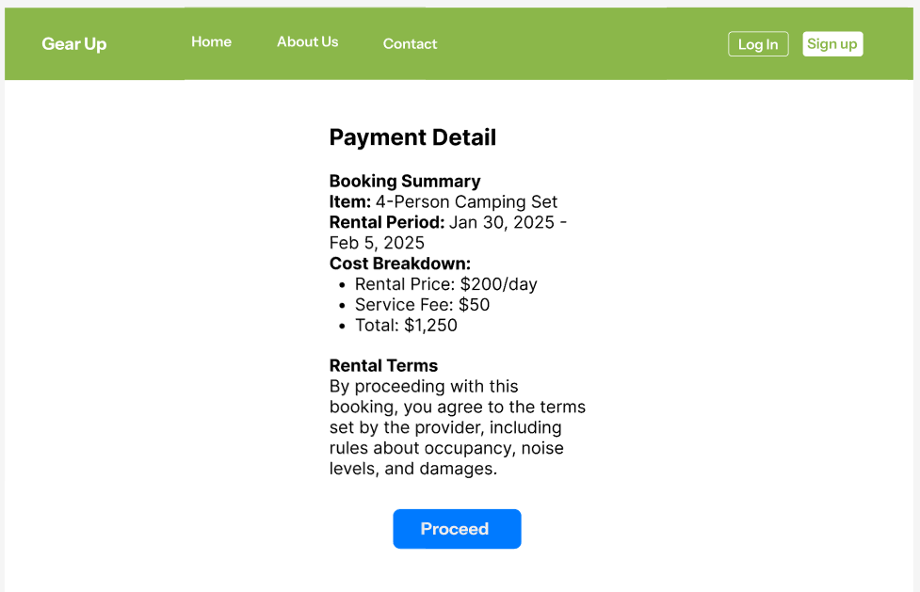

Shows a thorough rental cost breakdown including payment choices, taxes, service fees. Before deciding on their payment option, users should check their whole amount.

**Booking & Payment Screen**

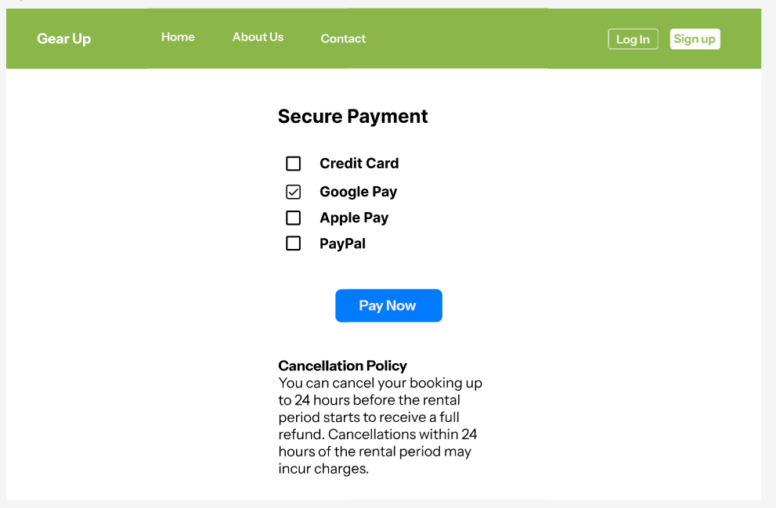

By verifying their booking and making the payment, this page lets renters finish their gear rental. It could call for safe payment gateway integration for transactions, cost summary, and rental length.

**Rental Agreement Screen**

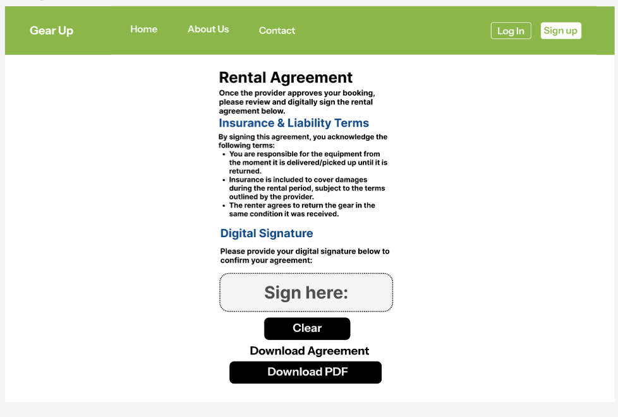

A rental agreement is generated upon booking approval, requiring both parties’ digital signatures. Terms regarding insurance, liability, and conditions are included, with a downloadable PDF option.

**Review & Rating Screen**

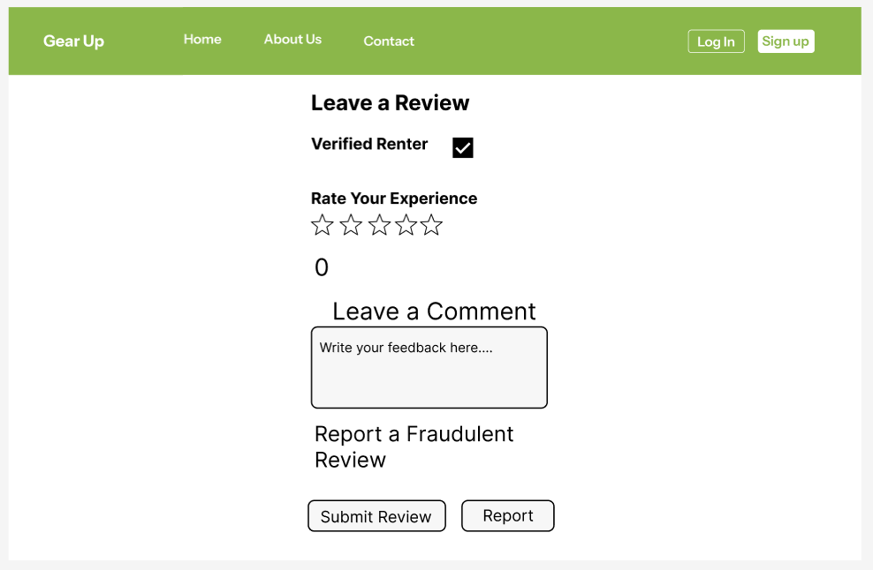

After completing a rental, renters and providers leave star ratings and feedback. Verified users can review, and a reporting feature prevents fraudulent ratings. Ratings impact provider credibility and renter trust.

**Dashboard (For Renters & Providers)**

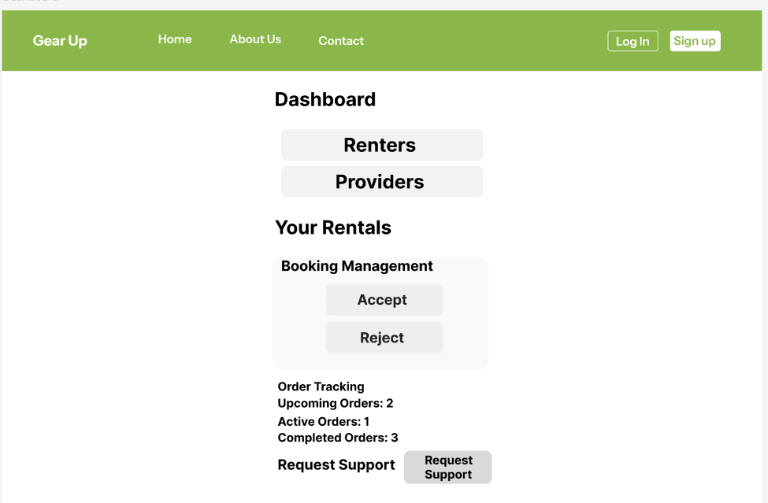

Renters track bookings, manage rentals, and request support. Providers monitor earnings, manage rental requests, and view gear availability. A summary of completed and upcoming transactions is available.

**Notification & Messaging Screen**

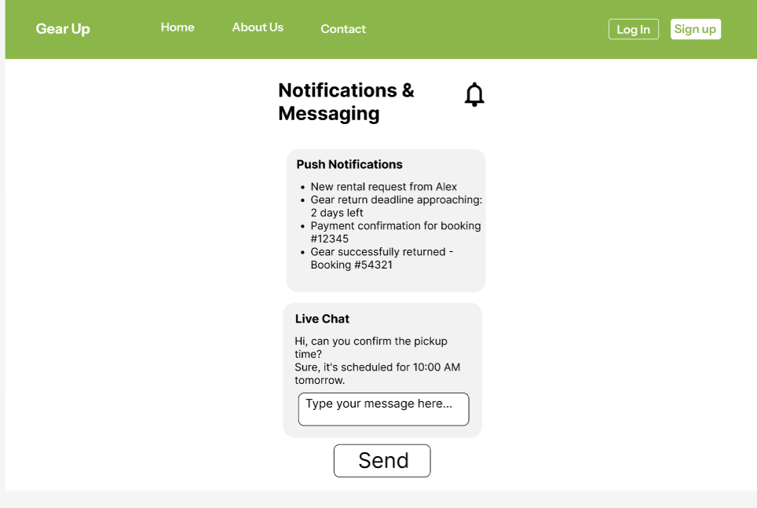

Users receive real-time notifications for new bookings, updates, and approvals. An in-app chat system enables direct communication between renters and providers, with automated reminders for payments and returns.

**Gear Pickup & Return Screen**

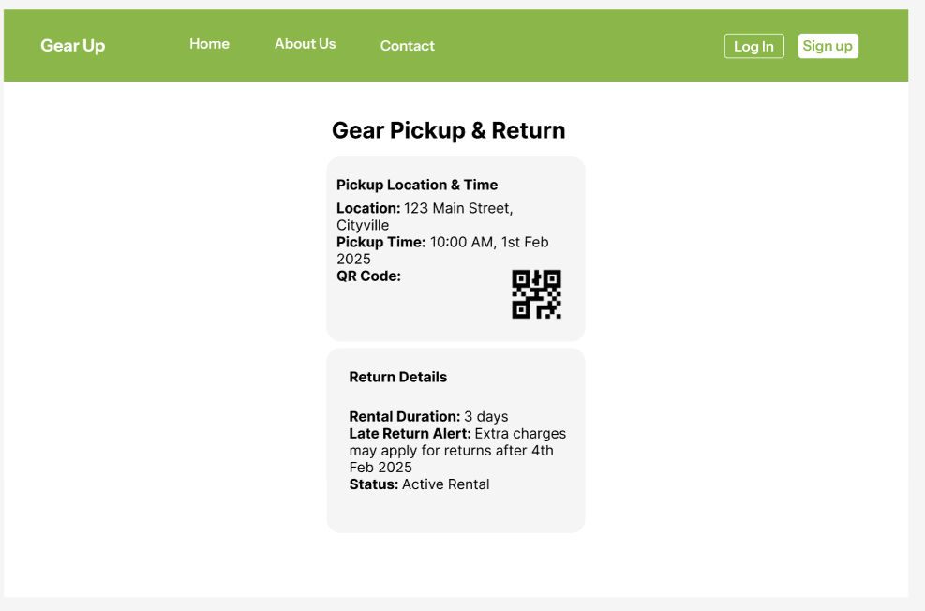

Displays gear pickup location and time, with QR code verification for secure handovers. Google Maps integration ensures easy navigation, while real-time tracking and late return alerts help manage rental durations efficiently.