11. Group the OSI layers by function.
The seven layers of the OSI model belonging to three subgroups. Physical, data link and network layers are the network support layers; they deal with the physical aspects of moving data from one device to another. Session, presentation and application layers are the user support layers; they allow interoperability among unrelated software systems. The transport layer ensures end-to-end reliable data transmission.

12. What are header and trailers and how do they get added and removed?
Each layer in the sending machine adds its own information to the message it receives from the layer just above it and passes the whole package to the layer just below it. This information is added in the form of headers or trailers. Headers are added to the message at the layers 6,5,4,3, and 2. A trailer is added at layer2. At the receiving machine, the headers or trailers attached to the data unit at the corresponding sending layers are removed, and actions appropriate to that layer are taken.

13. Discuss the mode for propagating light along optical channels.
There are two modes for propagating light along optical channels, multimode and single mode.

Multimode: Multiple beams from a light source move through the core in different paths.
Single mode: Fiber with extremely small diameter that limits beams to a few angles, resulting inan almost horizontal beam.

14. How are the guided media differing from unguided transmission media? Guided transmission media
1. Guided indicate, medium is contained have any within physical boundary
2. Transmission takes place through wire.
Unguided transmission media
1. Unguided medium does not Physical boundary
2. It is a wireless transmission.

15. What are the disadvantages of optical fiber as a transmission medium?
The disadvantages of optical fiber are
·Very expensive.
·Installation and maintenance is difficult.
·Fragility.

16. What are the criteria used to evaluate transmission medium?
The criteria used to evaluate transmission medium are
·Throughput
·Propagation speed
·Propagation time
·Wavelength

17. Give the relationship between propagation speed and propagation time?
Propagation time = distance / propagation speed
The time required for a signal or a bit to travel from one point to another is called Propagation time. Propagation speed is the distance, a signal or a bit travel through a mediumin one second.

18. Explain cross talk and what is needed to reduce it?
Effect of one wire on another is called as cross talk. One wire will be the sending antenna and the other wire will be the receiving antenna. We can use the shielded twisted pair cable or coaxial cable for transmission, which contains metal foil to reduce cross talk.

19. Compare datagram networks and virtual circuit networks.

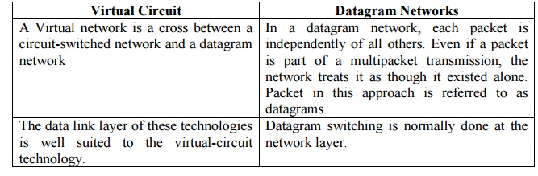

20. What is TCP/IP?
TCP/IP is a hierarchical protocol made up of interactive modules, each of which provides a specific functionality: however, the modules are not necessarily interdependent.

21. What are the features provided by layering?
Two nice features are:
It decomposes the problem of building a network into more manageable components.
It provides a more modular design.

