**Meter Sales Data Report**

select * from Data

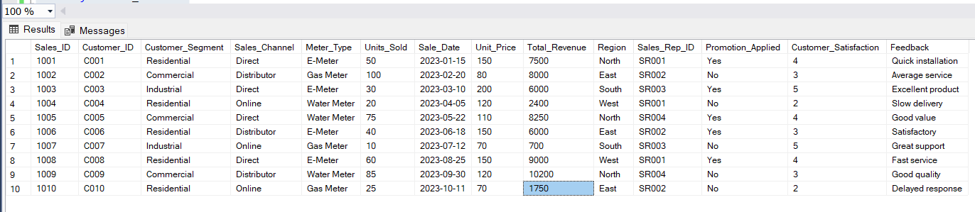

/*Total Revenue: Sum of the total price of all meters */

select sum(Total_Revenue) as Total_Revenue_Sum

from Data



/*Average order value: Average amt. spent per order*/

select sum(Total_Revenue)/ count(distinct Sales_ID) as Average_Order_Value

from Data

/*Total Meters sold*/

select sum(Units_Sold) as Total_Meters_Sold

from data



/*Total_Order_Sales*/

select count(Sales_ID) as Total_Order_Sales

from data



/*Average meter units sold per Sale*/

select sum(Units_Sold)/count( distinct Sales_ID) as Averge_Meters_Per_Order

from Data



/*Percentsge of Units sales by meter category*/

select Meter_Type,concat((sum(Units_Sold) * 100)/(select sum(Units_Sold) from Data), '%') as Perc_of_Units_Sales_By_Category

from Data

group by Meter_Type

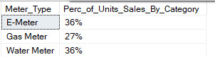

/*Total meter sold by meter category*/

select Meter_Type,sum(Units_Sold) as Total_meter_sold

from Data

group by Meter_Type

/*Top Meter sellers by revenue, total quantity, total orders*/

select top 1 Meter_Type,sum(Total_Revenue) as Top_Revenue, sum(Units_Sold) as Quantity_Sold, count(Sales_ID) as Total_Sales_ID

from Data

group by Meter_Type

order by Top_Revenue DESC

select top 1 Meter_Type,sum(Total_Revenue) as Lowest_Revenue, sum(Units_Sold) as Quantity_Sold, count(Sales_ID) as Total_Sales_ID

from Data

group by Meter_Type

order by Lowest_Revenue

