**2.How to create new instance using Amzon Machine Image**

**Created instance as sakshith-backup-sever**

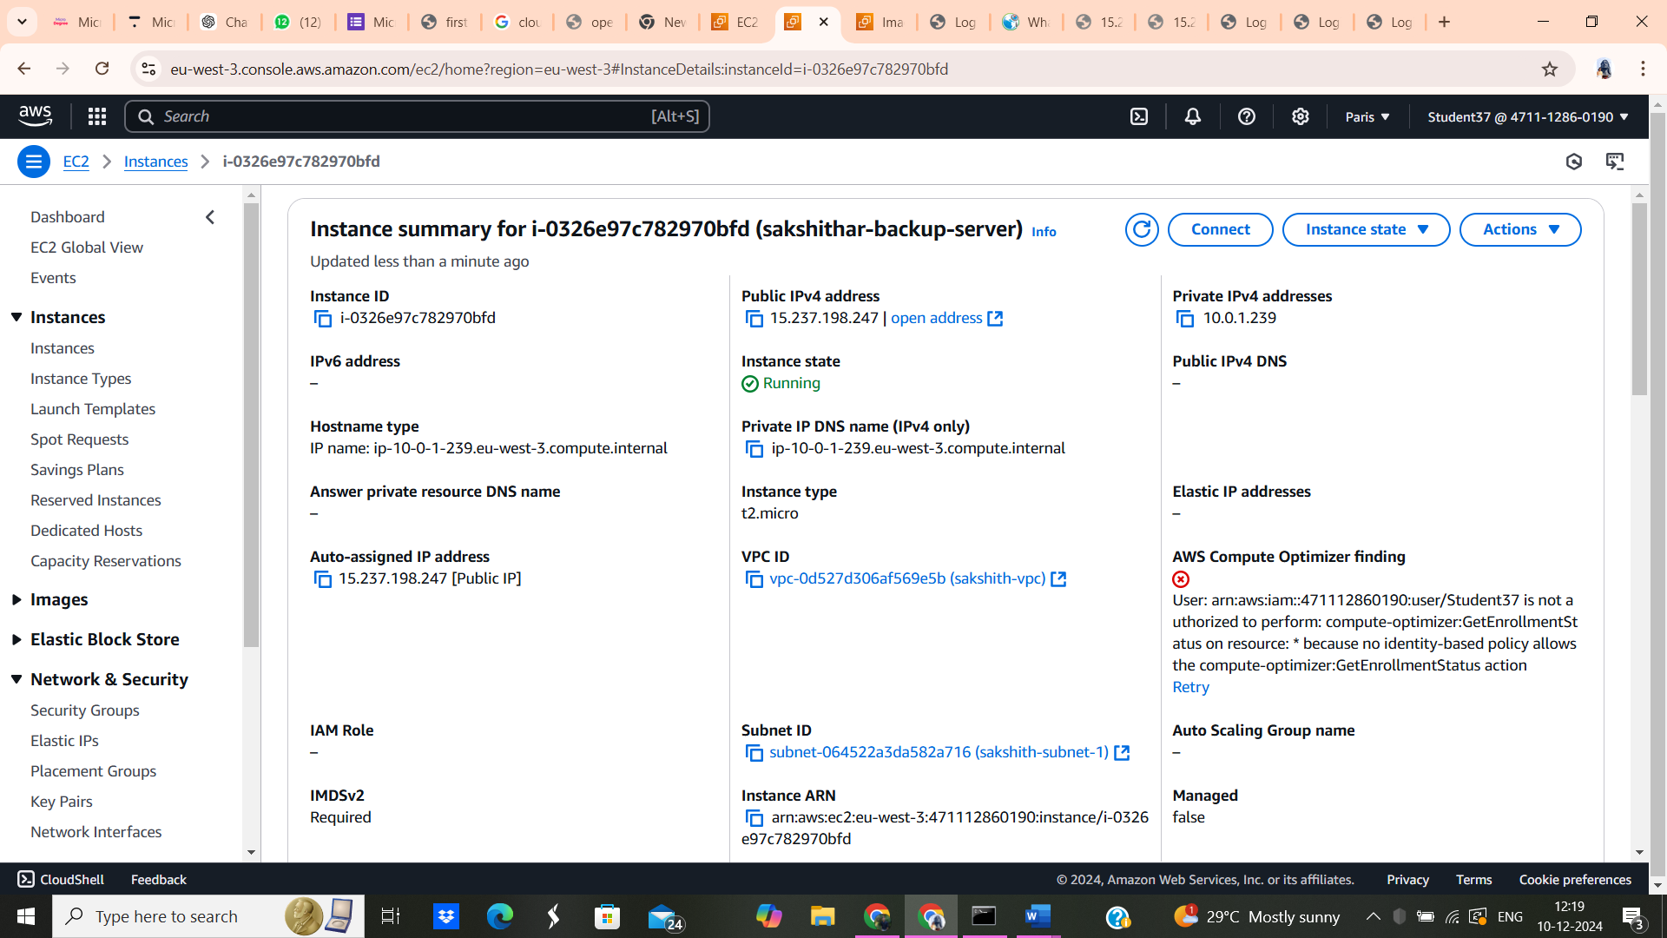

**created AMI image as sakshith-backups**

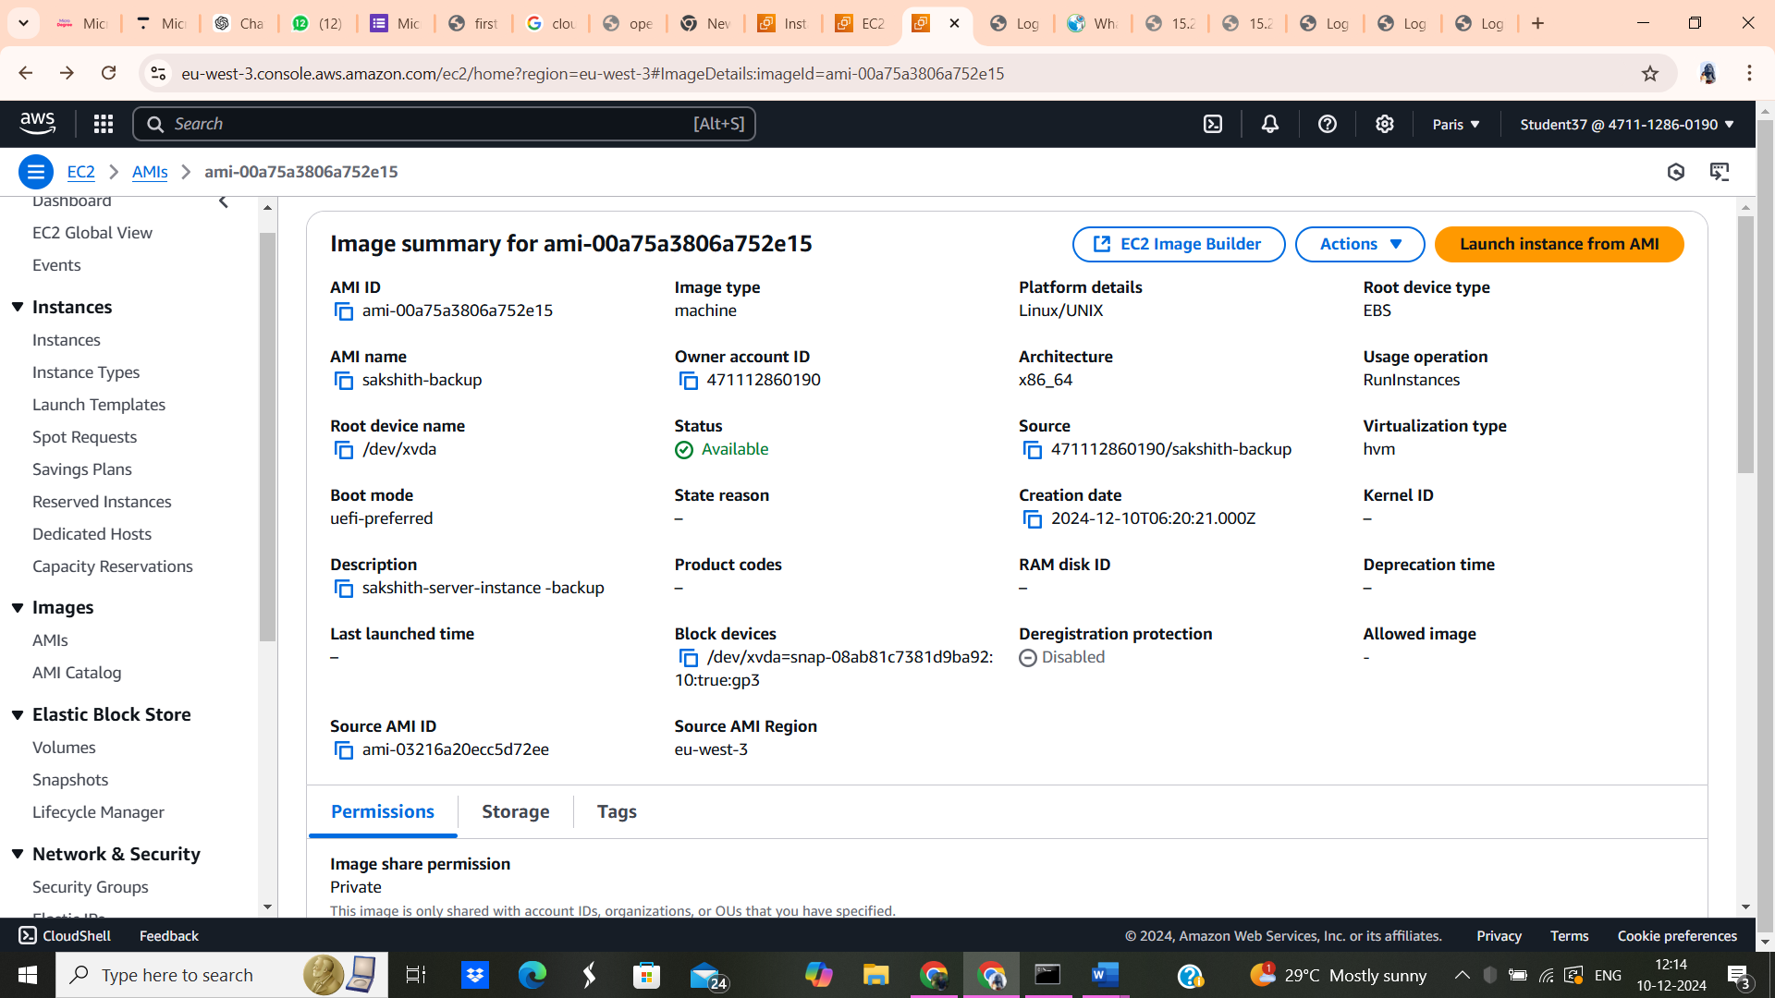

**Final output**

