AI ASSISTED CODING
LAB ASSIGNMENT -19.1
HTNO:2403A51363
NAME: M.sakshitha
Task Description #1 (Refactoring – Removing Code Duplication)
• Task: Use AI to refactor a given Python script that contains
multiple repeated code blocks.
• Instructions:
o Prompt AI to identify duplicate logic and replace it with
functions or classes.
o Ensure the refactored code maintains the same output.
o Add docstrings to all functions.
• Sample Legacy Code:
# Legacy script with repeated logic
print("Area of Rectangle:", 5 * 10)
print("Perimeter of Rectangle:", 2 * (5 + 10))
print("Area of Rectangle:", 7 * 12)
print("Perimeter of Rectangle:", 2 * (7 + 12))
print("Area of Rectangle:", 10 * 15)
print("Perimeter of Rectangle:", 2 * (10 + 15))
• Expected Output:
o Refactored code with a reusable function and no
duplication.
PROMPT:
'''print("Area of Rectangle:", 5 * 10)
print("Perimeter of Rectangle:", 2 * (5 + 10))
print("Area of Rectangle:", 7 * 12)
print("Perimeter of Rectangle:", 2 * (7 + 12))
print("Area of Rectangle:", 10 * 15)
print("Perimeter of Rectangle:", 2 * (10 + 15)) refactor the code using functions and use doc strings

CODE: 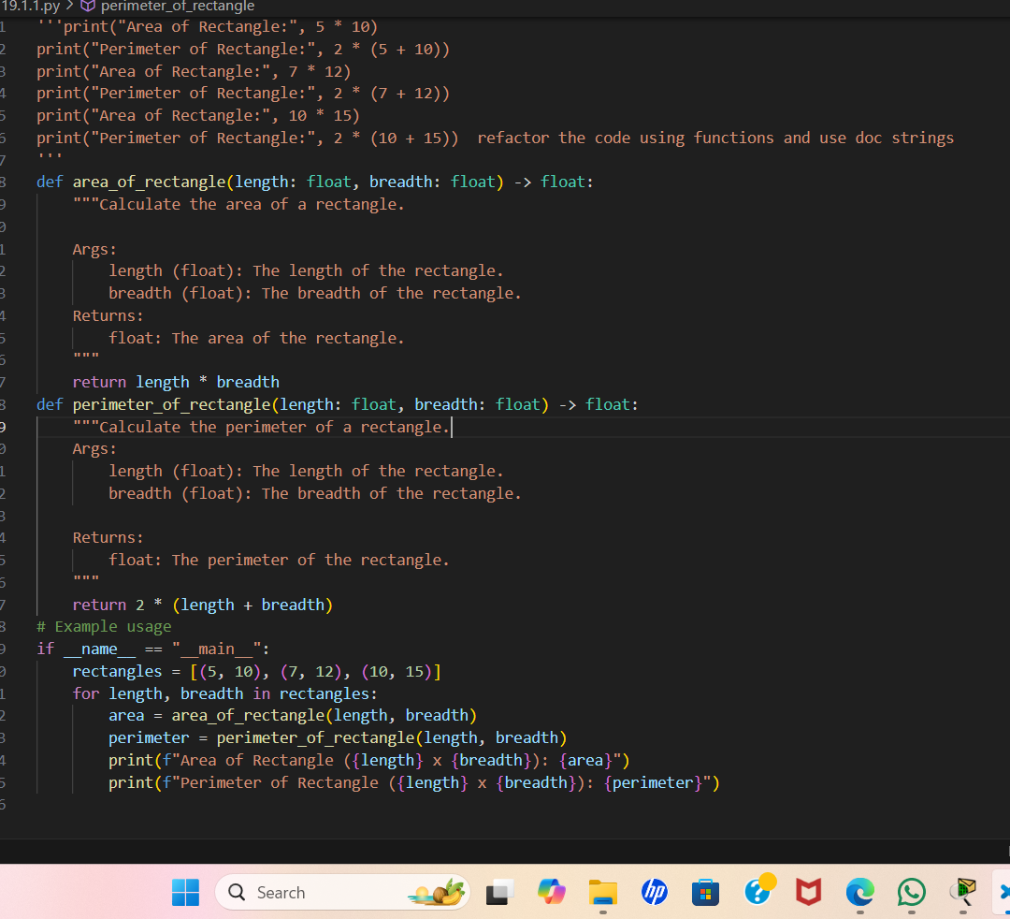
OUTPUT:
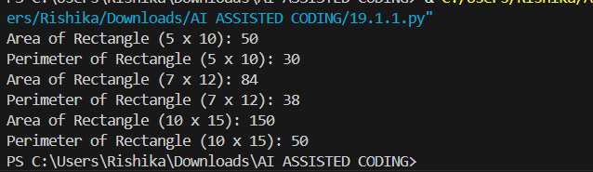
REMARKS:The above code explain the detaling and refactoring of the code using functions and doctstrings

Task Description #2 (Refactoring – Optimizing Loops and
Conditionals)
• Task: Use AI to analyze a Python script with nested loops and
complex conditionals.
• Instructions:
o Ask AI to suggest algorithmic improvements (e.g., replace
nested loops with set lookups or comprehensions).
o Implement changes while keeping logic intact.
o Compare execution time before and after refactoring.
• Sample Legacy Code:
# Legacy inefficient code
names = ["Alice", "Bob", "Charlie", "David"]
search_names = ["Charlie", "Eve", "Bob"]
for s in search_names:
found = False
for n in names:
if s == n:
found = True
if found:
print(f"{s} is in the list")
else:
print(f"{s} is not in the list")
• Expected Output:
o Optimized code using set lookups with performance
comparison table.
Task Description #3 (Refactoring – Extracting Reusable Functions)
(Refactoring – Replacing Hardcoded Values with Constants)
• Task: Use AI to identify and replace all hardcoded values in the
code with named constants.
• Instructions:
o Create constants at the top of the file.
o Replace all hardcoded occurrences in calculations with
these constants.
o Ensure the code remains functional and is easier to
maintain.
• Sample Legacy Code:
# Legacy script with hardcoded values
print("Area of Circle:", 3.14159 * (7 ** 2))
print("Circumference of Circle:", 2 * 3.14159 * 7)
• Expected Output:
o Code with constants like PI = 3.14159 and RADIUS = 7
used in calculations.
PROMPT:
'''names = ["Alice", "Bob", "Charlie", "David"]
search_names = ["Charlie", "Eve", "Bob"]
for s in search_names:
found = False
for n in names:
if s == n:
found = True
if found:
print(f"{s} is in the list")
else:
print(f"{s} is not in the list") Refactor the code using set lookups or comphrension instead of using nested loops'''

CODE:
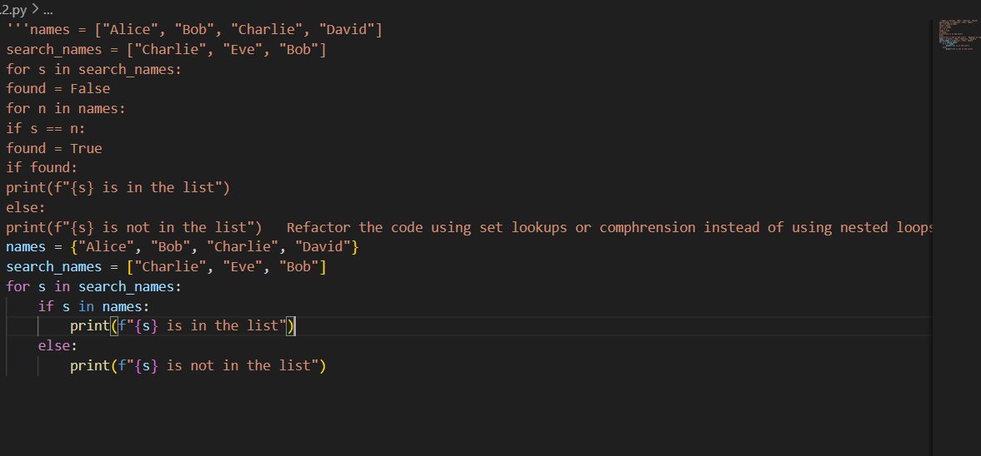
OUTPUT:
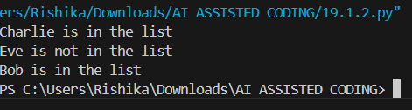
REMARKS: this is the code comphrension this is used to decrease the lines of code and interpreters time and it works fast it’s logic also will be easy to understand in the code
Task Description #3 (Refactoring – Extracting Reusable Functions)
(Refactoring – Replacing Hardcoded Values with Constants)
• Task: Use AI to identify and replace all hardcoded values in the
code with named constants.
• Instructions:
o Create constants at the top of the file.
o Replace all hardcoded occurrences in calculations with
these constants.
o Ensure the code remains functional and is easier to
maintain.
• Sample Legacy Code:
# Legacy script with hardcoded values
print("Area of Circle:", 3.14159 * (7 ** 2))
print("Circumference of Circle:", 2 * 3.14159 * 7)
• Expected Output:
o Code with constants like PI = 3.14159 and RADIUS = 7
used in calculations.
PROMPT:
'''print("Area of Circle:", 3.14159 * (7 ** 2))
print("Circumference of Circle:", 2 * 3.14159 * 7 '''print("Area of Circle:", 3.14159 * (7 ** 2)) Identify and replace all hardcoded values in the code with name constants
'''

CODE:
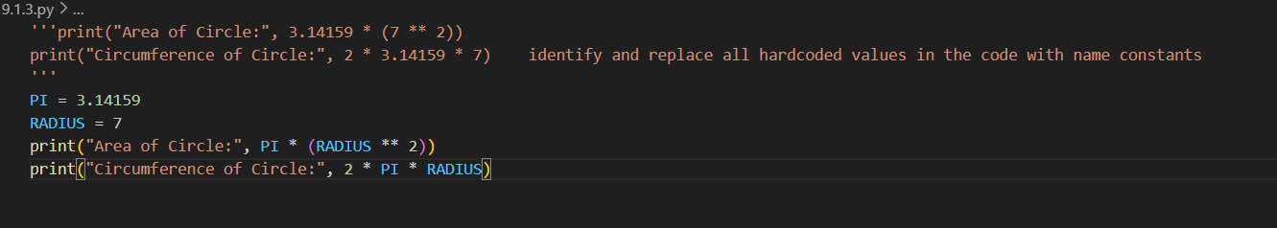

OUTPUT:
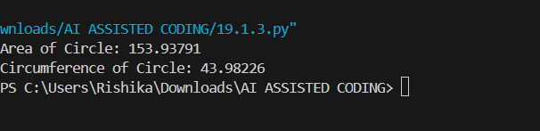
REMARKS:
Identifying and replace all hardcoded values in the code with name constants
Task Description #4 – Python to Java Conversion
Translate a simple Python class into Java using AI assistance.
Instructions:
• Prompt AI to convert a Python class with attributes and methods
into equivalent Java code.
• Verify that constructors, method signatures, and data types are
properly handled.
• Run both versions (Python & Java) to compare expected outputs.
Expected Output:
• Equivalent working Java class translated from Python.
PROMPT:
CODE:
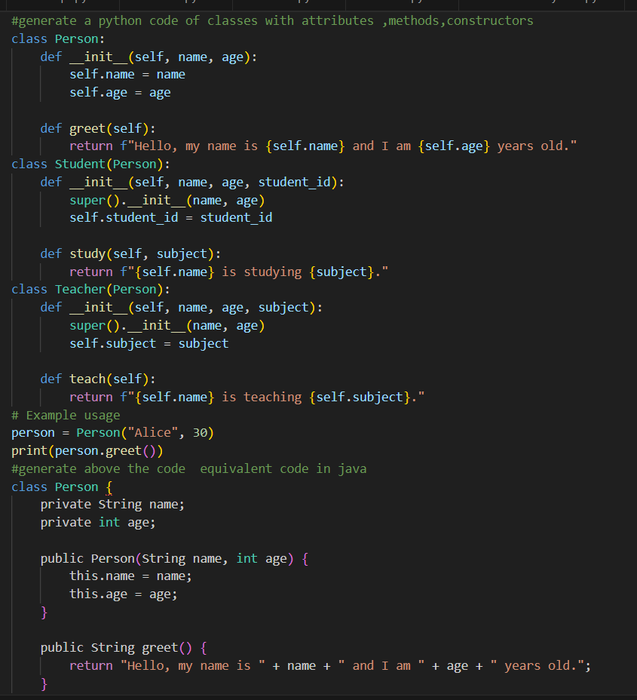

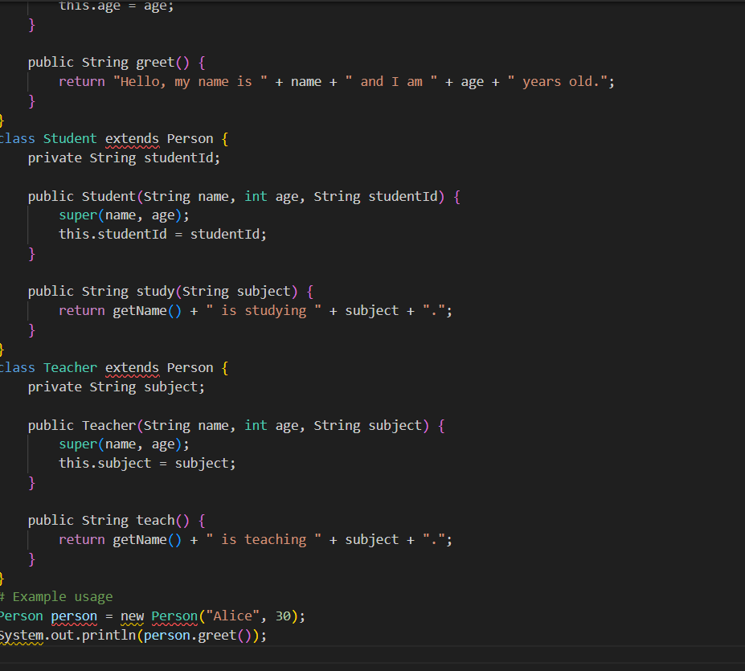REMARKS: This is the python code of class with attributes ,methods,constructor and same equivalent code in java
Task Description #5 – C++ to Python Function Conversion
Task:
Convert a C++ function for factorial calculation into Python.
Instructions:
• Ask AI to translate a recursive C++ factorial function into
Python.
• Validate correctness by testing with sample inputs.
• Ensure Python version follows Pythonic conventions.
Expected Output:
• A correct Python implementation equivalent to the original C++
factorial function.
PROMPT: #generate a C++ function for factorial calculation

CODE:
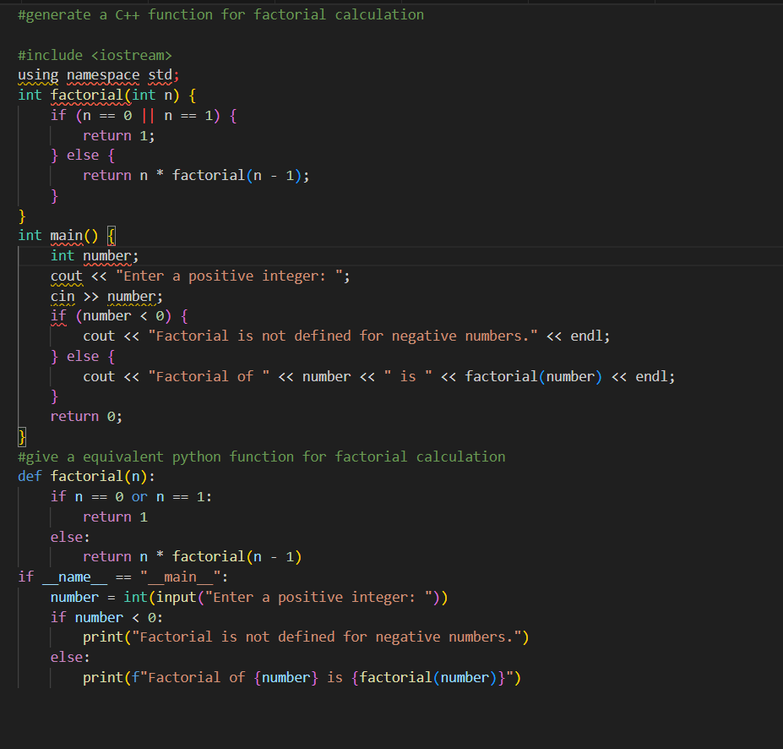
REMARKS: This is the c++ code of factorial of a number and same equivalent code in python
Task Description #6 (Privacy in API Usage)
Task: Use an AI tool to generate a Python program that connects to a
weather API.
Prompt: "Generate code to fetch weather data securely without
exposing API keys in the code."
Expected Output:
• Original AI code (check if keys are hardcoded).
• Secure version using environment variables.
PROMPT:generate code to fetch weather data securely without exposing API keys in the source code
CODE:
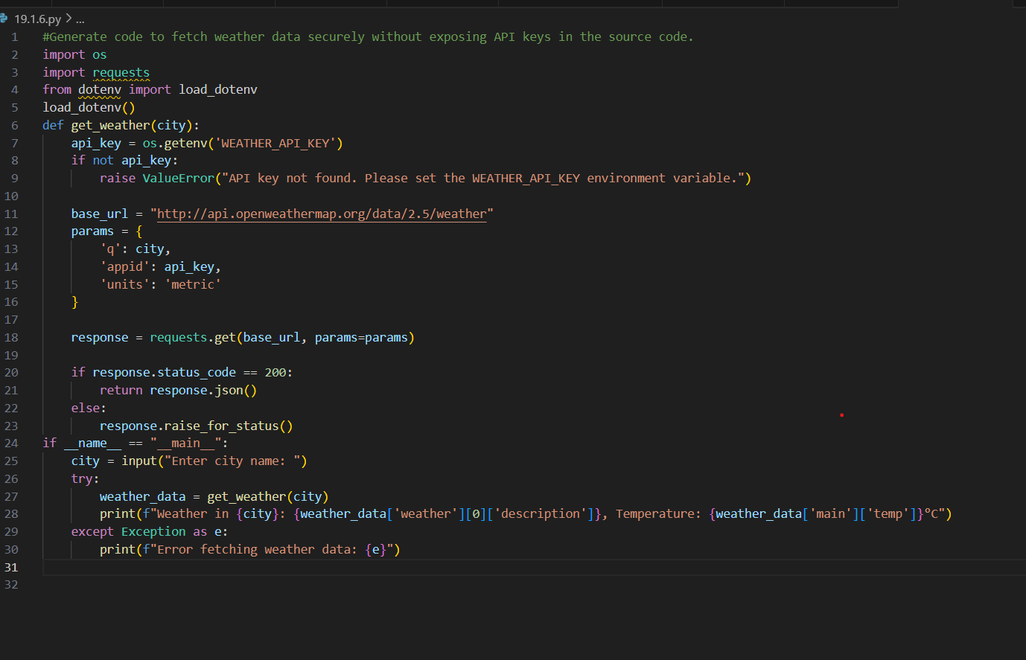
REMARKS:
Generating Python program that connects to weather API
Task Description #7 (Transparency in Algorithm Comparison)
Task: Use AI to implement two sorting algorithms (e.g., QuickSort and
BubbleSort).
Prompt: "Generate Python code for QuickSort and BubbleSort, and
include comments explaining step-by-step how each works and where
they differ."
Expected Output:
• Code for both algorithms.
• Transparent, comparative explanation of their logic and
efficiency.
PROMPT:
'''Generate Python code for QuickSort and BubbleSort, and
include comments explaining step-by-step how each works and where
they differ.'''

CODE:
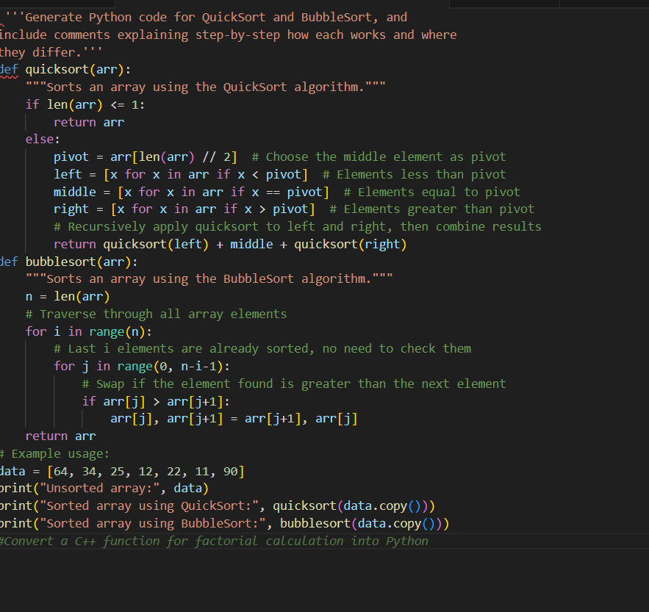

OUTPUT:
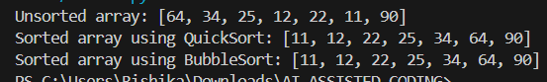
REMARKS:
Python code for QuickSort and BubbleSort, and
include comments explaining step-by-step how each works and where
they differ.
Task Description #8 (Transparency in Algorithm Design)
Objective: Use AI to generate an Armstrong number checking function
with comments and explanations.
Instructions:
1. Ask AI to explain the code line-by-line.
2. Compare the explanation with code functionality.
Expected Output:
• Transparent, commented code.
• Correct, easy-to-understand explanation.
PROMPT: generate an Armstrong number checking function
with comments and explanations
CODE:
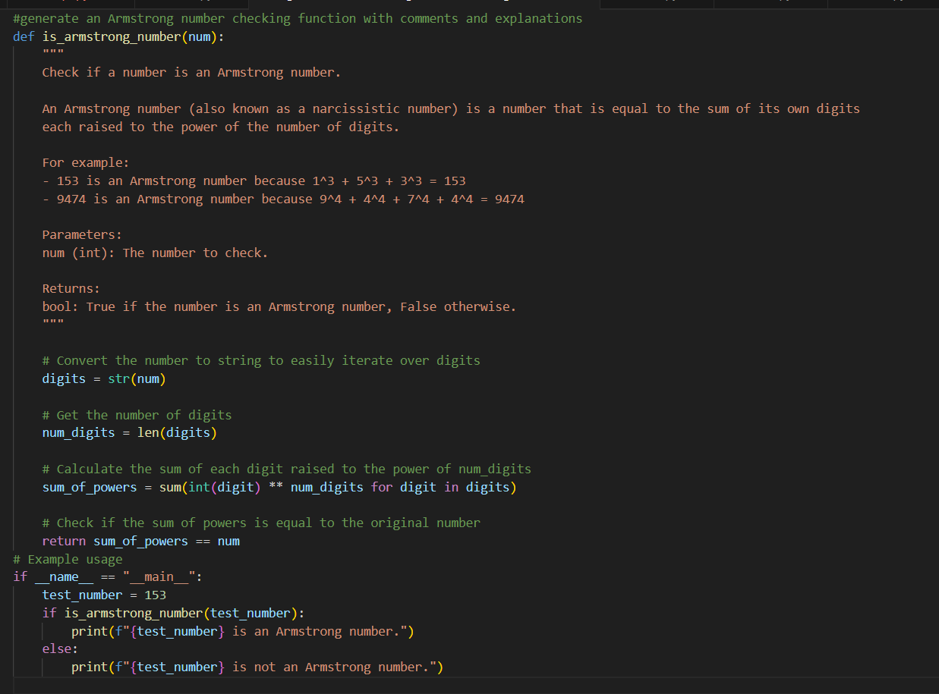
OUTPUT:
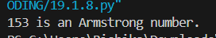
REMARKS:The above code is the detailed explanation of ARMSTRONG NUMBER
Task Description #9 (Transparency in AI Recommendations)
Task: Use AI to create a product recommendation system.
Prompt: "Generate a recommendation system that also provides reasons
for each suggestion."
Expected Output:
• Code with explainable recommendations.
• Evaluation of whether explanations are understandable
PROMPT: Generate a recommendation system that also provides reasons
for each suggestion."
CODE:
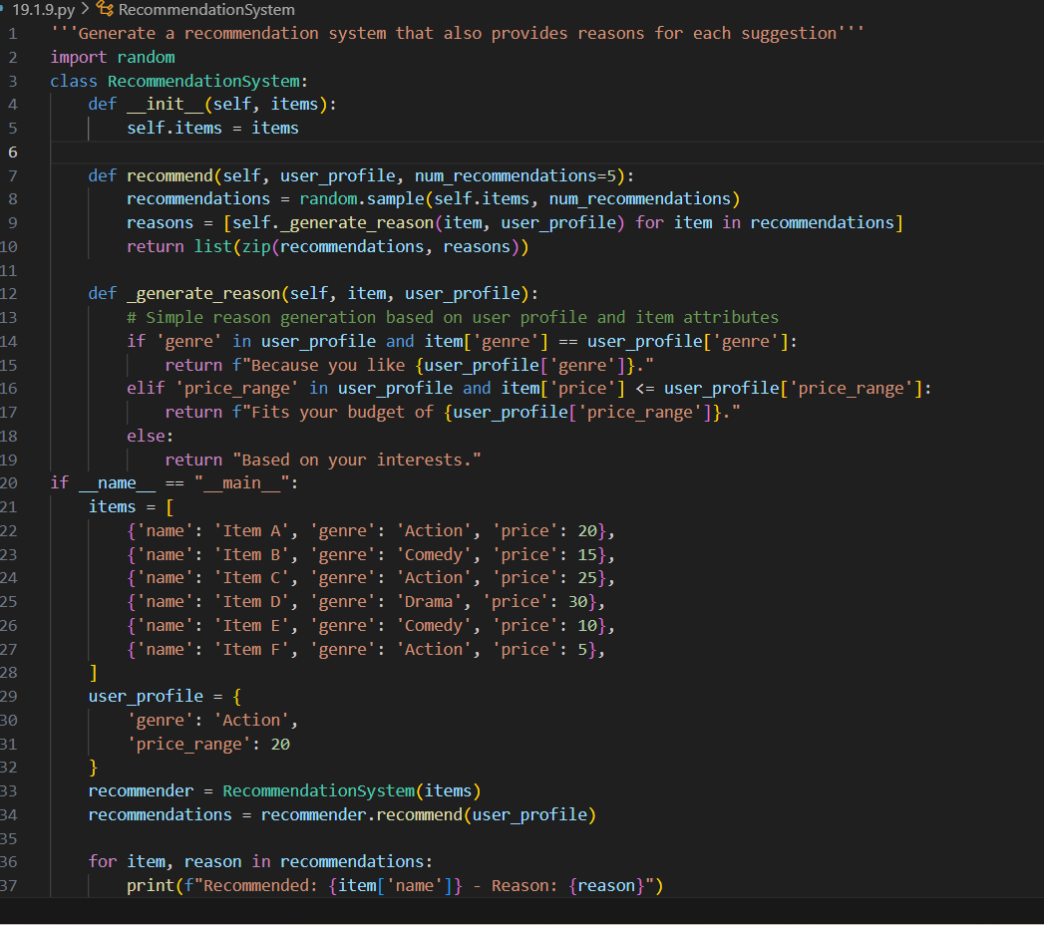

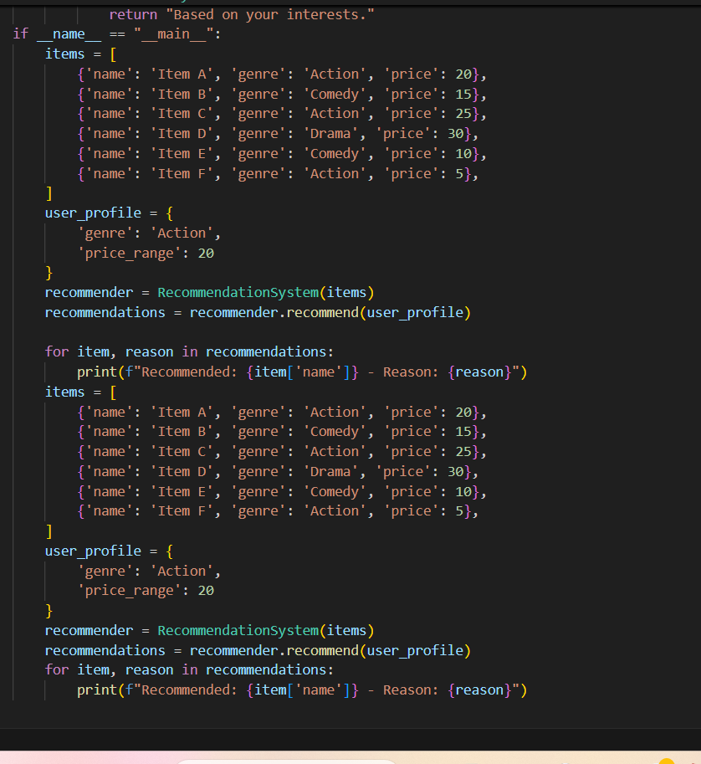
OUTPUT:
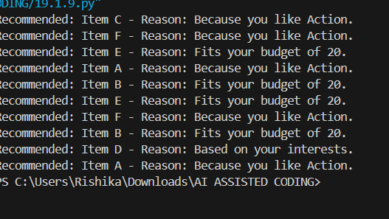
REMARKS:
Generating a recommendation system that also provides reasons
for each suggestion
Task Description #10 (Transparent Code Generation)
Task: Ask AI to generate a Python function for calculating factorial
using recursion.
Prompt: "Generate a recursive factorial function with comments that
explain each line and a final summary of the algorithm’s flow."
Expected Output:
• Fully commented code.
• Clear documentation of how recursion works.
PROMPT: : "Generate a recursive factorial function with comments that
explain each line and a final summary of the algorithm’s flow."
CODE:
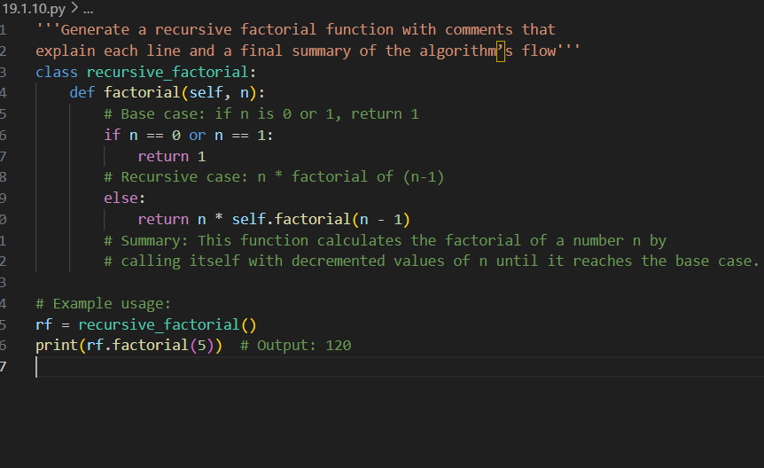
OUTPUT:
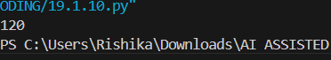

REMARKS:
: "Generating a recursive factorial function with comments that
explain each line and a final summary of the algorithm’s flow."
Task Description #11 (Inclusiveness in Customer Support)
Code Snippet:
Task:
Regenerate the code so that support messages use neutral language (e.g.,
“Dear {name}”) and optionally accept preferred titles.
Expected Output:
• Neutral, user-friendly support responses.
PROMPT:
Regenerate the code so that support messages use neutral language (e.g.,
“Dear {name}”) and optionally accept preferred titles.
CODE:
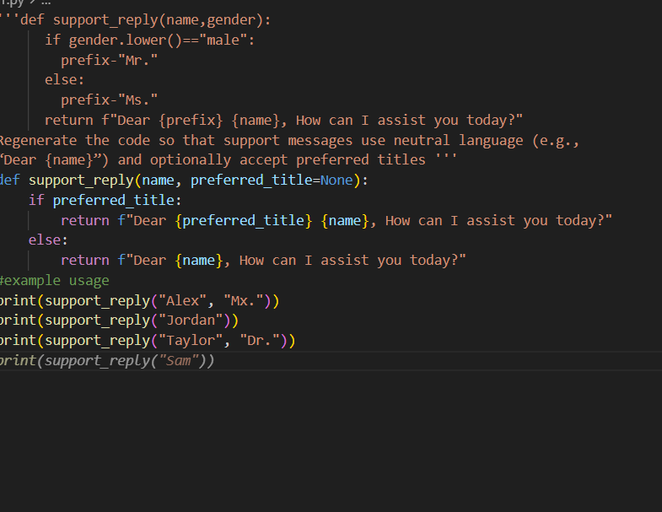
OUTPUT:
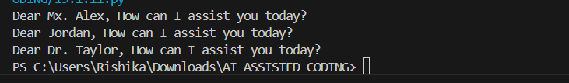
REMARKS:
Regenerating the code so that support messages use neutral language…

