SCHOOL OF COMPUTER SCIENCE AND ARTIFICIAL INTELLIGENCE |  |  |  |  | DEPARTMENT OF COMPUTER SCIENCE ENGINEERING
Program Name: B. Tech |  |  |  | Assignment Type: Lab |  |  | Academic Year:2025-2026
Course Coordinator Name |  |  |  | Venkataramana Veeramsetty
Instructor(s) Name |  |  |  | Dr. V. Venkataramana (Co-ordinator)  Dr. T. Sampath Kumar  Dr. Pramoda Patro  Dr. Brij Kishor Tiwari  Dr.J.Ravichander  Dr. Mohammand Ali Shaik  Dr. Anirodh Kumar  Mr. S.Naresh Kumar  Dr. RAJESH VELPULA  Mr. Kundhan Kumar  Ms. Ch.Rajitha  Mr. M Prakash  Mr. B.Raju  Intern 1 (Dharma teja)  Intern 2 (Sai Prasad)  Intern 3 (Sowmya)  NS_2 ( Mounika)
Course Code |  |  | 24CS002PC215 | Course Title |  | AI Assisted Coding
Year/Sem |  |  | II/III | Regulation |  | R24
Date and Day  of Assignment |  |  | Week3 – Monday | Time(s)
Duration |  |  | 2 Hours | Applicable to  Batches
Assignment Number:6.1(Present assignment number)/24(Total number of assignments)
 | Q.No. | Question |  |  |  |  |  | Expected Time  to complete
 | 1 | Lab 6: AI-Based Code Completion – Classes, Loops, and Conditionals  Lab Objectives:  - To explore AI-powered auto-completion features for core Python constructs.  - To analyze how AI suggests logic for class definitions, loops, and conditionals.  - To evaluate the completeness and correctness of code generated by AI assistants.  Lab Outcomes (LOs):  After completing this lab, students will be able to:  - Use AI tools to generate and complete class definitions and methods.  - Understand and assess AI-suggested loops for iterative tasks.  - Generate conditional statements through prompt-driven suggestions.  - Critically evaluate AI-assisted code for correctness and clarity.  Task Description #1 (Classes – Employee Management)  - Task: Use AI to create an Employee class with attributes (name, id, salary) and a method to calculate yearly salary.  - Instructions:  - Prompt AI to generate the Employee class.  - Analyze the generated code for correctness and structure.  - Ask AI to add a method to give a bonus and recalculate salary.  Expected Output #1:  - A class with constructor, display_details(), and calculate_bonus() methods.  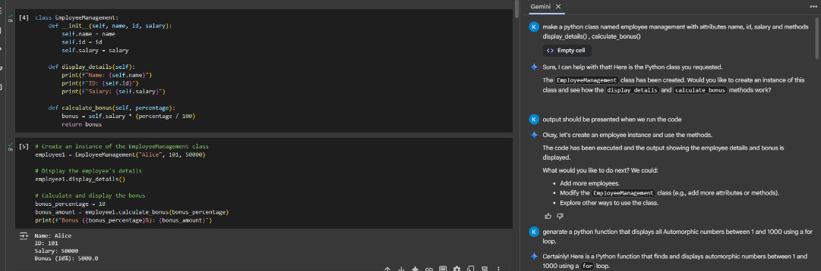  Task Description #2 (Loops – Automorphic Numbers in a Range)  - Task: Prompt AI to generate a function that displays all Automorphic numbers between 1 and 1000 using a for loop.  - Instructions:  - Get AI-generated code to list Automorphic numbers using a for loop.  - Analyze the correctness and efficiency of the generated logic.  - Ask AI to regenerate using a while loop and compare both implementations.  Expected Output #2:  - Correct implementation that lists Automorphic numbers using both loop types, with explanation.  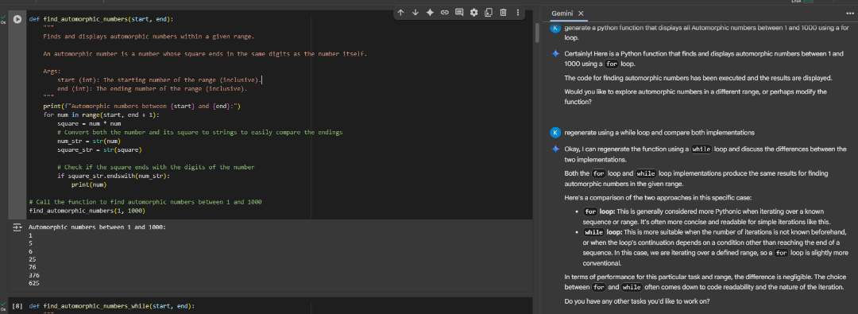  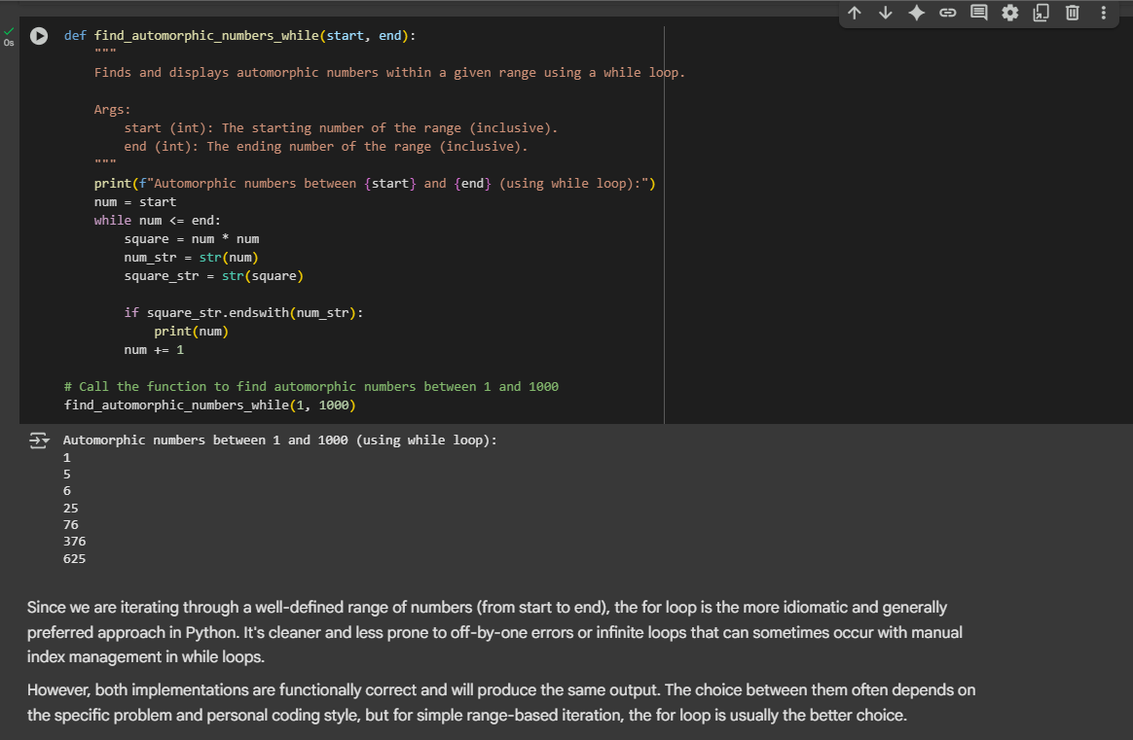  Task Description #3 (Conditional Statements – Online Shopping Feedback Classification)  - Task: Ask AI to write nested if-elif-else conditions to classify online shopping feedback as Positive, Neutral, or Negative based on a numerical rating (1–5).  - Instructions:  - Generate initial code using nested if-elif-else.  - Analyze correctness and readability.  - Ask AI to rewrite using dictionary-based or match-case structure.  Expected Output #3:  - Feedback classification function with explanation and an alternative approach.  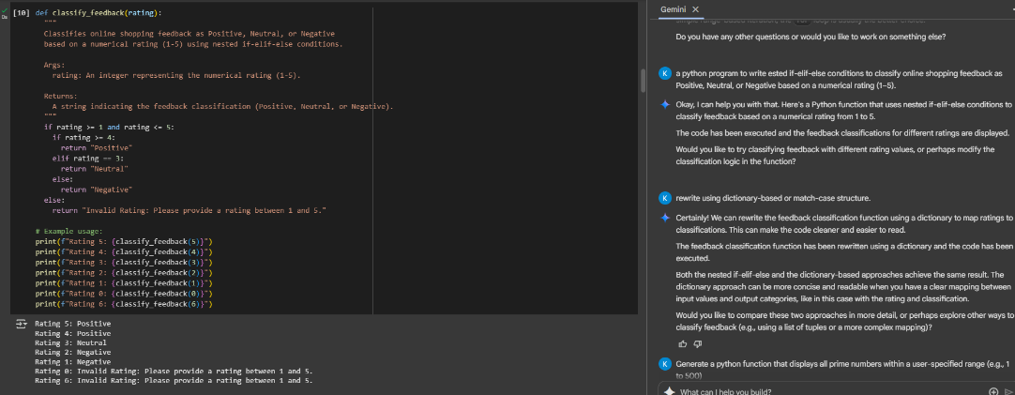  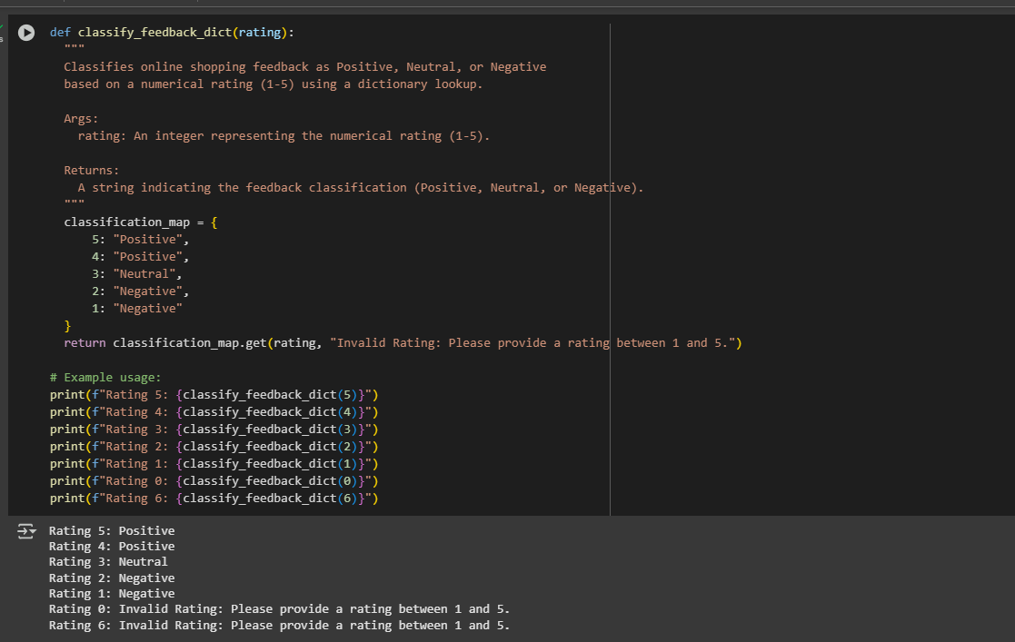  Task Description #4 (Loops – Prime Numbers in a Range)  - Task: Generate a function using AI that displays all prime numbers within a user-specified range (e.g., 1 to 500).  - Instructions:  - Get AI-generated code to list all primes using a for loop.  - Analyze the correctness and efficiency of the prime-checking logic.  - Ask AI to regenerate an optimized version (e.g., using the square root method).  Expected Output #4:  - Python program that lists all prime numbers within a given range, with an optimized version and explanation.  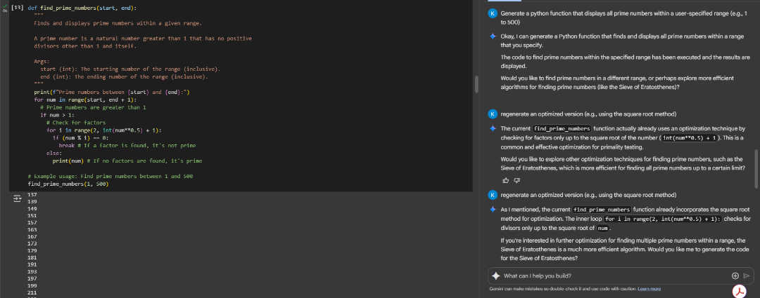  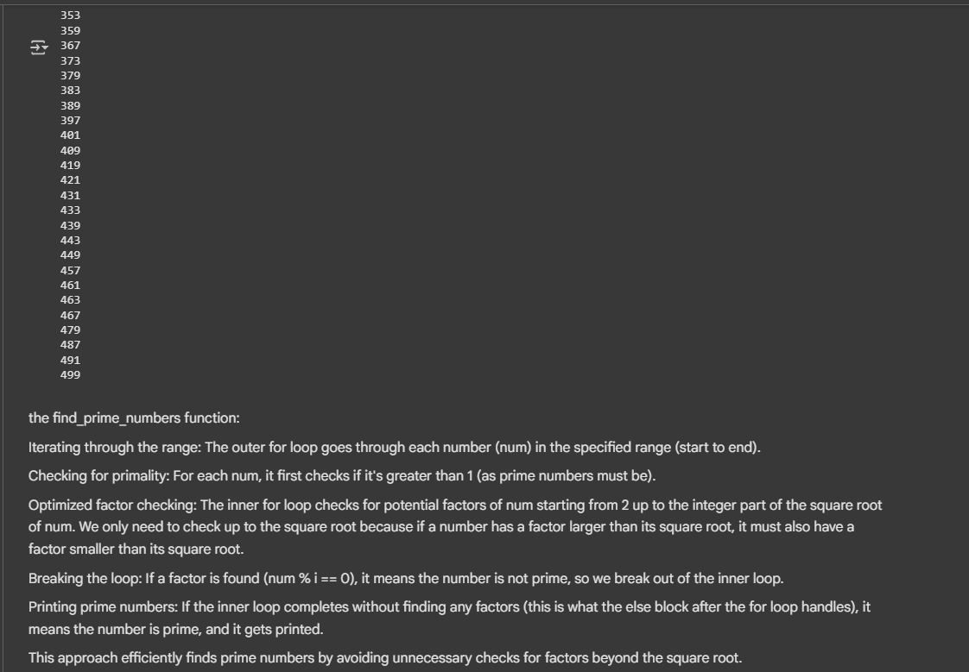  Task Description #5 (Classes – Library System)  - Task: Use AI to build a Library class with methods to add_book(), issue_book(), and display_books().  - Instructions:  - Generate Library class code using AI.  - Analyze if methods handle edge cases (e.g., issuing unavailable books).  - Ask AI to add comments and documentation.  Expected Output #5:  - Library class with all methods, inline comments, and explanation.  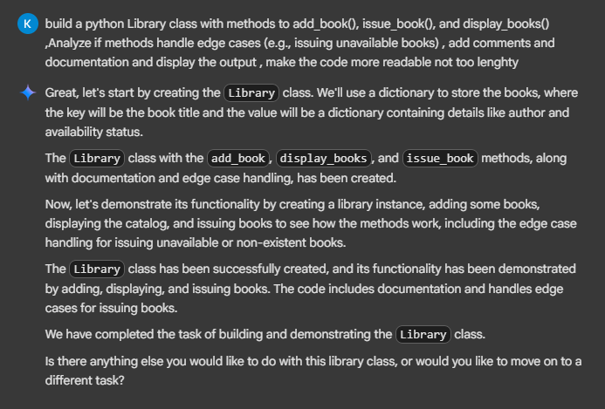  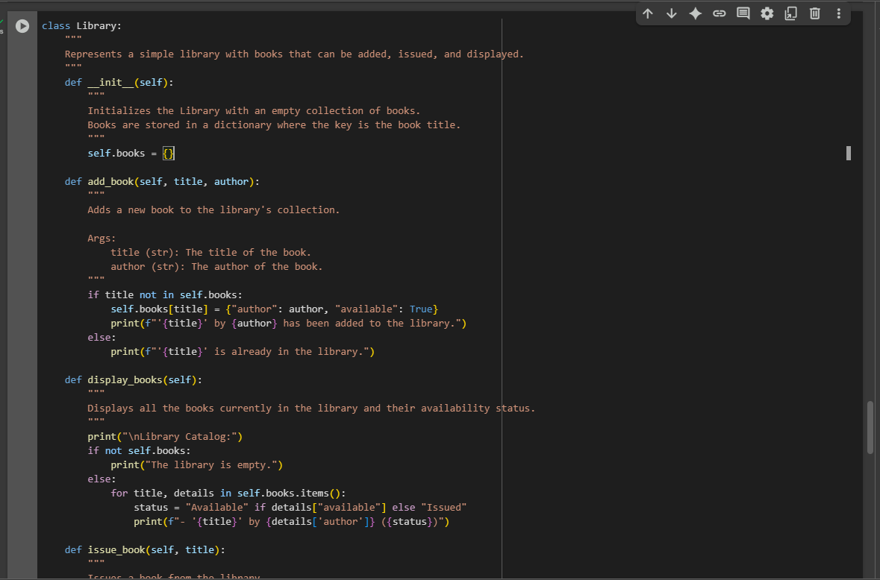  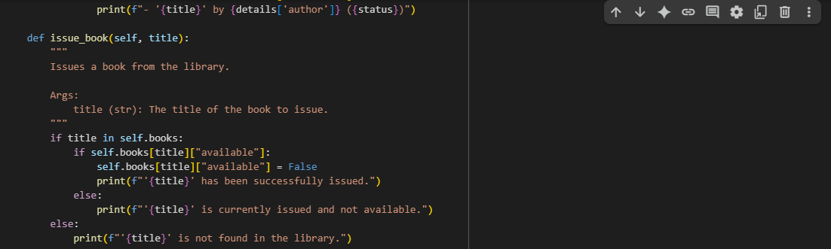  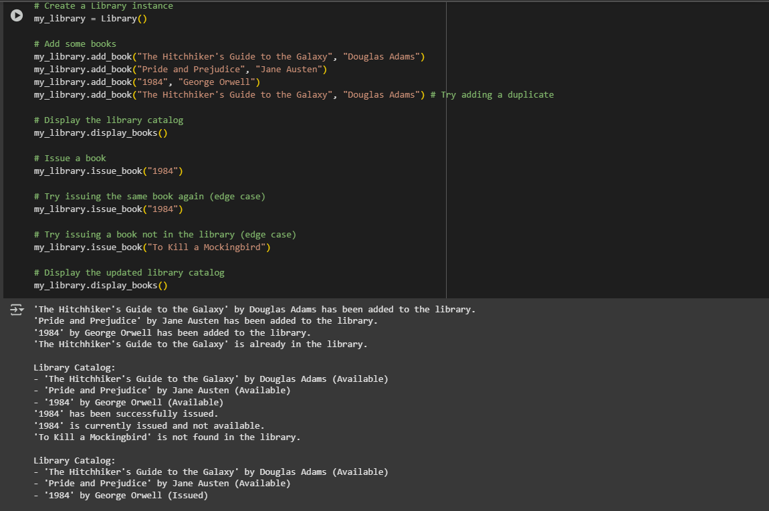  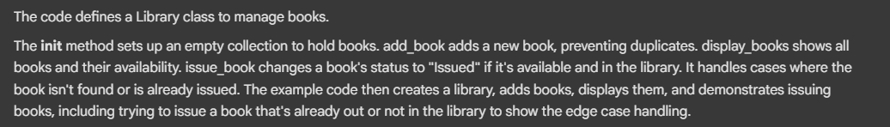  Note: Report should be submitted a word document for all tasks in a single document with prompts, comments & code explanation, and output and if required, screenshots  Evaluation Criteria:  Criteria Max Marks  Class 1.0  Loops 1.0  Conditional Statements 0.5  Total 2.5 Marks |  |  |  |  |  | Week3 - Monday

