SCHOOL OF COMPUTER SCIENCE AND ARTIFICIAL INTELLIGENCE |  |  |  |  | DEPARTMENT OF COMPUTER SCIENCE ENGINEERING
ProgramName:B. Tech |  |  |  | Assignment Type: Lab |  |  | AcademicYear:2025-2026
CourseCoordinatorName |  |  |  | Venkataramana Veeramsetty
Instructor(s)Name |  |  |  | Dr. V. Venkataramana (Co-ordinator)  Dr. T. Sampath Kumar  Dr. Pramoda Patro  Dr. Brij Kishor Tiwari  Dr.J.Ravichander  Dr. Mohammand Ali Shaik  Dr. Anirodh Kumar  Mr. S.Naresh Kumar  Dr. RAJESH VELPULA  Mr. Kundhan Kumar  Ms. Ch.Rajitha  Mr. M Prakash  Mr. B.Raju  Intern 1 (Dharma teja)  Intern 2 (Sai Prasad)  Intern 3 (Sowmya)  NS_2 ( Mounika)
CourseCode |  |  | 24CS002PC215 | CourseTitle |  | AI Assisted Coding
Year/Sem |  |  | II/I | Regulation |  | R24
Date and Day  of Assignment |  |  | Week5 - Tuesday | Time(s)
Duration |  |  | 2 Hours | Applicableto  Batches
AssignmentNumber:10.3(Present assignment number)/24(Total number of assignments)
 | Q.No. | Question |  |  |  |  |  | ExpectedTime  to complete
 | 1 | Lab 10: Code Review and Quality: Using AI to improve code quality and readability  Lab Objectives:  - To understand the importance of code readability, maintainability, and quality.  - To explore how AI-assisted coding tools can review code and suggest improvements.  - To practice identifying code smells, redundant code, and poor naming conventions.  - To apply AI tools for refactoring and improving readability.  - To critically evaluate AI feedback and integrate it into real projects  Lab Outcomes (LOs):  After completing this lab, students will be able to:  - Use AI-assisted tools (e.g., GitHub Copilot, Cursor AI) to review Python code.  - Identify and correct syntax issues, code smells, and inefficient logic.  - Improve readability by applying consistent formatting, naming, and comments.  - Refactor code with AI suggestions while ensuring functionality is preserved.  - Apply best practices for writing clean, maintainable, and professional code.  Task Description#1 AI-Assisted Code Review (Basic Errors)  - Write python program as shown below.  - Use an AI assistant to review and suggest corrections.  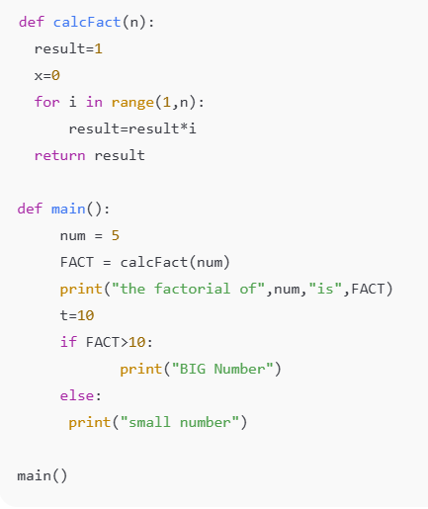  Expected Outcome#1: Students need to submit corrected code with comments.  Prompt : can you correct my code.  Code:  def calcFact(n):  result = 1  # The loop should go up to n (inclusive) for factorial calculation  for i in range(1, n + 1):  result = result * i  return result  def main():  num = 5  FACT = calcFact(num)  print("the factorial of", num, "is", FACT)  t = 10  # Check if the factorial is greater than or equal to 10  if FACT >= 10:  print("BIG Number")  else:  print("small number")  main()  Output:  the factorial of 5 is 120  BIG Number  Task Description#2 Automatic Inline Comments  - Write the Python code for Fibonacci as shown below and execute.  - Ask AI to improve variable names, add comments, and apply PEP8 formatting (cleaned up).  - Students evaluate which suggestions improve readability most. one.  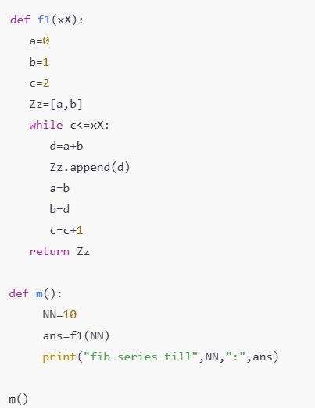  Expected Output#2: Clean format python code with much readability.  Prompt: Can you please improve variable names, add comments, and apply PEP8 formatting.  Code:  # Function to generate a Fibonacci sequence up to a given number  def generate_fibonacci(limit):  # Initialize the first two Fibonacci numbers  a = 0  b = 1  # Initialize the list with the first two numbers  fibonacci_sequence = [a, b]  # Initialize a counter for the loop  c = 0 # Initialize 'c' here to fix the UnboundLocalError  # Generate Fibonacci numbers until the limit is reached  while c <= limit:  # Calculate the next Fibonacci number  d = a + b  # Add the new number to the sequence  fibonacci_sequence.append(d)  # Update the values of a and b for the next iteration  a = b  b = d  # Increment the counter  c = c + 1  # Return the generated Fibonacci sequence  return fibonacci_sequence  # Main function to demonstrate the Fibonacci sequence generation  def main():  # Set the limit for the Fibonacci sequence  limit_number = 10  # Generate the Fibonacci sequence  result = generate_fibonacci(limit_number)  # Print the result  print("Fibonacci series till", limit_number, ":", result)  # Call the main function to run the program  main()  Output:  Fibonacci series till 10 : [0, 1, 1, 2, 3, 5, 8, 13, 21, 34, 55, 89, 144]  Task Description#3  - Write a Python script with 3–4 functions (e.g., calculator: add, subtract, multiply, divide).  - Incorporate manual docstring in code with NumPy Style  - Use AI assistance to generate a module-level docstring + individual function docstrings.  - Compare the AI-generated docstring with your manually written one.  Prompt:  Create a calculator python script with functions for add,subtract,multiply and divide  Code:  """  A simple calculator module providing basic arithmetic operations.  This module contains functions for adding, subtracting, multiplying,  and dividing two numbers.  """  def add(a, b):  """Adds two numbers.  Parameters  ----------  a : float  The first number.  b : float  The second number.  Returns  -------  float  The sum of a and b.  """  return a + b  def subtract(a, b):  """Subtracts the second number from the first.  Parameters  ----------  a : float  The first number.  b : float  The second number.  Returns  -------  float  The difference between a and b.  """  return a - b  def multiply(a, b):  """Multiplies two numbers.  Parameters  ----------  a : float  The first number.  b : float  The second number.  Returns  -------  float  The product of a and b.  """  return a * b  def divide(a, b):  """Divides the first number by the second.  Parameters  ----------  a : float  The first number.  b : float  The second number.  Returns  -------  float  The result of the division.  Raises  ------  ValueError  If the second number (b) is zero.  """  if b == 0:  raise ValueError("Cannot divide by zero.")  return a / b  # Example usage:  print(f"2 + 3 = {add(2, 3)}")  print(f"5 - 2 = {subtract(5, 2)}")  print(f"4 * 6 = {multiply(4, 6)}")  print(f"10 / 2 = {divide(10, 2)}")  print(f"5 / 0 = {divide(5, 0)}") # This will raise a ValueError  Output:  2 + 3 = 5  5 - 2 = 3  4 * 6 = 24  10 / 2 = 5.0  Common Examples of Code Smells  - Long Function – A single function tries to do too many things.  - Duplicate Code – Copy-pasted logic in multiple places.  - Poor Naming – Variables or functions with confusing names (x1, foo, data123).  - Unused Variables – Declaring variables but never using them.  - Magic Numbers – Using unexplained constants (3.14159 instead of PI).  - Deep Nesting – Too many if/else levels, making code hard to read.  - Large Class – A single class handling too many responsibilities.  Why Detecting Code Smells is Important  - Makes code easier to read and maintain.  - Reduces chance of bugs in future updates.  - Helps in refactoring (improving structure without changing behavior).  - Encourages clean coding practices  Dead Code – Code that is never executed.  Expected Output#3: Students learn structured documentation for multi-function scripts  Push documentation whole workspace as .md file in GitHub Repository  Note: Report should be submitted a word document for all tasks in a single document with prompts, comments & code explanation, and output and if required, screenshots |  |  |  |  |  | Week5

