SCHOOL OF COMPUTER SCIENCE AND ARTIFICIAL INTELLIGENCE |  |  |  |  | DEPARTMENT OF COMPUTER SCIENCE ENGINEERING
ProgramName:B. Tech |  |  |  | Assignment Type: Lab |  |  | AcademicYear:2025-2026
CourseCoordinatorName |  |  |  | Venkataramana Veeramsetty
Instructor(s)Name |  |  |  | Dr. V. Venkataramana (Co-ordinator)  Dr. T. Sampath Kumar  Dr. Pramoda Patro  Dr. Brij Kishor Tiwari  Dr.J.Ravichander  Dr. Mohammand Ali Shaik  Dr. Anirodh Kumar  Mr. S.Naresh Kumar  Dr. RAJESH VELPULA  Mr. Kundhan Kumar  Ms. Ch.Rajitha  Mr. M Prakash  Mr. B.Raju  Intern 1 (Dharma teja)  Intern 2 (Sai Prasad)  Intern 3 (Sowmya)  NS_2 ( Mounika)
CourseCode |  |  | 24CS002PC215 | CourseTitle |  | AI Assisted Coding
Year/Sem |  |  | II/I | Regulation |  | R24
Date and Day  of Assignment |  |  | Week3 - Thursday | Time(s)
Duration |  |  | 2 Hours | Applicableto  Batches
AssignmentNumber:6.4(Present assignment number)/24(Total number of assignments)
 | Q.No. | Question |  |  |  |  |  | ExpectedTime  to complete
 | 1 | Lab 6: AI-Based Code Completion – Classes, Loops, and Conditionals  Lab Objectives:  - To explore AI-powered auto-completion features for core Python constructs.  - To analyze how AI suggests logic for class definitions, loops, and conditionals.  - To evaluate the completeness and correctness of code generated by AI assistants.  Lab Outcomes (LOs):  After completing this lab, students will be able to:  - Use AI tools to generate and complete class definitions and methods.  - Understand and assess AI-suggested loops for iterative tasks.  - Generate conditional statements through prompt-driven suggestions.  - Critically evaluate AI-assisted code for correctness and clarity.  Task Description #1:  • Start a Python class named Student with attributes name, roll_number, and marks. Prompt GitHub Copilot to complete methods for displaying details and checking if marks are above average.  Expected Outcome #1:  • Completed class with Copilot-generated methods like display_details() and is_passed(), demonstrating use of if-else conditions.  Prompt:  Start a Python class named Student with attributes name, roll_number, and marks of 5 subjects . Completed class with methods like display_details() and is_passed(), demonstrating use of if-else conditions  Code:  class Student:  def __init__(self, name, roll_number, marks):  self.name = name  self.roll_number = roll_number  # marks should be a list of 5 integers/floats  if len(marks) != 5:  raise ValueError("Marks must be a list of 5 subjects.")  self.marks = marks  def display_details(self):  print(f"Name: {self.name}")  print(f"Roll Number: {self.roll_number}")  print("Marks:", self.marks)  def is_passed(self):  # Assuming passing marks for each subject is 35  for mark in self.marks:  if mark < 35:  print("Result: Failed")  return False  print("Result: Passed")  return True  student1 = Student("Manoj", 3044, [100,97, 99, 94,96])  student1.display_details()  student1.is_passed()  output:  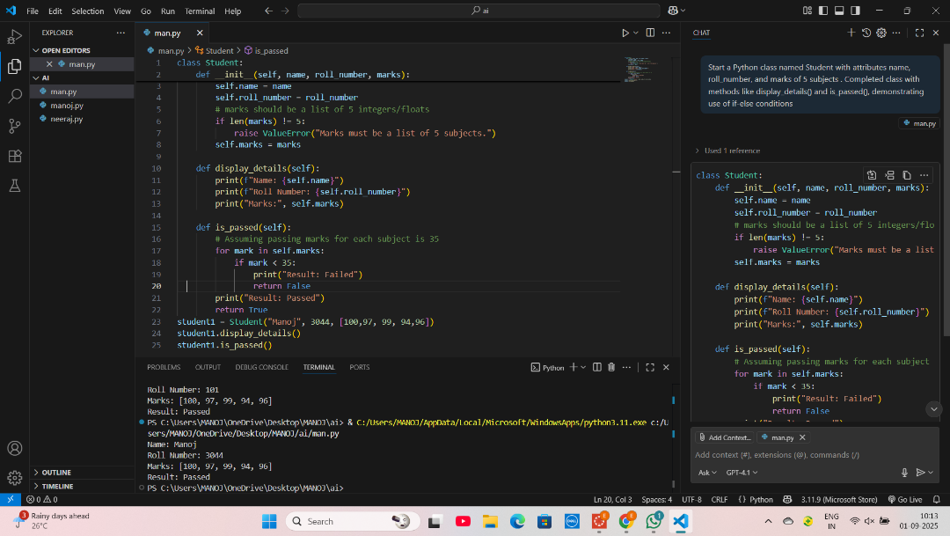  Task Description #2:  • Write the first two lines of a for loop to iterate through a list of numbers. Use a comment prompt to let Copilot suggest how to calculate and print the square of even numbers only.  Expected Outcome #2:  • A complete loop generated by Copilot with conditional logic (if number % 2 == 0) and appropriate output.  Prompt:  numbers = [1, 2, 3, 4, 5, 6, 7, 8, 9, 10]  for num in numbers:  # calculate and print the square of even numbers  Code :  numbers = [1, 2, 3, 4, 5, 6, 7, 8, 9, 10]  for num in numbers:  if num % 2 == 0:  print(f"Square of {num} is {num ** 2}")  output :  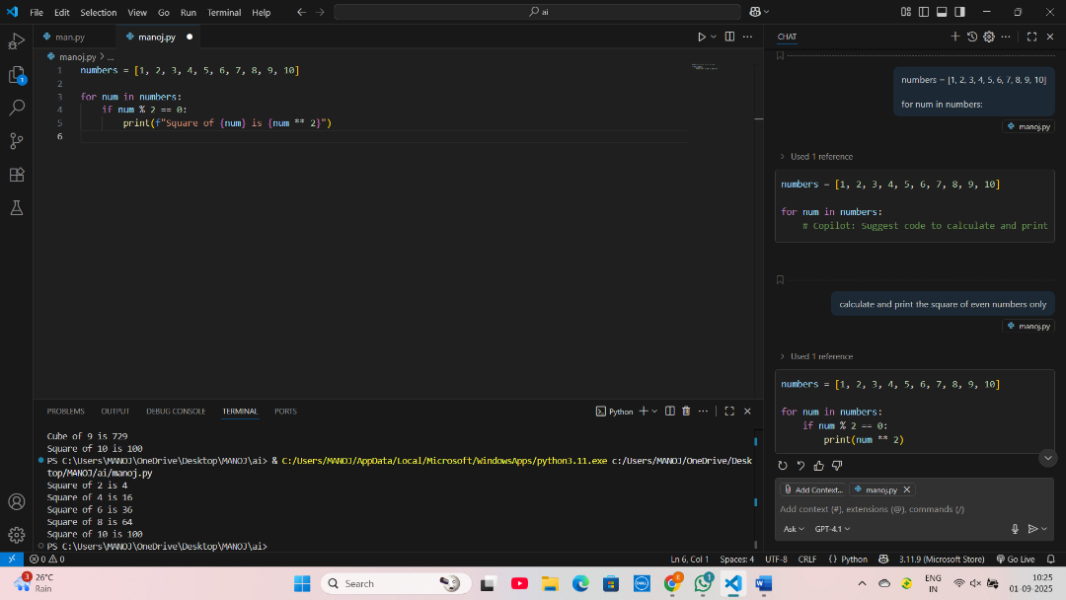  Task Description #3:  • Create a class called BankAccount with attributes account_holder and balance. Use Copilot to complete methods for deposit(), withdraw(), and check for insufficient balance.  Expected Outcome #3:  • Functional class with complete method definitions using if conditions and self attributes. Code should prevent overdrawing.  Prompt:  class BankAccount:  def init(self, account_holder, balance=0):  self.account_holder = account_holder  self.balance = balance  def deposit(self, amount):  # add amount to balance and print new balance  pass  def withdraw(self, amount):  # subtract amount if balance is enough, else print "Insufficient balance"  Pass  Code :  class BankAccount:  def __init__(self, account_holder, balance=0):  self.account_holder = account_holder  self.balance = balance  def deposit(self, amount):  if amount > 0:  self.balance += amount  print(f"Deposited {amount}. New balance: {self.balance}")  else:  print("Deposit amount must be positive.")  def withdraw(self, amount):  if amount > self.balance:  print("Insufficient balance")  elif amount <= 0:  print("Withdrawal amount must be positive.")  else:  self.balance -= amount  print(f"Withdrew {amount}. New balance: {self.balance}")  def display_balance(self):  print(f"Account Holder: {self.account_holder}, Balance: {self.balance}")  account = BankAccount("Manoj", 1000)  account.deposit(500)  account.withdraw(2000)  account.withdraw(300)  output :  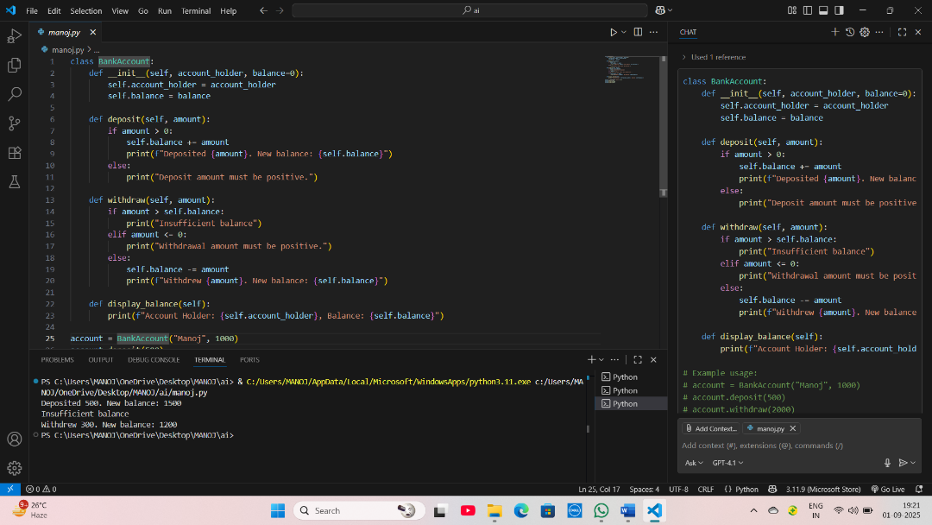  Task Description #4:  • Define a list of student dictionaries with keys name and score. Ask Copilot to write a while loop to print the names of students who scored more than 75.  Expected Outcome #4:  • A complete while loop generated by Copilot with proper condition checks and formatted output.  Prompt :  students = [  {"name": "Manoj", "score":100},  {"name": "Ranadheer", "score": 70},  {"name": "Gayathri", "score": 70},  {"name": "Lahari", "score": 95},  {"name": "Sanjeev", "score": 80},  ]  i = 0  # write a while loop to print the names of students who scored more than 75  Code :  students = [  {"name": "Manoj", "score": 100},  {"name": "Ranadheer", "score": 70},  {"name": "Gayathri", "score": 70},  {"name": "Lahari", "score": 95},  {"name": "Sanjeev", "score": 80},  ]  i = 0  while i < len(students):  if students[i]["score"] > 75:  print(students[i]["name"])  i +=1  output:  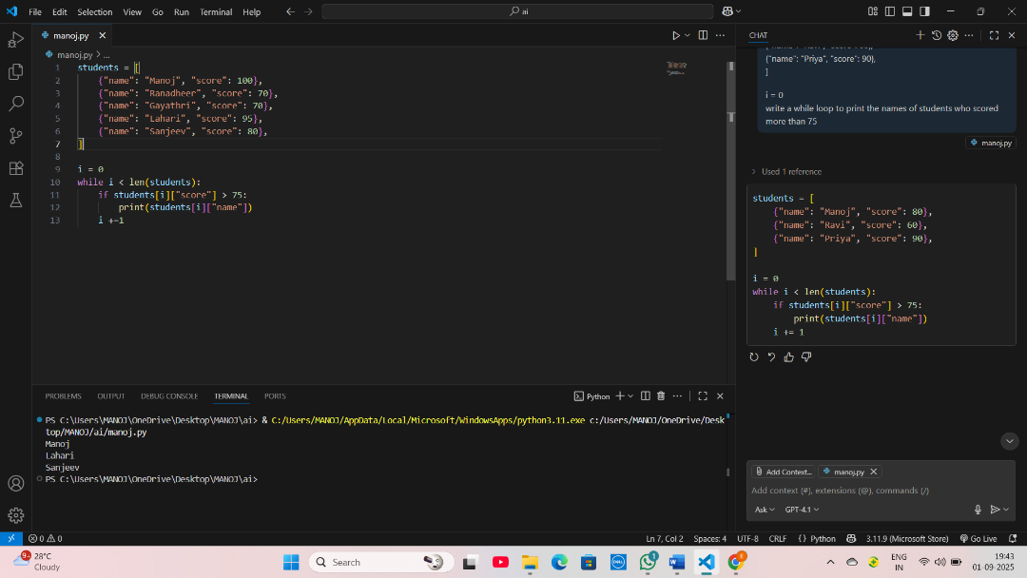  Task Description #5:  • Begin writing a class ShoppingCart with an empty items list. Prompt Copilot to generate methods to add_item, remove_item, and use a loop to calculate the total bill using conditional discounts.  Expected Outcome #5:  • A fully implemented ShoppingCart class with Copilot-generated loops and if-else statements handling item management and discount logic.  Prompt :  class ShoppingCart:  def __init__(self):  self.items = []  def add_item(self, item, price):  # add item with price to the items list  pass  def remove_item(self, item):  # remove item from the list if it exists  pass  def calculate_total(self, discount=0):  # use a loop to calculate total bill and apply conditional discount  pass  code:  class ShoppingCart:  def __init__(self):  self.items = []  def add_item(self, item, price):  self.items.append({"item": item, "price": price})  def remove_item(self, item):  for i in range(len(self.items)):  if self.items[i]["item"] == item:  del self.items[i]  print(f"Removed {item} from cart.")  return  print(f"{item} not found in cart.")  def calculate_total(self, discount=0):  total = 0  for entry in self.items:  total += entry["price"]  if discount > 0 and total >= discount:  total -= discount  print(f"Discount of {discount} applied.")  print(f"Total bill: {total}")  return total  cart = ShoppingCart()  cart.add_item("Milk", 40)  cart.add_item("Bread", 30)  cart.add_item("Eggs", 60)  cart.remove_item("Bread")  cart.calculate_total()  cart.calculate_total(discount=10)  output :  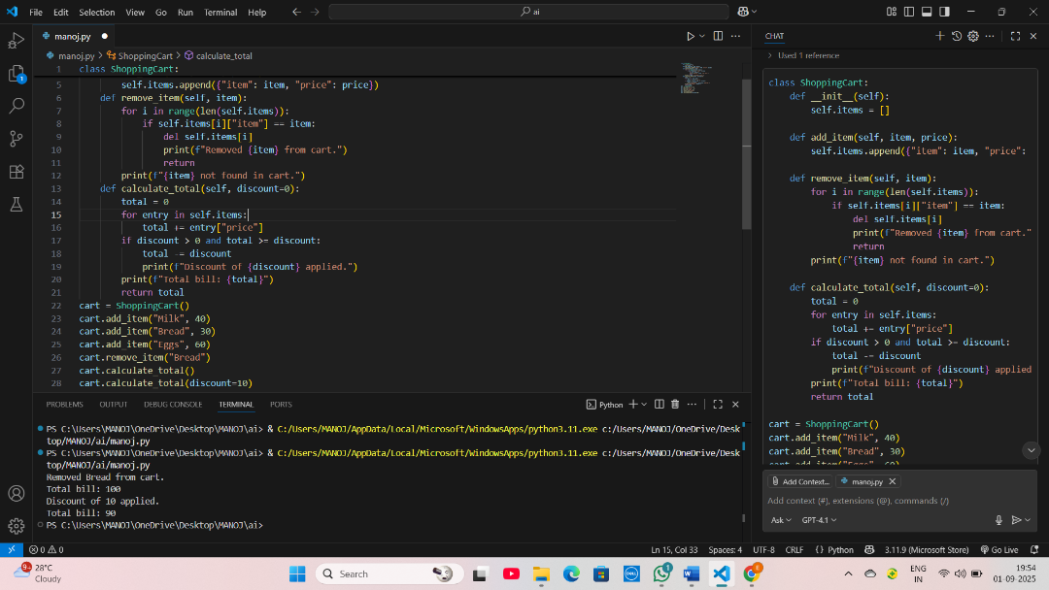  Note: Report should be submitted a word document for all tasks in a single document with prompts, comments & code explanation, and output and if required, screenshots  Evaluation Criteria:  Criteria Max Marks  Class 1  Loop 1  condition 0.5  Total 2.5 Marks |  |  |  |  |  | Week3 - Thursday

