AI ASSISTED CODING: 13.4
NAME:M.sakshitha
ROLLNO:2403A51363
Task1:
refactor loops in legacy python code into cleaner pythonic version using list comprehensions while giveing the output same
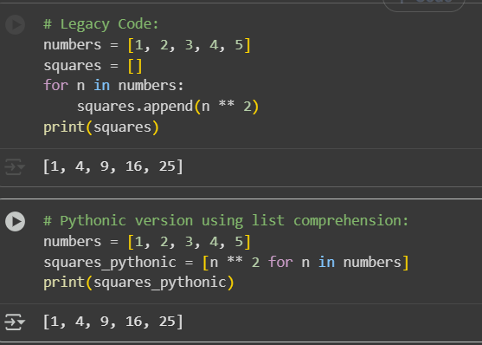
Task2:
Simplify string concatenation, Review the loop that builds a sentence using +=, Refactor using " ".join() to improve efficiency and readability.
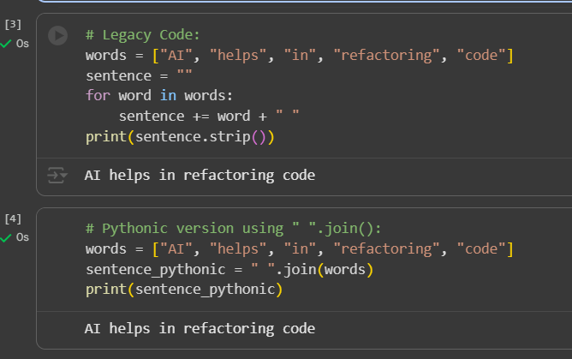
Task3:
Replace manual dictionary lookup with a safer method
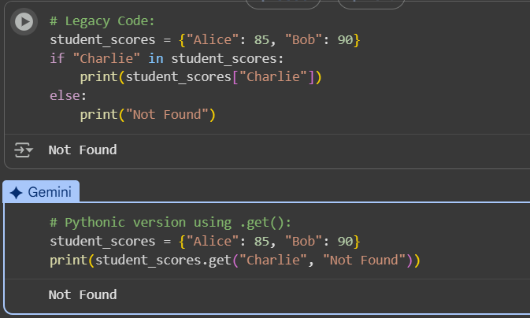

Task4: Refactor repetitive if-else blocks
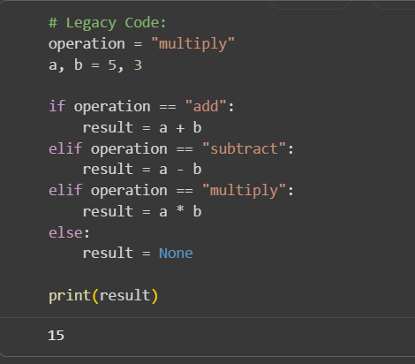
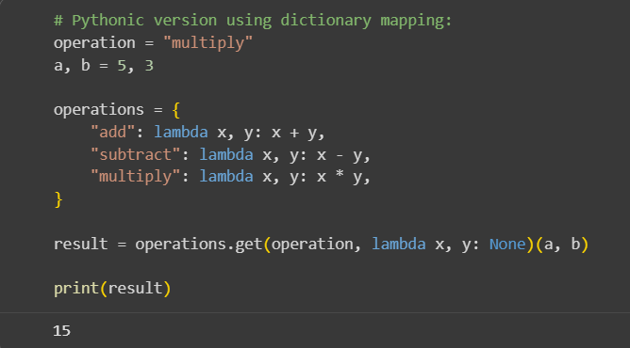

Task5: Optimize nested loops for searching
