SCHOOL OF COMPUTER SCIENCE AND ARTIFICIAL INTELLIGENCE |  |  |  |  | DEPARTMENT OF COMPUTER SCIENCE ENGINEERING
Program Name: B. Tech |  |  |  | Assignment Type: Lab |  |  | Academic Year:2025-2026
Course Coordinator Name |  |  |  | Venkataramana Veeramsetty
Instructor(s) Name |  |  |  | Dr. V. Venkataramana (Co-ordinator)  Dr. T. Sampath Kumar  Dr. Pramoda Patro  Dr. Brij Kishor Tiwari  Dr.J.Ravichander  Dr. Mohammand Ali Shaik  Dr. Anirodh Kumar  Mr. S.Naresh Kumar  Dr. RAJESH VELPULA  Mr. Kundhan Kumar  Ms. Ch.Rajitha  Mr. M Prakash  Mr. B.Raju  Intern 1 (Dharma teja)  Intern 2 (Sai Prasad)  Intern 3 (Sowmya)  NS_2 ( Mounika)
Course Code |  |  | 24CS002PC215 | Course Title |  | AI Assisted Coding
Year/Sem |  |  | II/I | Regulation |  | R24
Date and Day  of Assignment |  |  | Week4 - Monday | Time(s)
Duration |  |  | 2 Hours | Applicable to  Batches
AssignmentNumber:8.1(Present assignment number)/24(Total number of assignments)
 | Q.No. | Question |  |  |  |  |  | Expected Time  to complete
 | 1 | Lab 8: Test-Driven Development with AI – Generating and Working with Test Cases  Lab Objectives:  - To introduce students to test-driven development (TDD) using AI code generation tools.  - To enable the generation of test cases before writing code implementations.  - To reinforce the importance of testing, validation, and error handling.  - To encourage writing clean and reliable code based on AI-generated test expectations.  Lab Outcomes (LOs):  After completing this lab, students will be able to:  - Use AI tools to write test cases for Python functions and classes.  - Implement functions based on test cases in a test-first development style.  - Use unittest or pytest to validate code correctness.  - Analyze the completeness and coverage of AI-generated tests.  - Compare AI-generated and manually written test cases for quality and logic  Task Description #1 (Password Strength Validator – Apply AI in Security Context)  - Task: Apply AI to generate at least 3 assert test cases for is_strong_password(password) and implement the validator function.  - Requirements:  - Password must have at least 8 characters.  - Must include uppercase, lowercase, digit, and special character.  - Must not contain spaces.  Example Assert Test Cases:  assert is_strong_password("Abcd@123") == True  assert is_strong_password("abcd123") == False  assert is_strong_password("ABCD@1234") == True  Expected Output #1:  - Password validation logic passing all AI-generated test cases.  Code:  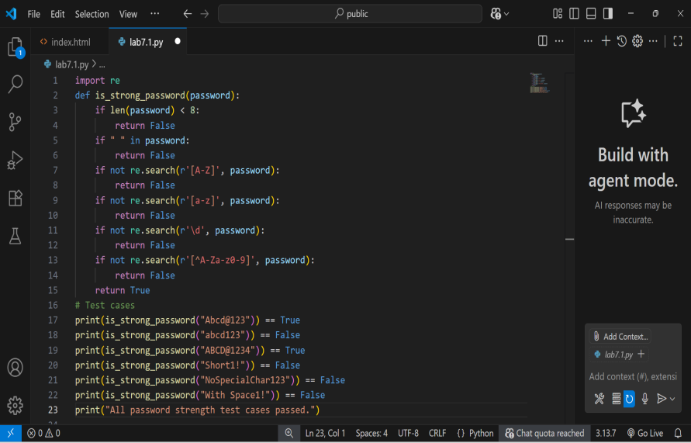  Output:  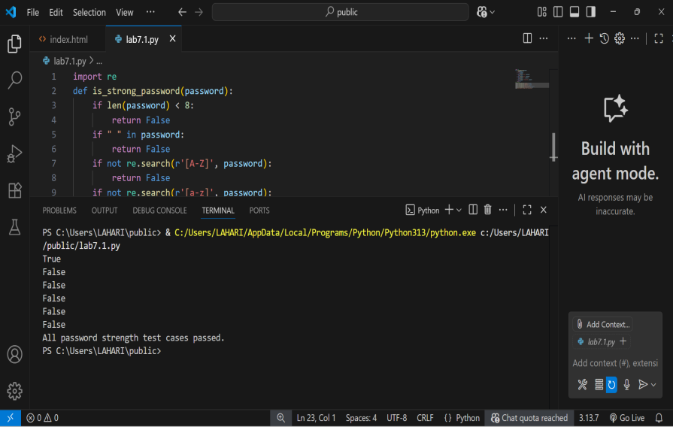  Explanation:  This function is_strong_password(password) checks if a password is strong by verifying these rules:  - At least 8 characters long  - No spaces allowed  - Contains at least one uppercase letter  - Contains at least one lowercase letter  - Contains at least one digit  - Contains at least one special character (non-alphanumeric)  If the password meets all these criteria, it returns True; otherwise, False.  The test cases print whether different example passwords pass or fail these rule  Task Description #2 (Number Classification with Loops – Apply AI for Edge Case Handling)  - Task: Use AI to generate at least 3 assert test cases for a classify_number(n) function. Implement using loops.  - Requirements:  - Classify numbers as Positive, Negative, or Zero.  - Handle invalid inputs like strings and None.  - Include boundary conditions (-1, 0, 1).  Example Assert Test Cases:  assert classify_number(10) == "Positive"  assert classify_number(-5) == "Negative"  assert classify_number(0) == "Zero"  Expected Output #2:  - Classification logic passing all assert tests.  Code:  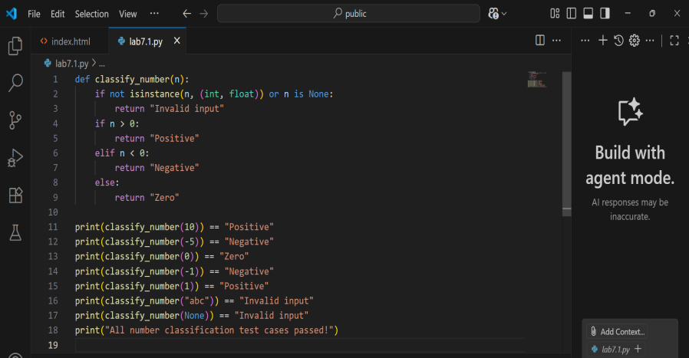  Output:  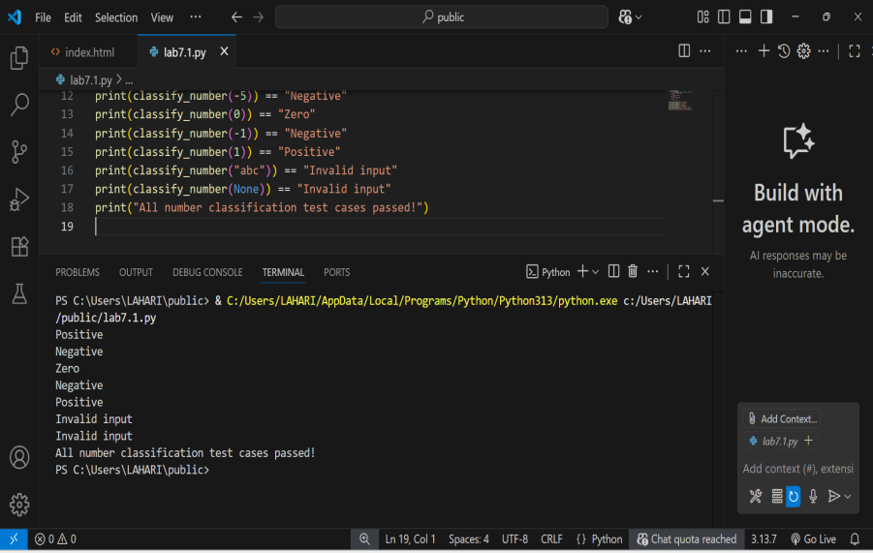  Explanation:  he function classify_number(n) classifies a given input n as:  - "Positive" if n is greater than 0  - "Negative" if n is less than 0  - "Zero" if n equals 0  - "Invalid input" if n is not a number (int or float) or is None  The print statements test the function with different values, including positive, negative, zero, strings, and None. The output shows if the function correctly classifies or handles invalid inputs.  Task Description #3 (Anagram Checker – Apply AI for String Analysis)  - Task: Use AI to generate at least 3 assert test cases for is_anagram(str1, str2) and implement the function.  - Requirements:  - Ignore case, spaces, and punctuation.  - Handle edge cases (empty strings, identical words).  Example Assert Test Cases:  assert is_anagram("listen", "silent") == True  assert is_anagram("hello", "world") == False  assert is_anagram("Dormitory", "Dirty Room") == True  Expected Output #3:  - Function correctly identifying anagrams and passing all AI-generated tests.  Code:  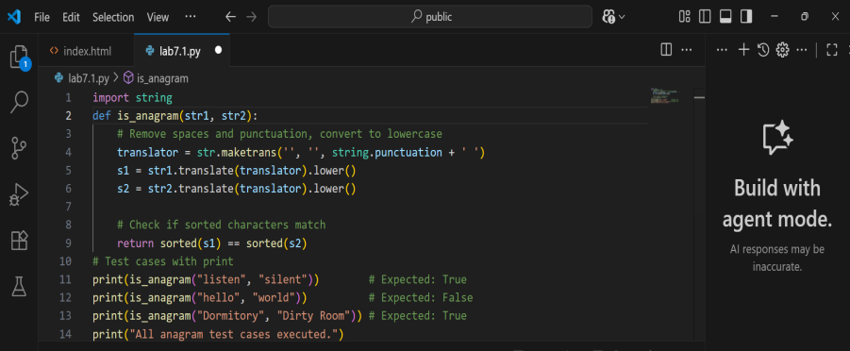  Output:  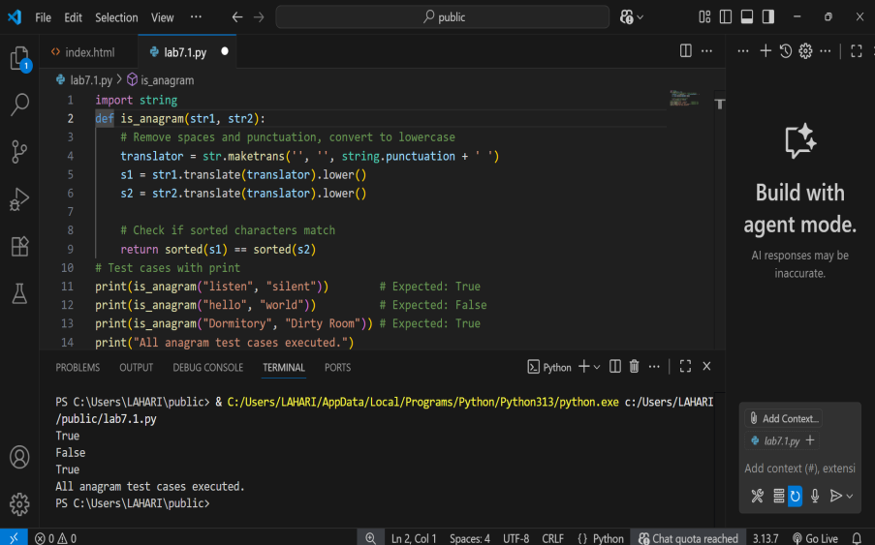  Explanation:  • The function is_anagram(str1, str2) checks if two strings are anagrams.  • It removes spaces and punctuation from both strings and converts them to lowercase for uniform comparison.  • This is done using str.translate with a translation table that removes punctuation, and lower() converts the text to lowercase.  • Then, it sorts the characters in both cleaned strings.  • If the sorted characters of both strings match, the function returns True (they are anagrams); otherwise, it returns False.  • The print statements test the function with examples, showing expected results.  Task Description #4 (Inventory Class – Apply AI to Simulate Real-World Inventory System)  - Task: Ask AI to generate at least 3 assert-based tests for an Inventory class with stock management.  - Methods:  - add_item(name, quantity)  - remove_item(name, quantity)  - get_stock(name)  Example Assert Test Cases:  inv = Inventory()  inv.add_item("Pen", 10)  assert inv.get_stock("Pen") == 10  inv.remove_item("Pen", 5)  assert inv.get_stock("Pen") == 5  inv.add_item("Book", 3)  assert inv.get_stock("Book") == 3  Expected Output #4:  - Fully functional class passing all assertions.  Code:  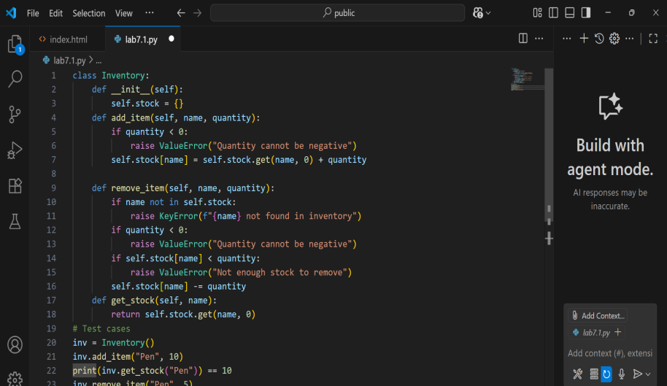  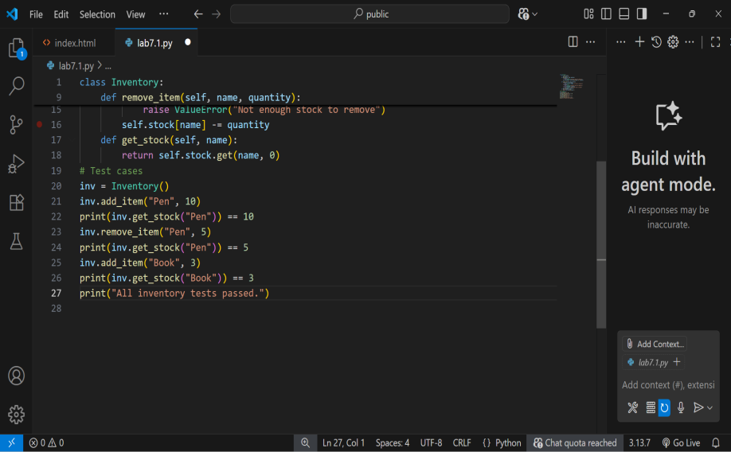  Output:  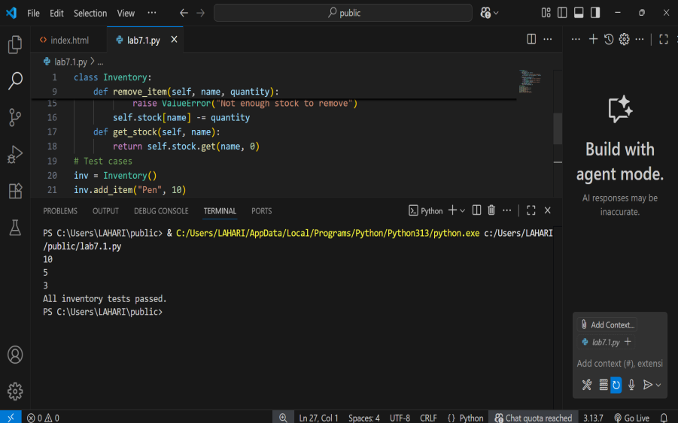  Explanation:  The Inventory class manages items and their quantities in stock. It can:  - Add items with add_item() (raises error if quantity is negative).  - Remove items with remove_item() (raises errors if item not found, quantity negative, or not enough stock).  - Check stock with get_stock() (returns quantity or 0 if not found).  The test cases add, remove, and check items to ensure the class works correctly.  Task Description #5 (Date Validation & Formatting – Apply AI for Data Validation)  - Task: Use AI to generate at least 3 assert test cases for validate_and_format_date(date_str) to check and convert dates.  - Requirements:  - Validate "MM/DD/YYYY" format.  - Handle invalid dates.  - Convert valid dates to "YYYY-MM-DD".  Example Assert Test Cases:  assert validate_and_format_date("10/15/2023") == "2023-10-15"  assert validate_and_format_date("02/30/2023") == "Invalid Date"  assert validate_and_format_date("01/01/2024") == "2024-01-01"  Expected Output #5:  - Function passes all AI-generated assertions and handles edge cases.  Code:  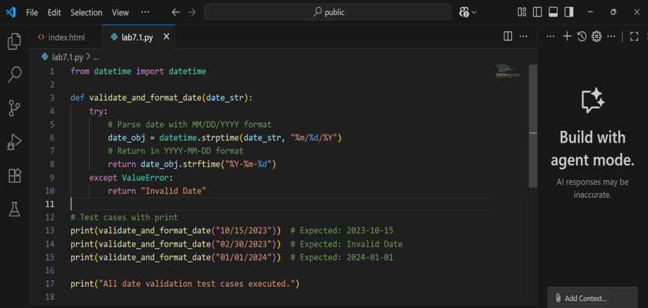  Output:  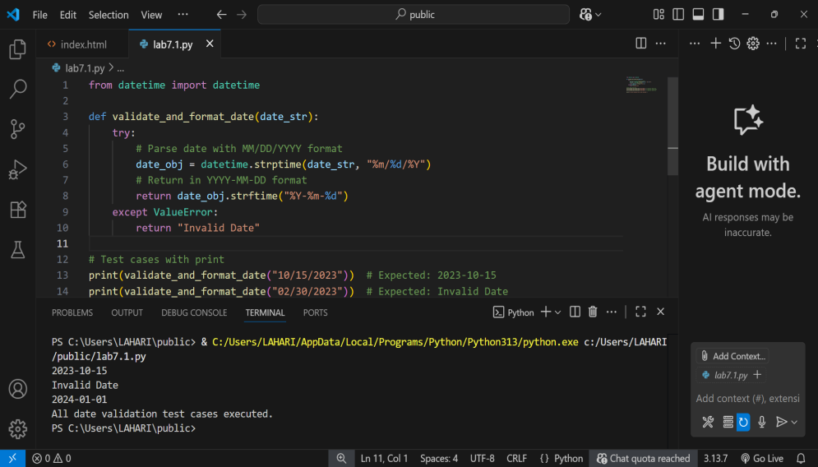  Explanation:  • The function validate_and_format_date(date_str) takes a date string in "MM/DD/YYYY" format.  • It tries to convert the string to a datetime object.  • If successful, it returns the date formatted as "YYYY-MM-DD".  • If the date is invalid (like "02/30/2023"), it catches the error and returns "Invalid Date".  • The print statements test the function with valid and invalid dates, showing expected outputs.  ✅ Deliverables (For All Tasks)  - AI-generated prompts for code and test case generation.  - At least 3 assert test cases for each task.  - AI-generated initial code and execution screenshots.  - Analysis of whether code passes all tests.  - Improved final version with inline comments and explanation.  - Compiled report (Word/PDF) with prompts, test cases, assertions, code, and output.  Evaluation Criteria:  Criteria Max Marks  Task #1 0.5  Task #2 0.5  Task #3 0.5  Task #4 0.5  Task #5 0.5  Total 2.5 Marks |  |  |  |  |  | Week4 - Monday

