**Circular double linked list**

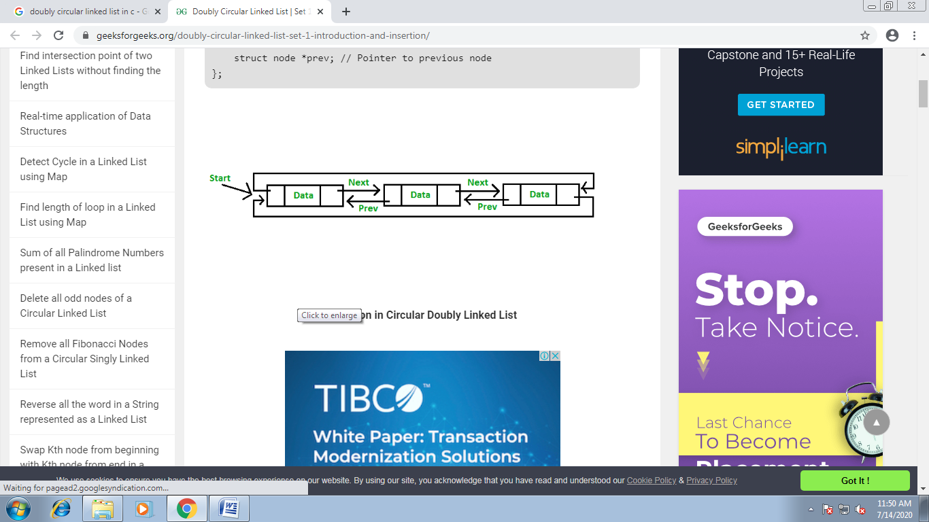

#include<stdio.h>

#include<conio.h>

#include<alloc.h>

struct node

{

int info;

struct node *next,*prev;

};

typedef struct node node;

node* create();

node* insbeg(node*);

node* insmid(node*);

node* insend(node*);

node* delbig(node*);

node* delmid(node*);

node* delend(node*);

int count(node*);

void sort(node*);

void search(node*);

void display(node*);

void main()

{

int choice;

node *head;

head=NULL;

while(1)

{

clrscr();

printf("\n\n\t\tThis is the program of DOUBLY LINKED LIST.");

printf("\n\t\t******************************************");

printf("\n\n\n\n\t\tWhich operation you want to perform --");

printf("\n\n\t\t------------------------------------------");

printf(“\n\t\t 1. Creation of list”);

printf("\n\t\t 2. Insert element at the beginning OR");

printf("\n\t\t 3. Insert element at the middle OR");

printf("\n\t\t 4. Insert element at the end OR");

printf("\n\t\t 5. Delete the starting element OR");

printf("\n\t\t 6. Delete the element in between OR");

printf("\n\t\t 7. Delete the last element OR");

printf("\n\t\t 8. Count the number of elements OR");

printf("\n\t\t 9. Sort the elements of the list OR");

printf("\n\t\t 10. Search any particular element OR");

printf("\n\t\t 11. Display the list OR");

printf("\n\t\t 12. Wanna exit from the program.");

printf("\n\t\t------------------------------------------");

printf("\n\n\n\n\t\tEnter your choice = ");

fflush(stdin);

scanf("%d",&choice);

switch(choice)

{

case 1: head=create();

Continue;

case 2: head=insbeg(head);

continue;

case 3: head=insmid(head);

continue;

case 4: head=insend(head);

continue;

case 5: head=delbig(head);

continue;

case 6: head=delmid(head);

continue;

case 7: head=delend(head);

continue;

case 8: clrscr();

printf("\n\n\t\tThe list has %d elements.",count(head));

printf("\n\n\t\t**Press any key to continue.**");

getch();

continue;

case 9: sort(head);

continue;

case 10: search(head);

continue;

case 11:display(head);

continue;

case 12:printf("\n\n\n\n\t\t**You have successfully terminated from the program.**");

getch();

exit(0);

default:printf("\n\n\t\tYou entered a invalid choice!!!");

printf("\n\n\t\tPress any key to choose again.......");

getch();

}

}

}

node * create()

{

node *p, *temp,*head;

head = (node*)malloc(sizeof(node));

head->next=NULL;

head->prev=NULL;

printf(“\n\n\t Enter data to insert or -999 to stop”);

scanf(“%d”, &head->info);

p=head;

while(p->info!= -999)

{

temp=(node*)malloc(sizeof(node));

temp->next=NULL;

temp->prev=NULL;

scanf(“%d”,&temp->info);

p->next=temp;

temp->prev=p;

p=temp;

}

p->next-head;

head->prev=p;

return(head);

}

node* insbeg(node *head)

{

node *ins;

clrscr();

ins=(node*)malloc(sizeof(node));

printf("\n\n\t\tEnter the number to insert at the beginning = ");

scanf("%d",&ins->info);

if(head==NULL)

{

ins->prev=ins;

ins->next=ins;

}

else

{

ins->next=head;

ins->prev=head->prev;

head->prev->next=ins;

head->prev=ins;

}

printf("\n\n\t\t**Your element has been successfully inserted.**");

getch();

return ins;

}

node* insmid(node *head)

{

node *tmp,*ins;

int pos,cout,num,i;

cout=count(head);

while(1)

{

clrscr();

printf("\n\n\t\tAt which position you want to insert the element = ");

fflush(stdin);

scanf("%d",&pos);

if(pos>cout+1 || pos<1)

{

printf("\n\n\t\tYou entered a wrong position.");

printf("\n\n\t\tPress any key to choose any other position.");

getch();

continue;

}

else

{

ins=(node*)malloc(sizeof(node));

printf("\n\n\n\n\t\tEnter the number to insert = ");

fflush(stdin);

scanf("%d",&num);

ins->info=num;

if(head==NULL)

{

head=ins;

head->next=head;

head->prev=head;

return head;

}

else

if(pos==1)

{

ins->next=head;

ins->prev=head->prev;

head->prev->next=ins;

head->prev=ins;

return ins;

}

else

{

tmp=head;

for(i=2;i<pos;i++,tmp=tmp->next);

ins->next=tmp->next;

ins->prev=tmp;

tmp->next=ins;

ins->next->prev=ins;

return head;

}

}

}

}

node* insend(node *head)

{

node *ins,*tmp;

int num;

clrscr();

printf("\n\n\t\tEnter any number to insert at the end = ");

fflush(stdin);

scanf("%d",&num);

if(head==NULL)

{

head=(node*)malloc(sizeof(node));

head->info=num;

head->next=head;

head->prev=head;

}

else

{

for(tmp=head;tmp->next!=head;tmp=tmp->next);

ins=(node*)malloc(sizeof(node));

tmp->next=ins;

ins->prev=tmp;

ins->info=num;

ins->next=head;

head->prev=ins;

}

printf("\n\n\t\t**Your element has been successfully inserted at end.**");

getch();

return head;

}

node* delbig(node *head)

{

clrscr();

if(head==NULL)

{

printf("\n\n\t\tUnderflow occur!!!");

printf("\n\n\t\tThere is no element in the list for deletion.");

getch();

return head;

}

else

if(head->next==head)

return NULL;

else

{

printf("\n\n\t\t**Starting element has been successfully deleted.**");

head->next->prev=head->prev;

head->prev->next=head->next;

getch();

return head->next;

}

}

node* delmid(node *head)

{

node *tmp;

int pos,cout;

char ch;

while(1)

{

clrscr();

if(head==NULL)

{

printf("\n\n\t\tUnderflow occur!!!");

printf("\n\n\t\tThere is no element in the list for deletion.");

getch();

}

else

{

printf("\n\n\tEnter the position of the element you wanna to delete =");

scanf("%d",&pos);

cout=count(head);

if(pos<1 || pos>cout)

{

printf("\n\n\t\tYou entered a wrong position.");

printf("\n\n\t\tPress any key to choose any other position");

printf("\n\n\t\tOR press 'N' to go back on the main menu.");

if((ch=getch())=='n' || ch=='N')

return head;

continue;

}

else

if(head->next==head)

return NULL;

else

if(pos==1)

{

head->prev->next=head->next;

head->next->prev=head->prev;

head=head->next;

}

else

{

tmp=head;

for(cout=2;cout<pos;cout++,tmp=tmp->next);

tmp->next=tmp->next->next;

tmp->next->prev=tmp;

}

printf("\n\n\t\t**Your element has been successfully deleted.**");

getch();

}

return head;

}

}

node* delend(node *head)

{

node *tmp;

clrscr();

tmp=head;

if(head==NULL)

{

printf("\n\n\t\tUnderflow occur!!!");

printf("\n\n\t\tThere is no element in the list for deletion.");

getch();

}

else

{

if(head->next==head)

head=NULL;

else

{

for(;tmp->next!=head;tmp=tmp->next);

tmp->prev->next=head;

head->prev=tmp->prev;

}

printf("\n\n\t\t**Last element has been successfully deleted.**");

}

getch();

return head;

}

int count(node *head)

{

int count;

node *tmp;

tmp=head;

if(head==NULL)

return 0;

else

for(count=1;tmp->next!=head;count++,tmp=tmp->next);

return count;

}

void sort(node *head)

{

node *tmp1,*tmp2,*swap;

clrscr();

if(head==NULL)

{

printf("\n\n\t\t**Lallu, sort karne k liye elements hone chahiye!!!**");

getch();

return;

}

for(tmp1=head;tmp1->next!=head;tmp1=tmp1->next)

for(tmp2=tmp1->next;tmp2!=head;tmp2=tmp2->next)

if(tmp1->info > tmp2->info)

{

swap->info=tmp1->info;

tmp1->info=tmp2->info;

tmp2->info=swap->info;

}

printf("\n\n\t\t**Your list has been sorted.**");

getch();

}

void search(node *head)

{

node *tmp;

int item,flag=0;

tmp=head;

clrscr();

if(head==NULL)

{

printf("\n\n\t\tEmpty list ko search kar raha hai, akal nahi hai.");

printf("\n\n\t\tPlease inseart some elements first then try again.");

}

else

{

printf("\n\n\t\tEnter the item to search in the list = ");

scanf("%d",&item);

printf("\n\n\t\tYour result is as follows --\n");

if(tmp->info==item)

{

printf("\n\n\t\t[%d] -->found",tmp->info);

flag=1;

}

else

printf("\n\n\t\t%d",tmp->info);

tmp=tmp->next;

while(tmp!=head)

{

if(tmp->info==item)

{

printf("\n\n\t\t[%d] -->found",tmp->info);

flag=1;

}

else

printf("\n\n\t\t%d",tmp->info);

tmp=tmp->next;

}

if(flag==0)

printf("\n\n\n\n\t\t**Your item is not present in the whole list!!!**");

else

printf("\n\n\n\n\t\t**Your item found at the above locations.**");

}

getch();

}

void display(node *head)

{

node *tmp;

clrscr();

tmp=head;

if(head==NULL)

{

printf("\n\n\t\tThere is no element in the linked list.");

printf("\n\n\t\tPlease inseart some elements first then try again.");

}

else

{

printf("\n\n\t\tYour list is as follows --\n");

printf("\n\t\t%d",tmp->info);

tmp=tmp->next;

for(;tmp!=head;tmp=tmp->next)

printf("\n\t\t%d",tmp->info);

}

getch();

}