**Topic – 09**

Function-Structure-Pointer

Functions

A function is a group of statements that together perform a task. Every C program has at least one function, which is **main()**, and all the most trivial programs can define additional functions.

A function **declaration** tells the compiler about a function's name, return type, and parameters. A function **definition** provides the actual body of the function.

## Defining a Function

return_type function_name( parameter list )

{

body of the function

}

A function definition in C programming consists of a *function header* and a *function body*. Here are all the parts of a function −

* **Return Type** − A function may return a value. The **return_type** is the data type of the value the function returns. Some functions perform the desired operations without returning a value. In this case, the return_type is the keyword **void**.
* **Function Name** − This is the actual name of the function. The function name and the parameter list together constitute the function signature.
* **Parameters** − A parameter is like a placeholder. When a function is invoked, you pass a value to the parameter. This value is referred to as actual parameter or argument. The parameter list refers to the type, order, and number of the parameters of a function. Parameters are optional; that is, a function may contain no parameters.
* **Function Body** − The function body contains a collection of statements that define what the function does.

## Function Declarations

A function **declaration** tells the compiler about a function name and how to call the function. The actual body of the function can be defined separately.

A function **declaration** tells the compiler about a function name and how to call the function. The actual body of the function can be defined separately.

A function declaration has the following parts −

return_type function_name( parameter list );

For the above defined function max(), the function declaration is as follows −

int max(int num1, int num2);

Parameter names are not important in function declaration only their type is required, so the following is also a valid declaration −

int max(int, int);

Function declaration is required when you define a function in one source file and you call that function in another file. In such case, you should declare the function at the top of the file calling the function.

## Calling a Function

While creating a C function, you give a definition of what the function has to do. To use a function, you will have to call that function to perform the defined task.

When a program calls a function, the program control is transferred to the called function. A called function performs a defined task and when its return statement is executed or when its function-ending closing brace is reached, it returns the program control back to the main program.

[Live Demo](http://tpcg.io/T4MSFr)

#include <stdio.h>

int max(int num1, int num2); /* function declaration */

int main () {

int a = 100; /* local variable definition */

int b = 200;

int ret;

ret = max(a, b); /* calling a function to get max value */

printf( "Max value is : %d\n", ret );

return 0;

}

/* function returning the max between two numbers */

int max(int num1, int num2) {

/* local variable declaration */

int result;

if (num1 > num2)

result = num1;

else

result = num2;

return result;

}

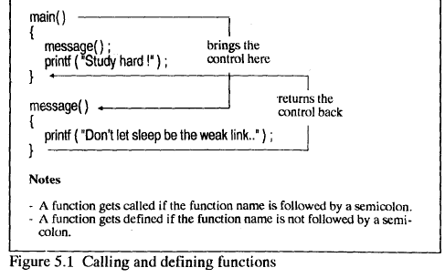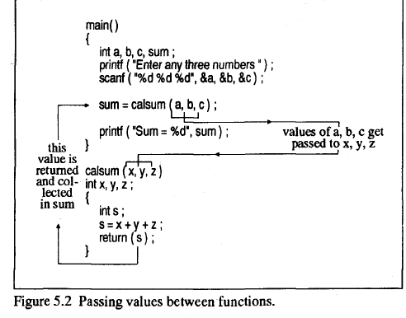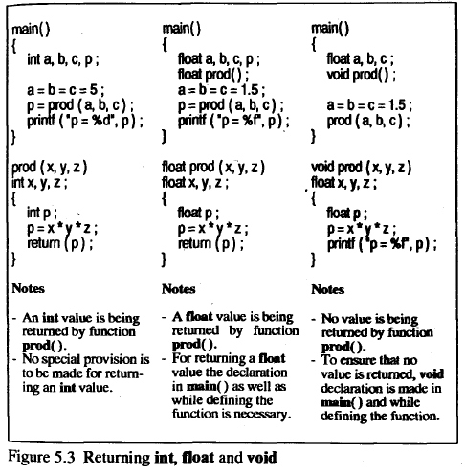

**Structure-**

**Structure** is another user defined data type available in C that allows combining data items of different kinds.

Structures are used to represent a record. Suppose you want to keep track of your books in a library. You might want to track the following attributes about each book −

* Title
* Author
* Subject
* Book ID

## Defining a Structure

To define a structure, you must use the **struct** statement. The struct statement defines a new data type, with more than one member. The format of the struct statement is as follows −

struct [structure tag] {

member definition;

member definition;

...

member definition;

} [one or more structure variables];

The **structure tag** is optional and each member definition is a normal variable definition, such as int i; or float f; or any other valid variable definition. At the end of the structure's definition, before the final semicolon, you can specify one or more structure variables but it is optional. Here is the way you would declare the Book structure −

struct Books {

char title[50];

char author[50];

char subject[100];

int book_id;

} book;

## Accessing Structure Members

To access any member of a structure, we use the **member access operator (.)**. The member access operator is coded as a period between the structure variable name and the structure member that we wish to access. You would use the keyword **struct** to define variables of structure type. The following example shows how to use a structure in a program –

#include <stdio.h>

#include <string.h>

struct Books {

char title[50];

char author[50];

char subject[100];

int book_id;

};

int main( ) {

struct Books Book1; /* Declare Book1 of type Book */

struct Books Book2; /* Declare Book2 of type Book */

/* book 1 specification */

strcpy( Book1.title, "C Programming");

strcpy( Book1.author, "Nuha Ali");

strcpy( Book1.subject, "C Programming Tutorial");

Book1.book_id = 6495407;

/* book 2 specification */

strcpy( Book2.title, "Telecom Billing");

strcpy( Book2.author, "Zara Ali");

strcpy( Book2.subject, "Telecom Billing Tutorial");

Book2.book_id = 6495700;

/* print Book1 info */

printf( "Book 1 title : %s\n", Book1.title);

printf( "Book 1 author : %s\n", Book1.author);

printf( "Book 1 subject : %s\n", Book1.subject);

printf( "Book 1 book_id : %d\n", Book1.book_id);

/* print Book2 info */

printf( "Book 2 title : %s\n", Book2.title);

printf( "Book 2 author : %s\n", Book2.author);

printf( "Book 2 subject : %s\n", Book2.subject);

printf( "Book 2 book_id : %d\n", Book2.book_id);

return 0;

}

## Pointers-

A **pointer** is a variable whose value is the address of another variable, i.e., direct address of the memory location. Like any variable or constant, you must declare a pointer before using it to store any variable address. The general form of a pointer variable declaration is −

type *var-name;

Here, **type** is the pointer's base type; it must be a valid C data type and **var-name** is the name of the pointer variable. The asterisk * used to declare a pointer is the same asterisk used for multiplication. However, in this statement the asterisk is being used to designate a variable as a pointer. Take a look at some of the valid pointer declarations −

int *ip; /* pointer to an integer */

double *dp; /* pointer to a double */

float *fp; /* pointer to a float */

char *ch /* pointer to a character */

The actual data type of the value of all pointers, whether integer, float, character, or otherwise, is the same, a long hexadecimal number that represents a memory address. The only difference between pointers of different data types is the data type of the variable or constant that the pointer points to.

**Using Pointers-**

There are a few important operations, which we will do with the help of pointers very frequently. **(a)** We define a pointer variable, **(b)** assign the address of a variable to a pointer and **(c)** finally access the value at the address available in the pointer variable. This is done by using unary operator **\*** that returns the value of the variable located at the address specified by its operand. The following example makes use of these operations −

#include <stdio.h>

int main () {

int var = 20; /* actual variable declaration */

int *ip; /* pointer variable declaration */

ip = &var; /* store address of var in pointer variable*/

printf("Address of var variable: %x\n", &var );

/* address stored in pointer variable */

printf("Address stored in ip variable: %x\n", ip );

/* access the value using the pointer */

printf("Value of *ip variable: %d\n", *ip );

return 0;

}

main()

{

int i = 30;

int*j,**k;

j = &i; /* store address of i in j */

k = &j; *I\** store address of j in k */

printf ("Address of i = %d %d %d\n", &i, j, * k ) ;

printf ("Address of j = %d %d\n", &j, k ) ;

printf ("Address of k = %d\n", & k ) ;

printf ("Value of i = %d %d %d %d", i, *(&i), *j, * * k ) ;

}

And here is the output...

Address of i = 6484 6484 6484

Address of j =9006 9006

Address of k = 9888

Value of i = 30 30 30 30

Consider the declaration,

**int i = 30;**

This declaration reserves space in memory, associates the name **i** with it and stores the value 30 in it. The following figure gives the snapshot of this reserved space.

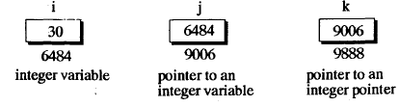

We see that the compiler has selected location number (address ) 6484 as the place to store the value 30. The location 6484 we took only for example, the compiler may choose any other location as well. The important point is, **i**'s address in memory is a number.

Next, the address of **i** is stored in **j** through the statement **j = &i.** Since **j** contains the address of **i** ( an integer variable ), **j** is called an integer pointer. Similarly, the address of **j** is stored in **k** through the statement **k = &j.** Since **k** contains the address of **j** ( an integer pointer ), **k** is called a pointer to an integer pointer. Here & is 'address of operator. Since **j** and **k** contain addresses their declaration is different from that of **i.** In the declaration of **j** and **k,** * is being used. This is a pointer operator called 'value at address'. Thus the declaration **int *j** means the value at address contained in **j** is an **int.** Or in other words **j** is an integer pointer. Similarly, the declaration **int **k** means the value at address contained in **\*k** is an **int.** Once this concept is clear, rest of the program is a breeze. Figure 5.4 would help you check the output as you step through the program.

