**Important Data Structures are-**

Data structure types are determined by what types of operations are required or what kinds of algorithms are going to be applied. These types include:

**Arrays-** An array stores a collection of items at adjoining memory locations. Items that are the same type get stored together so that the position of each element can be calculated or retrieved easily. Arrays can be fixed or flexible in length.

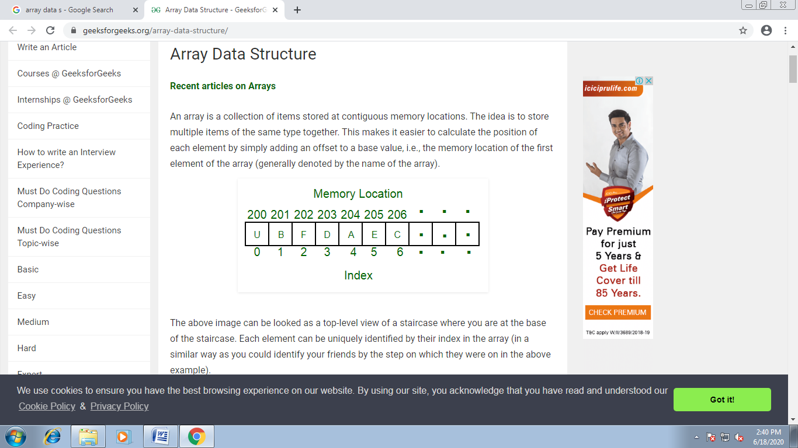

**Linked lists-** Linked List is a very commonly used linear data structure which consists of group of **nodes** in a sequence.

Each node holds its own **data** and the **address of the next node** hence forming a chain like structure.

Linked Lists are used to create trees and graphs.

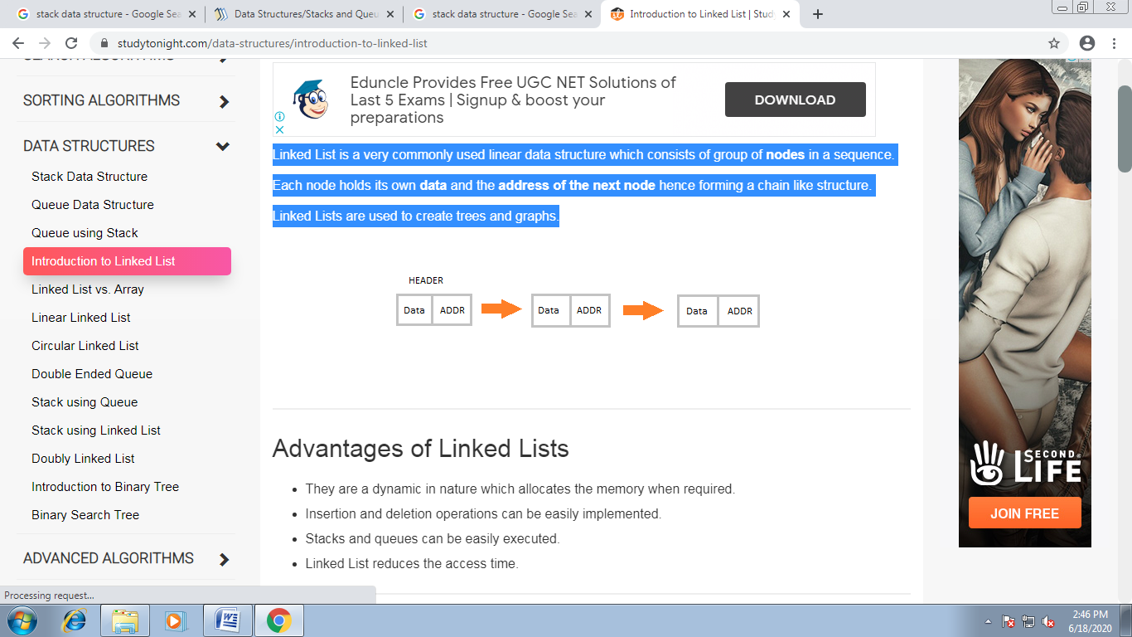

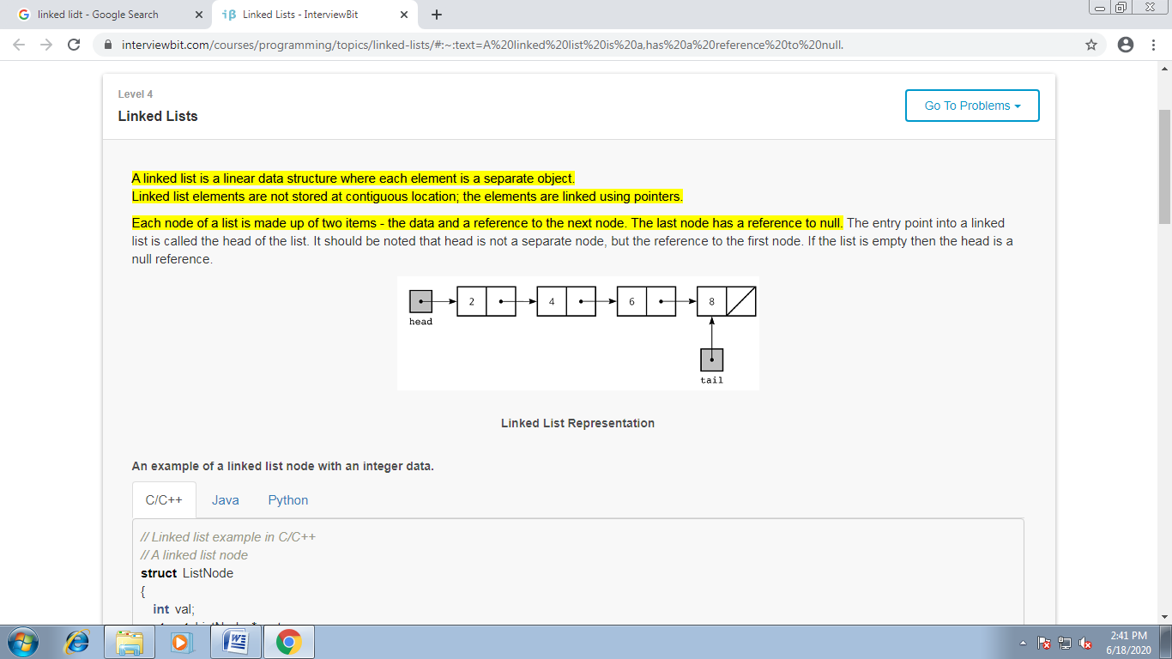

**Stack - Stack** is an abstract data type with a bounded(predefined) capacity. It is a simple data structure that allows adding and removing elements in a particular order. Every time an element is added, it goes on the **top** of the stack and the only element that can be removed is the element that is at the top of the stack, just like a pile of objects.

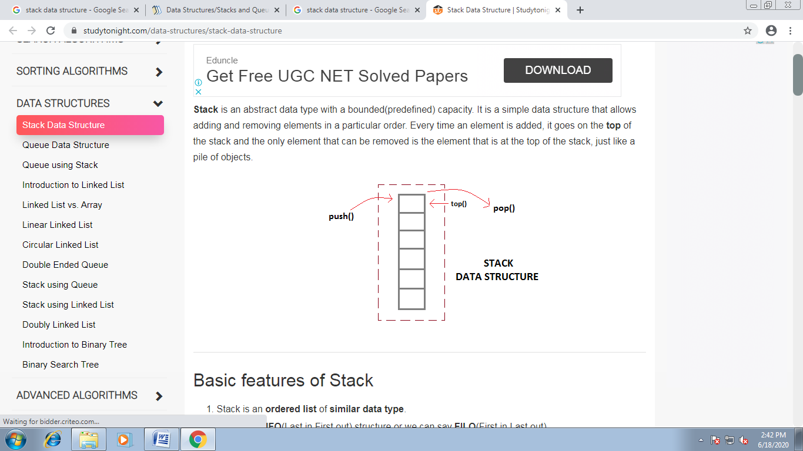

**Queues-** **Queue** is also an abstract data type or a linear data structure, just like [stack data structure](https://www.studytonight.com/data-structures/stack-data-structure), in which the first element is inserted from one end called the **REAR**(also called **tail**), and the removal of existing element takes place from the other end called as **FRONT**(also called **head**).

This makes queue as **FIFO**(First in First Out) data structure, which means that element inserted first will be removed first.

Which is exactly how queue system works in real world. If you go to a ticket counter to buy movie tickets, and are first in the queue, then you will be the first one to get the tickets. Same is the case with Queue data structure. Data inserted first, will leave the queue first.

The process to add an element into queue is called **Enqueue** and the process of removal of an element from queue is called **Dequeue**.

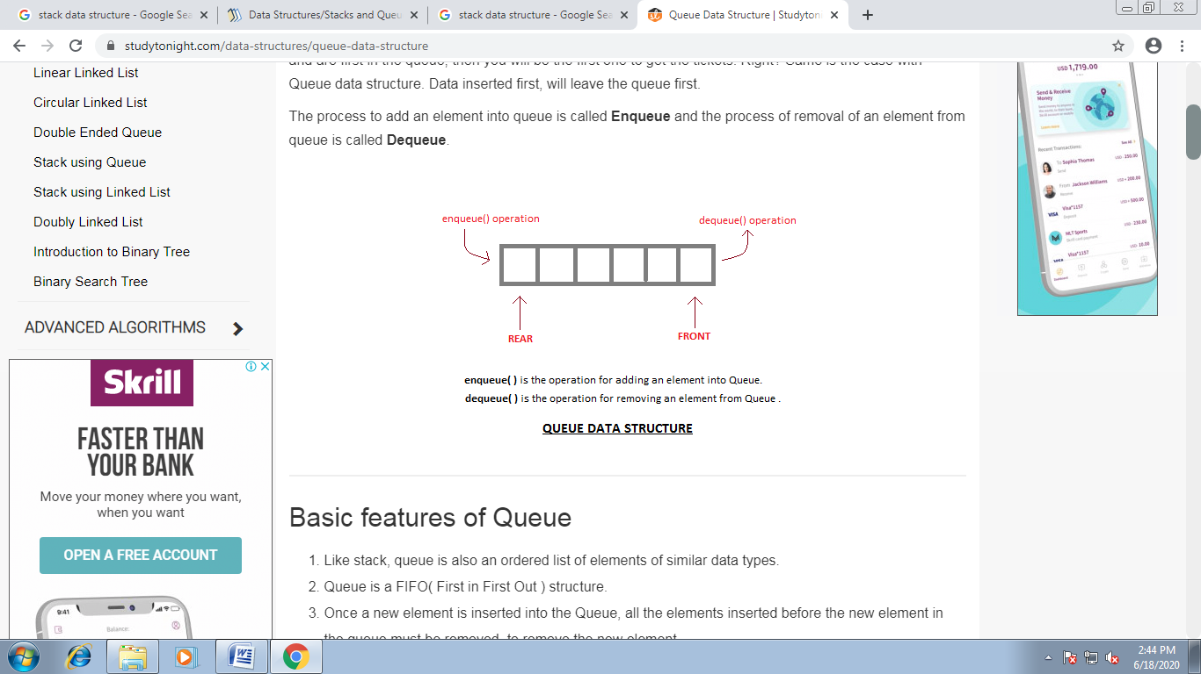

**Trees-** A tree stores a collection of items in an abstract, hierarchical way. Each node is linked to other nodes and can have multiple sub-values, also known as children.

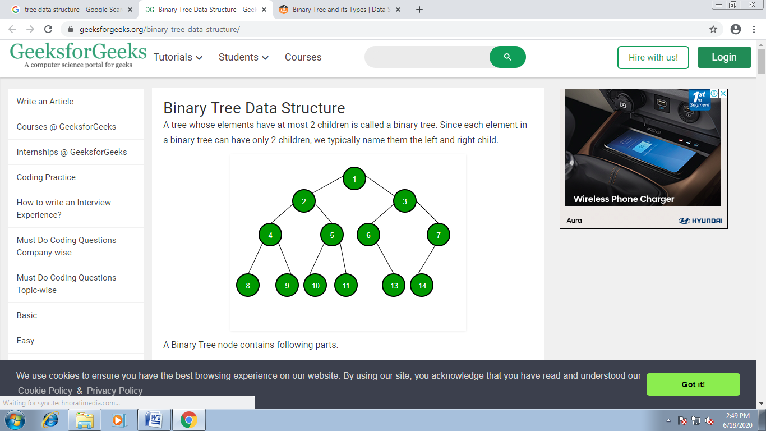

**Binary Tree-** A binary tree is a hierarchical data structure in which each node has at most two children generally referred as left child and right child.

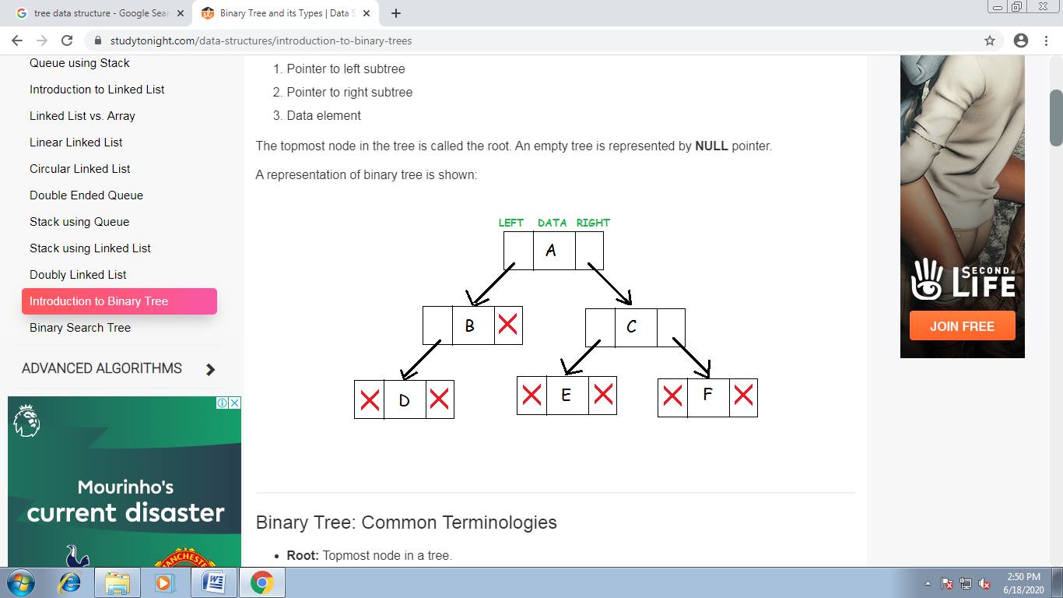

**Graphs-** A graph is a pictorial representation of a set of objects where some pairs of objects are connected by links. The interconnected objects are represented by points termed as **vertices**, and the links that connect the vertices are called **edges**.

Formally, a graph is a pair of sets **(V, E)**, where **V** is the set of vertices and **E** is the set of edges, connecting the pairs of vertices. Take a look at the following graph −

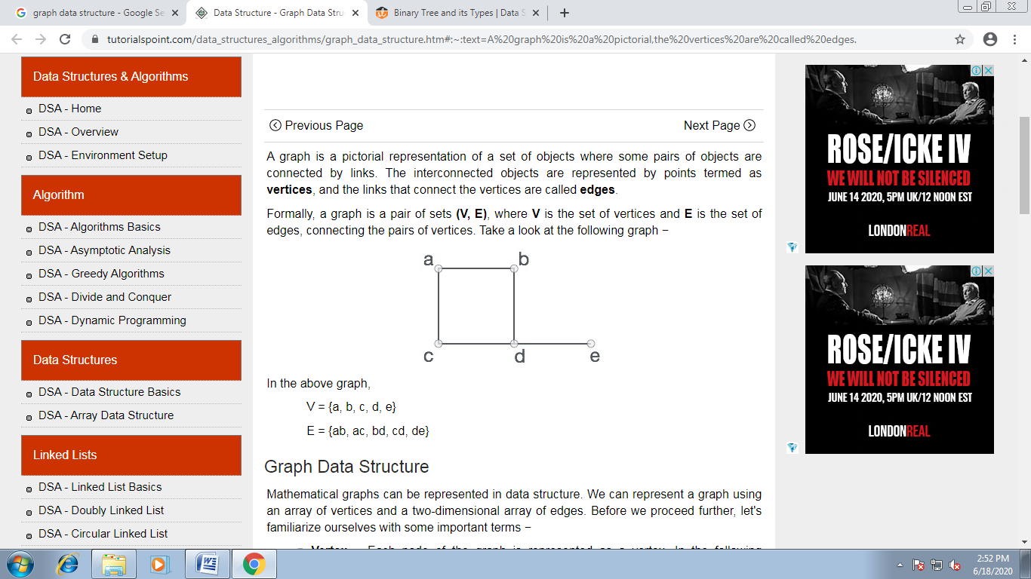

In the above graph,

V = {a, b, c, d, e}

E = {ab, ac, bd, cd, de}