#### ****Address Calculation in single (one) Dimension Array:****

[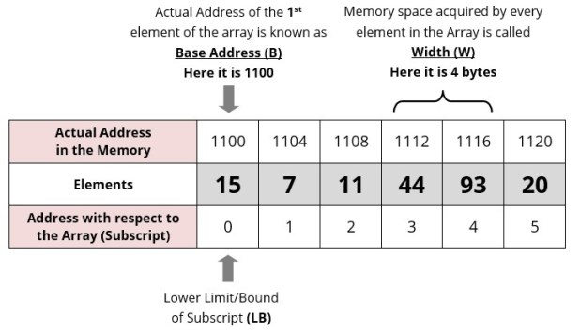](https://i1.wp.com/www.guideforschool.com/wp-content/uploads/2013/11/1d-one-dimensional-array-memory-address-calculation.jpg)

|  |  |  |  |  |  |  |  |  |  |  |
| --- | --- | --- | --- | --- | --- | --- | --- | --- | --- | --- |
| **Address** | **1000** | **1002** | **1004** | **1006** | **1008** | **1010** | **1012** | **1014** | **1016** | **1018** |
| **Element** | **111** | **222** | **333** | **444** | **555** | **666** | **777** | **888** | **999** | **000** |
| **Index** | **0** | **1** | **2** | **3** | **4** | **5** | **6** | **7** | **8** | **9** |

**Address of A [ I ] = B + W * ( I – LB )**

Where,  
**B** =Base address  
**W** =Storage Size of one element stored in the array (in byte)  
**I** = Subscript of element whose address is to be found  
**LB** = Lower limit / Lower Bound of subscript, if not specified assume 0 (zero)

**Example:**

Given the base address of an array **B[1300…..1900]** as 1020 and size of each element is 2 bytes in the memory. Find the address of **B[1700]**.

**Solution:**

The given values are: B = 1020, LB = 1300, W = 2, I = 1700

**Address of A [ I ] = B + W * ( I – LB )**

= 1020 + 2 * (1700 – 1300)  
= 1020 + 2 * 400  
= 1020 + 800  
= 1820 **[Ans]**

#### ****Address Calculation in Double (Two) Dimensional Array:****

While storing the elements of a 2-D array in memory, these are allocated contiguous memory locations. Therefore, a 2-D array must be linearized so as to enable their storage. There are two alternatives to achieve linearization: Row-Major and Column-Major.

[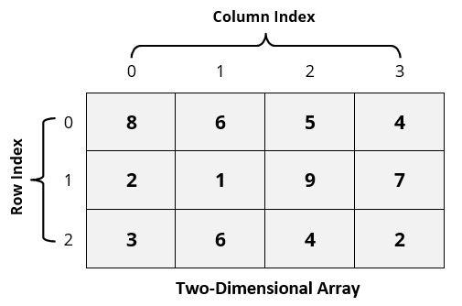](https://i2.wp.com/www.guideforschool.com/wp-content/uploads/2013/11/two-dimensional-array-memory-address-calculation.jpg) 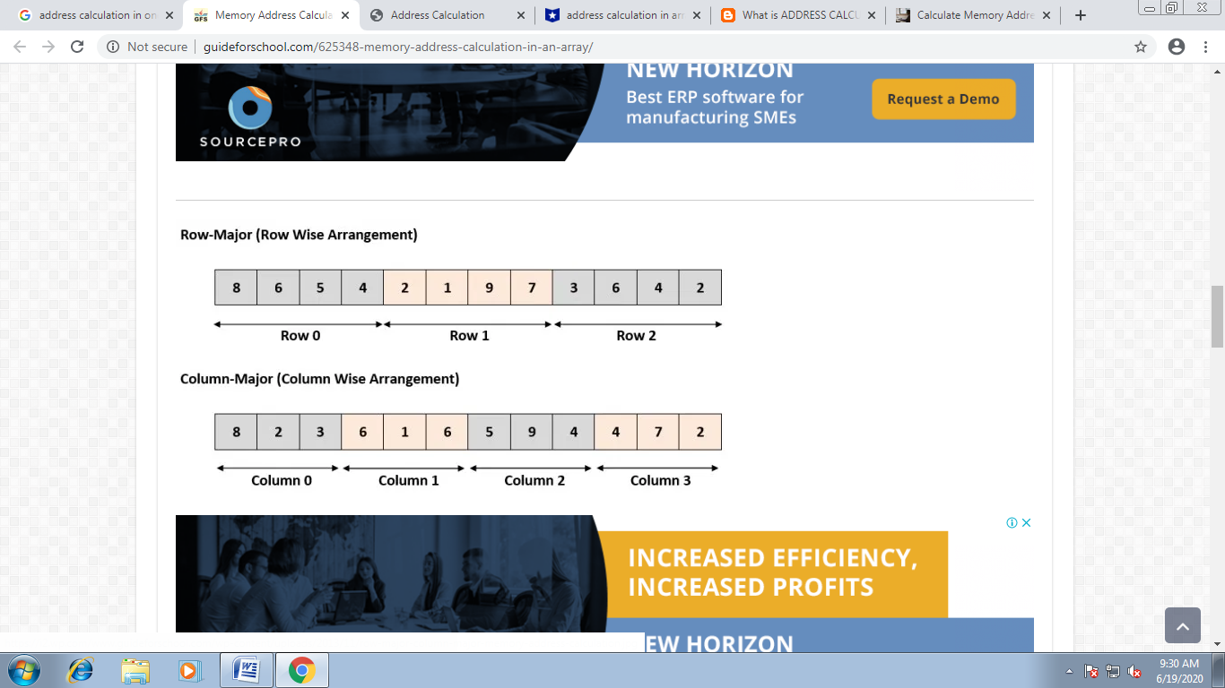

Address of an element of any array say “**A[ I ][ J ]**” is calculated in two forms as given:

(1) Row Major System (2) Column Major System

**Row Major System:**

The address of a location in Row Major System is calculated using the following formula:

**Address of A [ I ][ J ] = B + W * [ N * ( I – Lr ) + ( J – Lc ) ]**

**Column Major System:**

The address of a location in Column Major System is calculated using the following formula:

**Address of A [ I ][ J ] Column Major Wise = B + W * [( I – Lr ) + M * ( J – Lc )]**

Where,  
**B** = Base address  
**I** = Row subscript of element whose address is to be found  
**J** = Column subscript of element whose address is to be found  
**W** = Storage Size of one element stored in the array (in byte)  
**Lr** = Lower limit of row/start row index of matrix, if not given assume 0 (zero)  
**Lc** = Lower limit of column/start column index of matrix, if not given assume 0 (zero)  
**M** = Number of row of the given matrix  
**N** = Number of column of the given matrix

**Important :** Usually number of rows and columns of a matrix are given ( like A[20][30] or A[40][60] ) but if it is given as **A[Lr- – – – – Ur, Lc- – – – – Uc]**. In this case number of rows and columns are calculated using the following methods:

Number of rows (**M**) will be calculated as = **(Ur – Lr) + 1**  
Number of columns (**N**) will be calculated as = **(Uc – Lc) + 1**

**Examples:**

**Q 1**. An array X [-15……….10, 15……………40] requires one byte of storage. If beginning location is 1500 determine the location of X [15][20].

**Solution:**

As you see here the number of rows and columns are not given in the question. So they are calculated as:

Number or rows say **M = (Ur – Lr) + 1** = [10 – (- 15)] +1 = 26  
Number or columns say **N = (Uc – Lc) + 1** = [40 – 15)] +1 = 26

**(i) Column Major Wise Calculation of above equation**

The given values are: B = 1500, W = 1 byte, I = 15, J = 20, Lr = -15, Lc = 15, M = 26

Address of A [ I ][ J ] = B + W * [ ( I – Lr ) + M * ( J – Lc ) ]

= 1500 + 1 * [(15 – (-15)) + 26 * (20 – 15)] = 1500 + 1 * [30 + 26 * 5] = 1500 + 1 * [160] = 1660 **[Ans]**

**(ii) Row Major Wise Calculation of above equation**

The given values are: B = 1500, W = 1 byte, I = 15, J = 20, Lr = -15, Lc = 15, N = 26

Address of A [ I ][ J ] = B + W * [ N * ( I – Lr ) + ( J – Lc ) ]

= 1500 + 1* [26 * (15 – (-15))) + (20 – 15)] = 1500 + 1 * [26 * 30 + 5] = 1500 + 1 * [780 + 5] = 1500 + 785  
= 2285 **[Ans]**