OBJECTIVE

The Internet of Things (IoT) is known to play a critical capacity in regular daily existence the entire way through inescapable sensor correspondence networks that epitomize our general climate. Such framework is gives the plan capacity to screen fundamental actual occasions produced information that can be moved and put away in the cloud from which it is feasible to share this data by means of utilization and choice is made to make a move for a happened occasion. Ecological Monitoring framework uses sensors for encompassing area moistness and temperature. These information could be used to animate transient conduct like gadget becoming hot or getting cool down and other long haul insights of the gadgets. The detected information will be sent to cloud space, and the cloud is gotten to by a Smartphone application and results are introduced to end clients. The review is done the sort sensors, microcontroller and its ability, investigation of various kind's economical organization arrangement for ceaseless information assembling and checking. Different instruments used to investigate the information put away on the cloud.

KEYWORDS: Arduino, sensors, cloudstorage, IOT

INTRODUCTION

The Internet of Things (IoT) is set to modernize our environment by letting us to control and monitor essential phenomenon in our surroundings via using devices capable of capturing data, evaluating and wireless transmission of information to storage server, like the cloud, which collects, assesses and provides these data in a meaningful way. From the cloud this information can be obtained, based on appropriateness and demands, via numerous front end user interface design such as mobile and web applications. The Internet strikes at the heart of this transition and plays a big part in secure, effective, and fast transmitting data between fog and applications and end users. The definition of a traditional end user or server in the Internet is changed in this new paradigm and hosts consist of the devices or objects therefore the term Internet of Things. The "devices and sensor" will detect and transmit data such as temperature, pressure, humidity, sound, emissions, object tracking, vitality of the patient. Environment aspects tracking is an important IoT system that mainly includes data collection through the sensing system, as well as reviewing this data for successful short-term measures such as remote management of heating or cooling devices and long-term data interpretation and observations. The Internet of Things (IOT) has proven extremely successful and is expanding rapidly in all fields. Automated monitoring system will control and monitors by using the data processing micro - controller, data gathering sensors, and wireless data transmission sensor network. Nodes have sensing and transmission/ receiving capabilities on the wireless sensor network. Largenumber sensor nodes are either randomly fix on the confined area or are based on the structure defined. This paper focuses mainly on the diverse wireless sensor network issues considering such as higher energy consumption in the sensor nodes leads to node failure after some communications, reduction in data transfer rate causes network suffering, network destabilization leads to loss of data, long-range data transfer may result in even more energy, number of nodes can increase node traffic

METHODOLOGY/COMPONENTS

- Materials/Components

1. Arduino UNO
2. 10WATT1K
3. L293D
4. LDR
5. LED-RED, YELLOW
6. LM35
7. MOTOR
8. POT-HR
9. RELAY
10.ULN2003A

- Arduino UNO --

Arduino is an opensource physical programmable microcontroller board, it is also referred as a software , or IDE i.e. Integrated Development Environment which is connected through B type USB and it runs on the specific connected PC and also it allows to write and upload the code to that circuit, it has sets of computerized I/O sticks which is interfaced to some sheets called as development sheets or safeguards, this sheets had 14 I/O pins, it has working voltage of 5V and 7-12V input voltage.

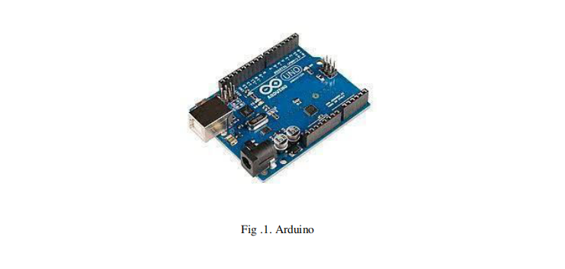

- 10WATT1K --

Resistors in circuit are the passive two-terminal electrical components, here are 1 * 1K ohm 10 Watt wire wound resistor.
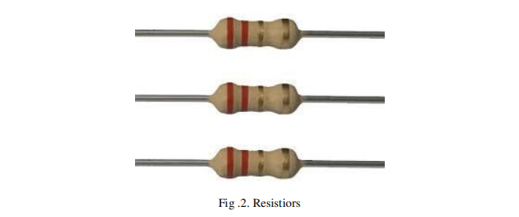

- L293D --

It is a popular 16 pin Motoar Driver IC, i.e. simultaneously drives two DC motors in direction and it receives signals from microprocessor and then transmits the relative signals to motor driver and it has two voltage pins like h bridge circuit with two channels with voltage range 4.5V to 36V.

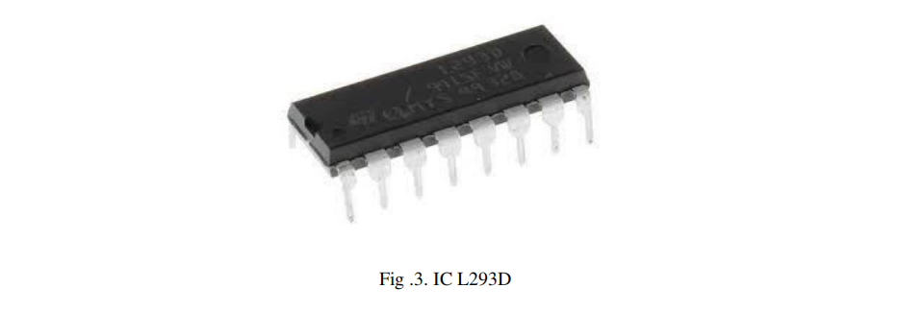
- LDR --

It is a variable resistor which varies according to the intensity of light falling on it.

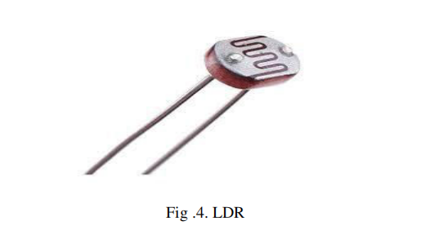

- LED-RED, YELLOW --

Used as indicator lamps, replacing small incandescent bulbs, they are of low intensity.
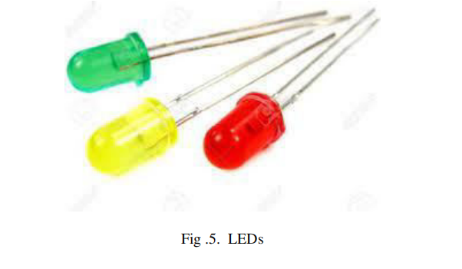

- LM35 --

It is used to measure temperature with an electrical output and in the immediate surroundings of the sensor and here output is an analog voltage.
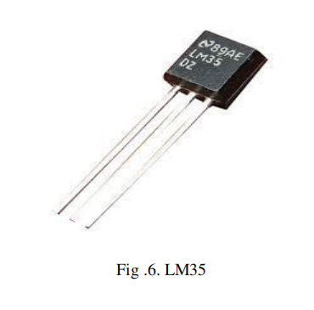

- MOTOR --

It is connected in a way to control spinning direction of DC motor and control speed and also acts as interface.

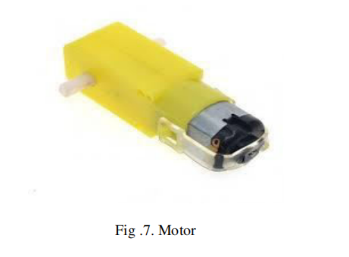
- POT-HR --

It provides a varying amt of resistance by passing voltage through it.
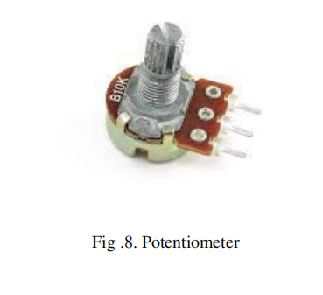

- RELAY --

It uses 5v which is outputted from an arduino pin which acts as a electrical switch.

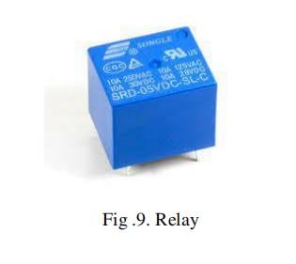

- ULN2003A --

It is a array or 7 NPN Darlington transistors and it capable of 500mA - 50V output.

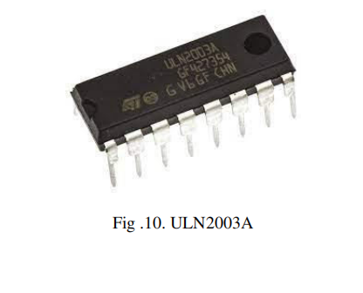

B. Tools:

1. Proteus circuit simulator
2. Windows
3. Arduino IDE

Every part is associated with the necessary force of +5V. LM35 temperature sensor, a cooling fan, motor, LED are furthermore connected with the Arduino.
Temperature sensor recognizes the level of temperature, if it goes high DC fans gets on and at the point when the temperature goes low Without light, the LDR sensor resources and the bulb starts shining. By this way it will end up being easy to screen and control the system.

At the moment when the temperature goes beyond threshold signal is sent to turn on the fan with the temperature magnitude like Its HOT Turn On the FAN, 31.25 *C, when the temperature goes to the conventional level, the temperature sensor detects the temperature and sends the signal to stop the fan. LDR sensor assesses light power. When sensor detects brightness beyond threshold then it sends the message to turn off the light LED, and vice versa. It gives message like Its BRIGHT turn OFF the LED. Moisture sensor senses the soddenness if it passes beyond threshold it sends message to turn off the pump and vice versa. It prints message on the virtual window Water level is low , turn ON the PUMP.

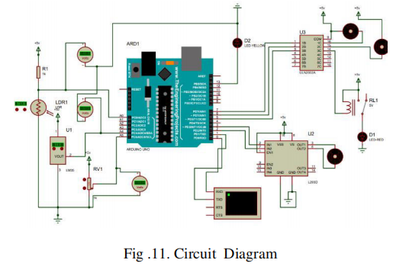
RESULTS AND DISCUSSION

Results are shown in the virtual window.
It shows both the monitored results and controlling signals along with the measures of temperature, brightness and water level.
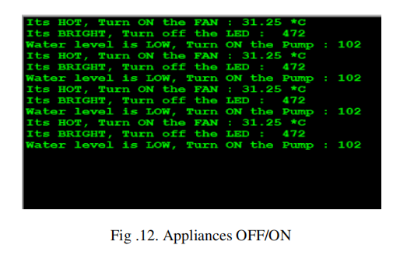
The project does have its limitations too.As it was a software semester, we couldnt convert the project into a real life project and couldnt come up with the necessary circuit offline.
Other issue with the project is power consumption may drain out the power supply attached to the arduino.Often in reality the arduino is seen to not handle so many sensors at one time.
In our design we have used common ground configurations for all sensor and arduinoconnections,which is not always physically safe.
Working with all these Sensors can be tricky as arduino gives priority to the first sensor being called in its code and this may have a cascading effect if that particular sensor fails.

IoT sending in shrewd climate applications may in any case confront various difficulties related to recognizable proof, information investigation, addressing security issues and giving interoperability ability among different kinds of climate depend perspective. However these troubles, it has more chances to add effect on the IoT markets and offer the bearing of future worldwide tasks in many portions of the climate.

CONCLUSION

Essentially, in this paper we focus on the past proposed strategies where we see that there are many examination openings that should be talked about. The paper tends to water wellbeing, air pollution, ecological observation, radiation location, synthetic defilement, normal risk, ranch guideline, squander the executives, etc. In smart Climate, IoT could likewise oversee and break down the ecological stream attributes on the both water, air and anticipated alterations which can trigger any human , creature and plant issues. Moreover, IoT plays a vital job in overseeing ecological harm, regular and non-catastrophic events, just as in controlling vegetation bosses in the climate.

