READ-ME TEXT FILE
This project consists of three parts, each implementing low-level system functionalities using direct system calls. The modifications are strictly limited to part-1.c, part-2.c, and part-3.c files
Part 1 - Basic System Calls and User Interaction
Overview
This part implements basic system call wrappers for read, write, and exit. It also includes helper functions to read a line of input and print output. The program continuously reads user input, prints it back, and terminates when the user enters "quit".
Modified/created file- part-1.c
Execution Flow
- The program starts by printing a prompt.
- It reads user input line by line using readline().
- If the input is "quit", the program terminates using exit(0).
- Otherwise, it prints back the input using print() and continues.
Tested Cases-
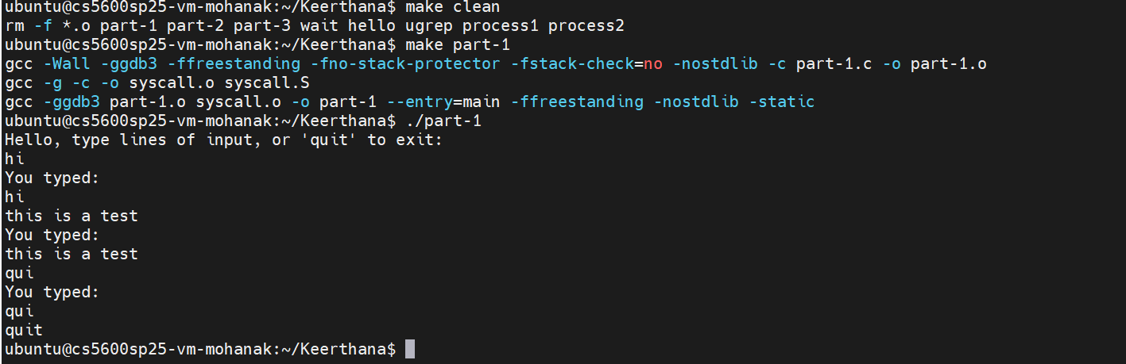

Part 2 - ELF Loader and Execution
Overview
This part implements an ELF file loader that reads and executes ELF binaries. It reads the ELF header, loads PT_LOAD sections into memory using mmap(), and executes the loaded program. It also provides argument parsing and execution handling.
Modified/created file- part-2.c
Execution Flow
- The program starts by prompting the user for a command.
- It reads input and splits it into arguments.
- If the command is "quit", the program exits.
- Otherwise, it tries to load and execute the given ELF file.
- After execution, it cleans up the allocated memory.
Tested Cases
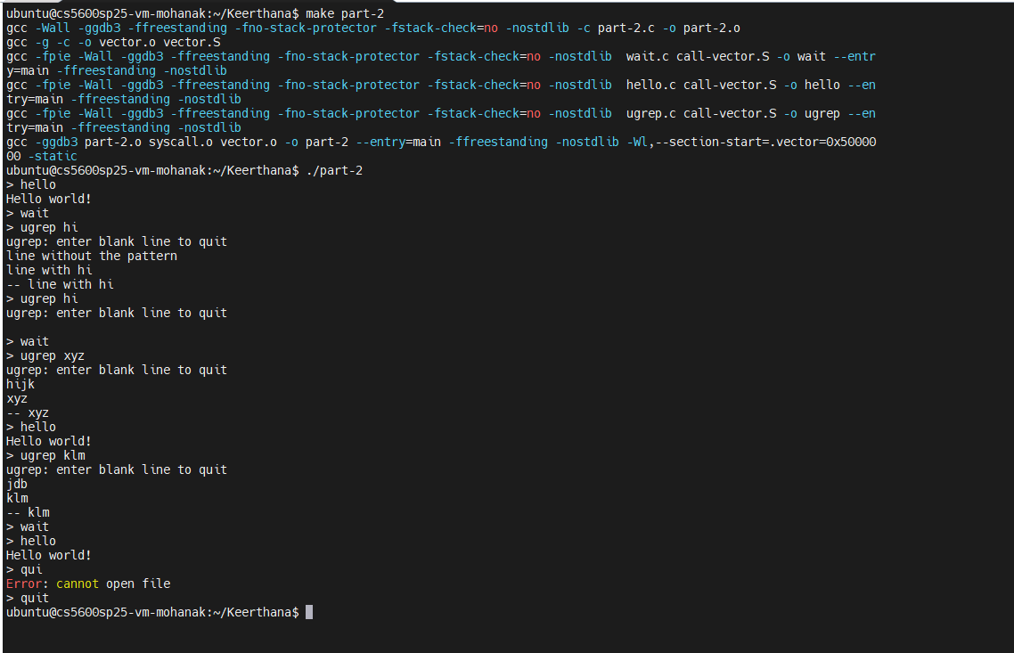

Part 3 - Context Switching and Multi-Process Execution
Overview
This part introduces context switching between multiple processes using stack switching. It sets up two processes, loads their ELF binaries, and allows them to yield execution between each other.
Modified/created file- part-3.c
Execution Flow
- The program sets up system call vector functions.
- It loads two ELF binaries (process1 and process2).
- It sets up separate stacks for both processes.
- switch_to() is used to alternate execution between processes.
- Processes can yield control to each other and eventually exit back to the main stack.
Tested Cases-
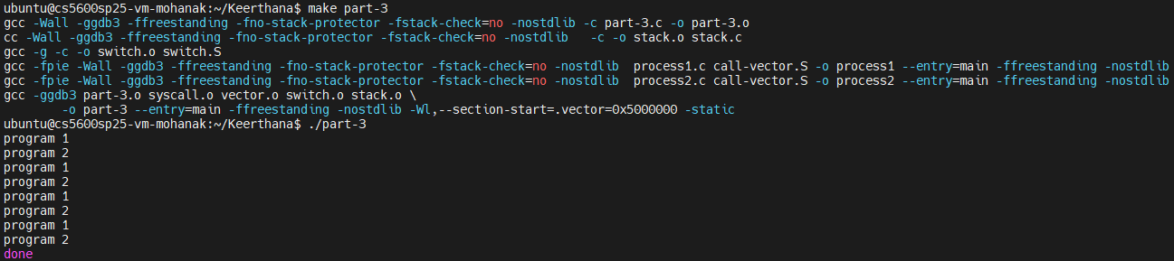
Conclusion
This project involved implementing basic system calls, handling ELF execution, and enabling process switching through context switching techniques. The changes were strictly limited to part-1.c, part-2.c, and part-3.c. The test cases implemented are included in the screenshots.

