

[Falcon - UI]

[User Guide]

**Index**

1. Falcon UI Framework
2. Environment Requirements
3. Setup Falcon UI Project
4. Understanding Project Structure
5. Understanding config. properties
6. Creating and Running Test Scripts

**1 . Falcon-UI Framework**

The Falcon UI Automation Framework is a tool for testing web applications.

This framework can be used for automating most routine processes in web application, such as:

* 1. Cross browser Testing, Execute on Local machine, remote machine(grid), Cloud (BrowserStack).
  2. Verification of different data types(Primitive and Non-Primitive).
  3. Utilities to read and write with different file formats(.xls, .xlsx, .txt, .csv, .xml).

Falcon-UI Automation framework uses the following tool and frameworks:

1. Java - Programming language

b) TestNG - Unit Framework

c) Maven - Build Management Tool

d) Selenium - Automation Tool

1. **Environment Requirements:**
2. Configure Java and Maven

* Follow the steps mentioned in the below link:
* <https://www.mkyong.com/maven/how-to-install-maven-in-windows/>

b) Eclipse IDE

* Follow the steps mentioned in the below link:
* <http://www.automationtestinghub.com/eclipse-ide-download-and-install/>

1. TestNG

* Follow the steps mentioned in the below link:
* <http://toolsqa.com/selenium-webdriver/install-testng/>

**3 .** **Setup Falcon UI Project**

Following are the steps to start Falcon-UI project for first time:

* Open **Eclipse**.
* Click on **File** menu and select **New** from given list then click on **Maven Project**.

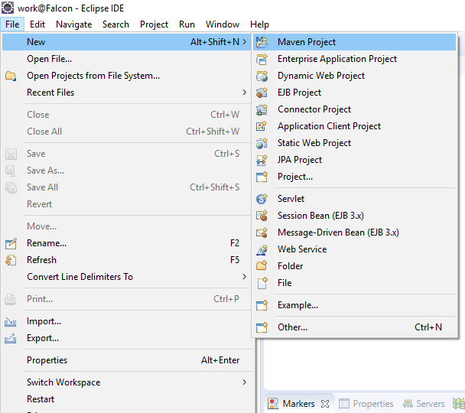

* Click **Next** under Maven Project.

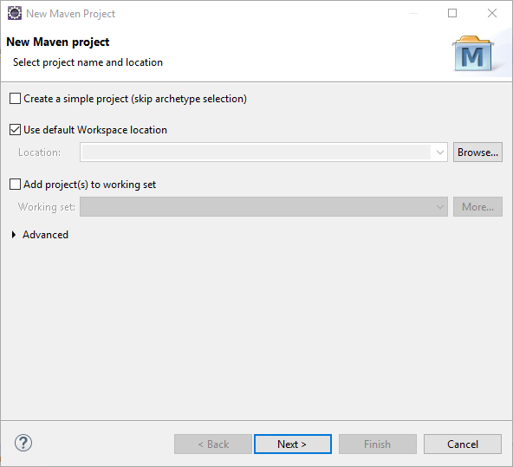

* Click **Configure**.

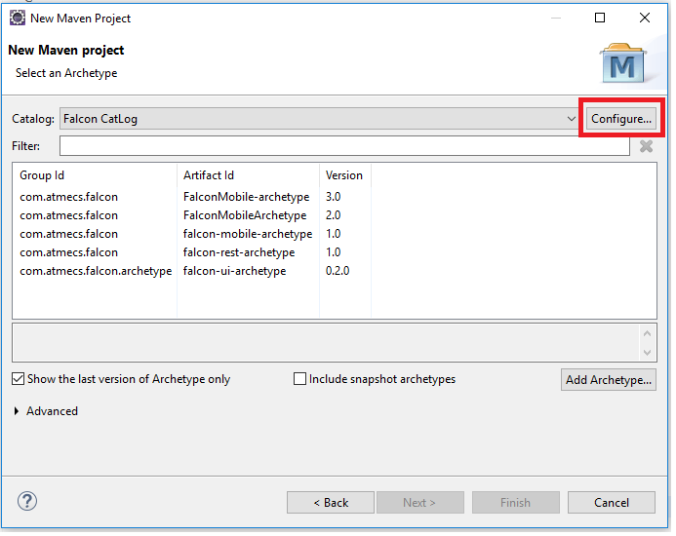

* Click on **Add Remote Catalog.**

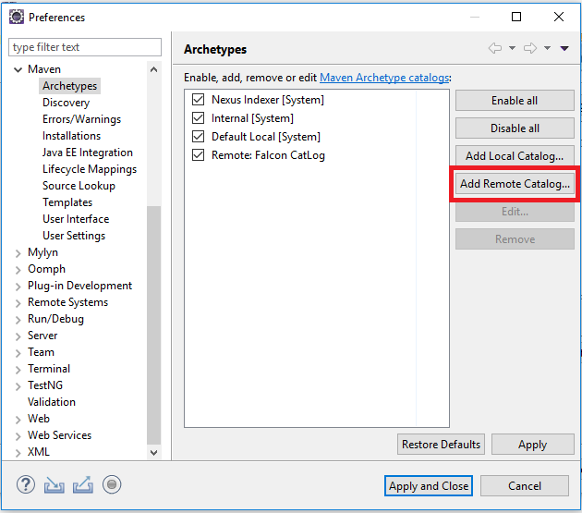

* Enter below details under **Remote Archetype Catalog** window and click Ok .

1. **Catalog File** : <http://10.10.10.150:8081/nexus/service/local/repositories/falcon/content/archetype-catalog.xml>
2. **Description** : It can be any name to identify the Catalog say Falcon-Catalog.

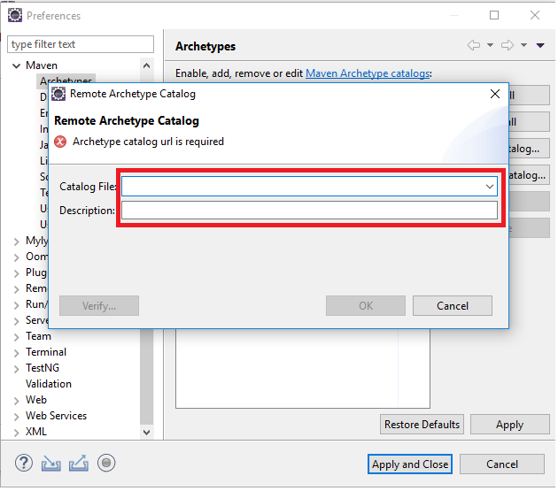

* After Adding Remote Catalog It will show as **Remote: NameWhichYouGave** on Archetypes Window
* Then click **Apply and Close** to save changes(after saving changes it will show all archetypes of falcon ).

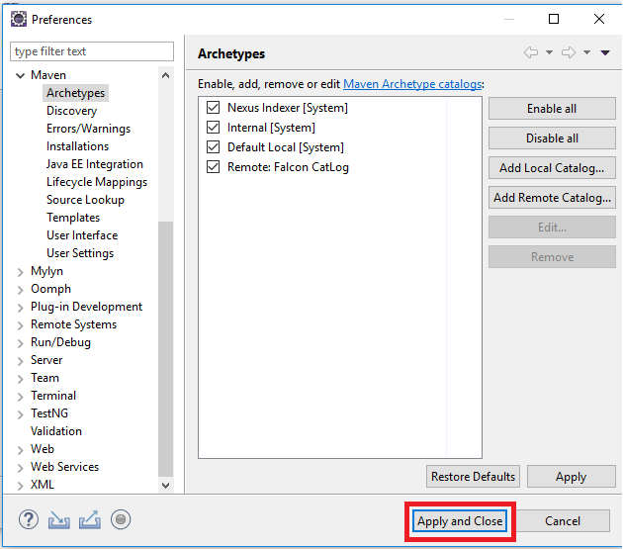

* **UnCheck** the option called “**Show the last version of Archetype only** ”(it will show you all old and new archetypes of falcon).

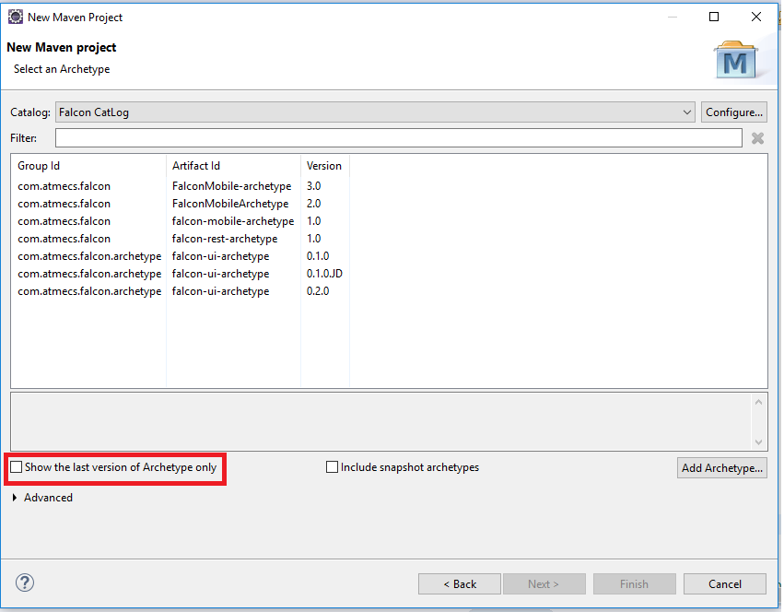

* Select **Falcon-UI Archetype** (with any version whatever we want eg . 0.1.0, 0.2.0 etc )as Archetype ID and then Click **Next**.

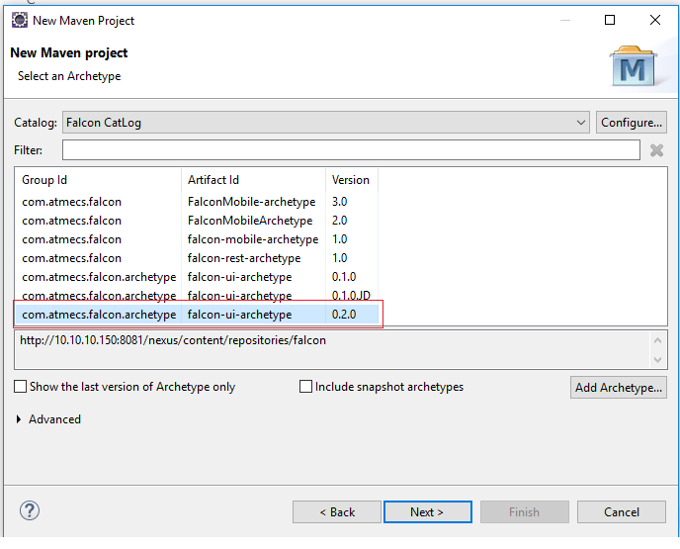

* Enter **Group Id** and **Artifact Id**, **package** and Click **Finish.**

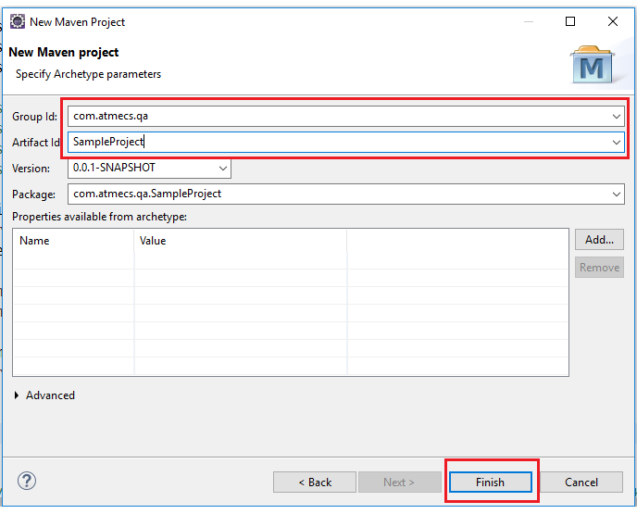

* Once project gets created You will found **project structure** as following

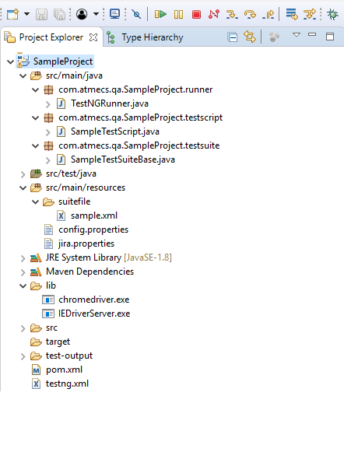

**4 . Understanding Project Structure:**

In this, we will try to explore the project folder structure.

1. src/main/java - Application/Library sources
2. src/main/resources - Application/Library resources
3. lib - Browser Executables
4. pom.xml
5. testng.xml
6. **src/main/java - Application/Library sources:**

This source folder contains packages like runner, testsuite and testscript.

The main package name follows as ***${Group Id}.${Artifact Id}***

Earlier, we have created ***Artifact Id*** as ***'falconUI'*** and ***Group Id*** as ***'com.qa.automation'***.

So Now, the package name will be ***com.qa.automation.falconUI***

For any application, if you want to add source code folder like utils, helper etc., you can very well create ***'utils/helper***' folder under ***'src/main/java/${packageName}***' and keep all your domain utils/helper under it.

* 1. **${packageName}/runner/**

This folder contains ‘***TestNGRunner.java***’ file which has the purpose to set up ***listeners***, ***suites to run*** to ***testng.xml*** and ***upload TestNG results*** (if configured, we will discuss this more detailed in Understanding config.properties)

***NOTE: Just keep this file as it is unless you don’t have any specific requirements.***

* 1. **${packageName}/testscript/**

This folder contains your actual test scripts to your application**.**

* 1. **${packageName}/testsuite/**

This folder contains Base Test Suite file for your test scripts.

1. **src/man/resources – Application/Library resources**

This resources folder contains domain specific resources and test data files.

* 1. **suitefile/**

This folder contains your application specific test suite files where you will mention test classes or packages.

Multiple suite files can be added to ***src/main/resources/suitefile/*** directory.

Path of the suite files should be added in ***testng.xml.***

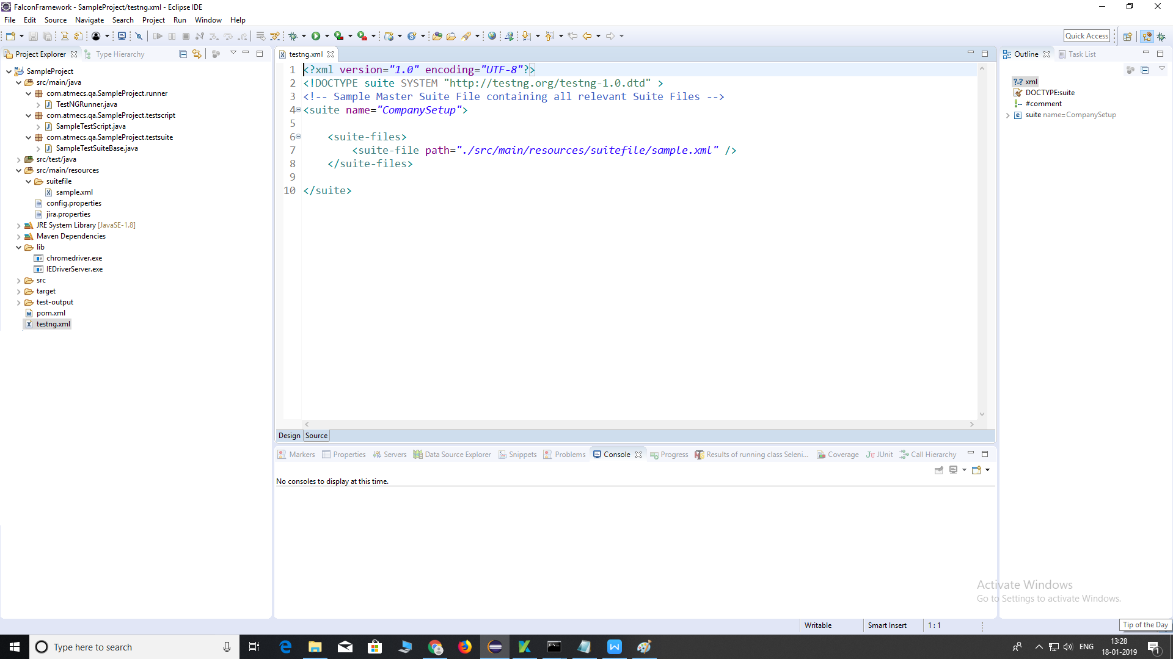

* 1. **config.properties**

This is the main entry for this project and its purpose is to set up the test environment, browser details and other configurations like bug creation, capturing screenshot and uploading testNG results.

We will discuss this file detailed in Understanding config.properties

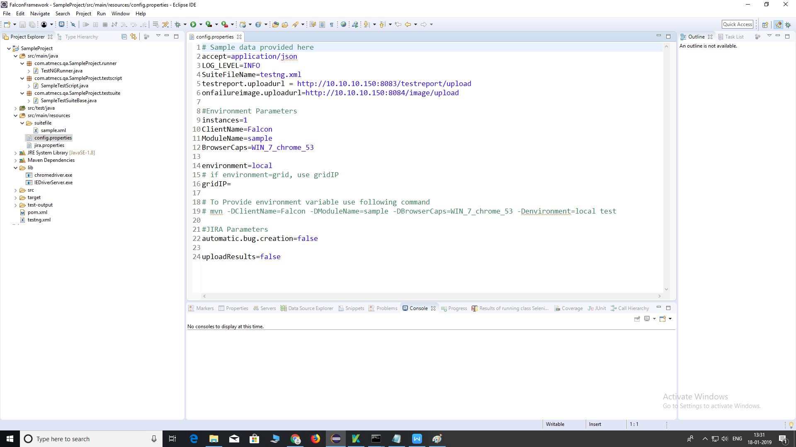

* 1. **jira.properties**

This is the file where we mention jira credentials for creation of a bug if there is any error or failure.

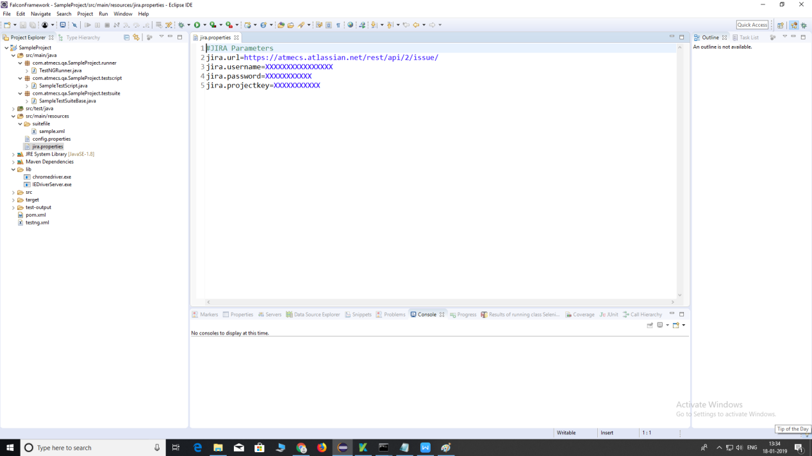

1. **lib/**

This is the folder which contains all the driver executable like ***chromedriver.exe,IEDriverServer.exe*** etc. This two drivers is provided by default. You can replace it with updated drivers and you can add gecko driver and MicrosoftEdge driver to lib folder.

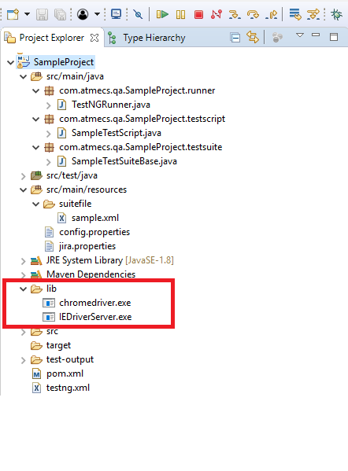

1. **pom.xml**

This is the main file where the Maven project info is stored and configured to run the test scripts, manage all the falcon and other dependencies.

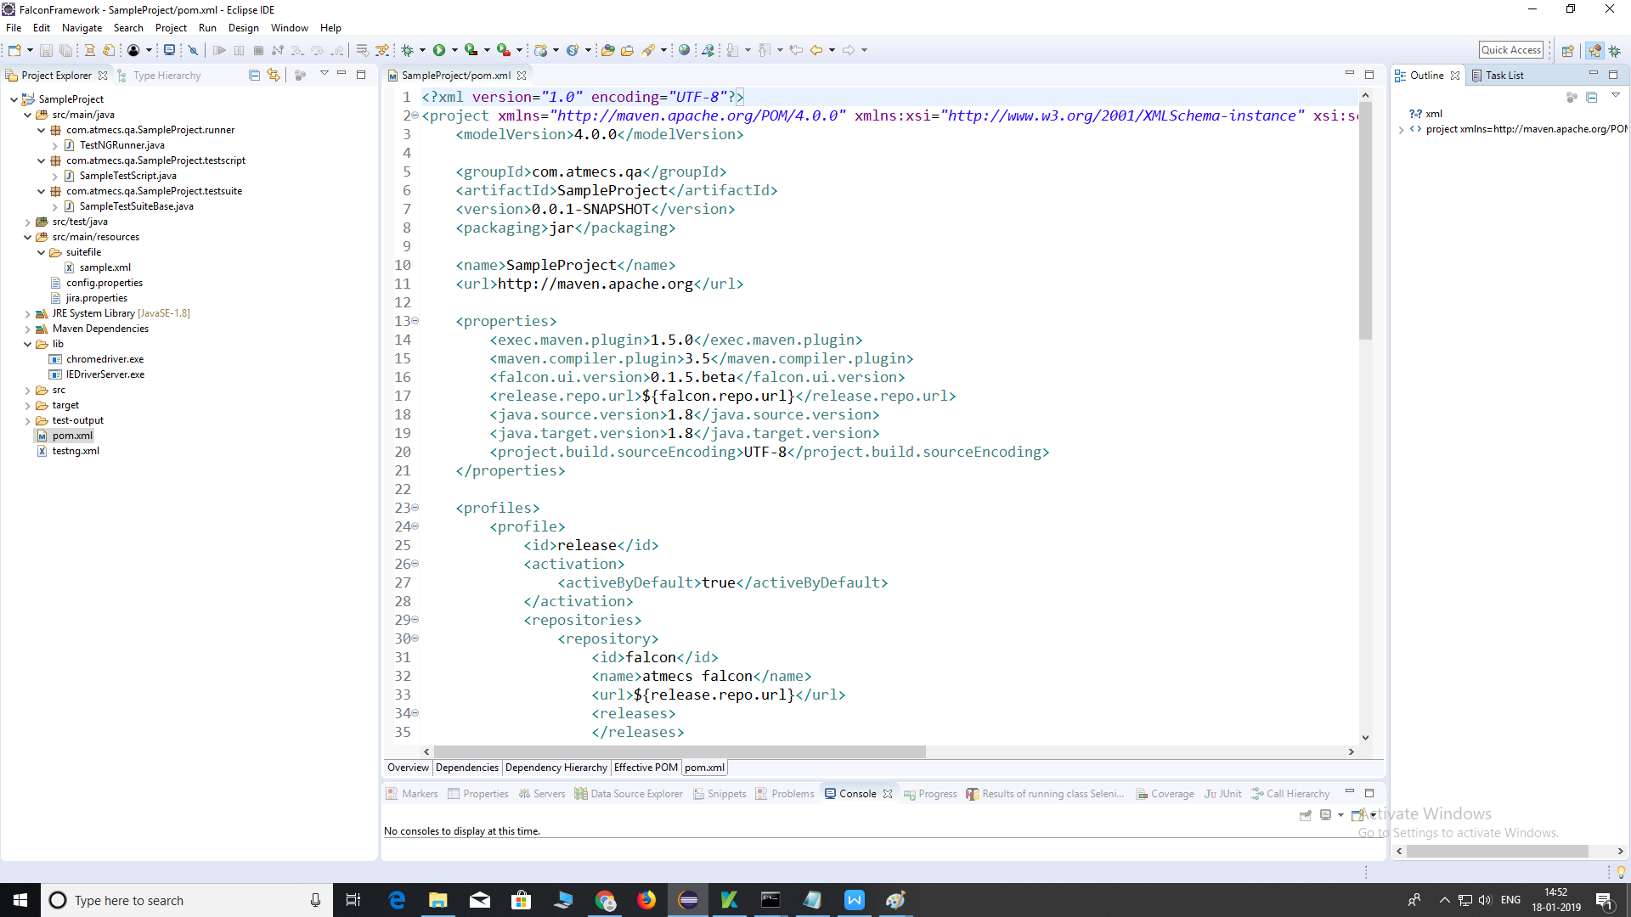

Note : If you select archetype of version 0.2.0 then you need to do changes in pom.xml file.You need to change following tabs with given values.

1. <falcon.ui.version>**0.2.0**</falcon.ui.version>
2. <release.repo.url**>http://10.10.10.150:8081/nexus/content/repositories/falcon**</release.repo.url>

Updated pom.xml will look like following:

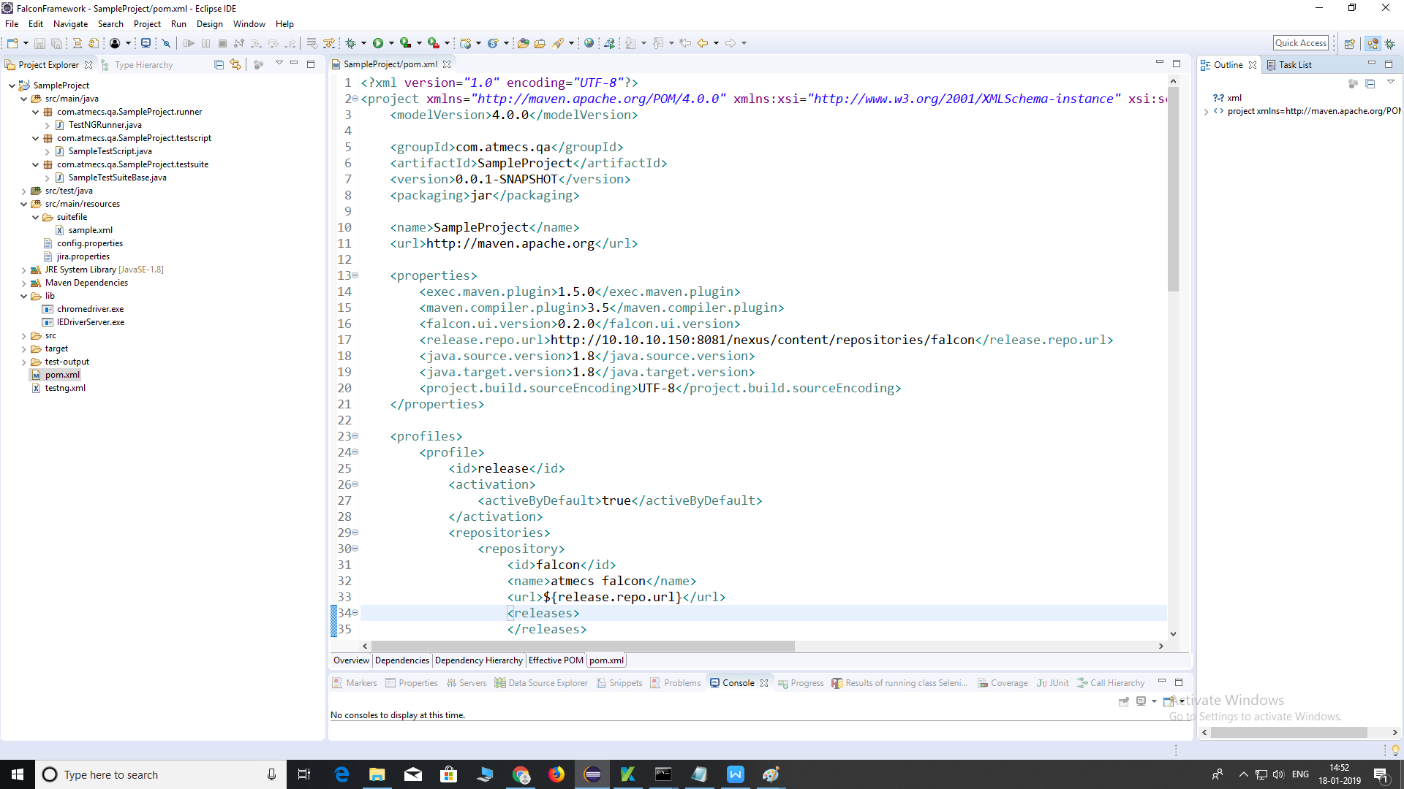

1. **testng.xml**

This is the master *.xml file where you will mention all the suite files as below:



***5*** ***.* Understanding config. properties:**

This is the main file which set up the complete test project. Here we will discuss all the main configurations one by one.

1. **SuiteFileName** – This is the property where we store the master *.xml file.

In our case, it is **testng.xml**

1. **testreport.uploadurl** – This is the property where we store the report dashboard report upload URL. In our case, it is <http://10.10.10.150:8083/testreport/upload>
2. **onfailureimage.uploadurl** - This is the property where we store the report dashboard image upload URL. In our case, it is

<http://10.10.10.150:8084/image/upload>

1. **instances** – This is the property where we store the number of parallel instances to run. It will create numbers of threads to execute script parallel.
2. **ClientName** – This is the property where we store the Client Name to identify the Report Dashboard.
3. **ModuleName** – This is the property where we store the list of suite files, comma separated, to execute. Module name is the name of the suite file which are present in ***src/main/resources/suitefile/*** without extension. To add multiple modules(suites) provide multiple ***ModuleName*** values separated by comma (,)

For Example:

***ModuleName=sample1,sample2,sampe3***

1. **BrowserCaps** – This is the property where we store the test browser details according to instances.

**Note**: To add multiple browsers provide multiple ***BrowserCaps*** value separated by comma (,).

***Supported OS***: Win, Mac, Linux

***Supported Browsers***: firefox (version<=46), chrome, ie, safari

For Example:

***WIN_7_chrome_66 (if instances as 1)***

***WIN_7_chrome_66, WIN_7_firefox_61 (if instances as 2)***

1. **environment *–*** This is the property where we store test environment details like
   1. local (for local machine run),
   2. grid (for Selenium Grid Machine run)
   3. browserstack (for Browser Stack run)
2. **gridIP *–*** This is the property where we store grid machine details. This property will be picked only when the environment is grid.
3. **automatic.bug.creation** – This is the property where we store a Boolean value to create a bug in JIRA.

If True, it will create a JIRA bug according to given properties in jira.properties

If False, it won’t create any bug in JIRA even if there is an error or failure.

1. **capture.screenshot** – This is the property where we store a Boolean value to capture a screenshot on test failure.

If True, it will capture a screenshot on test failure

If False, it won’t capture any screenshot even if there is an error or failure.

1. **uploadResults** – This is the property where we store a Boolean value to upload the results on completion of execution.

If True, it will upload the testNG results along with screenshot images (if capture.screenshot is true) and error messages if any.

If False, it won’t upload the testNG results upon completion of test execution.

1. ***Creating and Running Test Scripts:***

In this we will look how to create Test Scripts and execute them as per test requirement.

1. Creation of Test Scripts:

Create Your Test Scripts under ***testscript*** folder as shown in below.

Create a simple class in **testscript** folder.

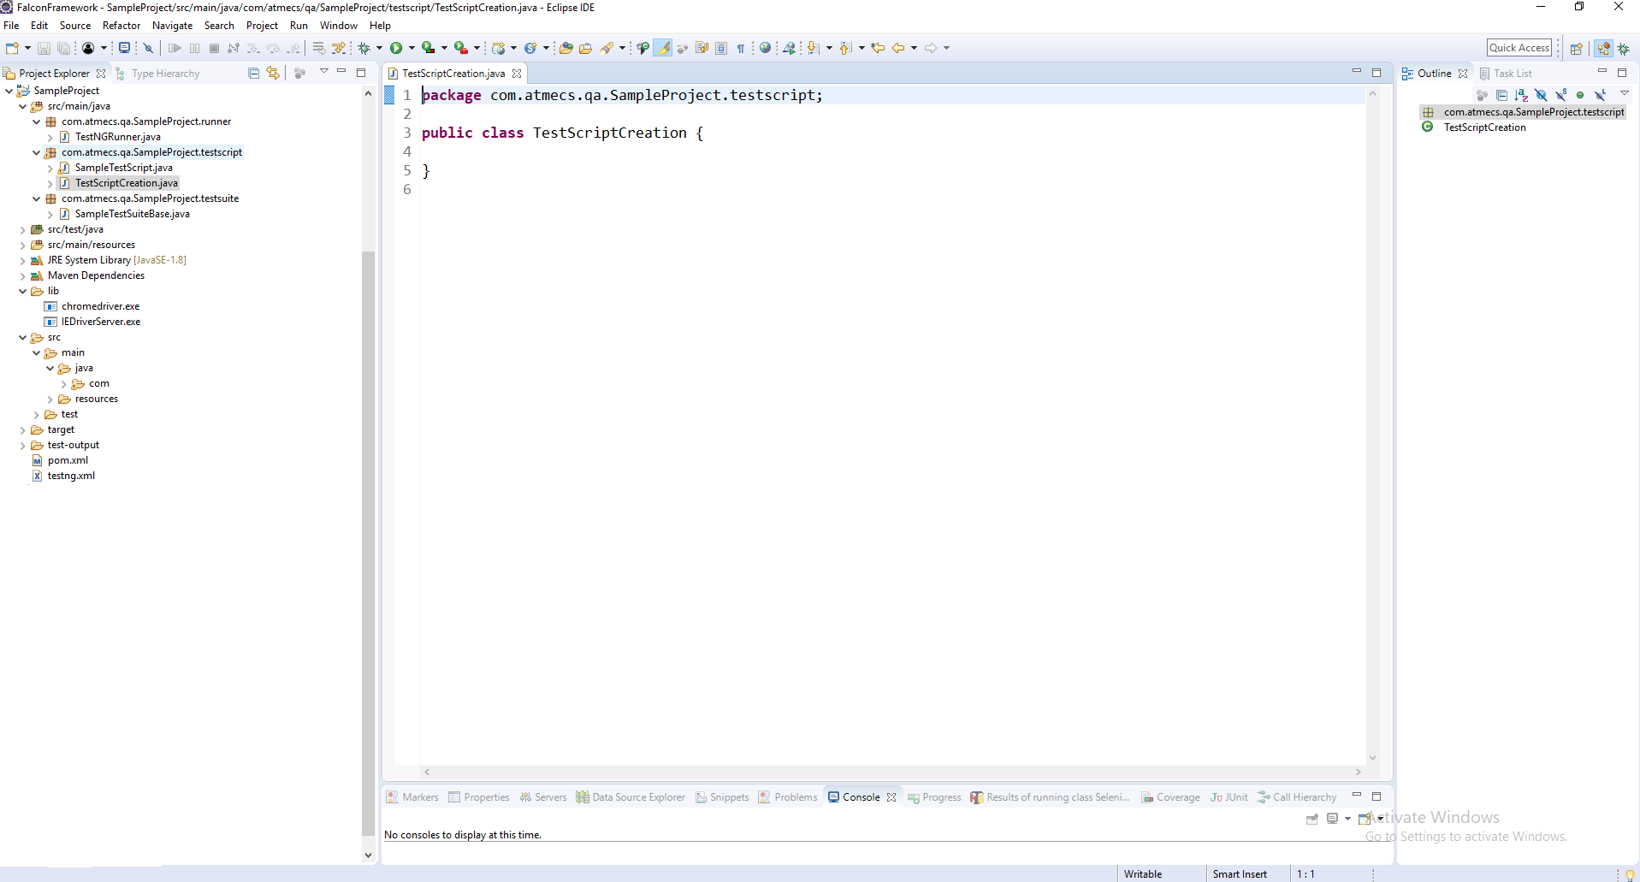

1. Adding Test Scripts to Suite File:

Create a Suite File under ***src/main/resources/suitefile*** and Add the Created Test Script to it as below:

In sample.xml we need to add class which we want to execute.

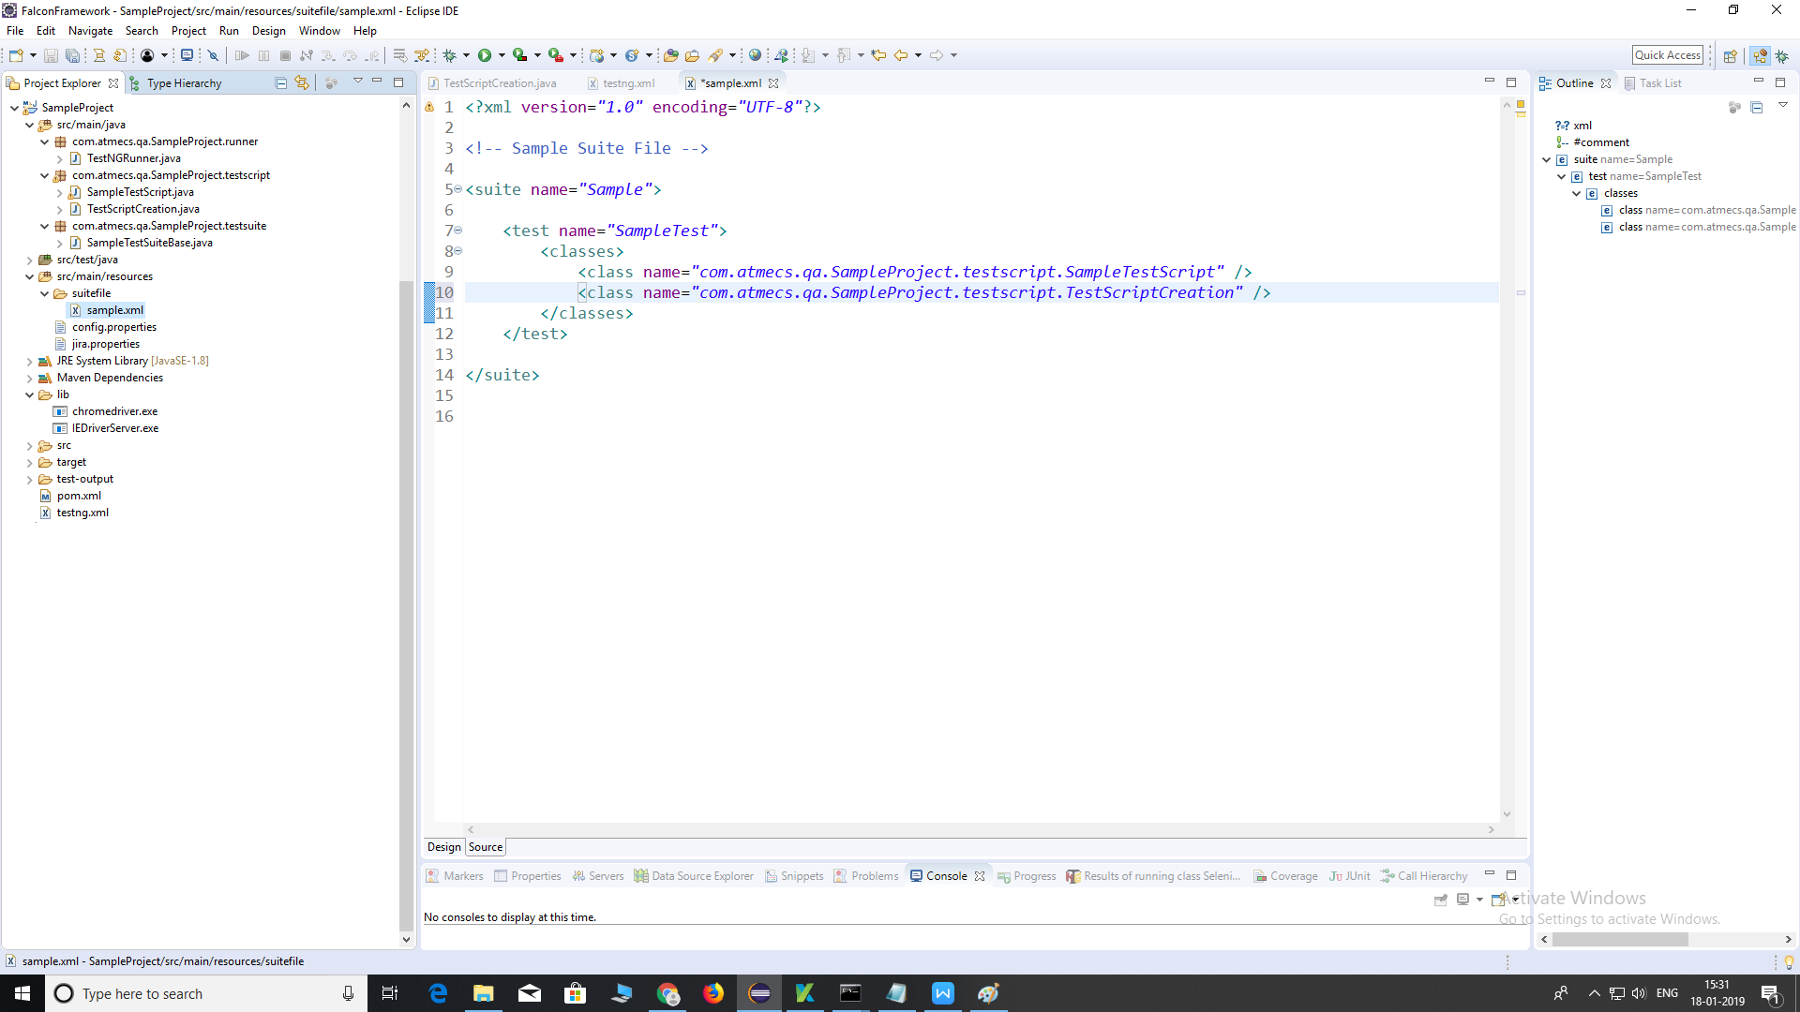

1. Adding Suite Files to testng.xml:

Add created suite files to ***testng.xml*** as below:

We can add more than one sample.xml files and this suites adds to testNG.xml file

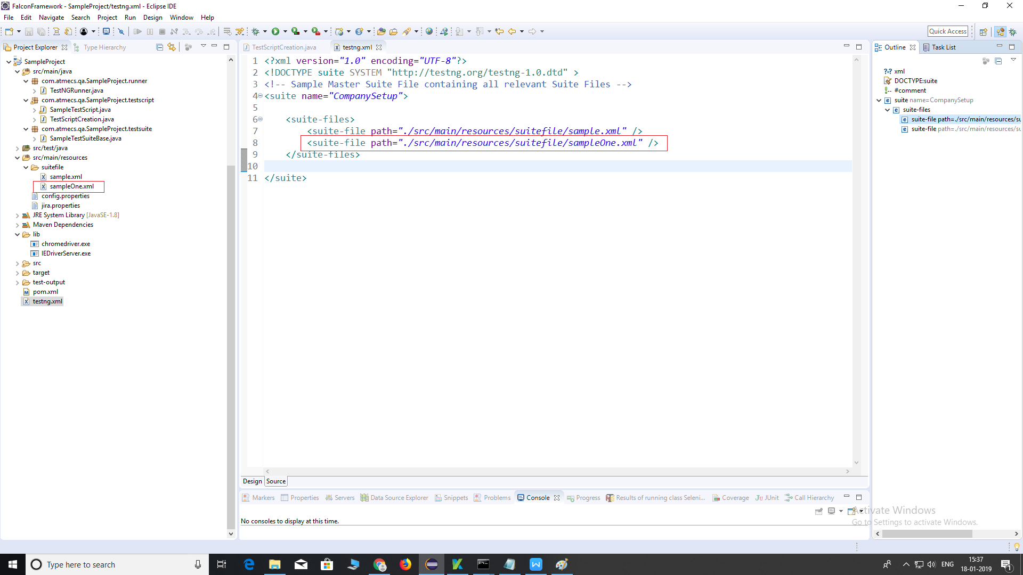

1. Setting up Test Environment in config.properties:

Configure Test Environment under config.properties as below:

Important Configurations:

1. **testreport.uploadurl** – Report Dashboard Upload URL (if uploadResults=true)
2. **onfailureimage.uploadurl** – Report Dashboard Image Upload URL (if uploadResults=true & capture.screenshot=true)

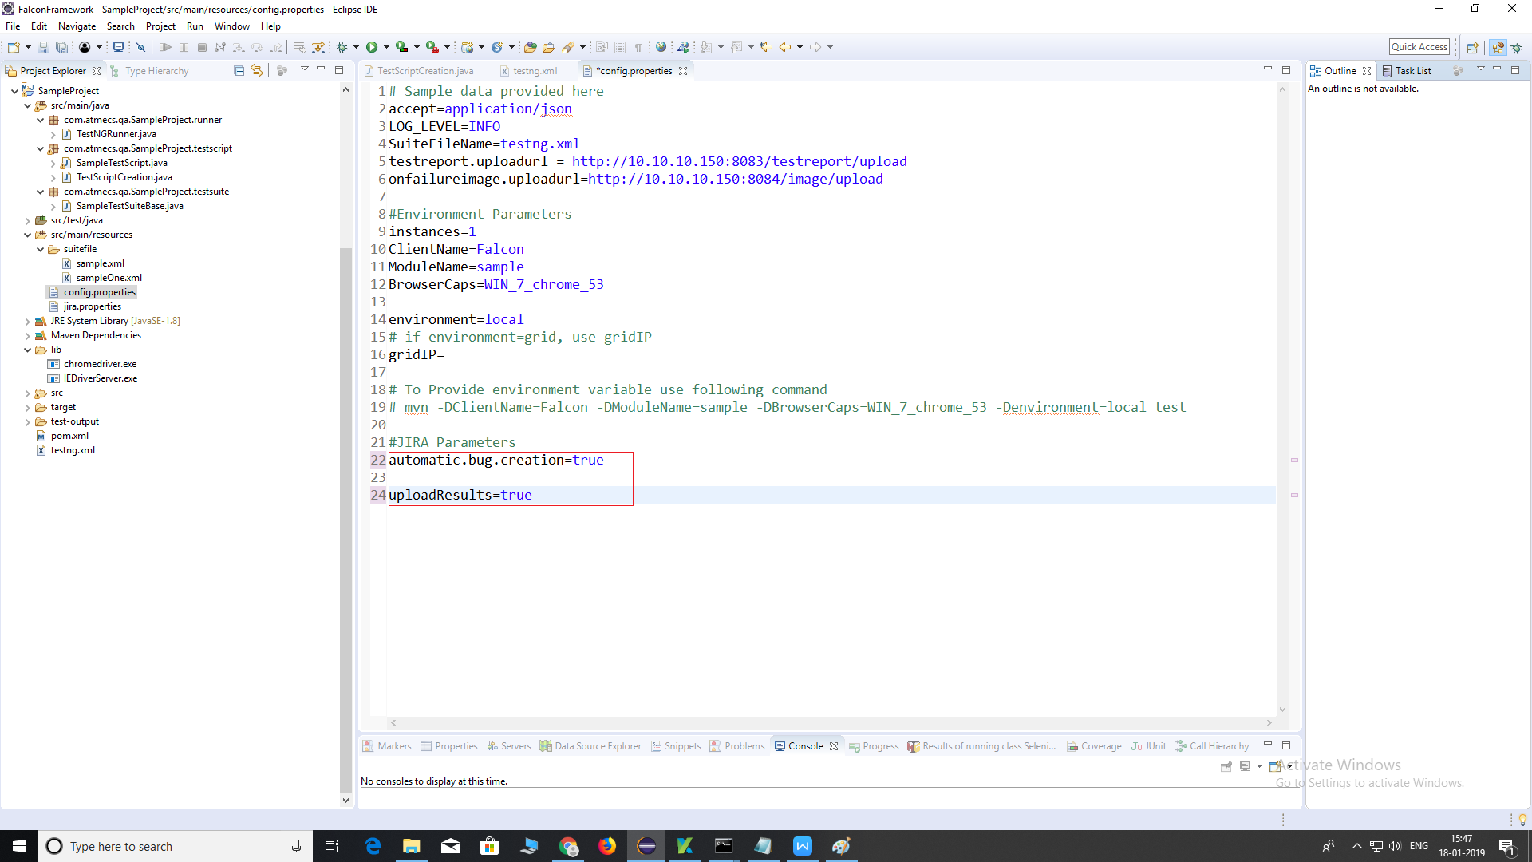

1. **instances** – Number of Parallel Test Runs (1 for Single Run, 2 for Parallel Run)
2. **ClientName** – Client Name to identify Reports under Report Dashboard
3. **ModuleName** – This is the suite files separated by comma (,) without any extension. For Example: ***demoSuite***

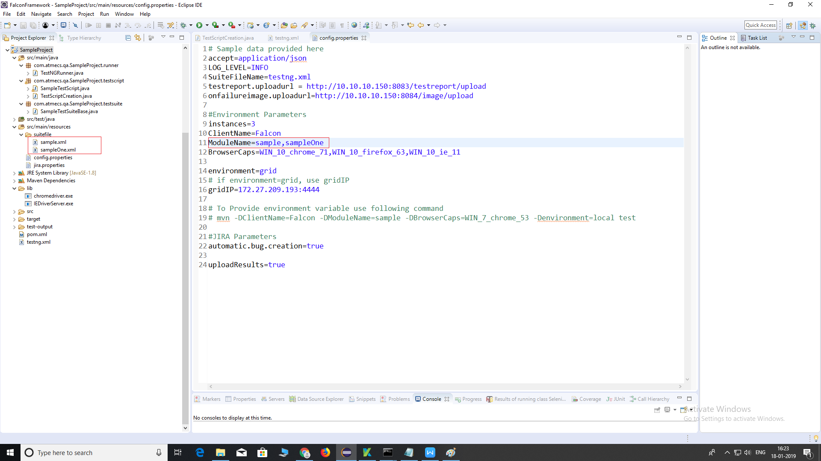

1. **BrowserCaps** – Browser and OS Details, Syntax will be

OSName_OSVersion_BrowserName_BrowserVersion

We can ‘ve multiple BrowserCaps for Parallel run when instances are more than 1.

For Example:

BrowserCaps=WIN_10_chrome_66 (when instances as 1).

BrowserCaps=WIN_10_chrome_66,WIN_10_ie_11 (when instances as 2).

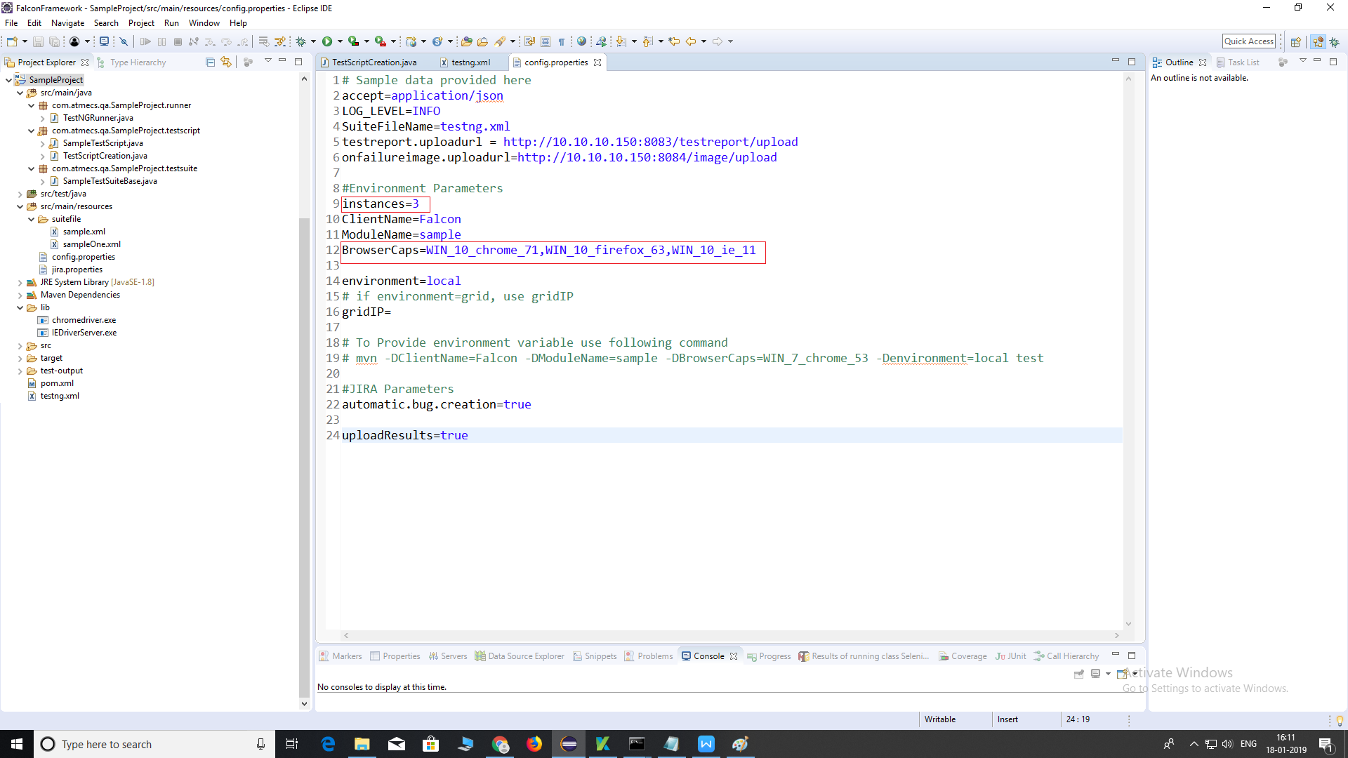

1. **Environment/gridIp** – This will work as below:

* Local – To Run in the Local Machine.
* Grid – To Run in the Grid Machine (gridIP should be mentioned).
* Browserstack – To Run in the Cloud Machine (Browser Stack).

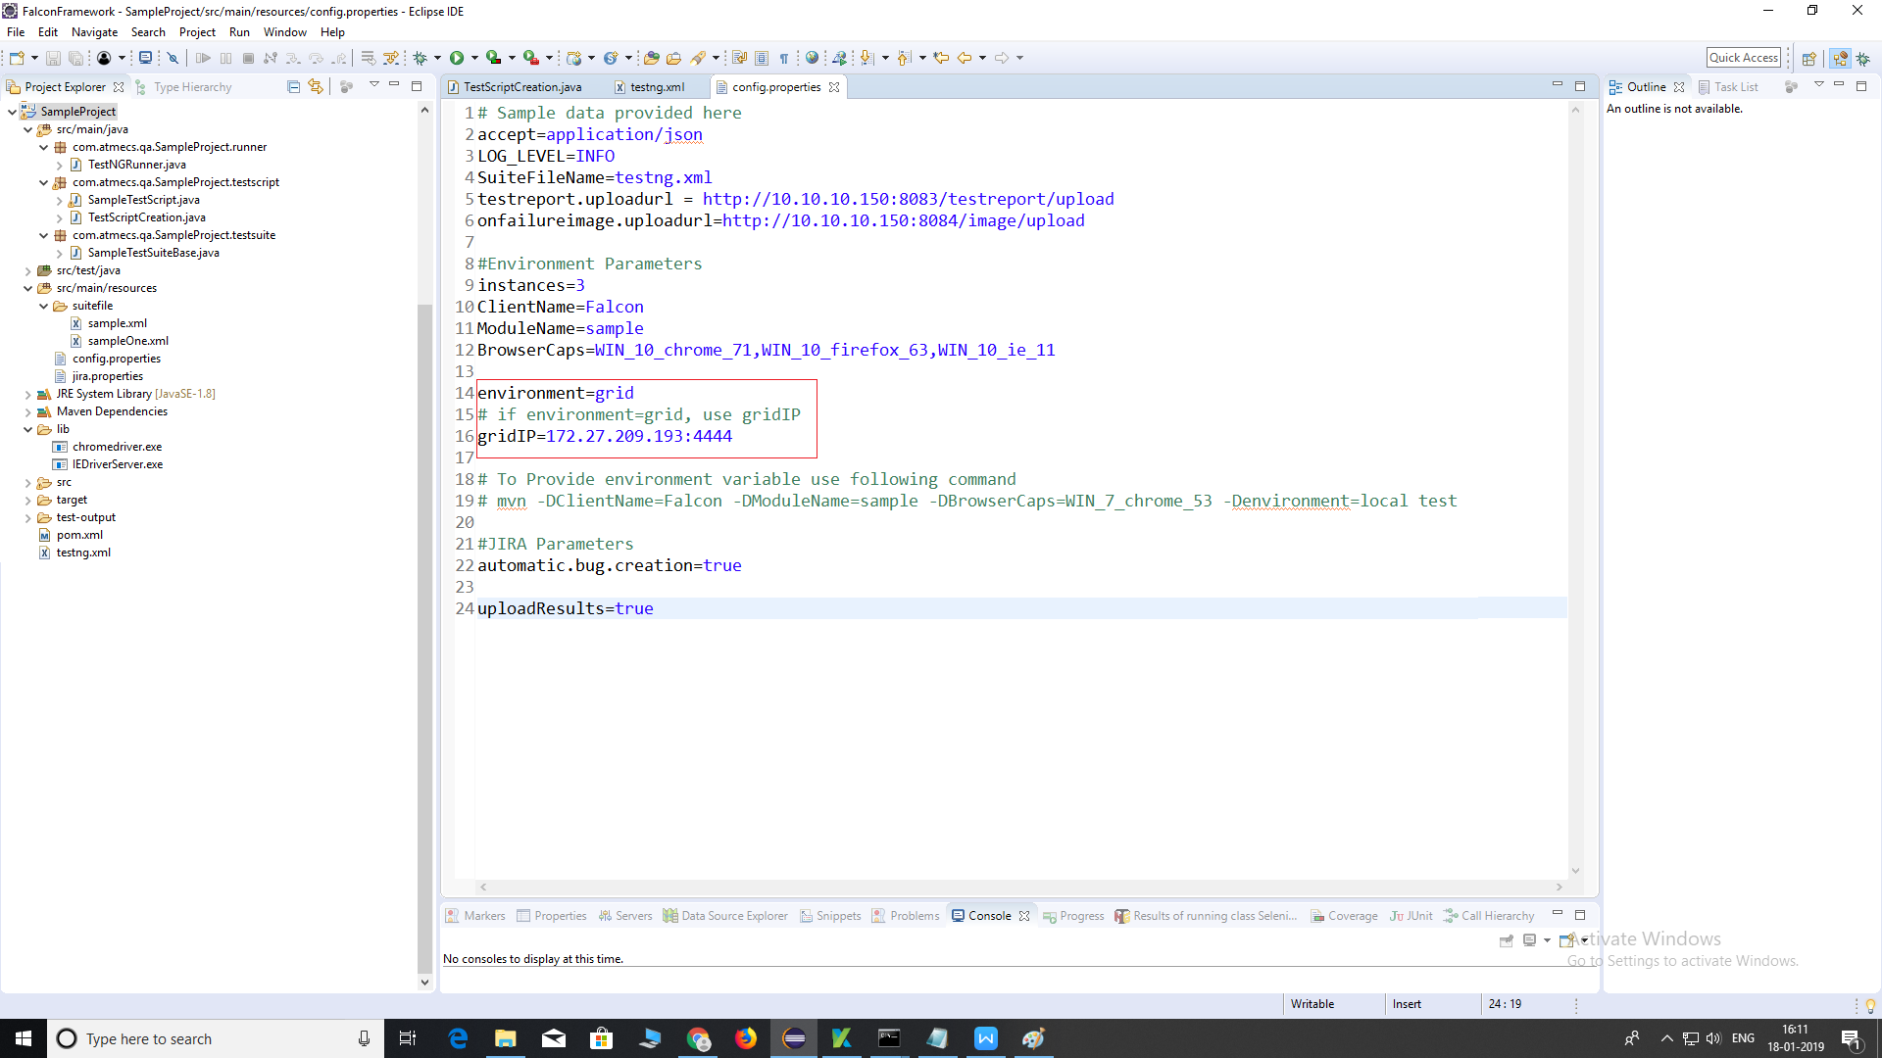

1. **automatic.bug.creation** – To Create JIRA Issues if there is an error.
2. **capture.screenshot** – To Capture Screenshot if there is an error.
3. **uploadResults** – To Upload Results to Report Dashboard.

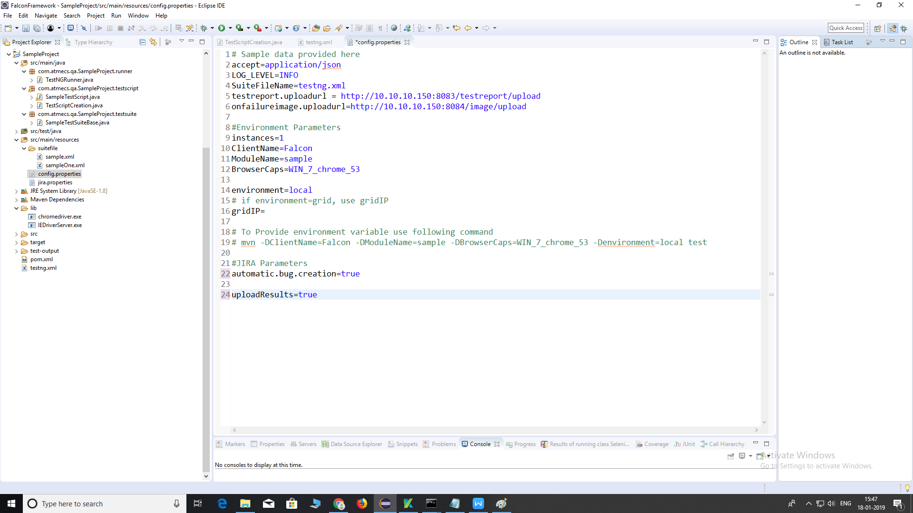

1. Running Test Scripts:

To Run the Project, Right Click on the ***Project*** and Click on ***Run as*** and then ***Maven Test*** as shown in below:

