Technical Story Card

Revision History

|  |  |  |  |
| --- | --- | --- | --- |
| Version No. | Date | Prepared by / Modified by | Significant Changes |
| 0.1 | 20-Oct-2021 | Sakthi | Draft version |
| 1.0 | 29-Oct-2021 | Sakthi | Reworked based on Review comments |
| 1.1 | 19-Oct-2021 | Sakthi | Reworked based on Review comments |

Glossary

|  |  |
| --- | --- |
| Abbreviation | Description |
| UI | User Interface |
| DB | Database |
| UML | Unified Modeling Language |
| DD | Detailed Design |
|  |  |
|  |  |

Table of Contents

1 Introduction 2

2 Scope 2

3 Non Scope of Change 2

4 Design and Detailed technical updates 3

4.1 Process model 3

4.1.1 Use case Model 3

5 Technical Architecture Diagram 4

6 Class Diagram 4

7 Sequence diagram 4

8 ER Diagram for database Design 4

9 Other Technical changes 4

9.1 CI / Build relates tasks 4

9.2 Non-functional Requirements and Design 4

10 Additional details 5

10.1 Open Questions / clarifications / Assumptions 5

10.2 Additional notes to technical team 5

11 References 5

# Introduction

Currently, most of the existing vehicle parks do not have a systematic system. Most of them are manually managed and a little inefficient This project will help the parking lot availability inside the vehicle parking is generally expressed in terms of full or empty on display board at entry of park. Every day, hundreds of vehicles enter the parking and look for empty slot inside the car park.

Inside most local parking, drivers still need to find out empty parking slot themselves. They will definitely waste a slot time for searching an empty parking slots if they do not know where they are, especially when there are only a few of empty parking slot available at each row of parking slot. Therefore, it is important to have an effective empty parking slot tracking system to display empty parking available at each row of parking slot and guide car driver to there. The development of this project prototype can act as way-finder to guide drivers inside the car park to parking slot available inside car park and guides car driver to go there through availability or by booking.

The objective of this project is to build a Vehicle Parking management system that enables the time management and control of vehicles using number plate recognition. The system that will track the entry and exit of cars, maintain a listing of cars within the parking lot, and determine if the parking lot is full or not. It will determine the cost of per vehicle according to their time consumption.

# 

# Scope

* In the modern age. Many people have vehicles. Vehicle is now a basic need.
* Everyplace is under the process of urbanization. There are many corporate offices and shopping centers etc.
* There are many recreational places where people used to go for refreshment. So, all these places need a parking space where people can park their vehicles safely and easily.
* With the help of computerized system, we can deliver a good service to customer who wants to park their vehicle into any organization’s premises.
* Vehicle parking management system is an automatic system which delivers data processing in very high speed in systematic manner.
* By using our system, they can maintain records very easily. Our system covers every area of parking management. In coming future there will be excessive need of Vehicle parking management system.

# Non Scope of Change

a) User Profile details (like Name, Age, Password, etc.).

b) Encryption and Decryption of Password stored in Database.

c) upload of data using files.

# Design and Detailed technical updates

## Process model

### Use case Model

**UI Screen Flow**

### Login

|  |  |
| --- | --- |
| Brief Description | Login |
| Basic Flow | The user will enter its credentials to login to the system and upon successful validation the user will be able to access the system |
| Alternate Flow | If the user is not register he/she needs to click on New user link to register or if user is already register and forgot his password he can reset his password by clicking on Reset password link |
| Validation | The user credentials will be validated against the database records |
| Pre-Conditions | The user must be a registered user in order to access the system. He/she must provide his/her valid email id and password. |
| Post-Conditions | The user will be able to access dashboard and he can book a slot by providing details as Location, Entry date, Exit date, Entry time, Exit time and Vehicle Number. |

**UI Screen Flow**



|  |  |
| --- | --- |
| Brief Description | Registering a New User |
| Basic Flow | 1. Click on Registration Tab 2. Enter details like Email, Name, Address, password and confirm password 3. After entering all required details click on Register button |
| Alternate Flow | If user is unable to register he/she can contact Admin in order to get registered. |
| Validation | The entered details will be validated against all the validation rules and upon successful validation user account will be successfully created. |
| Pre-Conditions | The user must fill all the details with valid data as email should be a valid email, password should be greater than or equals to 8-digit and password and confirm password should be same. |
| Post-Conditions | The user details will get stored into the database and the user will be able to login using his/her credentials. |

**UI Screen Flow**



User

|  |  |
| --- | --- |
| Brief Description | Booking |
| Basic Flow | After the user successfully logged in, the user will be able to book its parking slot by entering the details - location of parking site, entry date & time, exit date & time, vehicle number and vehicle type. |
| Alternate Flow | If user is unable to book he/she must contact with admin for booking his/her slot. |
| Validation | The entered details will be validated against the regular express of time & date, booking slot for the selected time frame is valid or not. |
| Pre-Conditions | The user will be able to access dashboard and he can book a slot by providing details as Location, Entry date, Exit date, Entry time, Exit time and Vehicle Number. |
| Post-Conditions | The user gets redirected to payment page where payment amount will calculated according to the parking duration and the type of vehicle selected. |

**UI Screen Flow**



Admin nn

|  |  |
| --- | --- |
| Brief Description | Admin Login |
| Basic Flow | At the main page select Login as Admin option. After the successful Login , admin can view all the vehicles in the parking area and can also create and delete the records. |
| Alternate Flow | If the credentials doesn’t match he/she gets an error message as “Incorrect credentials”. |
| Validation | The entered details will be validated against the credentials stored in the database. |
| Pre-Conditions | The admin must supply the correct credentials in order to access the system. |
| Post-Conditions | The admin can create new users, edit the existing users and also delete the existing users. |

**Technical Architecture Diagram**

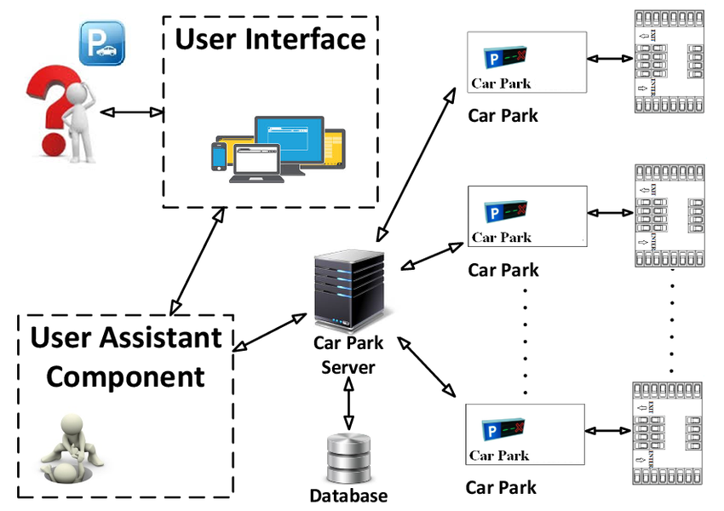

The user gets an interactive user interface through which he/she can register by providing his/her required details like Email, Name, Address, Password. As soon as the user get registered he/she has the access to login and book his/her slot for parking by providing the following details Location, Entry time, Entry time, Exit date, Exit time, Vehicle number. As the user book his/her slot he/she is redirected to price page, there he/she can select vehicle type and duration. The details of the users get stored in database and can be accessed through admin.

**Schema Diagram**

|  |
| --- |
| **New User** |
| Email |
| Name |
| Password |
| Confirm Password |
| Address |

|  |
| --- |
| **USER LOGIN** |
| Email |
| Password |
| Submit |

|  |
| --- |
| **Create/Edit/Delete** |
| Vehicle Number |
| Vehicle type |
| Entry time |
| Entry date |
| Exit time |
| Exit date |

|  |
| --- |
| **Parking** |
| Location |
| Vehicle Number |
| Entry date |
| Entry time |
| Exit time |
| Exit date |

About

Contact

Payment

Log Out

**Use Case Diagram**



Admin



User

# Class Diagram

|  |
| --- |
| Booking slot |
| * Location * Entry date * Entry time * Exit date * Exit time * Vehicle Number |

|  |
| --- |
| Price |
| * Duration * Vehicle Type * Price list |

|  |
| --- |
| Admin login |
| * Email * Password |

|  |
| --- |
| User Registration |
| * Email * Name * Address * Password * Confirm Password |

|  |
| --- |
| User login |
| * Email * Password |

|  |
| --- |
| Update Password |
| * Email * Current Password * New Password * Confirm Password |

# Sequence diagram

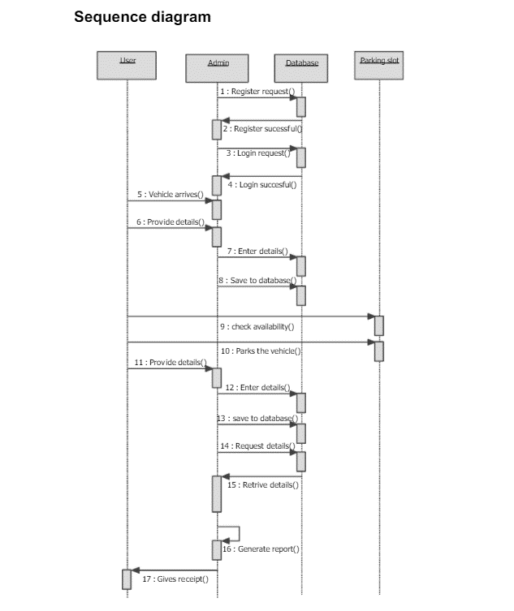

Proceed with the Payment

# ER Diagram for database Design

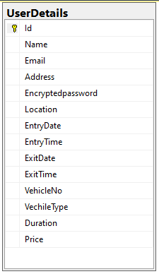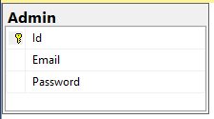

# Other Technical changes

## Non-functional Requirements and Design

1. **Usability:** This website has appropriate user interface and adequate information to guide the user in order to use the website.
2. **Portability:** The website is portable as it is online website running across the browser.

1. **Flexibility:** It is very flexible
2. **Security:** This website provides user and authentication so that only the legitimate user are allowed to use the website
3. **Maintainability:** This website is capable to secure the data and easily retrieve the data.
4. **Scalability:** These systems can further modify in future

# Additional details

## Open Questions / clarifications / Assumptions

**Assumptions:**

User Profile page is omitted from the scope because it is assumed that

most people don’t care about their profile page once they login to the

system.

## Additional notes to technical team

# References

* <https://dotnet.microsoft.com/learn/csharp>
* <https://www.w3schools.com/css/default.asp>