Technical Story Card

Revision History
Version No. | Date | Prepared by / Modified by | Significant Changes
0.1 | 20-Oct-2021 | Sakthi | Draft version
1.0 | 29-Oct-2021 | Sakthi | Reworked based on Review comments
1.1 | 19-Nov-2021 | Sakthi | Reworked based on Review comments

Glossary
Abbreviation | Description
UI | User Interface
DB | Database
UML | Unified Modeling Language
DD | Detailed Design

Table of Contents
1 Introduction 2
2 Scope 2
3 Non Scope of Change 2
4 Design and Detailed technical updates 3
4.1 Process model 3
4.1.1 Use case Model 3
5 Technical Architecture Diagram 4
6 Class Diagram 4
7 Sequence diagram 4
8 ER Diagram for database Design 4
9 Other Technical changes 4
9.1 CI / Build relates tasks 4
9.2 Non-functional Requirements and Design 4
10 Additional details 5
10.1 Open Questions / clarifications / Assumptions 5
10.2 Additional notes to technical team 5
11 References 5

Introduction
Covid-19 has put the world to a standstill. Doctors, healthcare workers and personnel of many other essential services are fighting at the frontline to tackle this global pandemic. Although we are not fighting the battle at the frontline, as a citizen this is our humble attempt at partaking in the struggle.
In this we discuss about people who get registers in our website they like to know about their health condition and status of vaccination.

This project aims to develop content in the COVID-19 modules such as
1. Registration for Testing
2.Covid Effected
3.Recovered
4.Registration for vaccination.
5.Vaccinated Members.
6.Death Members.

Scope

- Covid Tracking System is a digital platform, was created for real-time monitoring of COVID-19 which provides the people with the facility to register for vaccination, using your Mobile number or Aadhaar number or any other Identity docs.
- The system also provides details about the total infected people and the deaths reported due to this disease.
- The application aims to facilitate users to online register for vaccination from the comfort of their home and gets vaccinated to protect themselves from this infectious disease.
- The application has been made available as a digital public good for all the nations globally.
- It is a scalable, inclusive, and open platform that serves the entire public health system of a nation.
- Vaccines have proven to be a boon to the mankind and can be regarded as potential weapons against infectious diseases. With the help of our application users can easily book their slots for vaccination.

Non Scope of Change

a) User Profile details (like Name, DOB, Address, etc.)
b) Encryption and Decryption of Password stored in Database.
c) Bulk upload of data using files.

Design and Detailed technical updates

Process model

Use case Model

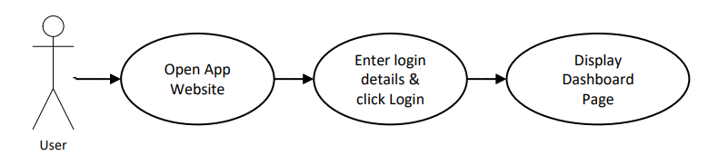
Register by providing details

User will get registered
Brief Description | Register
Basic Flow | - Click on Registration Tab  - Enter details like Name, Age, Gender, Address, Mobile Number, Aadhar Number.  - After entering all required details click on Register button,
Alternate Flow | If user is unable to register he/she can contact Admin in order to get registered.
Pre-Conditions | The user should have valid adhar card and mobile number linked with adhar card in order to register in the application.
Post-Conditions | Display Dashboard Screen

UI Screen Flow

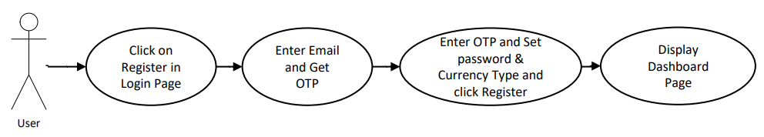
Search by Name, Adhar or Mobile Number
Covid Effected page opens

Displays a list of covid patients

Brief Description | Covid Effected
Basic Flow | - Display covid effected page  - In this page user will be able to find a list of people effected by covid using these parameters:  • Full Name  • Aadhar Number  • Mobile Number  • Effected Date
Alternate Flow | If the user is not a registered user, he/she will not be able to access the page.
Pre-Conditions | The user must be registered in order to view the list of persons who has effected with covid and displays the details of effected person’s.
Post-Conditions | User can also see number of people recovered, vaccinated members. They can find number of people died of different diseases.

UI Screen Flow

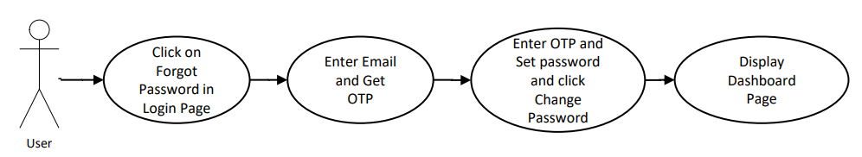
Registration for vaccine
Enter user details.
Get registered

Brief Description | Registration for vaccination
Basic Flow | - Click on Registration Tab  - Enter details like Name, Age, Gender, Address, Mobile Number, Aadhar Number.  - After entering all required details click on Register button.
Input Screen | User gets a page to enter their details
Special Requirement | NA
Pre-Conditions | In order to register for vaccination first the user must be a registered user of the application and he/she has to select the date and time slot for vaccination.
Post-Conditions | User get registered and gets a confirmation message on the registered adhar linked mobile number

Technical Architecture Diagram

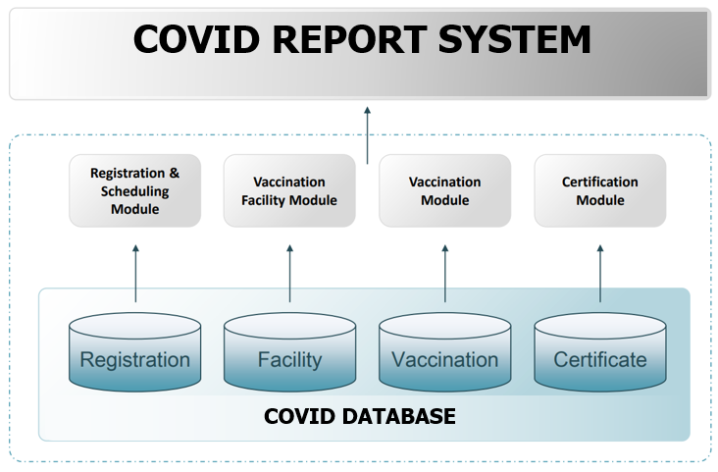

USER

USER INTERFACE

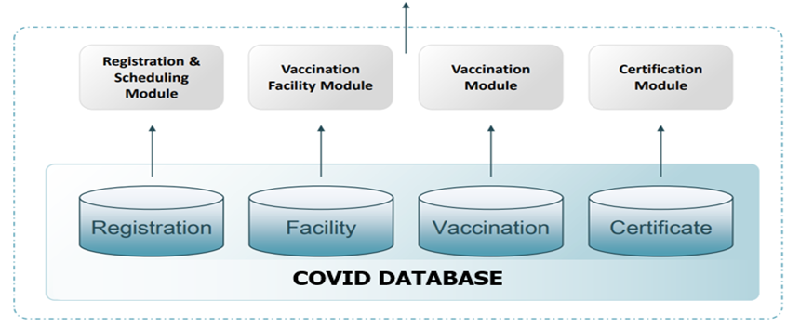

First the user should be registered to access the system, then user will be able to use the system easily with the help user interface. He/she will be able to get slots for vaccination. After getting successfully vaccinated he/she will be able to download their respective certificate.

Use Case Diagram

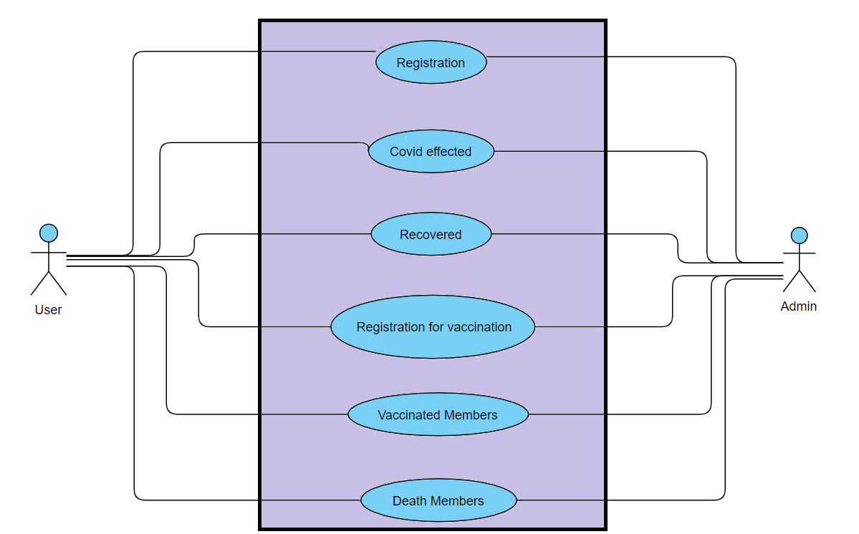

Class Diagram

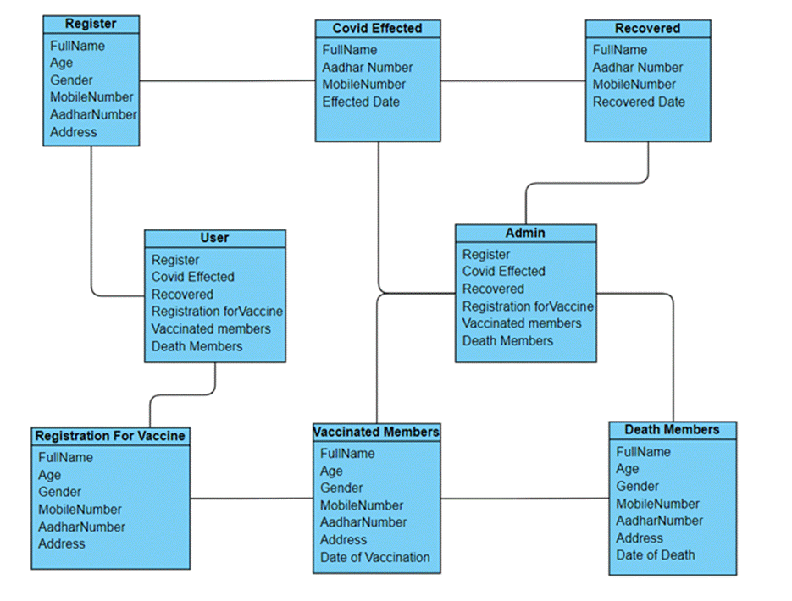

Sequence diagram

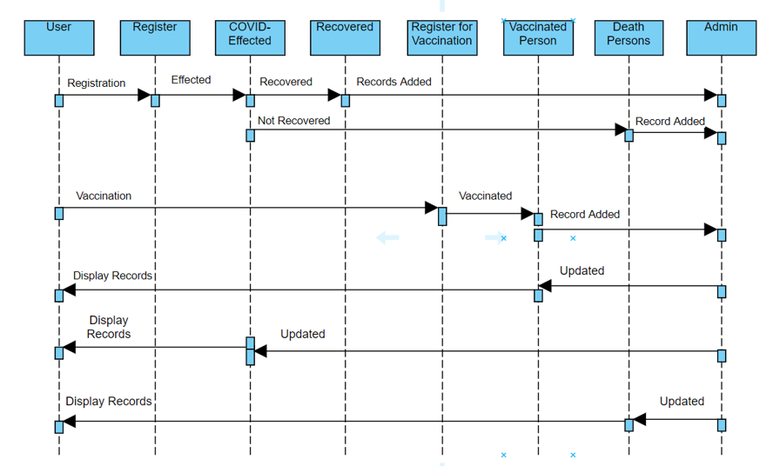

ER Diagram for database Design

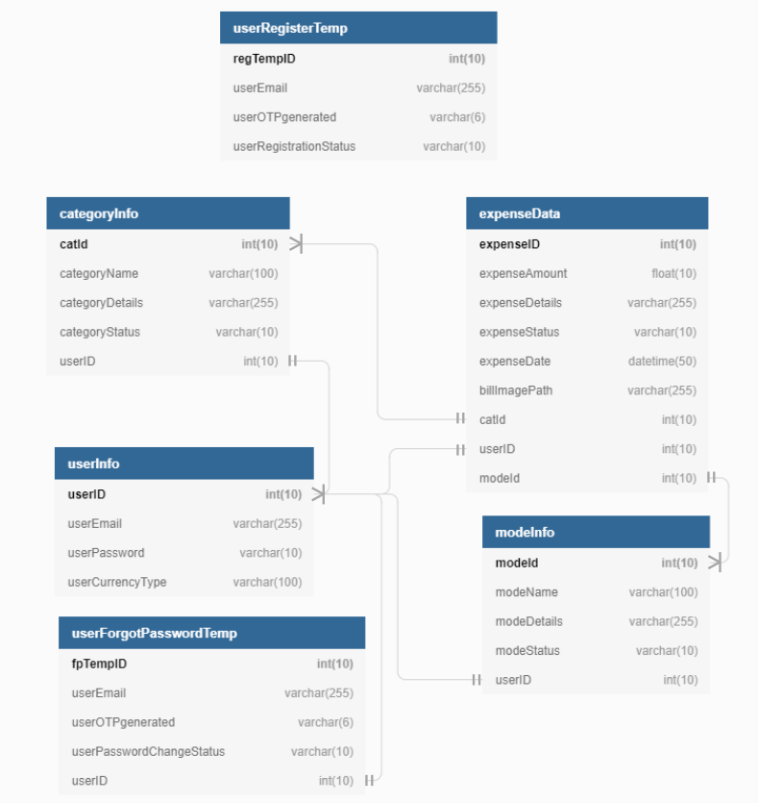

Other Technical changes

Non-functional Requirements and Design
- Usability: This website has appropriate user interface and adequate information to guide the user in order to use the website.

- Portability: This website is portable as it is online website running across the browser.

- Flexibility: It is very flexible.

- Security: This website provides user and authentication so that only the legitimate user are allowed to use the website

- Maintainability: This website is capable to secure the data and easily retrieve the data.

- Scalability: These systems can further modify in future

Additional details

Open Questions / clarifications / Assumptions

Assumptions:

User Profile page is omitted from the scope because it is assumed that
most people don’t care about their profile page once they login to the
system.

Conclusion:

COVID REPORT SYSTEM (CRS) provides the information about the person who has register for Covid test, who has effected with Corona Virus, it also gives details of recovered person, it gives details of person who had register for vaccination and retrieve the details of vaccinated person and also death person’s data.
Our Website is used for the quick data access and retrieving the information of person in this COVID situation. And it is generally used in Hospitals, Government survey, own users.

Additional notes to technical team

References

- https://people.utm.my/noraini/files/2016/09/Chapter-5-Detailed-Design-Principles.pdf
- https://users.ece.cmu.edu/~koopman/lectures/ece642/14_sw_architecture.pdf
- https://www.dbdesigner.net/

