Technical Story Card

Revision History
Version No. | Date | Prepared by / Modified by | Significant Changes
0.1 | 20-Oct-2021 | Sakthi | Draft version
1.0 | 29-Oct-2021 | Sakthi | Reworked based on Review comments
1.1 | 17-Nov-2021 | Sakthi | Reworked based on Review comments

Glossary
Abbreviation | Description
UI | User Interface
DB | Database
UML | Unified Modeling Language
DD | Detailed Design

Table of Contents
1 Introduction 2
2 Scope 2
3 Non Scope of Change 2
4 Design and Detailed technical updates 3
4.1 Process model 3
4.1.1 Use case Model 3
5 Technical Architecture Diagram 4
6 Class Diagram 4
7 Sequence diagram 4
8 ER Diagram for database Design 4
9 Other Technical changes 4
9.1 CI / Build relates tasks 4
9.2 Non-functional Requirements and Design 4
10 Additional details 5
10.1 Open Questions / clarifications / Assumptions 5
10.2 Additional notes to technical team 5
11 References 5

Introduction
Covid-19 has put the world to a standstill. Doctors, healthcare workers and personnel of many other essential services are fighting at the frontline to tackle this global pandemic. Although we are not fighting the battle at the frontline, as a citizen this is our humble attempt at partaking in the struggle.
In this we discuss about people who get registers in our website they like to know about their health condition and status of vaccination.

This project aims to develop content in the COVID-19 modules such as
1. Registration for Testing
2.Covid Effected
3.Recovered
4.Registration for vaccination.
5.Vaccinated Members.
6.Death Members.

Scope

Most people infected with the virus will experience mild to moderate respiratory illness and recover without requiring special treatment. Covid Tracking System is a digital platform, was created for real-time monitoring of COVID-19 which provides the people with the facility to register for vaccination, using your Mobile no. or Aadhaar no. or any other Identity docs.
The system also provides details about the total infected people and the deaths reported due to this disease. The application aims to facilitate users to online register for vaccination from the comfort of their home and gets vaccinated to protect themselves from this infectious disease.

Non Scope of Change

a) User Profile details (like Name, DOB, Address, etc).
b) Encryption and Decryption of Password stored in Database.
c) Bulk upload of data using files.

Design and Detailed technical updates

Process model

Use case Model

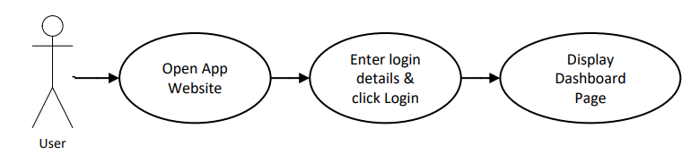
Register by providing details

User will get registered
Brief Description | Register
Basic Flow | - Enter Name  - Enter Age  - Enter Gender  - Enter Address  - Enter Mobile Number  - Enter Aadhar Number
Alternate Flow | If User ID or Password is incorrect, display an error message
Pre-Conditions | When the user enters the page, they have to register to visit the website. They can access the different modules in the website.
Post-Conditions | Display Dashboard Screen

UI Screen Flow

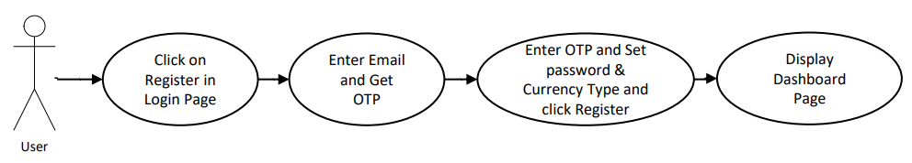
Search by Name, Adhar or Mobile Number
Covid Effected page opens

Displays a list of covid patients

Brief Description | Covid Effected
Basic Flow | - Opens covid effected page  - Display a list of people effected by covid using this parameters:  • Full Name  • Aadhar Number  • Mobile Number  • Effected Date
Alternate Flow | NA
Pre-Conditions | In this module, we find the list of persons who has effected with covid and displays the details of effected person’s. The most common symptoms of this viral infection are fever, cold, cough, bone pain and breathing problems, and ultimately leading to pneumonia. This, being a new viral disease affecting humans for the first time.
Post-Conditions | NA

UI Screen Flow

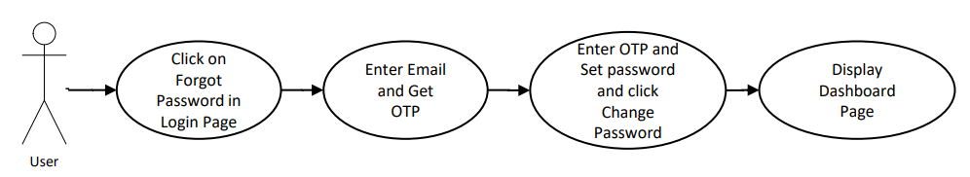
Registration for vaccine
Enter user details.
Get registered

Brief Description | Registration for vaccination
Basic Flow | - Enter Name  - Enter Age  - Enter Gender  - Enter Address  - Enter Mobile Number  - Enter Aadhar Number
Input Screen | User gets a page to enter their details
Special Requirement | NA
Pre-Conditions | In this module, user have to register for Covid vaccination. Certificate of vaccination will be provided by government on completion of the second dose of the Covid-19 vaccine.  Two Covid-19 vaccines that have been granted emergency use authorization by the Central Drugs Standard Control Organization (CDSCO). In India, available vaccines are Covishield and Covaxin (manufactured by Bharat Biotech Limited).
Post-Conditions | User get registered.

Technical Architecture Diagram

Use Case Diagram

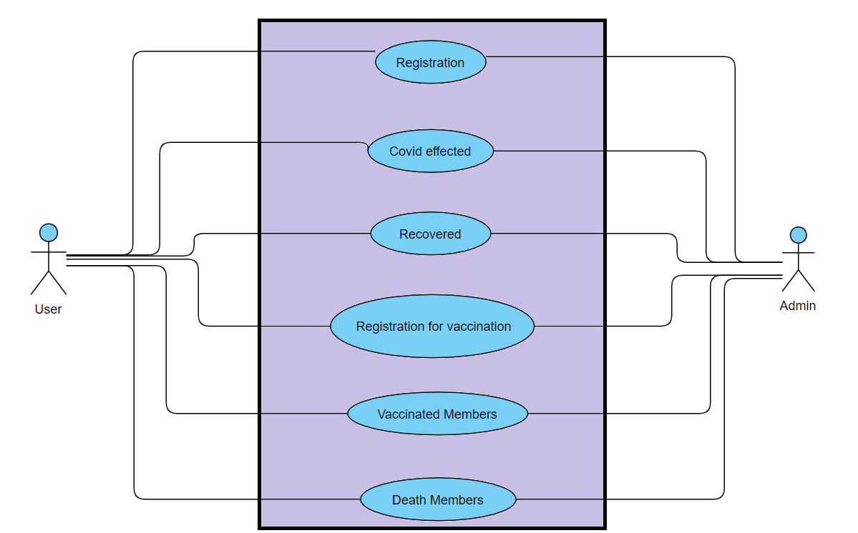

Class Diagram

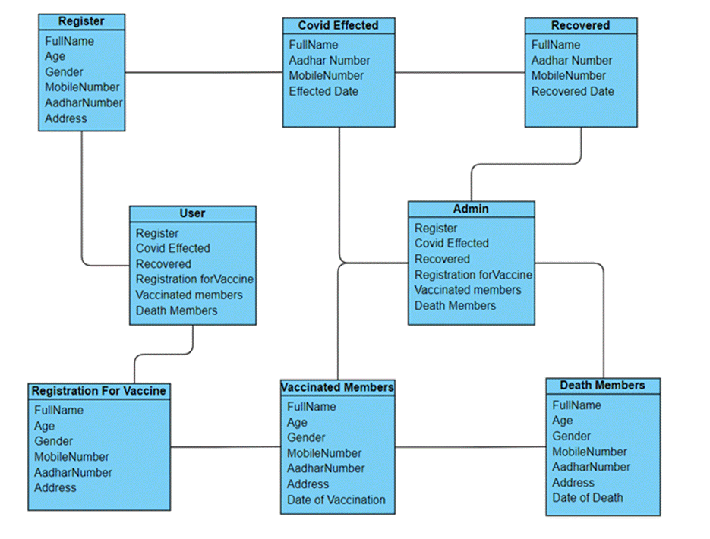

Sequence diagram

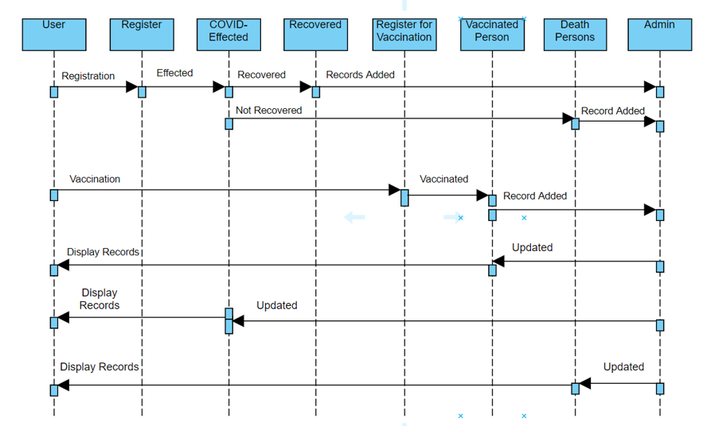

Other Technical changes

Non-functional Requirements and Design
- Usability: These website has appropriate user interface and adequate information to guide the user in order to use the website.

- Portability: The website is portable as it is online website running across the net

- Flexibility: It is very flexible

- Security: This website provides user and authentication so that only the legitimate user are allowed to use the website

- Maintainability: These website is capable to secure the data and easily retrieve the data.

- Scalability: These systems can further modify in future

Additional details

Open Questions / clarifications / Assumptions

Assumptions:

User Profile page is omitted from the scope because it is assumed that
most people don’t care about their profile page once they login to the
system.

Conclusion:

COVID REPORT SYSTEM (CRS) provides the information about the person who has register for Covid test, who has effected with Corona Virus, it also gives details of recovered person, it gives details of person who had register for vaccination and retrieve the details of vaccinated person and also death person’s data.
Our Website is used for the quick data access and retrieving the information of person in this COVID situation. And it is generally used in Hospitals, Government survey, own users.

Additional notes to technical team

References

- https://people.utm.my/noraini/files/2016/09/Chapter-5-Detailed-Design-Principles.pdf
- https://users.ece.cmu.edu/~koopman/lectures/ece642/14_sw_architecture.pdf
- https://www.dbdesigner.net/

