TITLE:SMART WATER FOUNTAIN

PHASE 4:DEVELOPMENT.

*Student Name:K.Sakthivel*

*Reg_No:510421106039*

# Creating a real-time smart water fountain platform involves a combination of front end and backend technologies. Here’s a simplified outline using C and C++ and python programming with wi-fi connection for the front end and Node.

* **PYTHON:**

**# Setup GPIO**

**GPIO.setmode(GPIO.BCM)**

**Water_sensor_pin = 17**

**Pump_pin = 18**

**GPIO.setup(water_sensor_pin, GPIO.IN)**

**GPIO.setup(pump_pin, GPIO.OUT)**

**While True:**

**If GPIO.input(water_sensor_pin) == GPIO.LOW:**

**Print(“Water level is low. Turning on the pump.”)**

**GPIO.output(pump_pin, GPIO.HIGH)**

**Else:**

**Print(“Water level is sufficient. Turning off the pump.”)**

**GPIO.output(pump_pin, GPIO.LOW)**

**Time.sleep(5) # Check water level every 5 seconds**

**Except KeyboardInterrupt:**

**Print(“Exiting…”)**

**GPIO.cleanup()**

**```**

* **C++**

**#include <Arduino.h>**

**// Define pins for water pump and water level sensor.**

**Const int PUMP_PIN = 8;**

**Const int SENSOR_PIN = 9;**

**Void setup() {**

**pinMode(PUMP_PIN, OUTPUT);**

**pinMode(SENSOR_PIN, INPUT);**

**Serial.begin(9600);**

**}**

**Void turnOnPump() {**

**digitalWrite(PUMP_PIN, HIGH);**

**}**

**Void turnOffPump() {**

**digitalWrite(PUMP_PIN, LOW);**

**}**

**Bool isWaterLevelLow() {**

**Return digitalRead(SENSOR_PIN) == LOW;**

**}**

**Void loop() {**

**If (isWaterLevelLow()) {**

**Serial.println(“Water level is low. Turning on the pump.”);**

**turnOnPump();**

**Delay(5000); // Run the pump for 5 seconds (adjust as needed).**

**turnOffPump();**

**}**

**Delay(1000); // Check water level periodically.**

**}**

**```**

* **C PROGRAM**

**#include <stdio.h>**

**#include <stdlib.h>**

**#include <wiringPi.h> // You’ll need to install WiringPi library for Raspberry Pi or similar.**

**// Define GPIO pins for water pump and water level sensor.**

**#define PUMP_PIN 17**

**#define SENSOR_PIN 18**

**Void setup() {**

**wiringPiSetupGpio(); // Initialize the WiringPi library.**

**pinMode(PUMP_PIN, OUTPUT);**

**pinMode(SENSOR_PIN, INPUT);**

**}**

**Void turnOnPump() {**

**digitalWrite(PUMP_PIN, HIGH);**

**}**

**Void turnOffPump() {**

**digitalWrite(PUMP_PIN, LOW);**

**}**

**Int isWaterLevelLow() {**

**Return digitalRead(SENSOR_PIN) == LOW;**

**}**

**Int main() {**

**If (wiringPiSetupGpio() == -1) {**

**Fprintf(stderr, “Unable to initialize WiringPi. Exiting.\n”);**

**Return 1;**

**}**

**Setup();**

**While (1) {**

**If (isWaterLevelLow()) {**

**turnOnPump();**

**delay(5000); // Run the pump for 5 seconds (adjust as needed).**

**turnOffPump();**

**}**

**}**

**Return 0;**

**}**

* **MICROPROCESSOR PROGRAM:**

**```assembly**

**ORG 0x1000 ; Set the origin address**

**PUMP_PIN EQU P1.0 ; Define pump control pin**

**SENSOR_PIN EQU P1.1 ; Define water level sensor pin**

**MAIN: ; Main program**

**MOV P1, #0xFF ; Set P1 as output**

**MOV P2, #0x00 ; Set P2 as input**

**LOOP:**

**CLR A ; Clear accumulator**

**MOV A, P2 ; Read the state of the water level sensor**

**CJNE A, #0, WATER_LOW ; If water level is low, jump to WATER_LOW**

**SJMP CONTINUE**

**WATER_LOW:**

**SETB P1.0 ; Turn on the water pump**

**ACALL DELAY ; Delay for 5 seconds**

**CLR P1.0 ; Turn off the water pump**

**CONTINUE:**

**ACALL DELAY ; Delay before checking water level again**

**SJMP LOOP ; Repeat the loop**

**DELAY:**

**MOV R5, #100 ; Load R5 with 100**

**DELAY_LOOP:**

**DJNZ R5, DELAY_LOOP ; Decrement R5, repeat until R5 is zero**

**RET**

**END**

**BLOCK DIAGRAM:**

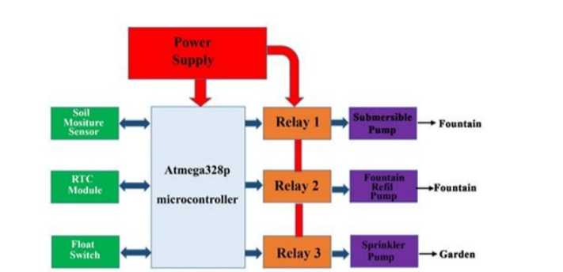

COUNCLUSION:

In conclusion, the smart water fountain represents an innovative and efficient solution for promoting hydration and environmental sustainability. Its advanced features, such as automated refilling, water quality monitoring, and user-friendly mobile app control, make it a valuable addition to both public spaces and homes. By encouraging healthier hydration habits and reducing water wastage, these smart fountains contribute to a more sustainable and well-connected future.