**Project Title: COVID-19 Analysis: Cases, Deaths, and Global Trends**

**Developer: Sakthipriya**

**Description:** This project provides an in-depth analysis of the COVID-19 pandemic's impact across the globe. The dataset is transformed to focus on daily case confirmations by melting the date columns into rows and converting them into a datetime format for accurate time-series analysis. The data is sorted by date and grouped to observe trends in confirmed cases over time.

**Goals and Objectives:**

* **Understand the Global Spread of COVID-19:** Analyze the confirmed cases and death rates across different countries and continents to identify patterns and trends.
* **Evaluate the Pandemic's Impact:** Assess the impact of COVID-19 on various countries by examining key metrics like the total number of cases, deaths, and growth rates.

**Key analyses include:**

* Identifying the top 10 countries by total confirmed cases and deaths.
* Analyzing the countries that took the longest to reach 1,000 confirmed cases.
* Examining the distribution of COVID-19 deaths by continent.
* Ranking the top 10 countries by growth rate in the last week of the dataset.

The project utilizes Python libraries such as Matplotlib and Seaborn for data visualization, providing insights into the spread and impact of COVID-19.  
  
**Platform: Python**

**Process Methodology:**

I used the following steps to carry out the analysis:

* Data Collection
* Data Preparation
* Data Transformation
* Data Analysis
* Insights and Interpretation
* Conclusion and Recommendations
* Documentation and Presentation

**Data Collection:** Obtain COVID-19 data, including confirmed cases, deaths, and recovery rates from reliable sources.

**Data Preparation:** Load the Dataset: Import the dataset into a Python environment for analysis. Data Cleaning: Handle missing values, remove duplicates, and standardize the format of columns (e.g., country names, dates).

**Data Transformation:** Melt the Dataframe: Convert date columns into rows for a time-series format to analyze trends over time.Convert to Datetime Format: Ensure all date columns are in the correct datetime format to facilitate chronological sorting.Sort and Group Data: Sort the data by date and group by country to calculate the total confirmed cases and deaths over time.

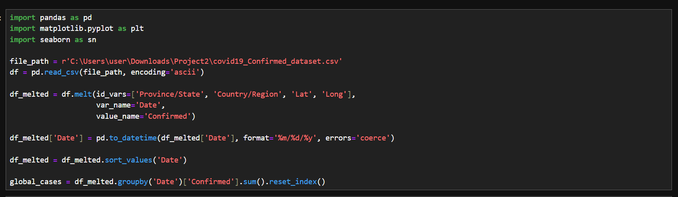

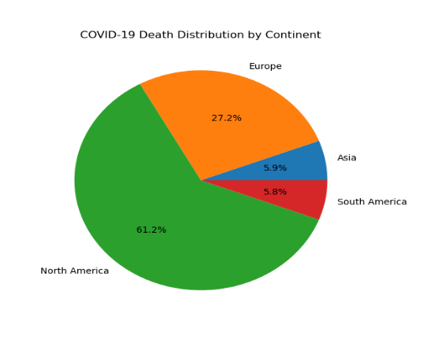**Data Analysis:** Visualize Trends: Use Matplotlib and Seaborn to create visualizations, such as line plots, bar charts, and histograms, to display the progression of COVID-19 cases and deaths globally. Identify Top 10 Countries: Determine the top 10 countries by total confirmed cases, total deaths, and growth rate in the last week of data. Analyze Delays in Reaching Case Milestones: Identify countries that took the longest to reach 1,000 cases, offering insights into their pandemic response strategies. Examine Death Distribution by Continent: Evaluate the distribution of COVID-19 deaths across different continents.

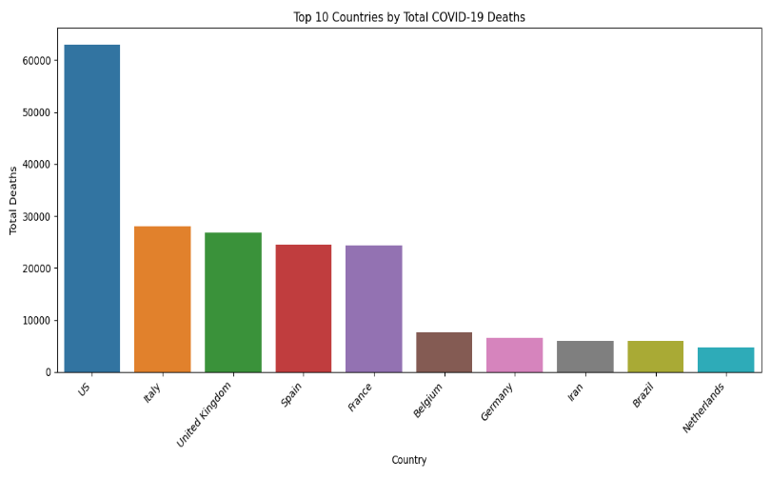

**Insights and Interpretation:** Interpret the findings from the visualizations and analyses to identify key patterns and insights, such as which countries were most affected, the speed of spread, and regional differences in mortality rates.

**Platform: Power BI**

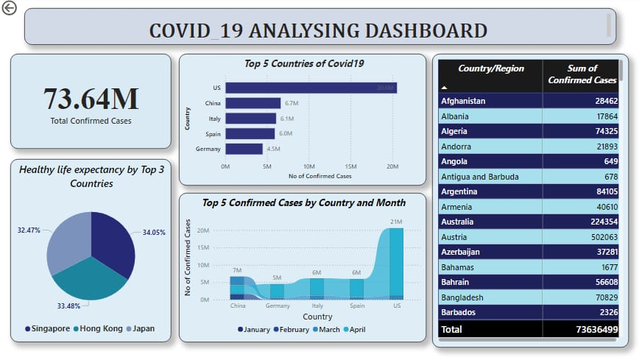 **Conclusion and Recommendations:** Summarize the key findings, highlight important patterns and trends, and provide recommendations for public health responses and future research.

**Documentation and Presentation:** Document the methodology, results, and conclusions in a well-structured report or presentation, including all visualizations and key insights.