10 - Searching & Sorting

Ex. No. : 10.1 Date: 30.05.2024
Register No.: 231401091 Name: SAKTHI ELUMALAI MANICKAVELU

Merge Sort
Write a Python program to sort a list of elements using the merge sort algorithm.

For example:
Input | Result
5  6 5 4 3 8 | 3 4 5 6 8

a=int(input())
l=[]
l.extend(input().split())
for i in range(a-1):
for j in range(a-1):
if(int(l[j])>int(l[j+1])):
t=int(l[j])
l[j]=int(l[j+1])
l[j+1]=t
for i in range(a):
print(int(l[i]),end=" ")

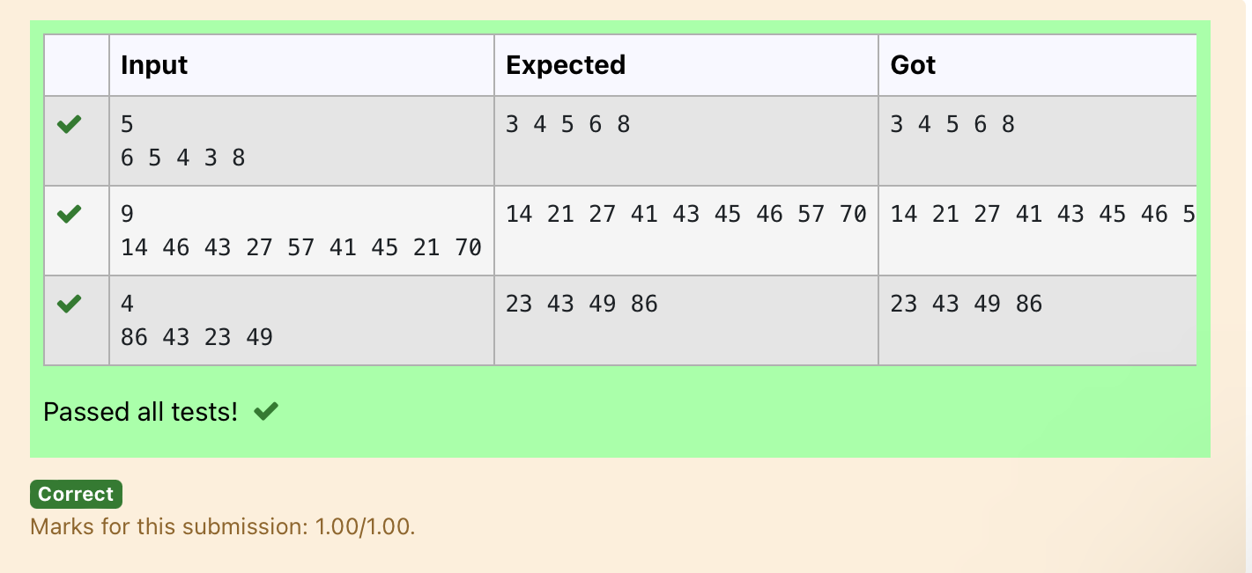

Ex. No. : 10.2 Date: 30.05.2024
Register No.: 231401091 Name: SAKTHI ELUMALAI MANICKAVELU

Bubble Sort
Given an listof integers, sort the array in ascending order using the Bubble Sort algorithm above. Once sorted, print the following three lines:
1. List is sorted in numSwaps swaps., where numSwaps is the number of swaps that took place.
2. First Element: firstElement, the first element in the sorted list.
3. Last Element: lastElement, the last element in the sorted list.
For example, given a worst-case but small array to sort: a=[6,4,1]. It took 3 swaps to sort the array. Output would be
Array is sorted in 3 swaps.
First Element: 1
Last Element: 6

Input Format
The first line contains an integer,n , the size of the list a .
The second line contains n, space-separated integers a[i].
Constraints
· 2<=n<=600
· 1<=a[i]<=2x10⁶.
Output Format
You must print the following three lines of output:
1. List is sorted in numSwaps swaps., where numSwaps is the number of swaps that took place.
2. First Element: firstElement, the first element in the sorted list.
3. Last Element: lastElement, the last element in the sorted list.

Sample Input 0
3
1 2 3
Sample Output 0
List is sorted in 0 swaps.
First Element: 1
Last Element: 3

For example:
Input | Result
3  3 2 1 | List is sorted in 3 swaps.  First Element: 1  Last Element: 3
5  1 9 2 8 4 | List is sorted in 4 swaps.  First Element: 1  Last Element: 9

def bubble_sort(arr):
n = len(arr)
swaps = 0

for i in range(n):
for j in range(0, n-i-1):
if arr[j] > arr[j + 1]:
# Swap elements
arr[j], arr[j + 1] = arr[j + 1], arr[j]
swaps += 1

return swaps

# Input the size of the list
n = int(input())

# Input the list of integers
arr = list(map(int, input().split()))

# Perform bubble sort and count the number of swaps
num_swaps = bubble_sort(arr)

# Print the number of swaps
print("List is sorted in", num_swaps, "swaps.")

# Print the first element
print("First Element:", arr[0])

# Print the last element
print("Last Element:", arr[-1])

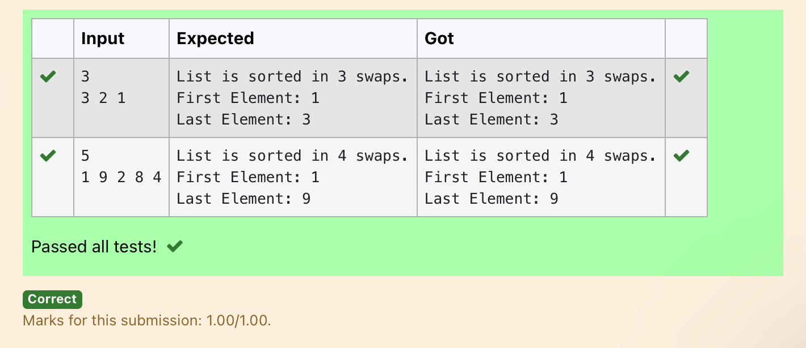

Ex. No. : 10.3 Date: 30.05.2024
Register No.: 231401091 Name: SAKTHI ELUMALAI MANICKAVELU

Peak Element
Given an list, find peak element in it. A peak element is an element that is greater than its neighbors.
An element a[i] is a peak element if
A[i-1] <= A[i] >=a[i+1] for middle elements. [0<i<n-1]
A[i-1] <= A[i] for last element [i=n-1]
A[i]>=A[i+1] for first element [i=0]
Input Format
The first line contains a single integer n , the length of A .
The second line contains n space-separated integers,A[i].

Output Format
Print peak numbers separated by space.

Sample Input
5
8 9 10 2 6
Sample Output
10 6

For example:
Input | Result
4  12 3 6 8 | 12 8

def find_peak(arr):
peak_elements = []

# Check for the first element
if arr[0] >= arr[1]:
peak_elements.append(arr[0])

# Check for middle elements
for i in range(1, len(arr) - 1):
if arr[i - 1] <= arr[i] >= arr[i + 1]:
peak_elements.append(arr[i])

# Check for the last element
if arr[-1] >= arr[-2]:
peak_elements.append(arr[-1])

return peak_elements

# Input the length of the list
n = int(input())

# Input the list of integers
arr = list(map(int, input().split()))

# Find peak elements and print the result
peak_elements = find_peak(arr)
print(*peak_elements)

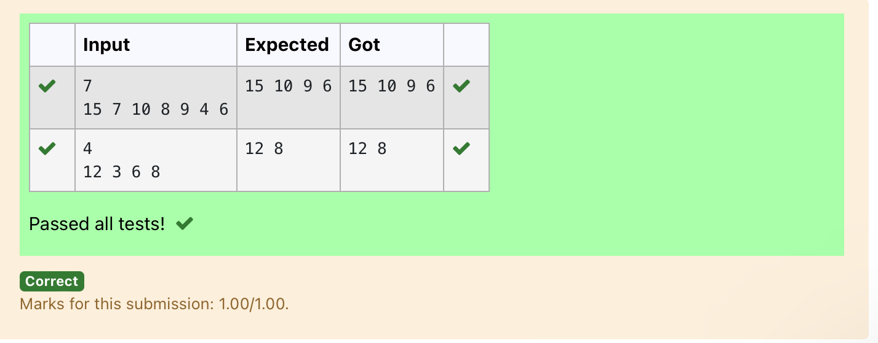

Ex. No. : 10.4 Date: 30.05.2024
Register No.: 231401091 Name: SAKTHI ELUMALAI MANICKAVELU

Binary Search
Write a Python program for binary search.

For example:
Input | Result
1 2 3 5 8  6 | False
3 5 9 45 42  42 | True

a = input().split(",")
b = input()
print(b in a)

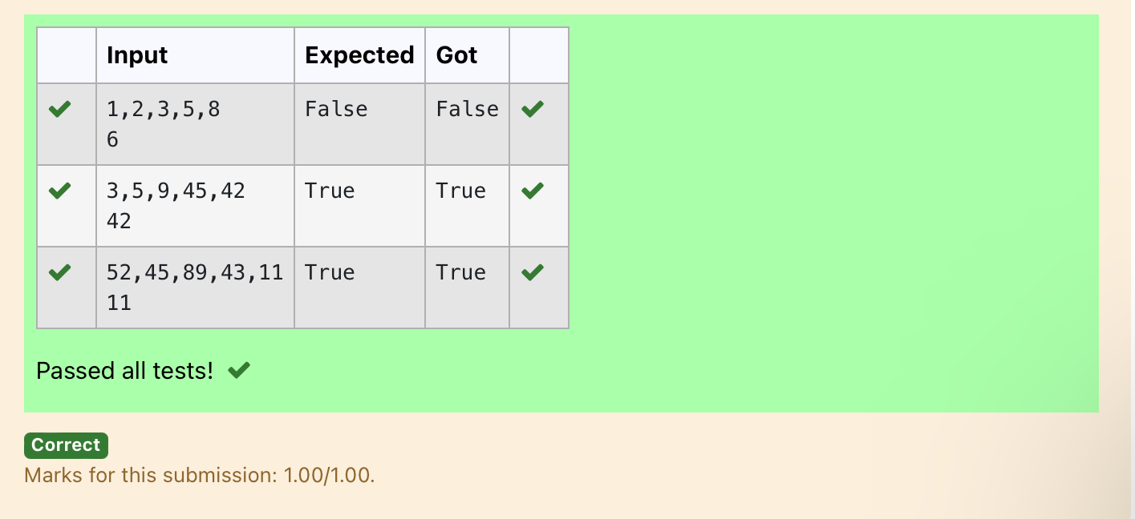

Ex. No. : 10.5 Date: 30.05.2024
Register No.: 231401091 Name: SAKTHI ELUMALAI MANICKAVELU

Frequency of Elements
To find the frequency of numbers in a list and display in sorted order.
Constraints:
1<=n, arr[i]<=100
Input:
1 68 79 4 90 68 1 4 5
output:
1 2
4 2
5 1
68 2
79 1
90 1

For example:
Input | Result
4 3 5 3 4 5 | 3 2  4 2  5 2

def count_frequency(arr):
frequency = {}

# Count the frequency of each number in the list
for num in arr:
frequency[num] = frequency.get(num, 0) + 1

# Sort the dictionary based on keys
sorted_frequency = sorted(frequency.items())

# Print the frequency of each number
for num, freq in sorted_frequency:
print(num, freq)

# Input the list of numbers
arr = list(map(int, input().split()))

# Count the frequency and print the result
count_frequency(arr)



