07 - Functions

Ex. No. : 7.1 Date: 09.05.2024
Register No.: 231401091 Name: SAKTHI ELUMALAI MANICKAVELU

Abundant Number
An abundant number is a number for which the sum of its proper divisors is greater than the number itself. Proper divisors of the number are those that are strictly lesser than the number.

Input Format:
Take input an integer from stdin
Output Format:
Return Yes if given number is Abundant. Otherwise, print No
Example input:
12
Output:
Yes
Explanation
The proper divisors of 12 are: 1, 2, 3, 4, 6, whose sum is 1 + 2 + 3 + 4 + 6 = 16. Since sum of proper divisors is greater than the given number, 12 is an abundant number.
Example input:
13
Output:
No
Explanation
The proper divisors of 13 is: 1, whose sum is 1. Since sum of proper divisors is not greater than the given number, 13 is not an abundant number.

For example:
Test Result
print(abundant(12)) Yes
print(abundant(13)) No
def abundant(n):
l,s=[],0
for i in range(1,int(n//2)+1):
if(n%i==0):
l.append(i)
for i in l:
s+=i
if(s>n):
return("Yes")
else:
return("No")
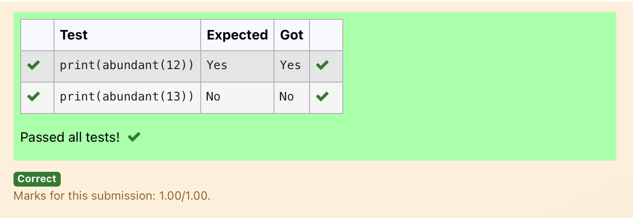

Ex. No. : 7.2 Date: 09.05.2024
Register No.: 231401091 Name: SAKTHI ELUMALAI MANICKAVELU

Automorphic number or not
An automorphic number is a number whose square ends with the number itself. For example, 5 is an automorphic number because 5*5 =25. The last digit is 5 which same as the given number.

If the number is not valid, it should display “Invalid input”.
If it is an automorphic number display “Automorphic” else display “Not Automorphic”.

Input Format:
Take a Integer from Stdin
Output Format:
Print Automorphic if given number is Automorphic number, otherwise Not Automorphic
Example input: 5 Output: Automorphic Example input: 25 Output: Automorphic Example input: 7 Output: Not Automorphic
For example:
Test Result
print(automorphic(5)) Automorphic

def automorphic(n):
a=str(n*n)
if(int(a[-1])==n):
return("Automorphic")
else:
return("Not Automorphic")
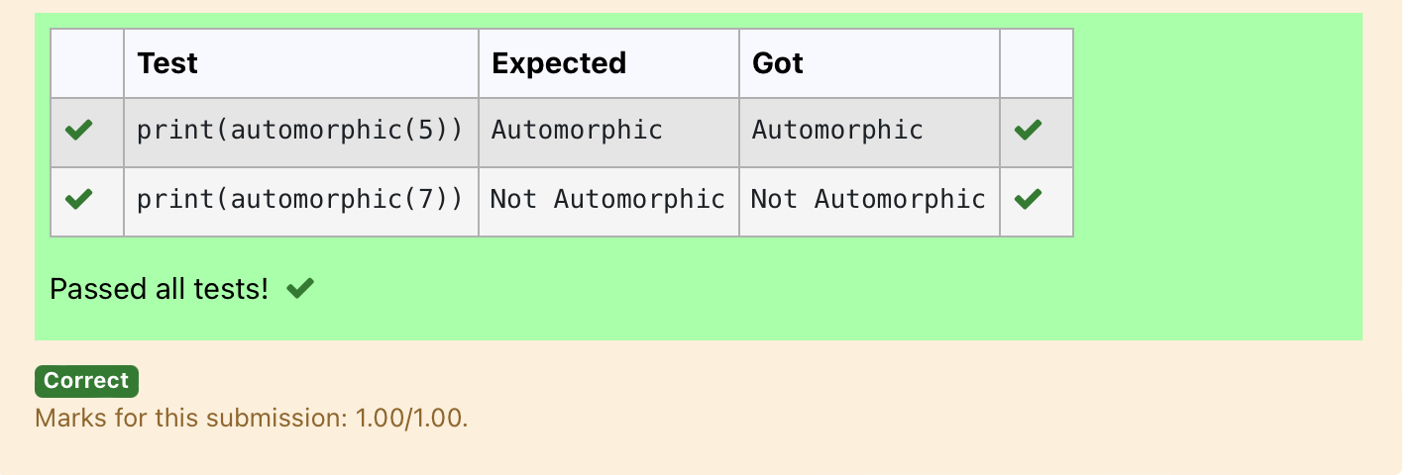

Ex. No. : 7.3 Date: 09.05.2024
Register No.: 231401091 Name: SAKTHI ELUMALAI MANICKAVELU

Check Product of Digits
Write a code to check whether product of digits at even places is divisible by sum of digits at odd place of a positive integer.
Input Format:

Take an input integer from stdin.

Output Format:

Print TRUE or FALSE.

Example Input:

1256

Output:

TRUE

Example Input:

1595

Output:

FALSE

For example:

Test | Result
print(productDigits(1256)) | True
print(productDigits(1595)) | False

def productDigits(n):
a=str(n)
s,p=0,1
for i in range(0,len(a),2):
s+=int(a[i])
for i in range(1,len(a),2):
p*=int(a[i])
if(p%s==0):
return("True")
else:
return("False")
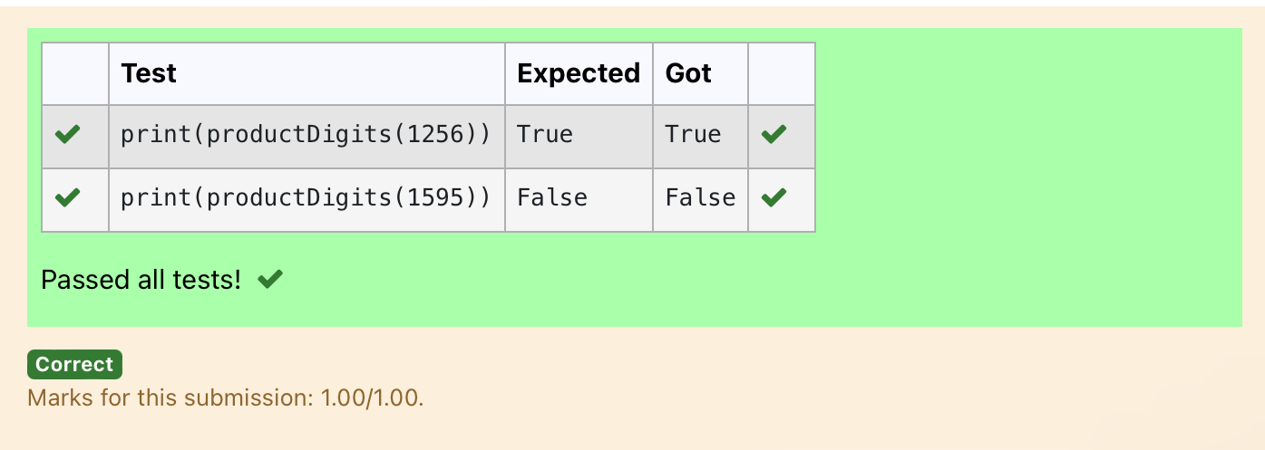

Ex. No. : 7.4 Date: 09.05.2024
Register No.: 231401091 Name: SAKTHI ELUMALAI MANICKAVELU

Christmas Discount
An e-commerce company plans to give their customers a special discount for Christmas.
They are planning to offer a flat discount. The discount value is calculated as the sum of all the prime digits in the total bill amount.
Write an python code to find the discount value for the given total bill amount.
Constraints
1 <= orderValue< 10e¹⁰⁰⁰⁰⁰
Input
The input consists of an integer orderValue, representing the total bill amount.
Output
Print an integer representing the discount value for the given total bill amount.
Example Input
578
Output
12
For example:
Test | Result
print(christmasDiscount(578)) | 12

def christmasDiscount(n):
res=0
while n!=0:
rem=n%10
flag=0
for i in range(1,rem+1):
if rem%i==0:
flag+=1
if flag==2:
res=res+rem
n=n//10

return res
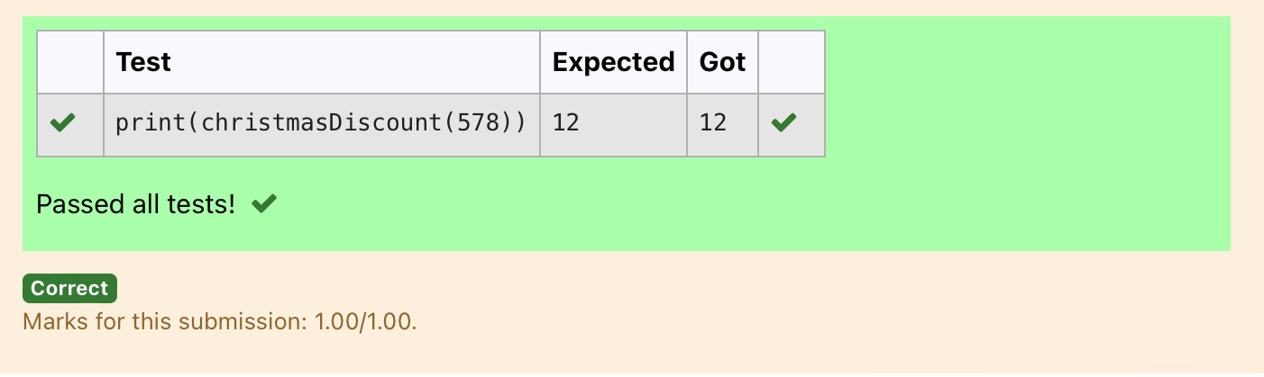

Ex. No. : 7.5 Date: 09.05.2024
Register No.: 231401091 Name: SAKTHI ELUMALAI MANICKAVELU

Coin Change
complete function to implement coin change making problem i.e. finding the minimum
number of coins of certain denominations that add up to given amount of money.
The only available coins are of values 1, 2, 3, 4
Input Format:
Integer input from stdin.
Output Format:
return the minimum number of coins required to meet the given target.
Example Input:
16
Output:
4
Explanation:
We need only 4 coins of value 4 each
Example Input:
25
Output:
7
Explanation:
We need 6 coins of 4 value, and 1 coin of 1 value

def coinChange(amount):
# Available coin denominations
coins = [1, 2, 3, 4]
# Initialize a list to store the minimum number of coins for each amount from 0 to the target amount
dp = [float('inf')] * (amount + 1)
dp[0] = 0 # Base case: 0 coins needed to make amount 0

# Iterate through all amounts from 1 to the target amount
for i in range(1, amount + 1):
# Iterate through all available coin denominations
for coin in coins:
# If the current coin denomination is less than or equal to the current amount
if coin <= i:
# Update dp[i] to be the minimum between its current value and dp[i - coin] + 1
dp[i] = min(dp[i], dp[i - coin] + 1)

# The result is stored at dp[amount]
return dp[amount]
amount = int(input())
print(coinChange(amount))
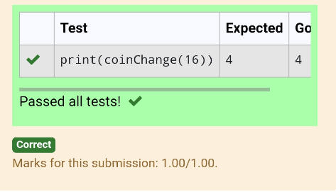

Ex. No. : 7.6 Date: 09.05.2024
Register No.: 231401091 Name: SAKTHI ELUMALAI MANICKAVELU

Difference Sum
Given a number with maximum of 100 digits as input, find the difference between the sum of odd and even position digits.
Input Format:
Take a number in the form of String from stdin.
Output Format:
Print the difference between sum of even and odd digits
Example input:
1453
Output:
1
Explanation:
Here, sum of even digits is 4 + 3 = 7
sum of odd digits is 1 + 5 = 6.
Difference is 1.
Note that we are always taking absolute difference
def differenceSum(n):
a=[]
b=[]
k=str(n)
for i in range(len(k)):
if int(i)%2==0:
a.append(int(k[i]))
else:
b.append(int(k[i]))
s=sum(b)
r=sum(a)
j=s-r
return j
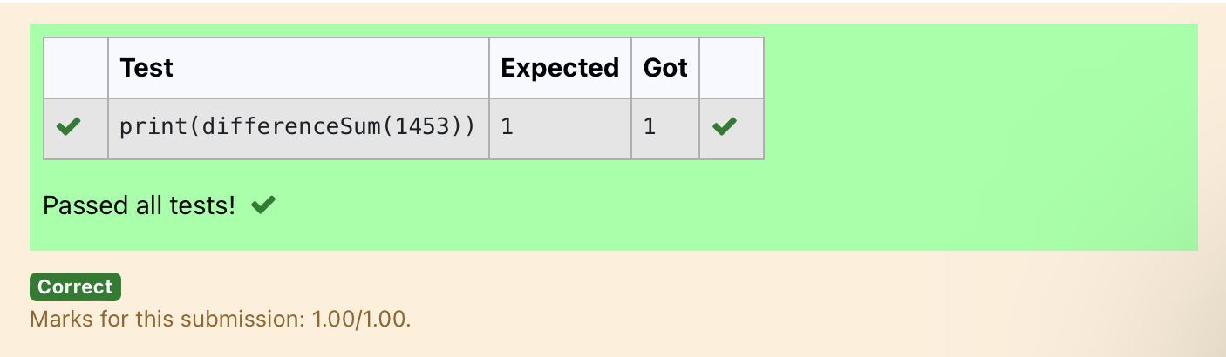

Ex. No. : 7.7 Date: 09.05.2024
Register No.: 231401091 Name: SAKTHI ELUMALAI MANICKAVELU

Ugly number

A number is considered to be ugly if its only prime factors are 2, 3 or 5.
[1, 2, 3, 4, 5, 6, 8, 9, 10, 12, 15, …] is the sequence of ugly numbers.
Task:
complete the function which takes a number n as input and checks if it's an ugly number. return ugly if it is ugly, else return not ugly
Hint:
An ugly number U can be expressed as: U = 2^a * 3^b * 5^c, where a, b and c are nonnegative integers.
For example:
Test | Result
print(checkUgly(6)) | ugly
print(checkUgly(21)) | not ugly

def checkUgly(n):
for i in range(n):
for j in range(n):
for k in range(n):
if(n==(2**i)+(3**j)+(5**k)):
return("ugly")
return("not ugly")


