08 – Tuple/Set

Department of Computer Science and Engineering | Rajalakshmi Engineering College
PA.

Ex. No. : 8.1 Date: 29.05.2024

Register No.: 231401091 Name: SAKTHI ELUMALAI MANICKAVELU

Binary String

Coders here is a simple task for you, Given string str. Your task is to check whether it is a binary string or not by using python set.

Examples:
Input: str = "01010101010" Output: Yes

Input: str = "REC101" Output: No

For example:

Input | Result
01010101010 | Yes
010101 10101 | No

a = input() try:
c = int(a) print("Yes")
except:
print("No")

Department of Computer Science and Engineering | Rajalakshmi Engineering College
PA.
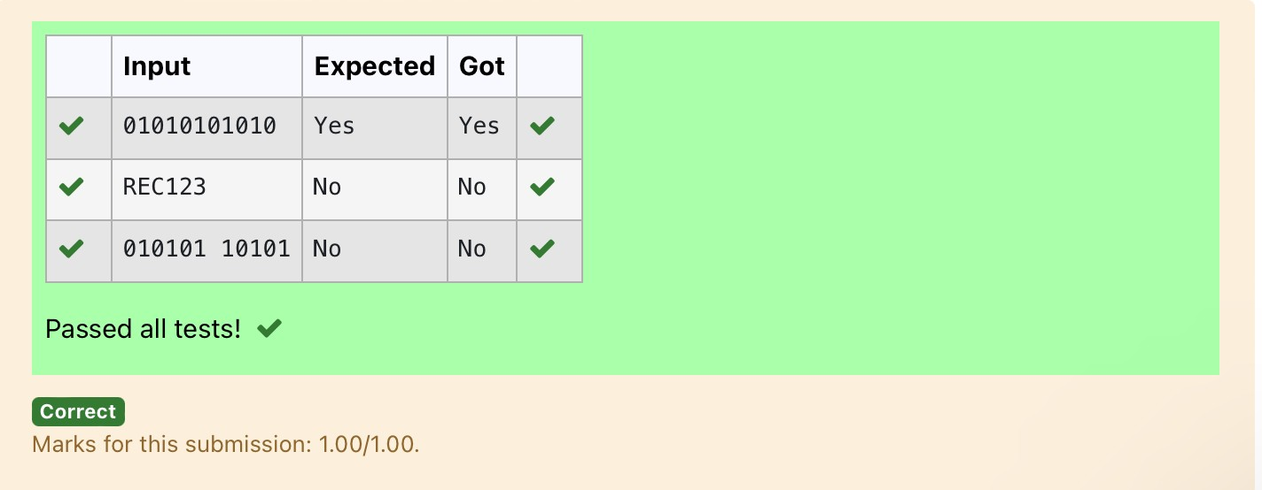

Department of Computer Science and Engineering | Rajalakshmi Engineering College
PA.

Ex. No. : 8.2 Date: 29.05.2024

Register No.: 231401091 Name: SAKTHI ELUMALAI MANICKAVELU

Check Pair

Given a tuple and a positive integer k, the task is to find the count of distinct pairs in the tuple whose sum is equal to K.

Examples:
Input: t = (5, 6, 5, 7, 7, 8 ), K = 13
Output: 2 Explanation:
Pairs with sum K( = 13) are {(5, 8), (6, 7), (6, 7)}.
Therefore, distinct pairs with sum K( = 13) are { (5, 8), (6, 7) }. Therefore, the required output is 2.

For example:

Input | Result
1,2,1,2, | 1
5
3
1,2  0 | 0

t = input()
k = int(input()) a = t.split(",")
l = [int(x) for x in a] count = 0
x = set()

Department of Computer Science and Engineering | Rajalakshmi Engineering College
PA.

for i in range(len(l)):
for j in range(i + 1, len(l)): if l[i] + l[j] == k:
s = (l[i], l[j])
if s not in x and (l[j], l[i]) not in x: count += 1
x.add(s)

print(count)

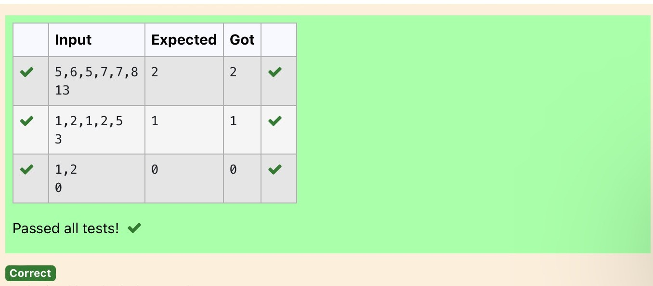

Department of Computer Science and Engineering | Rajalakshmi Engineering College
PA.

Ex. No. : 8.3 Date: 29.05.2024

Register No.: 231401091 Name: SAKTHI ELUMALAI MANICKAVELU

DNA Sequence

The DNA sequence is composed of a series of nucleotides abbreviated as 'A', 'C', 'G', and 'T'.
For example, "ACGAATTCCG" is a DNA sequence.
When studying DNA, it is useful to identify repeated sequences within the DNA.
Given a string s that represents a DNA sequence, return all the 10-letter- long sequences (substrings) that occur more than once in a DNA molecule. You may return the answer in any order.

Example 1:
Input: s = "AAAAACCCCCAAAAACCCCCCAAAAAGGGTTT"
Output: ["AAAAACCCCC","CCCCCAAAAA"]

Example 2:
Input: s = "AAAAAAAAAAAAA"
Output: ["AAAAAAAAAA"]

For example:

Input | Result
AAAAACCCCCAAAAACCCCCCAAAAAGGGTT T | AAAAACCCCC CCCCCAAAAA

s = input() j = []
repeated = set()
for i in range(len(s) - 9): sequence = s[i:i+10] if sequence in j:
Department of Computer Science and Engineering | Rajalakshmi Engineering College
PA.
repeated.add(sequence) else:
j.append(sequence) l=list(repeated) l=list(reversed(l))
for i in l: print(i)
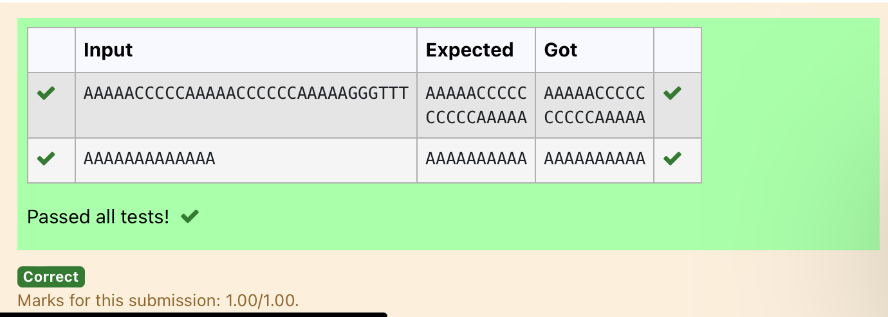

Department of Computer Science and Engineering | Rajalakshmi Engineering College
PA.

Ex. No. : 8.4 Date: 29.05.2024

Register No.: 231401091 Name: SAKTHI ELUMALAI MANICKAVELU

Print repeated no

Given an array of integers nums containing n + 1 integers where each integer is in the range [1, n] inclusive.There is only one repeated number in nums, return this repeated number. Solve the problem using set.

Example 1:
Input: nums = [1,3,4,2,2]
Output: 2

Example 2:
Input: nums = [3,1,3,4,2]
Output: 3

For example:

Input | Result
1 3 4 4 2 | 4

n =input().split(" ") n = list(n)
for i in range(len(n)):
for j in range(i+1,len(n)): if n[i] == n[j]:
print(n[i]) exit(0)

Department of Computer Science and Engineering | Rajalakshmi Engineering College
PA.
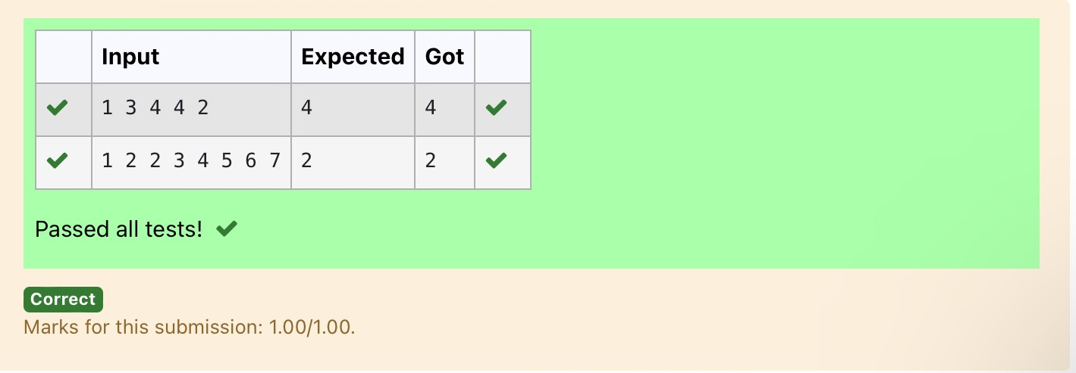

Department of Computer Science and Engineering | Rajalakshmi Engineering College
PA.

Ex. No. : 8.5 Date: 29.05.2024

Register No.: 231401091 Name: SAKTHI ELUMALAI MANICKAVELU

Remove repeated

Write a program to eliminate the common elements in the given 2 arrays and print only the non-repeating elements and the total number of such non-repeating elements.
Input Format:
The first line contains space-separated values, denoting the size of the two arrays in integer format respectively.
The next two lines contain the space-separated integer arrays to be compared.

Sample Input:
5 4
1 2 8 6 5
2 6 8 10
Sample Output:
1 5 10
3
Sample Input:
5 5
1 2 3 4 5
1 2 3 4 5
Sample Output:
NO SUCH ELEMENTS

For example:

Department of Computer Science and Engineering | Rajalakshmi Engineering College
PA.
Input | Result
5 4 | 1 5 10
1 2 8 6 5  2 6 8 10 | 3

a=input() d=[]
b=input() c=input()
b=tuple(b.split(" "))

c=tuple(c.split(" ")) for i in b:
if i not in c: d.append(i)
for i in c:

if i not in b: d.append(i)
for i in range(len(d)): print(int(d[i]),end=' ')
print() print(len(d))

Department of Computer Science and Engineering | Rajalakshmi Engineering College
PA.

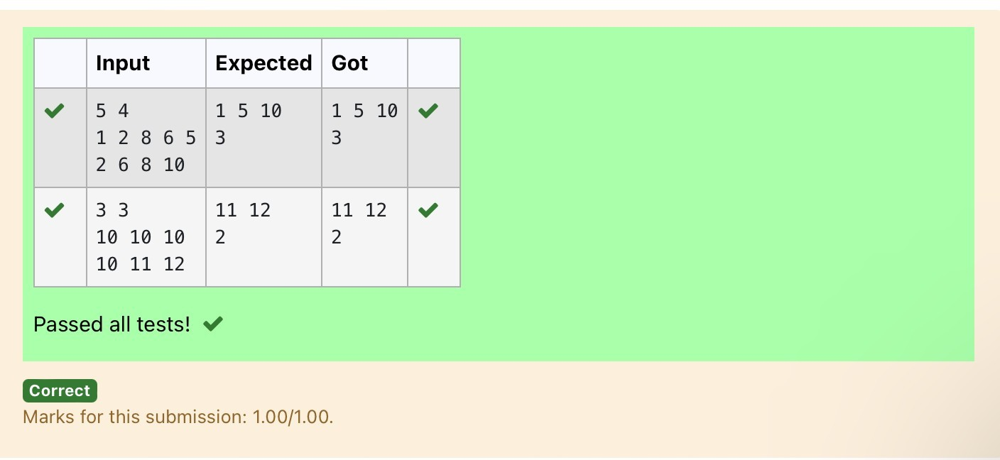

Department of Computer Science and Engineering | Rajalakshmi Engineering College
PA.

Ex. No. : 8.6 Date: 29.05.2024

Register No.: 231401091 Name: SAKTHI ELUMALAI MANICKAVELU

Malfunctioning Keyboard
There is a malfunctioning keyboard where some letter keys do not work. All other keys on the keyboard work properly.
Given a string text of words separated by a single space (no leading or trailing spaces) and a string brokenLetters of all distinct letter keys that are broken, return the number of words in text you can fully type using this keyboard.
Example 1:
Input: text = "hello world", brokenLetters = "ad" Output:
1
Explanation: We cannot type "world" because the 'd' key is broken.

For example:

Input | Result
hello world ad | 1

a=input() b=input() c=set() for i in a:
for j in b: if j in i:

c.add(i)
print(len(c))

Department of Computer Science and Engineering | Rajalakshmi Engineering College
PA.
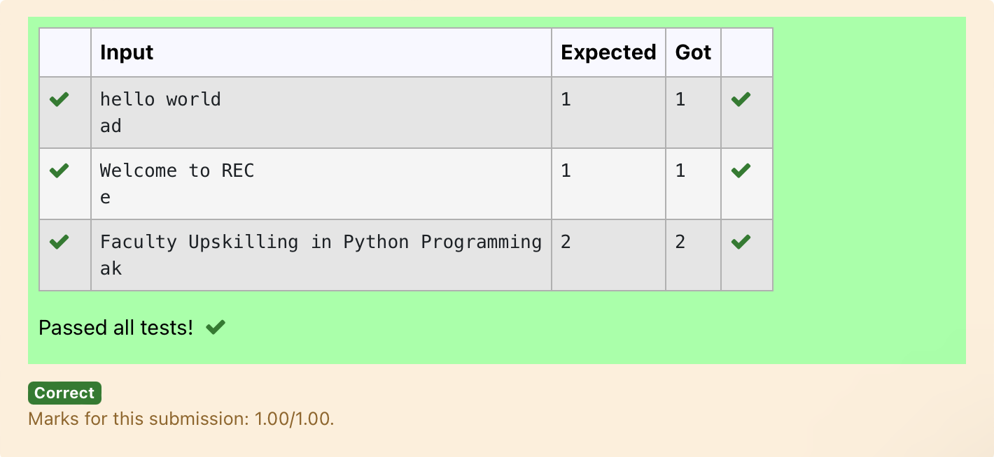

Department of Computer Science and Engineering | Rajalakshmi Engineering College
PA.

Ex. No. : 8.7 Date: 29.05.2024

Register No.: 231401091 Name: SAKTHI ELUMALAI MANICKAVELU

American keyboard
Given an array of strings words, return the words that can be typed using letters of the alphabet on only one row of American keyboard like the image below.
In the American keyboard:

- the first row consists of the characters "qwertyuiop",
- the second row consists of the characters "asdfghjkl", and
- the third row consists of the characters "zxcvbnm"
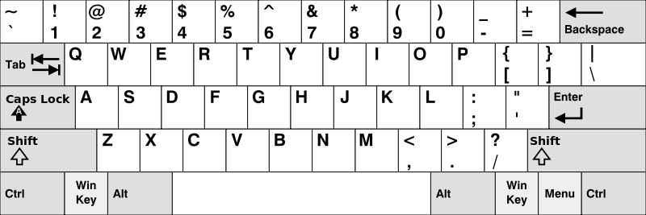

Example 1:
Input: words = ["Hello","Alaska","Dad","Peace"]
Output: ["Alaska","Dad"]

Example 2:
Input: words = ["omk"]
Output: []

Example 3:
Input: words = ["adsdf","sfd"]
Output: ["adsdf","sfd"]

For example:

Department of Computer Science and Engineering | Rajalakshmi Engineering College
PA.
Inpu t | Result
4 | Alaska
Hello | Dad
Alaska
Dad
Peace

def findWords(words): row1 = set('qwertyuiop') row2 = set('asdfghjkl') row3 = set('zxcvbnm')

result = []
for word in words:

w = set(word.lower())
if w.issubset(row1) or w.issubset(row2) or w.issubset(row3): result.append(word)

if len(result) == 0: print("No words")
else:

for i in result: print(i)

a = int(input())

arr = [input() for i in range(a)] findWords(arr)

Department of Computer Science and Engineering | Rajalakshmi Engineering College
PA.

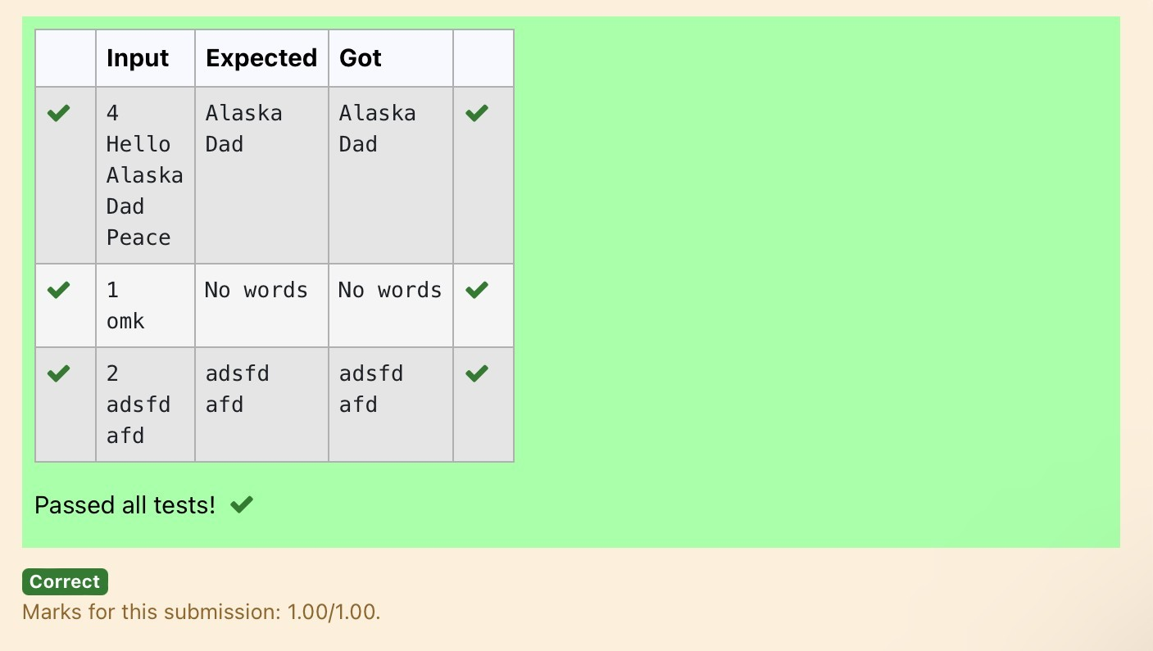

Department of Computer Science and Engineering | Rajalakshmi Engineering College
PA.

