Department of Computer Science and Engineering | Rajalakshmi Engineering College
PA.

09 – Dictionary

Ex. No. : 9.1 Date: 29.05.2024

Register No.: 231401091 Name: SAKTHI ELUMALAI MANICKAVELU

Uncommon words

A sentence is a string of single-space separated words where each word consists only of lowercase letters.A word is uncommon if it appears exactly once in one of the sentences, and does not appear in the other sentence.
Given two sentences s1 and s2, return a list of all the uncommon words. You may return the answer in any order.
Example 1:
Input: s1 = "this apple is sweet", s2 = "this apple is sour" Output: ["sweet","sour"]
Example 2:

Input: s1 = "apple apple", s2 = "banana" Output: ["banana"]
Constraints:
1 <= s1.length, s2.length <= 200
s1 and s2 consist of lowercase English letters and spaces. s1 and s2 do not have leading or trailing spaces.
All the words in s1 and s2 are separated by a single space. Note:
Use dictionary to solve the problem
For example:

Input | Result
this apple is sweet this apple is sour | sweet sour

a=input().split()
Department of Computer Science and Engineering | Rajalakshmi Engineering College
PA.
b=input().split() c1,c2,l={},{},[]
Department of Computer Science and Engineering | Rajalakshmi Engineering College
PA.
for i in a: c1[i]=c1.get(i,0)+1
for j in b: c2[j]=c2.get(j,0)+1
for w,c in c1.items(): if(c==1 and w not in b):
l.append(w)
for w,c in c2.items(): if(c==1 and w not in a):
l.append(w) print(*l)

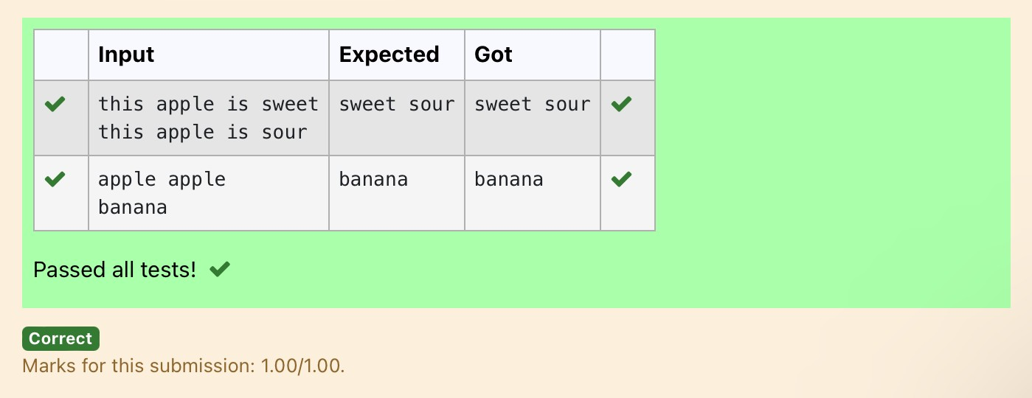

Ex. No. : 9.2 Date: 29.05.2024

Register No.: 231401091 Name :SAKTHI ELUMALAI MANICKAVELU

Sort Dictionary by Values Summation

Give a dictionary with value lists, sort the keys by summation of values in value list.
Input : test_dict = {‘Gfg’ : [6, 7, 4], ‘best’ : [7, 6, 5]}
Output : {‘Gfg’: 17, ‘best’: 18}
Explanation : Sorted by sum, and replaced. Input : test_dict = {‘Gfg’ : [8,8], ‘best’ : [5,5]} Output : {‘best’: 10, ‘Gfg’: 16}
Explanation : Sorted by sum, and replaced. Sample Input:
2
Gfg 6 7 4
Best 7 6 5 Sample Output Gfg 17
Best 18

For example:

Input | Result
2  Gfg 6 7 4  Best 7 6 5 | Gfg 17  Best 18

a=int(input()) d={}
for i in range(a):
Department of Computer Science and Engineering | Rajalakshmi Engineering College
PA.
b=input() b=b.partition(" ") d[b[0]]=b[-1].split(" ")
Department of Computer Science and Engineering | Rajalakshmi Engineering College
PA.
n=list(d.values()) k=list(d.keys())
for i in range(len(n)): s=0
for j in range(len(n[i])):
s+=int(n[i][j])
d.update({k[i]:s}) l=list(d.items()) if(l[0][1]<l[1][1]):
for k,v in d.items(): print(k,v)
else:
j=1
for k,v in d.items(): if(j==1):
k1,v1=k,v j+=1
else:
print(k,v) print(k1,v1)
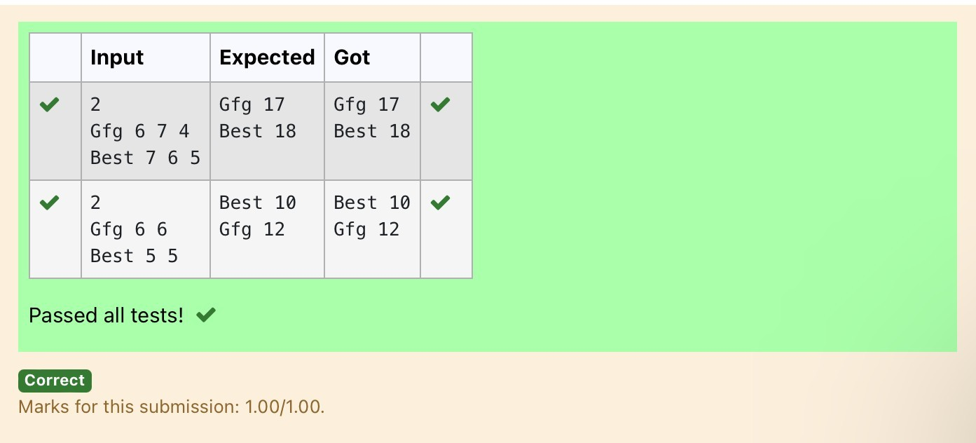
Department of Computer Science and Engineering | Rajalakshmi Engineering College
PA.

Ex. No. : 9.3 Date: 29.05.2024

Register No.: 231401091 Name: SAKTHI ELUMALAI MANICKAVELU

Winner of Election

Given an array of names of candidates in an election. A candidate name in the array represents a vote cast to the candidate. Print the name of candidates received Max vote. If there is tie, print a lexicographically smaller name.
Examples:
Input : votes[] = {"john", "johnny", "jackie", "johnny", "john", "jackie",
"jamie", "jamie", "john",
"johnny", "jamie", "johnny", "john"};
Output : John
We have four Candidates with name as 'John', 'Johnny', 'jamie', 'jackie'. The candidates John and Johny get maximum votes. Since John is alphabetically smaller, we print it. Use dictionary to solve the above problem

Sample Input:
10
John John Johny Jamie Jamie Johny Jack Johny Johny Jackie

Sample Output:
Johny

For example:
Department of Computer Science and Engineering | Rajalakshmi Engineering College
PA.
Inpu t | Result
10 | Johny

Inpu t | Result
John John Johny Jamie Jamie Johny Jack Johny Johny Jackie

n = int(input())

votes = {}

for _ in range(n): candidate = input()
votes[candidate] = votes.get(candidate, 0) + 1

max_votes = max(votes.values())
max_candidates = [candidate for candidate, count in votes.items() if count == max_votes]

print(min(max_candidates))
Department of Computer Science and Engineering | Rajalakshmi Engineering College
PA.

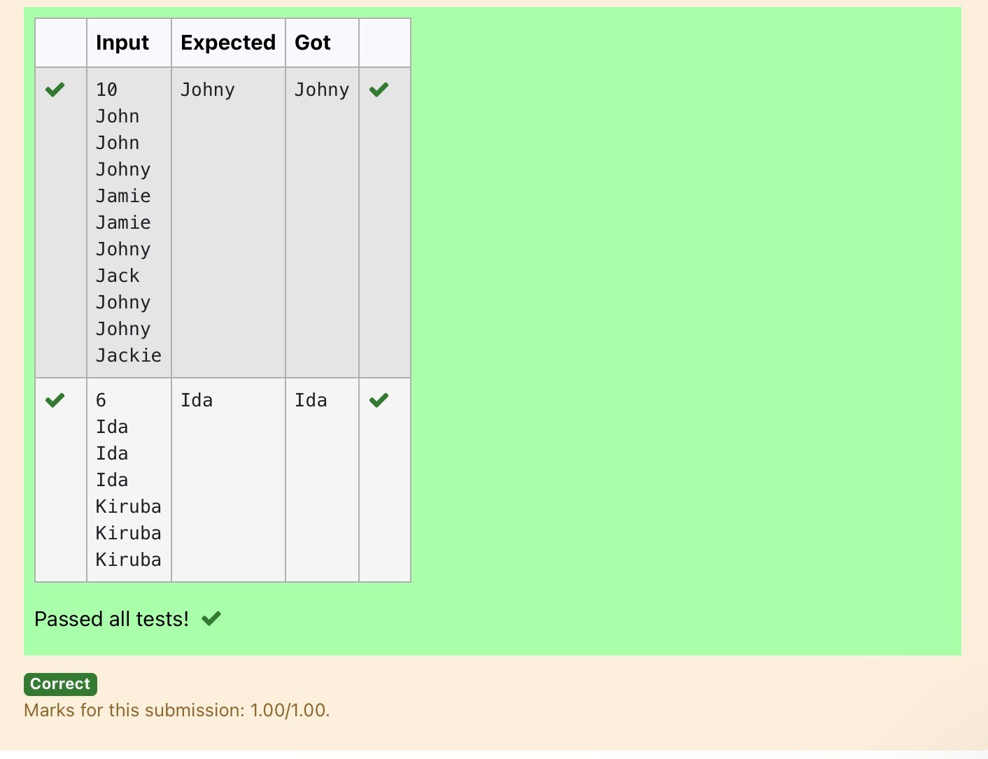
Department of Computer Science and Engineering | Rajalakshmi Engineering College
PA.

Ex. No. : 9.4 Date: 29.05.2024

Register No.: 231401091 Name: SAKTHI ELUMALAI MANICKAVELU

Student Record

Create a student dictionary for n students with the student name as key and their test mark assignment mark and lab mark as values. Do the following computations and display the result.
1.Identify the student with the highest average score 2.Identify the student who as the highest Assignment marks 3.Identify the student with the Lowest lab marks
4.Identify the student with the lowest average score Note:
If more than one student has the same score display all the student names

Sample input:
4
James 67 89 56
Lalith 89 45 45
Ram 89 89 89
Sita 70 70 70 Sample Output:
Ram
James Ram Lalith Lalith

n = int(input()) max_average = float('-inf') min_average = float('inf')
max_assignment = float('-inf') min_lab = float('inf') max_average_students = [] max_assignment_students = [] min_lab_students = [] min_average_students = []
Department of Computer Science and Engineering | Rajalakshmi Engineering College
PA.
for _ in range(n):
Department of Computer Science and Engineering | Rajalakshmi Engineering College
PA.
name, test, assignment, lab = input().split() test = int(test)
assignment = int(assignment) lab = int(lab)
average = (test + assignment + lab) / 3 if average > max_average:
max_average = average max_average_students = [name]
elif average == max_average: max_average_students.append(name)
if average < min_average: min_average = average min_average_students = [name]
elif average == min_average: min_average_students.append(name)
if assignment > max_assignment: max_assignment = assignment max_assignment_students = [name]
elif assignment == max_assignment: max_assignment_students.append(name)
if lab < min_lab: min_lab = lab
min_lab_students = [name] elif lab == min_lab:
min_lab_students.append(name) print(*sorted(max_average_students)) print(*sorted(max_assignment_students)) print(*sorted(min_lab_students)) print(*sorted(min_average_students))
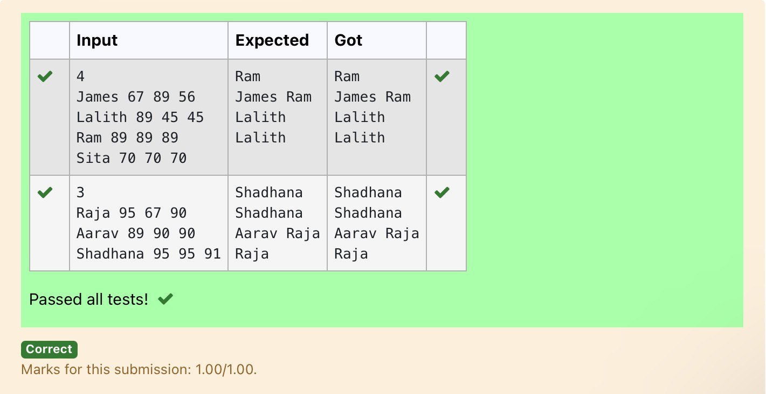
Department of Computer Science and Engineering | Rajalakshmi Engineering College
PA.

Ex. No. : 9.5 Date: 29.05.2024

Register No.: 231401091 Name: SAKTHI ELUMALAI MANICKAVELU

Scramble Score

In the game of Scrabble™, each letter has points associated with it. The total score of a word is the sum of the scores of its letters. More common letters are worth fewer points while less common letters are worth more points.
Write a program that computes and displays the Scrabble™ score for a word. Create a dictionary that maps from letters to point values. Then use the dictionary to compute the score.
A Scrabble™ board includes some squares that multiply the value of a letter or the value of an entire word. We will ignore these squares in this exercise.

The points associated with each letter are shown below: Points Letters
- A, E, I, L, N, O, R, S, T and U
- D and G
- B, C, M and P
- F, H, V, W and Y
- K
8 J and X 10 Q and Z

Sample Input REC
Sample Output
REC is worth 5 points.

letter_scores = {
'A': 1, 'E': 1, 'I': 1, 'L': 1, 'N': 1, 'O': 1, 'R': 1, 'S': 1, 'T': 1, 'U': 1,
'D': 2, 'G': 2,
'B': 3, 'C': 3, 'M': 3, 'P': 3,
'F': 4, 'H': 4, 'V': 4, 'W': 4, 'Y': 4,
Department of Computer Science and Engineering | Rajalakshmi Engineering College
PA.
'K': 5,
Department of Computer Science and Engineering | Rajalakshmi Engineering College
PA.
'J': 8, 'X': 8,
'Q': 10, 'Z': 10
}
word = input().upper()
score = sum(letter_scores.get(letter, 0) for letter in word) print(word,"is worth",score,"points.")
