# football_tweets_Analysis

# Dataframe:

|  |  |  |  |  |  |  |  |  |
| --- | --- | --- | --- | --- | --- | --- | --- | --- |
| DateTime | Tweet_ID | Content | User_Name | URL | Reply_count | Re_Tweet_Count | Language | Like_Count |
| 2019-06-29 23:59:50+00:00 | 1145119716618280960 | 2019 High School Football America Preseason 100 high school football rankings https://t.co/bW9r4IQoki | theF00TBALLguy | https://twitter.com/theF00TBALLguy/status/1145119716618280960 | 0 | 0 | en | 0 |
| 2019-06-29 23:59:48+00:00 | 1145119709748170752 | 'The progress around the women’s game is just going too slow' - Bell reveals FAI disagreement as he makes exit (via @football_ie) https://t.co/MVNeYSMeqa | UKSportsPromo | https://twitter.com/UKSportsPromo/status/1145119709748170752 | 0 | 0 | en | 0 |
| 2019-06-29 23:59:42+00:00 | 1145119683680583681 | Neymar en plus de son football qui me rendait heureux ce que je kiffais c'est que je trouvais injustes toutes les remarques sur son comportement ou quoi c'était de la hagra je trouvais. Mais c'est lui le hagar en fait sle encule. | KeemoXV | https://twitter.com/KeemoXV/status/1145119683680583681 | 1 | 0 | fr | 0 |
| 2019-06-29 23:59:40+00:00 | 1145119673488424960 | @dj_kayyeee Hes playing football in Olney this season? | bmoreblack | https://twitter.com/bmoreblack/status/1145119673488424960 | 1 | 0 | en | 0 |
| 2019-06-29 23:59:39+00:00 | 1145119670191702016 | @theghissilent But the football. 😂 | cordialcatholic | https://twitter.com/cordialcatholic/status/1145119670191702016 | 0 | 0 | en | 1 |
| 2019-06-29 23:59:39+00:00 | 1145119669977673729 | W杯やコパアメリカでVARが大活躍しまくってて、「サッカーがつまらなくなった」という人は少なくないが、それは新ルールに適応できていないだけなのではと思ってる 問題は主審の判断で使う使わないが決まるところだが、VARが積極的に主審に助言をできるシステムにしていければ改善していくと思う | football__cone | https://twitter.com/football__cone/status/1145119669977673729 | 1 | 0 | ja | 2 |
| 2019-06-29 23:59:32+00:00 | 1145119641313955840 | Suarez miss decisive as Peru knock Uruguay out of Copa America in shoot-out (via @football_ie) https://t.co/caq3S8QfhW | EgtTour | https://twitter.com/EgtTour/status/1145119641313955840 | 0 | 0 | en | 0 |
| 2019-06-29 23:59:31+00:00 | 1145119636385669126 | @mpawson22 @paddybarclay Have you watched Scottish football or have you just formed this opinion from reading the Daily Brexit.. Trust me, KT is a better left back than Andy Robertson, I have watched both. Personally, I hope the boy stays at Celtic. Gone are the days of selling players in the cheap. | kevinfraser69 | https://twitter.com/kevinfraser69/status/1145119636385669126 | 1 | 0 | en | 0 |
| 2019-06-29 23:59:30+00:00 | 1145119634175221766 | Mi-temps  Les grenadiers ont eu toutes les peines du monde pour gérer le jeu simple et rapide des Canadiens. Marc Collat doit faire des ajustements.  Haïti 0-2 Canada  #THISISYOURS #SEKOUPANOU #FOOTKOLE #HAITI #FOOTBALL #GOLDCUP2019 #ALASO | FootKole | https://twitter.com/FootKole/status/1145119634175221766 | 1 | 1 | fr | 7 |
| 2019-06-29 23:59:27+00:00 | 1145119622259236866 | Why do niggas play college football until they’re 28? I don’t understand 😐 | OverdoseOnKiA | https://twitter.com/OverdoseOnKiA/status/1145119622259236866 | 1 | 0 | en | 4 |
| 2019-06-29 23:59:25+00:00 | 1145119611710578688 | @royallypalace @livgano Skip football games | chef_bo_r_de | https://twitter.com/chef_bo_r_de/status/1145119611710578688 | 0 | 0 | en | 5 |
| 2019-06-29 23:59:19+00:00 | 1145119588524449795 | Un safety me puso de rabo, pero así es este deporte. Yo juego football, no Madden, no fantasy, no tochito mixto. | RS_Vargas | https://twitter.com/RS_Vargas/status/1145119588524449795 | 0 | 0 | es | 0 |
| 2019-06-29 23:59:17+00:00 | 1145119578483232770 | petition to call football “feetball” | neonhotsauce | https://twitter.com/neonhotsauce/status/1145119578483232770 | 0 | 0 | en | 1 |
| 2019-06-29 23:59:15+00:00 | 1145119570971287552 | Suarez miss decisive as Peru knock Uruguay out of Copa America in shoot-out (via @football_ie) https://t.co/QZ4EGt58Us | UKSportsPromo | https://twitter.com/UKSportsPromo/status/1145119570971287552 | 0 | 0 | en | 0 |
| 2019-06-29 23:59:13+00:00 | 1145119563123765248 | Update on Vacation   Will have to skip going to take pictures of Odessa Permian football field for @Kreager  Called ahead and Holiday Inn has my room on indefinite hold...  Missing dinner at https://t.co/oI1IS9qGf6 so lunch tomorrow then head home... | RHS_SID | https://twitter.com/RHS_SID/status/1145119563123765248 | 0 | 0 | en | 1 |
| 2019-06-29 23:59:13+00:00 | 1145119560825266183 | @royalchant @mPinoe PS: it’s called football.... | FeeFiFoFee | https://twitter.com/FeeFiFoFee/status/1145119560825266183 | 0 | 0 | en | 0 |
| 2019-06-29 23:59:10+00:00 | 1145119547332190209 | 💥OFICIAL: Estas serán las 4 SELECCIONES que disputaran las SEMIFINALES de la COPA AMERICA @tufpf @argentina @rafaribeirorio @laroja conmebol copaamerica   #copa #america #copaamerica #semifinal #football #futbol… https://t.co/Sg2KGDbCT4 | Javliyo55 | https://twitter.com/Javliyo55/status/1145119547332190209 | 0 | 1 | es | 5 |
| 2019-06-29 23:59:07+00:00 | 1145119537974665216 | Suarez miss decisive as Peru knock Uruguay out of Copa America in shoot-out (via @football_ie) https://t.co/kb1YbqmQKq | exec_tours | https://twitter.com/exec_tours/status/1145119537974665216 | 0 | 0 | en | 0 |
| 2019-06-29 23:59:06+00:00 | 1145119534338076679 | @SergioADippW Remember Denver, Monday Night Football??? | mrgianfutbolusa | https://twitter.com/mrgianfutbolusa/status/1145119534338076679 | 0 | 0 | en | 0 |
| 2019-06-29 23:59:04+00:00 | 1145119524502626304 | Anyone playing fantasy football this year add me 👀 | Neef_Rozayy | https://twitter.com/Neef_Rozayy/status/1145119524502626304 | 0 | 0 | en | 0 |
| 2019-06-29 23:58:59+00:00 | 1145119501937192962 | Sullivan’s Jack Conner TD pass to Greencastle’s Gavin Bollman to put Gold Team up 14-0 in Wabash Valley Football Coaches Association All-Star game https://t.co/0tXnOO3HRB | Rick_Sports10 | https://twitter.com/Rick_Sports10/status/1145119501937192962 | 1 | 6 | en | 19 |
| 2019-06-29 23:58:58+00:00 | 1145119500548882433 | petition to call football “american football” and soccer “football” | neonhotsauce | https://twitter.com/neonhotsauce/status/1145119500548882433 | 0 | 0 | en | 0 |
| 2019-06-29 23:58:55+00:00 | 1145119487458467840 | Registration for 2019 Bronco football closes tomorrow, June 30th! If you haven’t played, this is the year to start as we have some of our largest teams in years, and 37 rookies ranging… https://t.co/annZNe1KKI | LI_Broncos | https://twitter.com/LI_Broncos/status/1145119487458467840 | 0 | 0 | en | 0 |
| 2019-06-29 23:58:55+00:00 | 1145119485034213376 | @bandorelo1 That, anything football &amp; Logo's are probably my best topics 😂 | aadenomer | https://twitter.com/aadenomer/status/1145119485034213376 | 0 | 0 | en | 0 |
| 2019-06-29 23:58:53+00:00 | 1145119478822461441 | @KHeneage Don't think I'm willing to accept people watch football on TV from that angle | Matt__Murphy | https://twitter.com/Matt__Murphy/status/1145119478822461441 | 2 | 0 | en | 1 |
| 2019-06-29 23:58:43+00:00 | 1145119435935629312 | I wanna play flag football. | T_gawjus | https://twitter.com/T_gawjus/status/1145119435935629312 | 0 | 0 | en | 0 |
| 2019-06-29 23:58:36+00:00 | 1145119407556849664 | Did they accidentally play football https://t.co/aIj5NxAOyQ | hollykmichels | https://twitter.com/hollykmichels/status/1145119407556849664 | 0 | 0 | en | 6 |
| 2019-06-29 23:58:35+00:00 | 1145119404470034433 | @StoneDiJneral It’s for cristy gad and Buffon really, if they win next season I believe those two are done with Europe football | ttoouuggh | https://twitter.com/ttoouuggh/status/1145119404470034433 | 0 | 0 | en | 0 |
| 2019-06-29 23:58:29+00:00 | 1145119377529987072 | Did this guy see past University of Maryland football duds? | robertblowe | https://twitter.com/robertblowe/status/1145119377529987072 | 1 | 0 | en | 0 |
| 2019-06-29 23:58:26+00:00 | 1145119366096310277 | American Football &amp; Rachel Goswell - "I Can’t Feel You" (2019) #AmericanFootball #Emo https://t.co/ahD0LL0wk1 | RockRollBlogBR | https://twitter.com/RockRollBlogBR/status/1145119366096310277 | 0 | 0 | en | 0 |
| 2019-06-29 23:58:26+00:00 | 1145119362656821250 | @jongewoud 仰る通りです、失礼しました | football__cone | https://twitter.com/football__cone/status/1145119362656821250 | 0 | 0 | ja | 0 |
| 2019-06-29 23:58:24+00:00 | 1145119354805248000 | Happy birthday to the greatest fan in non league football and a fantastic person in general @undateables_jb I hope you have a fantastic day James 🙂👍🏼🥳 | Tjw0401 | https://twitter.com/Tjw0401/status/1145119354805248000 | 1 | 1 | en | 12 |
| 2019-06-29 23:58:22+00:00 | 1145119349130371077 | @EHS__Football @BrookeAyres Good luck coach D! | Scottyg15 | https://twitter.com/Scottyg15/status/1145119349130371077 | 0 | 0 | en | 2 |
| 2019-06-29 23:58:22+00:00 | 1145119347800772609 | After a great camp and a great talk with Coach McLaughlin, I’m excited to announce I have received an offer to play football at @WayneStFootball Thank you @BrianFrana for working with me, and the other coaches for a great camp! #WildState https://t.co/dTqmFwwOAt | Evan_Johnson2 | https://twitter.com/Evan_Johnson2/status/1145119347800772609 | 4 | 5 | en | 57 |
| 2019-06-29 23:58:21+00:00 | 1145119342885003269 | Légui daaal football dafa doywar!!! Ay Numéro 10 yo khamni 2eme mi-temps laniouy dougou, ay Numéro 7,8 ak 9 youy dameu banc 🤦🏿‍♂️ | OmarMaady | https://twitter.com/OmarMaady/status/1145119342885003269 | 0 | 0 | fr | 3 |
| 2019-06-29 23:58:14+00:00 | 1145119316037316608 | @standart45 11 kap genyen pa chanje fasil konsa Nan football,se sa nap peye la | Baldouze12 | https://twitter.com/Baldouze12/status/1145119316037316608 | 0 | 0 | ht | 0 |
| 2019-06-29 23:58:14+00:00 | 1145119314841866240 | Really hoping this is just precautionary.  #NYCFC 1-2 #DOOP #MLS #Football | BenikageCasts | https://twitter.com/BenikageCasts/status/1145119314841866240 | 0 | 0 | en | 0 |
| 2019-06-29 23:58:13+00:00 | 1145119311608066049 | @THEUNITEDVOICE2 @Intuitive_boy @TheManUtdWay says the guy who doesn't think running is important in a 11vs11 team, football game. lol, that's a true martialFC member. | 67Chilavert | https://twitter.com/67Chilavert/status/1145119311608066049 | 1 | 0 | en | 0 |
| 2019-06-29 23:58:07+00:00 | 1145119285666373632 | I miss being pompey women's Facebook admin, I miss going to random 'home' games &amp; posting live updates, I miss believing in women's football, I miss thinking women's football isnt as money driven as men's, I miss the hope, the optimism, I miss believing I can make a difference | hjfranklin | https://twitter.com/hjfranklin/status/1145119285666373632 | 0 | 0 | en | 0 |
| 2019-06-29 23:58:00+00:00 | 1145119257614639104 | @BleedingGreen @BrianDawkins not all heroes wear capes. This man is the reason I love Eagles football and maybe football in general. I caught a glimpse of him at The Eagles v Redskins opener two years ago and nearly cried. Truly a hero to me! #FlyEaglesFly https://t.co/2fR3quUA2M | Trap_Jeezus | https://twitter.com/Trap_Jeezus/status/1145119257614639104 | 0 | 0 | en | 0 |
| 2019-06-29 23:57:59+00:00 | 1145119253017661441 | @IvanCarter9 Wiggins is like if a football player had Trent Green’s talent, but the drive and work ethic of JaMarcus Russell. | ChrisKBills | https://twitter.com/ChrisKBills/status/1145119253017661441 | 0 | 0 | en | 0 |
| 2019-06-29 23:57:52+00:00 | 1145119222571458562 | Dangerous in attack, but some issues at the back in the first 45. Canada is playing an entertaining brand of football. #CanMNT #GoldCup2019 | LeachCityNewsTO | https://twitter.com/LeachCityNewsTO/status/1145119222571458562 | 1 | 0 | en | 2 |
| 2019-06-29 23:57:51+00:00 | 1145119216669880320 | @PeteCarroll hey coach Pete I want join the Seahawks football team a equipment manager I let owners know your guys be okay with I staying out the players and coaches way | young85_young | https://twitter.com/young85_young/status/1145119216669880320 | 0 | 0 | en | 0 |
| 2019-06-29 23:57:39+00:00 | 1145119166426505217 | Saba gen on volume football nan main li | JeffUltimatum | https://twitter.com/JeffUltimatum/status/1145119166426505217 | 0 | 0 | ht | 0 |
| 2019-06-29 23:57:35+00:00 | 1145119151599435776 | I wonder I’d these Afghan fans live in Britain and have been influenced by hoodlum behaviour of British football fans. Otherwise Afghans world over are best behaved except when confronting Amreekans in their country. | MarianaBaabar | https://twitter.com/MarianaBaabar/status/1145119151599435776 | 2 | 0 | en | 4 |
| 2019-06-29 23:57:31+00:00 | 1145119135782907904 | @seanrleahy So football is dead then | jezmyers | https://twitter.com/jezmyers/status/1145119135782907904 | 0 | 0 | en | 0 |
| 2019-06-29 23:57:31+00:00 | 1145119135631847425 | We should probably incorporate talk about general indie music and baseball, maybe also college football, but with the understanding that we’re Braves homers. | ToddFarrellJr | https://twitter.com/ToddFarrellJr/status/1145119135631847425 | 0 | 0 | en | 2 |
| 2019-06-29 23:57:31+00:00 | 1145119133643628544 | @Primetime_jet @OU_Football Great job! | Tim50404077 | https://twitter.com/Tim50404077/status/1145119133643628544 | 0 | 0 | en | 0 |
| 2019-06-29 23:57:20+00:00 | 1145119087389003776 | @wzawacki @MLB Not like this. MLB has become boring. It's like watching a football game where both teams throw the long bomb on every play. All or nothing. No strategey. Just boring. | pebblewolfcreek | https://twitter.com/pebblewolfcreek/status/1145119087389003776 | 0 | 0 | en | 0 |
| 2019-06-29 23:57:19+00:00 | 1145119084771762176 | Was that a Football game or Baseball game played in London? The Yankees beat the Red Sox 17-13 in what looks more like a low scoring football score!! | AppelHowie | https://twitter.com/AppelHowie/status/1145119084771762176 | 0 | 0 | en | 0 |
| 2019-06-29 23:57:18+00:00 | 1145119081256775680 | gettin all the weird looks as I point at the first person I see outside of the church and scream “NO SIN GANG BABY WHAT’S UP THAT’S WHAT I THOUGHT” right before spiking a football I brought | theghissilent | https://twitter.com/theghissilent/status/1145119081256775680 | 3 | 1 | en | 87 |

# Frequently used words

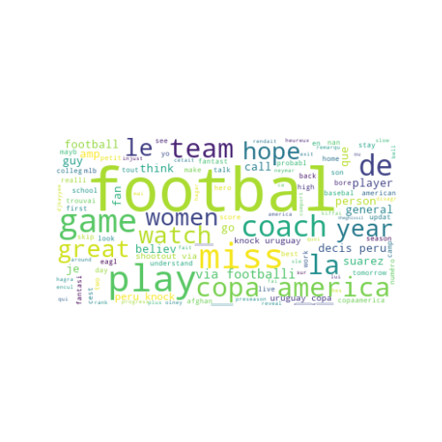

# Frequently used Positive words

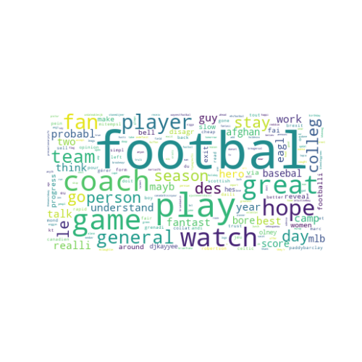

# Frequently used Negative words used

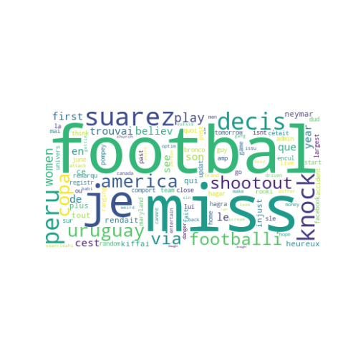

# Top words that repeated in many tweets

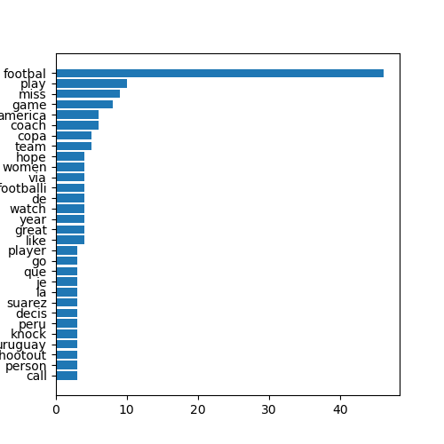

The tweets that frequently contain: Neutral Words🙂

# Overall Scores:

Positive: 8.339

Negative: 3.376

Neutral: 39.284