SMART LIBRARY REQUEST WORKFLOW IN SERVICENOW

TEAM MEMBERS
1. S Sakthipriya (Team Leader) – 50A6362BC712270A36C447666046EDEB
2. S Shalini – 79DB5A6551CDC6082B54F3DAFD4644EB
3. J Anumalya– EEB2B57E6E02D44BF244ADAB93ED891E
4. R Swathi – 82FDBE09D38A106A11C4239922B1C763
5. M Amina fahima– 4CFAFEC4681F22F94F24547902BC8129

ABSTRACT
This project focuses on developing a Smart Library Request Workflow using the ServiceNow platform. In many libraries, book requests and approvals are handled manually, which can lead to delays, miscommunication, and inefficient tracking of requests. The Smart Library Request Workflow automates the process of requesting, approving, and issuing library resources through a digital workflow.Using ServiceNow features such as catalog items, workflows, and request management, users can submit requests for books or library materials through a service portal. The request is then routed to the librarian or administrator for approval. Once approved, the system updates the request status and notifies the user.This automated workflow improves efficiency, transparency, and record management within the library system. The project demonstrates how ServiceNow can be used to create structured workflows for resource management in educational institutions.

INTRODUCTION
Libraries are important knowledge centers in educational institutions. Managing book requests manually can be time-consuming and prone to errors. The Smart Library Request Workflow system aims to automate the process of requesting, approving, and managing library resources using the ServiceNow platform. This system allows students or staff to request books digitally and enables librarians to track and manage those requests efficiently.

SCREEN LAYOUT

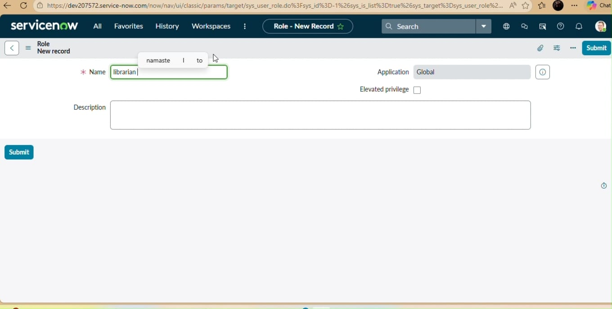

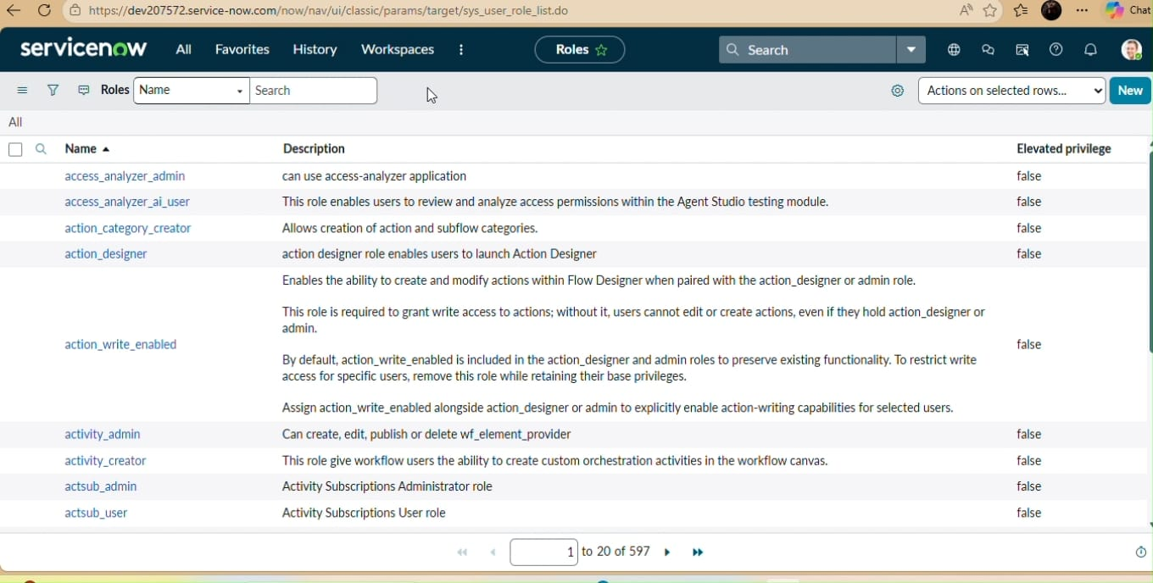

OBJECTIVES
• Automate the process of requesting books or library resources.
• Reduce manual paperwork and administrative workload.
• Provide a structured approval workflow for librarians.
• Improve request tracking and transparency.
• Enhance user experience through a digital service portal.

SYSTEM ARCHITECTURE
The Smart Library Request Workflow is built using the ServiceNow platform. The system includes a service portal where users submit book requests. The request is stored in the ServiceNow request tables and processed through an automated workflow that routes the request to the librarian for approval. Notifications are sent to users regarding the request status.

WORKFLOW PROCESS
1. User logs into the ServiceNow Service Portal.
2. User submits a library book request form.
3. The request is recorded in the system.
4. The request is sent to the librarian for approval.
5. Librarian approves or rejects the request.
6. User receives notification of the request status.
7. Approved requests proceed for book issue or reservation.

MODULES USED
• Service Catalog
• Request Management
• Workflow Automation
• Notifications
• Service Portal

ADVANTAGES
• Faster request processing.
• Improved record management.
• Reduced manual work.
• Better tracking of library resources.
• Increased transparency in request approvals.

CONCLUSION
The Smart Library Request Workflow developed using ServiceNow demonstrates how digital workflows can simplify and improve library management systems. By automating the request and approval process, the system reduces delays, improves efficiency, and ensures proper tracking of library resources. This project highlights the potential of ServiceNow in building practical workflow automation solutions for educational institutions.

