**Knowing Your Customer Requirement in E-Commerce (KYCRE)**

*by*

Sakthidevi T

**Objective**

This project is to develop a general analysis on e-commerce store where any sports product (such as Air Sports, Combat Sports, Dancing, Exercise & Fitness, Games, Gymnastics, Indoor Games, Jumping, Outdoor Play Equipment, Outdoor Recreation, Puzzles, Racquet Sports, Team Sports, Water Sports, Winter Sports) can be bought from the comfort of home through the Internet.

This applications support the interaction between different parties participating in a commerce transaction via the network, as well as the management of the data involved in the process.

**Scope**

The scope of the process is to analyze the requirement of the customer in terms of transaction, category, product, payment mode, city etc. The outcome of this analysis will lead the organization to satisfy the customer as well as in economic benefit.

**Background**

E-commerce is fast gaining ground as an accepted and used business paradigm. More and more business houses are implementing web sites providing functionality for performing commercial transactions over the web. It is reasonable to say that the process of shopping on the web is becoming commonplace.

**Requirements Specifications**

This project deals with E-Commerce transaction, we have to handle huge volume of data (which will rise tremendously). Here we are having two kinds of data.

* Transactional data which contains transaction details of each customer (such as transaction id, transaction amount, customer id, payment mode, transaction place, transaction date etc.)
* Customer data which contains the details of customer (such as customer id, first name, last name, professional and age).

**Analysis**

Being a data analyzing project, we are going to implement this project with the help HADOOP, an open source Java-based programming framework. There are many Ecosystem tools in HADOOP from there we used **Pig** and **Hive**

**Technologies**

* **Map Reduce:** Hadoop Map Reduce is a software framework for easily writing applications which process vast amounts of data (multi-terabyte data-sets) in-parallel on large clusters (thousands of nodes) of commodity hardware in a reliable, fault-tolerant manner
* **Pig:** Pig is a high-level platform for creating programs. The language for this platform is called Pig Latin. It can be extended using User Defined Functions (UDFs) which the user can write in Java, Python, JavaScript, Ruby or Groovy and then call directly from the language.
* **Hive:** Hive gives an SQL-like interface to query data stored in various databases and file systems that integrate with Hadoop. The traditional SQL queries must be implemented in the Map Reduce Java API to execute SQL applications and queries over a distributed data.

**Use cases:**

Project tasks are divided into different use cases based on analysis.

**Sales Report**

A sales analysis report shows the trends that occur in a company's sales volume over time. In its most basic form, a sales analysis report shows whether sales are increasing or declining. Under this category we have taken two tasks

1. Calculate total amount sales for each Month.
2. Divide the file into 12 files, each file containing each month of data. For e.g. file 1 should contain data of January transaction, file 2 should contain data of February transaction.
3. We have implemented Custom Input Format and Validation.

Execution Step:

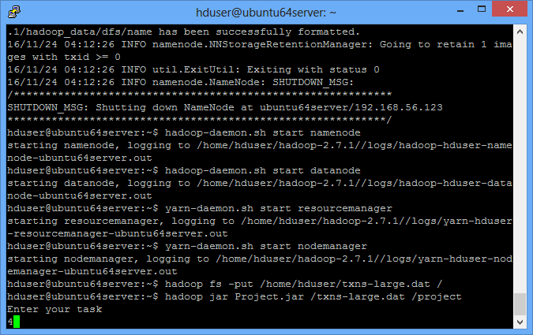

Output

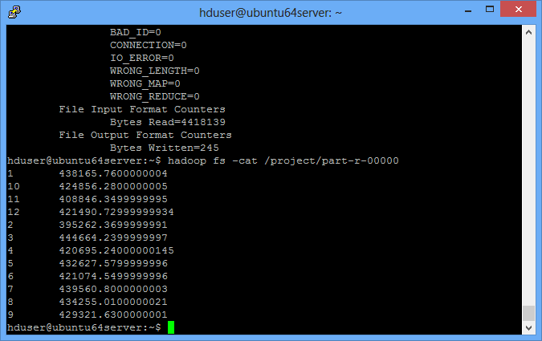

Execution Step:

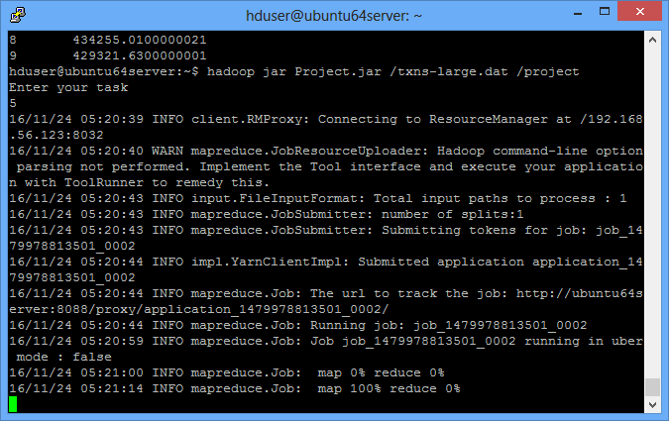

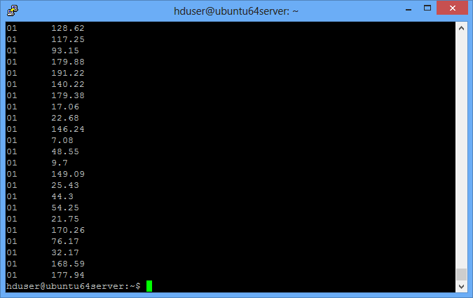

Report

**Gift card**

Gift cards can be an effective way to increase online sales, acquire new customers, and encourage return visits. It’s even discounted ones, may also contribute to margins. Kickback gift card promotions give money, in the form of a second gift card, back to the giver as a reward for buying the gift card. Under this category we have taken three tasks

1. Transaction made above 160.
2. Transaction made between the range 175 to 200
3. Number of transaction, Sum of transaction and average of transaction calculated for each customer.
4. We have implemented Custom Input Format and Validation.

Execution Step:

Transaction Task1

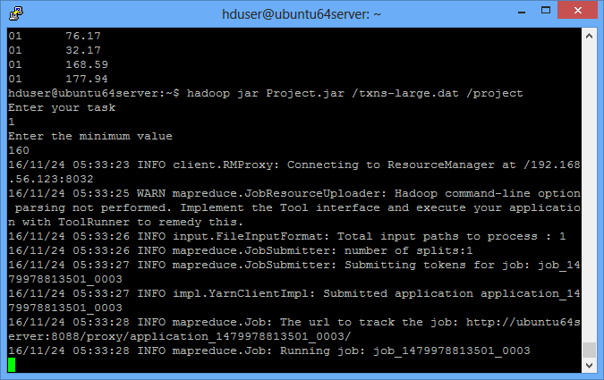

Output

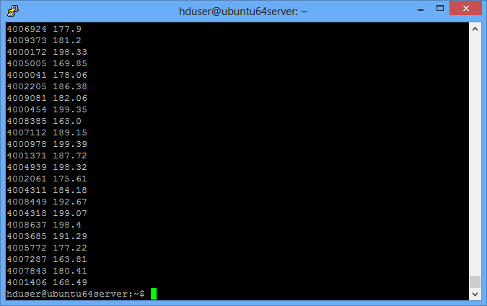

Transaction Task2

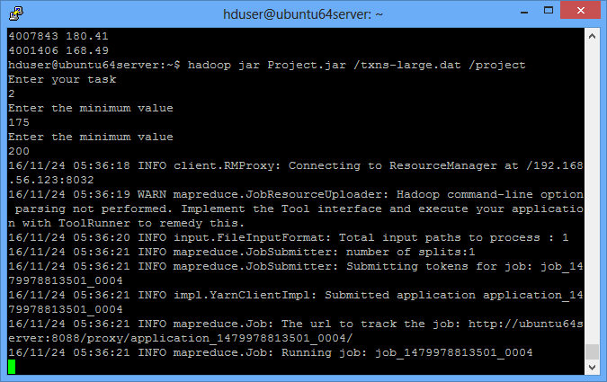

Output

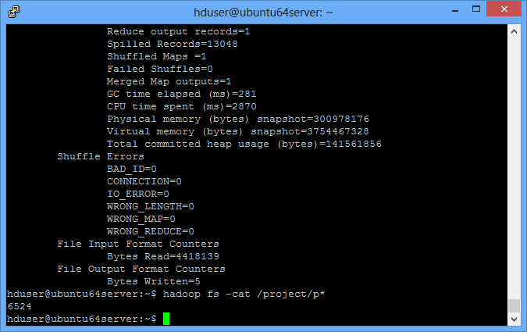

Transaction Task3

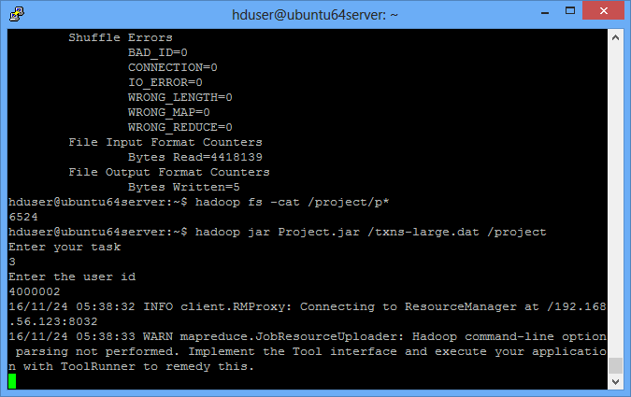

Output

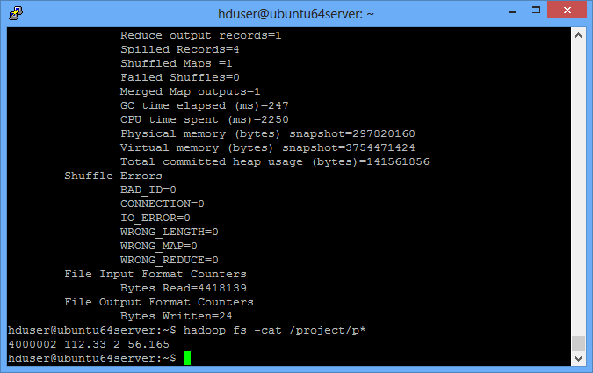

**Economic Growth**

E-Commerce is a business issue rather than a technology issue. It involves a number of forms, varying level of cost and complexity, depending on business need. It can also improve the operations through greater use of electronic book-keeping and records management. On line banking services such as electronic bill payment, funds transfer and payroll management improves the efficiency of the business.

**Extras**

**Payment mode**

Ecommerce is the exchange of goods and services enabled through an electronic method. It is also known as a sample of Electronic Data Interchange (EDI), e-commerce payment systems have become increasingly popular due to the widespread use of the internet-based shopping and banking. There are various forms of payment for ecommerce. From the given data we are having

* + Credit: The easiest form of electronic money that is available and most widely used today.
  + Cash: Cash on delivery has emerged as one of the most sought after services for e-commerce entities and it is reported that in some cases as high as 50 per cent of orders are placed with various online retailers with this payment option, while the remaining opt for credit card or bank payments.

**Conclusion**

The rapid growth in electronic commerce around world has prompted many to look for better ways of measuring the phenomenon. As more and more countries and international agencies become involved, it is important to develop plans to ensure that there is no unnecessary duplication of effort and that users have the data necessary for informed decision making at the earliest possible opportunity. From the above analysis, it appears that there are a number of actions to be taken to develop the organization economic and to satisfy the customer.