Confidential

Revision / Document History
Ver. | Date | Changed by | Modifications
0.1 | 21/07/2009 | Jagadeesh K | Initial version of document
0.2 | 23/07/2009 | Deepa Janamatti | Added design diagrams

Table of Contents
Introduction 3
1 Design Scope 3
2 Design Overview 3
3 Module Design 4
3.1 Parser Packages 4
3.2 Parser Factory Pattern 5
3.3 Parser Processors 7
3.4 Parser Model 7
3.5 Parser data model handler 8
3.6 Parser Utilities 9
4 Design Tools used 9
4.1 Co-ordinators for the Task 9

Abbreviations

Abbreviations and non-standard terms and acronyms that are used in this document are to be listed here.

RBEI Robert Bosch Engineering And Business Solutions Limited
HLD High Level Design

Introduction
The scope of this document is the design specification for Hex Parser to support parse S19 files.

Hex Parser is used to parse the Intel Hex files and Motorola S19 files and create a model which can be integrated with other projects.

Input parameters: Motorola S19 files

A pictorial diagram of the working of the Motorola S19 Parser is show below.

S19 File
Hex Data Model
Hex Parser

Design Scope

The scope of this design is for the Hex Parser to parse S19 files.

Design Overview

The main components of the hex parser to parse S19 files are depicted in the below diagram.

Output Hex Data Model
HexParser Factory
Motorola S19 Parser
Input S19 file
Data Persistent Layer
Business Layer
Model Layer
creates

The project created for the parser is “com.bosch.calcomp.hexparser” and is available in CVS under /sae/sae_components/plugins/com.bosch.calcomp.hexparser.

Module Design

Parser Packages
The hex parser packages are restructured as below.

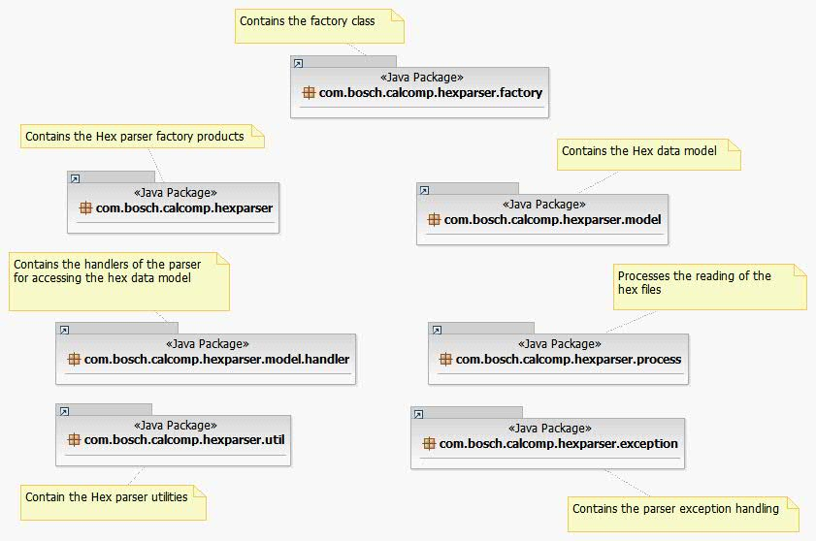

Figure 1: Parser packages

Parser Factory Pattern
The factory design pattern is used to create the IntelHexParser and MotorolaS19Parser

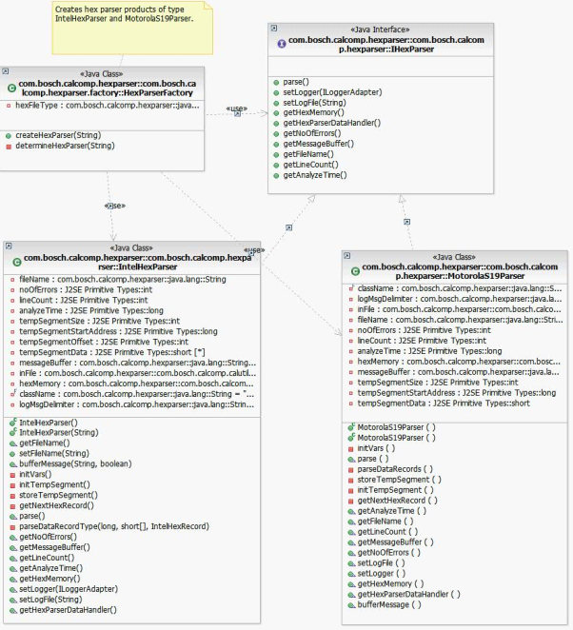

Figure 2: Parser Factory Pattern

Parser Processors

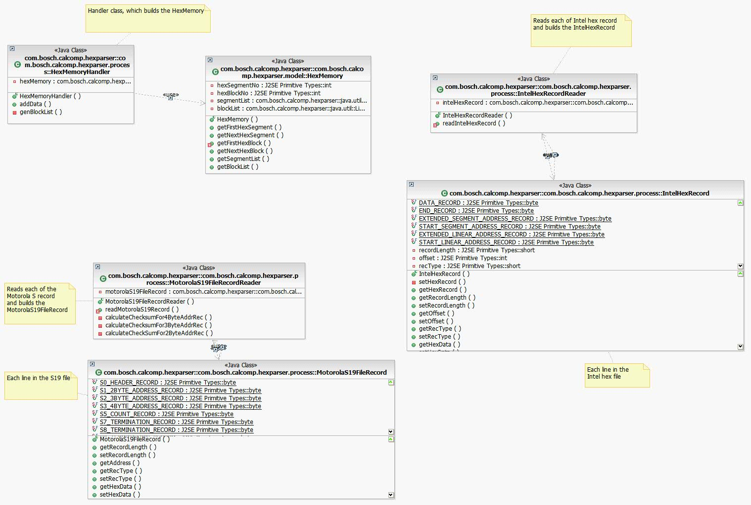

Figure 3: Parser processors

Parser Model
The Hex data model will be populated as shown in the below diagram. The model remains same for both Intel Hex file and Motorola S19 file.
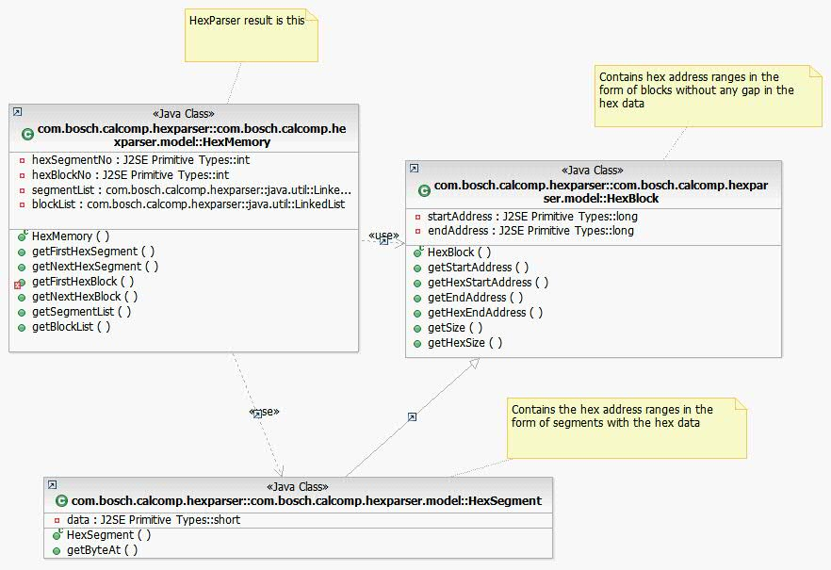

Figure 4: Hex Data Model

Parser data model handler
The hex data model can be accessed through HexParserDataHandler.

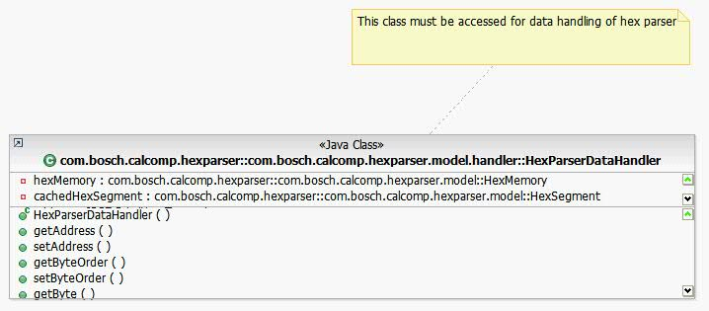
Figure 5: Parser data model handler

Parser Utilities
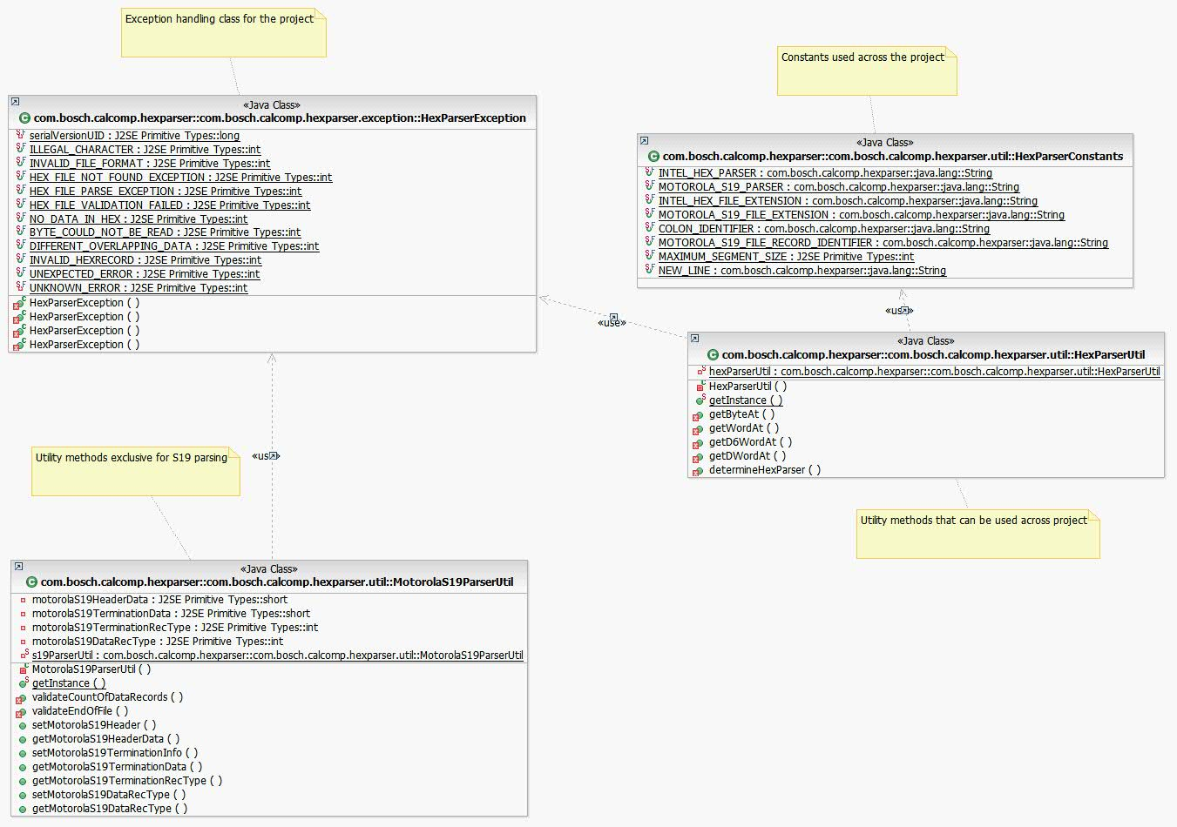

Figure 6: Parser Utilities

Design Tools used
Design tool used: IBM Rational Software Architect

Co-ordinators for the Task
RBEI : RBEI/EMT2-CalToolsTeam
Customer side : Mr. Henze Frank (DGS-EC/ESM4)

