FLOOD MONITORING AND EARLY WARNING SYSTEM

# OBJECTIVES:

## The objectives of a flood monitoring and early warning system are to:

1.***Risk Assessment:*** Assess and monitor flood-prone areas to understand the potential risks and vulnerabilities associated with flooding.

2.***Real-Time Data Collection:*** Continuously collect and analyze data from various environmental sensors, such as water level sensors, rain gauges, and weather stations.

3.***Early Detection:*** Identify early signs of flooding, such as rising water levels and heavy rainfall, to provide advance warning.

4.***Alert Generation:*** Develop a system that can generate timely alerts and warnings to the public, local authorities, and emergency services when flood risks are detected.

5.***Data Visualization:*** Provide a user-friendly interface for visualizing real-time data, enabling informed decision-making.

6.***Emergency Response Coordination:*** Enhance coordination among emergency response teams, enabling a faster and more effective response to flood events.

7.***Community Safety:*** Educate and raise awareness among the public about flood risks and appropriate safety measures to reduce the impact of floods.

8.***Mitigation and Planning:*** Use collected data to inform urban planning, flood mitigation strategies, and infrastructure improvements to reduce the impact of future floods.

Overall, the primary goal of a flood monitoring and early warning system is to save lives, protect property, and minimize the socio-economic impact of flooding through early detection and effective response.

# IOT SENSORS DEPLOYMENT:

## Deploying IoT sensors for flood monitoring and early warning systems involves several steps:

1.***Sensor Selection:*** Choose suitable IoT sensors for monitoring parameters like water level, rainfall, and weather conditions. These sensors should be durable and able to withstand harsh environmental conditions.

2.***Sensor Placement:*** Install sensors strategically in flood-prone areas, such as near rivers, streams, and in low-lying regions. Ensure proper calibration and connectivity.

3***.Data Collection:*** IoT sensors continuously collect data on water levels, rainfall, and other relevant factors. This data is sent to a central server for analysis.

4.***Data Analysis***: Implement algorithms to analyze the collected data in real-time. Look for trends, anomalies, and triggers that indicate potential flooding.

5.***Early Warning System:*** When the analysis detects possible flooding, activate an early warning system. This can include sirens, text messages, mobile apps, and other notification methods.

6.***Data Visualization:*** Present the data and flood alerts through user-friendly interfaces, such as web-based dashboards or mobile apps, to keep the public informed.

7.***Communication:*** Establish communication protocols with local authorities, emergency responders, and the community to ensure a coordinated response in the event of a flood.

8.***Regular Maintenance***: Maintain and calibrate the sensors to ensure their accuracy. Monitor the network's health and make necessary repairs or updates.

9***.Test and Evolve***: Regularly test the system to ensure it functions correctly. Continuously improve the system based on user feedback and changing environmental conditions.

10.***Public Awareness***: Educate the public about the system and how to respond to flood warnings. Encourage preparedness.

Successful IoT sensor deployment for flood monitoring and early warning systems can help save lives and minimize property damage during flooding events.

# PLATFORM DEVELOPMENT:

## Platform development for flood monitoring and early warning system:

Developing a flood monitoring and early warning system is a complex task that involves various components. Here's a high-level overview of the platform development process:

1***.Data Collection:***

•Integrate various data sources, such as weather data, river level sensors, and rainfall measurements.

•Use remote sensing technologies like satellites and drones for real-time data collection.

2.***Data Processing and Analysis:***

•Implement data processing pipelines to clean, transform, and store incoming data.

•Use geospatial analysis to assess flood risk and predict potential flood areas.

3.***Modeling and Forecasting:***

•Develop predictive models using historical data to forecast potential flood events.

•Incorporate machine learning and AI algorithms to improve accuracy.

4.***Early Warning System:***

•Set up an alerting system to disseminate warnings to authorities and the public.

•Utilize communication channels like SMS, mobile apps, and sirens.

5.***Geographic Information System (GIS):***

•Integrate GIS tools to visualize and map flood-prone areas.

•Provide real-time maps and flood extent information.

6.***Community Engagement:***

•Develop public awareness campaigns to educate communities on flood risks and preparedness.

•Encourage community reporting of flood events through mobile apps.

7***.Infrastructure for Remote Monitoring:***

•Install and maintain a network of remote sensors and monitoring stations.

•Ensure redundancy and backup systems for data collection.

8.***Scalability and Redundancy:***

•Design the system to scale with the potential increase in data volume.

•Implement redundancy and failover mechanisms to ensure system availability.

9.***Data Storage and Retrieval:***

•Choose appropriate databases and storage solutions for data retention.

•Enable quick data retrieval for analysis and reporting.

10.***Regulatory Compliance:***

•Ensure the system complies with relevant regulations and data privacy laws.

•Coordinate with government agencies for data sharing and compliance.

11.***User Interfaces:***

•Create user-friendly interfaces for both the public and emergency responders.

•Provide dashboards for data visualization and real-time monitoring.

12.***Testing and Validation:***

•Conduct extensive testing to verify the accuracy of the warning system.

•Validate the system's effectiveness in real-world scenarios.

13.***Maintenance and Updates:***

•Regularly update and maintain the system to adapt to changing conditions.

•Monitor and calibrate sensors to ensure accuracy.

14.***Collaboration:***

•Collaborate with meteorological agencies, local governments, and disaster management organizations for data sharing and coordinated responses.

15.***Education and Training:***

•Train personnel and the public on how to use the system and respond to warnings.

16.***Continuous Improvement:***

•Gather feedback and data to continuously improve the system's accuracy and effectiveness.

Developing a flood monitoring and early warning system is an ongoing process that requires a multidisciplinary team, adequate funding, and close collaboration with relevant stakeholders. It plays a crucial role in mitigating the impact of floods and saving lives.

# CODE IMPLEMENTATION:

## Code implementation for flood monitoring and early warning system:

Implementing a flood monitoring and early warning system is a complex task that typically involves multiple components, such as data collection, data analysis, and communication. Here's a high-level overview of how you can implement such a system:

1.***Data Collection:***

•Set up sensors for monitoring water levels, rainfall, and weather conditions in flood-prone areas.

•Collect data from these sensors and store it in a database.

2.***Data Analysis:***

•Develop algorithms to process the collected data to detect potential flood events.

• This might involve analyzing rainfall patterns, river water levels, and weather forecasts.

•Use historical data to create baseline models for flood prediction.

3.***Early Warning System:***

•Establish trigger thresholds for different sensors and data points that indicate potential flooding.

•When these thresholds are crossed, trigger warnings or alerts.

4.***Alert and Notification:***

•Implement a notification system to alert relevant authorities and residents in the affected areas.

•Notifications can be sent through SMS, mobile apps, email, or automated phone calls.

5.***GIS Integration:***

•Integrate Geographical Information System (GIS) to visualize the flood-prone areas and the real-time data on a map.

•Use GIS for better decision-making and response coordination.

6.***Response Planning:***

•Develop protocols for emergency response, evacuation plans, and resource allocation.

7.***Community Engagement:***

•Educate the local community about the early warning system and what to do in case of a flood.

•Provide information through community meetings, websites, and social media.

Here's a simplified Python code example for a flood warning system that monitors water levels using random data:

import random

def monitor_water_levels():

water_level = random.randint(0, 100) # Simulate water level data

return water_level

def check_flood_risk(water_level_threshold):

water_level = monitor_water_levels()

if water_level > water_level_threshold:

return f"Warning: Water level ({water_level} cm) is above threshold ({water_level_threshold} cm). Potential flood risk!"

def main():

water_level_threshold = 70 # Set your desired threshold

alert = check_flood_risk(water_level_threshold)

if alert:

print(alert)

else:

print("No flood risk detected.")

if __name__ == "__main":

main()

This is a very basic example. In a real-world system, you would replace the random data with actual sensor data, implement data analysis, and integrate with a notification system and GIS for comprehensive flood monitoring and early warning. Additionally, you may need to adhere to data privacy and security regulations when handling sensitive information.

***FLOOD MONITORING SYSTEM IOT DAIGRAM:***

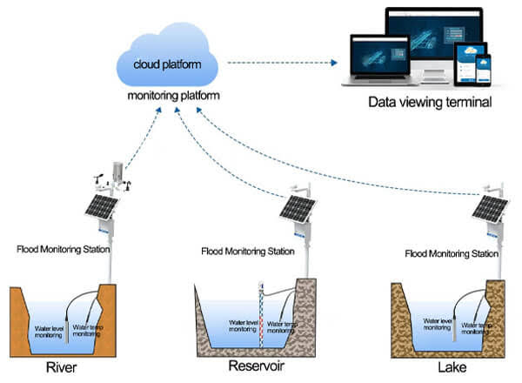

***FLOOD MONITORING SYSTEM IOT SEMANTICS:***

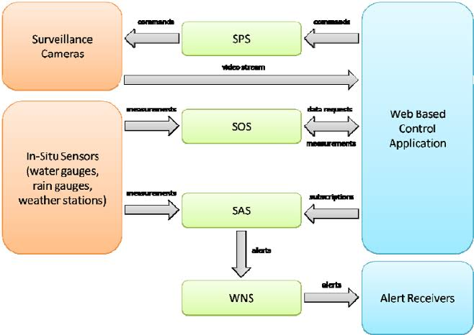

***FLOOD MONITORING SYSTEM SCREENSHOTS FOR IOT SENSORS:***

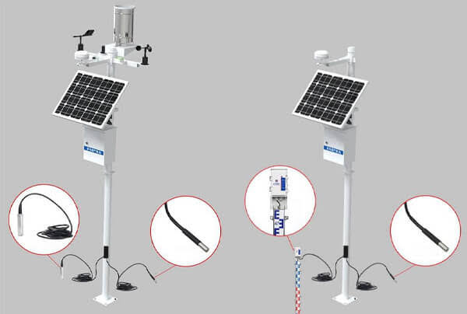

# The real-time flood monitoring and early warning system can enhance public safety and emergency response coordination:

A real-time flood monitoring and early warning system can significantly enhance public safety and emergency response coordination in several ways:

1.***Early Warning***:

The system continuously monitors weather conditions, river levels, and other relevant data. When it detects conditions conducive to flooding, it can issue early warnings to the public, allowing them to take preventive measures or evacuate in advance.

2.***Rapid Response:***

Emergency response teams can be alerted as soon as the system detects an imminent flood threat. This enables them to mobilize quickly, allocate resources, and prepare for rescue and relief efforts, potentially saving lives.

3.***Timely Evacuation:***

Residents in flood-prone areas receive timely alerts, helping them evacuate safely. This minimizes the risk of people being trapped in hazardous situations and reduces the need for high-risk rescues.

4.***Resource Allocation***:

Emergency services can better allocate resources, such as boats, helicopters, and medical supplies, based on real-time data, ensuring that they are deployed to areas with the greatest need.

5.***Communication and Coordination***:

The system provides a common platform for various agencies and stakeholders to share information and coordinate response efforts. This streamlines communication and avoids duplication of efforts.

6.***Infrastructure Protection***:

Early warnings can also be used to safeguard critical infrastructure like dams and bridges, giving authorities time to take protective measures or release controlled amounts of water to prevent catastrophic failures.

7.***Data for Decision-Making:***

Decision-makers have access to up-to-date data, enabling them to make informed choices about evacuation orders, road closures, and emergency declarations.

8.***Public Awareness***:

Over time, the system can raise public awareness about flood risks and preparedness, leading to a more informed and proactive population.

9.***Reduction in Casualties:***

By providing timely information and facilitating organized responses, the system can lead to a significant reduction in flood-related injuries and fatalities.

In summary, a real-time flood monitoring and early warning system serves as a critical tool for mitigating the impact of floods by improving preparedness, response, and coordination, ultimately enhancing public safety and minimizing the loss of life and property during flood events.