Issue No. | Sheet No. | Rev. No. | Title | Date
1 | 1-23 | 0 | User Manual of TVS NIRIX B110 Cluster Flashing Application | 23-07-2026

PREPARED BY | REVIEWED BY | APPROVED BY | ISSUE NO
SRI SAKTHIVEL R | MALLAMMA M PUJAR | J SOMA SUNDAR | 1
TABLE OF CONTENTS
1. INTRODUCTION 2
1.1 Overview 2
1.2 Scope 2
2. INSTALLATION 3
2.1 SYSTEM REQUIREMENTS 3
2.2 SOFTWARE INSTALLATION 3
2.3 HARDWARE SETUP 3
3. FILE MANIPULATION 4
4. SETUP FILE INSTALLATION 5
5. CONFIGURATION 7
5.1 PCAN CONFIGURATION 7
5.2 SCANNER.INI CONFIGURATION 8
5.3 STATION.INI CONFIGURATION 8
5.4 API.INI CONFIGURATION 9
5.5 SKU MAPPING 10
6. APPLICATION OVERVIEW 10
6.1 APPLICATION STARTUP 11
6.2 APPLICATION WORKFLOW 12
6.3 AUTOMATED TEST SEQUENCE 13
6.4 APPLICATION EXECUTION PROCEDURE 14
Step 1 – Scan the VIN 15
Step 2 – SKU Retrieval 15
Step 3 – IPC IMEI and IPC ICCID Number 16
Step 4 – Hex_Version_Check 16
Step 5 – HEX Flashing 17
Step 6 – WIC Flashing 18
7. TEST COMPLETION 18
PASS 19
FAIL 19
8. LOG FILES 20
9. TROUBLESHOOTING 20
9.1 Application Fails to Launch: 21
9.2 Scanner Issues: 21
9.3 API Connection Problems: 21
9.4 Log Deletion Fails: 21
9.5 Can Communication Error: 21
9.6 Test Sequence Failure: 21
9.7 Incorrect API Address Retrieval: 22
9.8 UI Freezing or Crashing: 22
10. SAFETY PRECAUTIONS 22

1. INTRODUCTION

1.1 Overview
The B110 Cluster Flashing application is a specialized tool designed to automate the flashing and validation process of B110 clusters. The application streamlines software updates by performing IMEI Number verification, ICCID1/ICCID2 Number verification, HEX version verification, WIC version checking, and firmware flashing operations through a guided workflow.

The tool minimizes unnecessary flashing by comparing the current software versions with the available HEX and WIC files before initiating the flashing process. It provides real-time status updates, progress monitoring, and detailed test results to ensure reliable and efficient cluster programming.
The tool automatically retrieves the corresponding SKU information, loads the appropriate production test sequence, and performs all required ECU programming, verification, and diagnostic operations. Upon completion, the application displays the final test result as PASS or FAIL and generates detailed log files for traceability and troubleshooting.
The application minimizes manual intervention, reduces production time, and ensures consistency and reliability during vehicle testing.

1.2 Scope
This document provides comprehensive instructions for operating the TVS NIRIX Production Tool during vehicle production testing. It outlines the application workflow, operator responsibilities, automated test execution process, result interpretation, and log generation procedures to ensure efficient and accurate production validation.

This manual provides step-by-step guidance for operating the B110 Cluster Flashing Application. It explains the complete flashing workflow, validation process, and result interpretation, enabling users to perform cluster programming reliably and verify successful flashing outcomes with confidence.

2. INSTALLATION

2.1 SYSTEM REQUIREMENTS
- Operating System: Windows 10/11 (64-bit)
- Processor: Intel Core i5 or equivalent
- RAM:8GB
- Storage: 10-15 GB free space
- Internet connection required for API communication

2.2 SOFTWARE INSTALLATION
- Install PCAN-Basic API from Drivers: PEAK-System.
- Download the distributed .zip package with the TVS NIRIX setup file and extract them.
- PCAN-View: Used to verify whether the PCAN VCI is communicating with the vehicle, the application interface will appear as shown like the below figure,
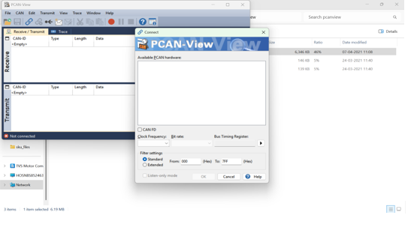

2.3 HARDWARE SETUP
- USB Ports: At least three available USB ports are required for the Scanner, PCAN adapter and for USB Flashing.
- Scanner Device: Serial-based scanner with COM port support (USB-to-Serial adapter).
- PCAN VCI: Required for CAN communication and is implemented in all the test sequences with the help of PEAK drivers.

3. FILE MANIPULATION
The below figure will list down the files and folders in the setup file,
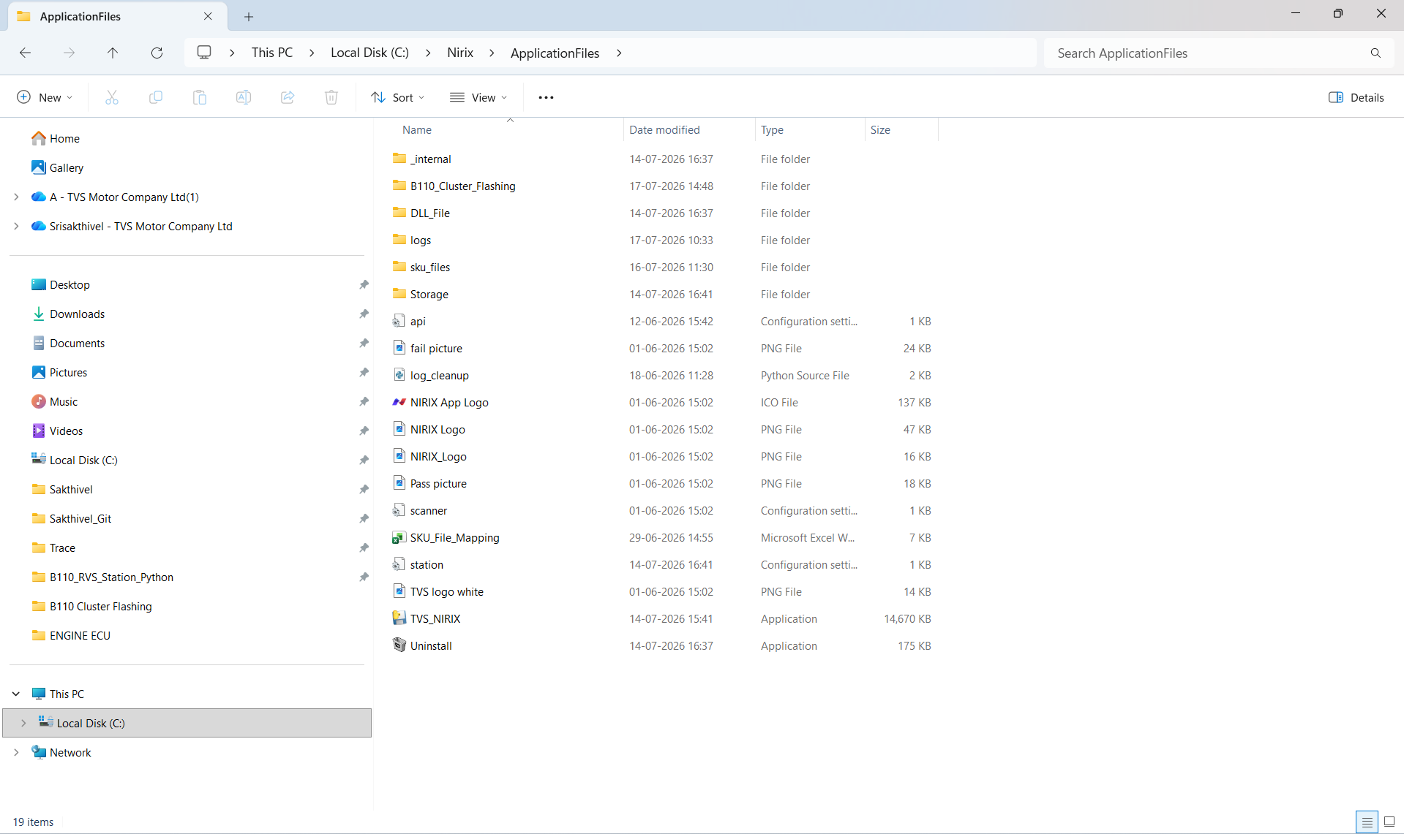

- Api.ini: API Configuration
- Scanner.ini: Scanner COM Port Settings
- Station.ini: Station.ini Settings
- SKU_File_Mapping.xlsx: SKUs to test sku_files
- Sku_files/: Folder containing SKU test file sequences (Ex.NMB14100GB-details.xlsx)
- DLL File/: Folder where the dll file exists to run the Security
- TVS_NIRIX: Executable file, run this to open the application.
- Storage: .zip file location and inside .hex and .wic files will be present.
- B110_Cluster_Flashing/: Folder where it contains the test sequences.
- Logs/: MPU flash trace files will be saved
- _internal/: Folder contains all the libraries
- Uninstall: To delete the installed setup file

4. SETUP FILE INSTALLATION
- The setup file has been given to you. You need to click on that file; it will open as shown in the figure below.

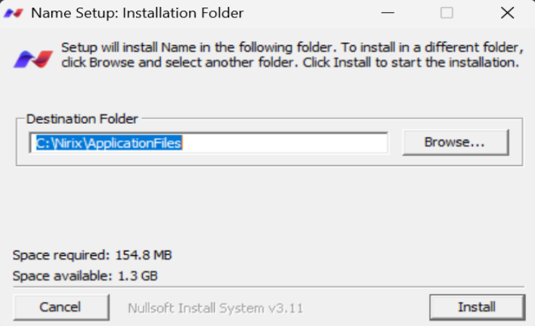

- As shown in the figure, there is an entry field that allows you to select the destination folder where you can save the file. After choosing the folder, click the Install button it starts to install the application as shown below,

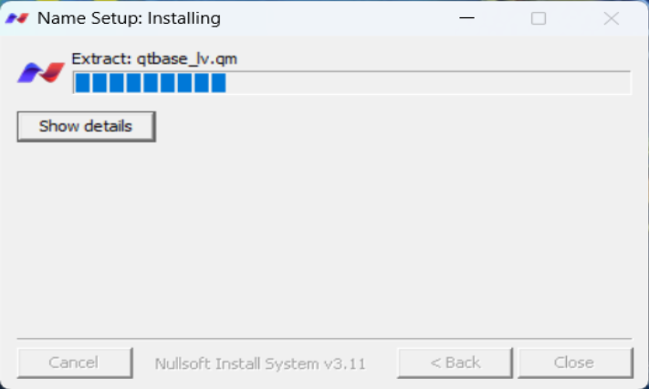

- After completion of the installation, we can close the setup file as shown in the figure below.

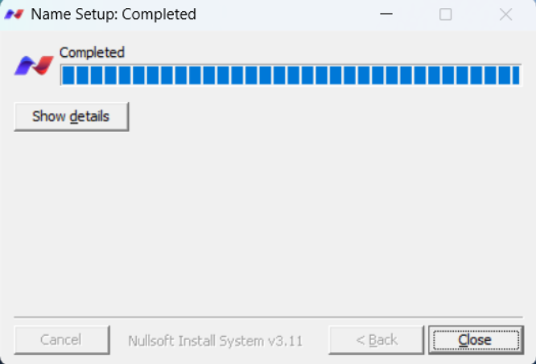
- After closing the setup file, you can see the application where you have selected the destination folder, as shown in the figure below,

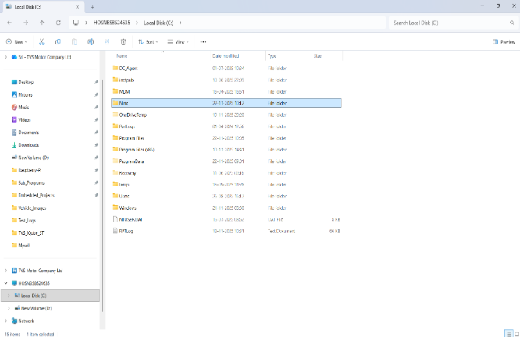

5. CONFIGURATION

5.1 PCAN CONFIGURATION
- No manual configuration is required in the GUI; ensure the PCAN adapter is connected to the cable where the vehicle is connected.
- Check the LED on the CAN interface. If the LED is on, then the driver was initialized successfully.
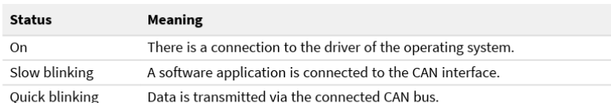
- If not already configured, set the bitrate to 500 kbit/s and the clock frequency to 8 MHz in PCAN-View. Then, click "OK" to establish the connection between the vehicle and PCAN.
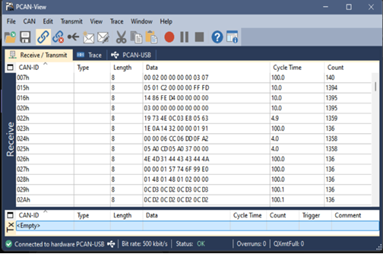

5.2 SCANNER.INI CONFIGURATION
- Location: Destination folder where you have selected when you install the setup.
- Ensure that the scanner.ini file is within the zip folder to get the connection_mode details to scan the VIN number. The scanner.ini looks like,
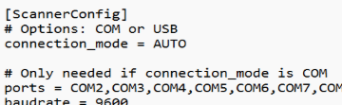
- Check whether the scanner is in serial connection_mode, to check that go to device manager ->port
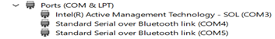

5.3 STATION.INI CONFIGURATION
- Location: Destination folder where you have selected when you install the setup.
- active_library: Specifies the test library (default: test_library).
- log_deletion_days: Number of days to retain log files, if we do not give the deletion days by default the logs are deleted within 4 days.
- Log_folder_path: Path to store the xml logs as well as can_trace files while flashing.
- Operation No: Station number based on Track and Trace
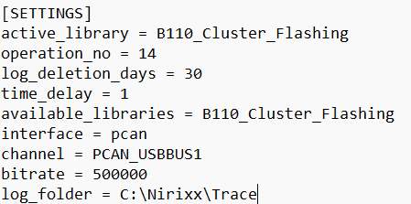

5.4 API.INI CONFIGURATION
The TVS NIRIX app talks to an external system using an API to get data and send test results.
- Location: Destination folder where you have selected when you install the setup.

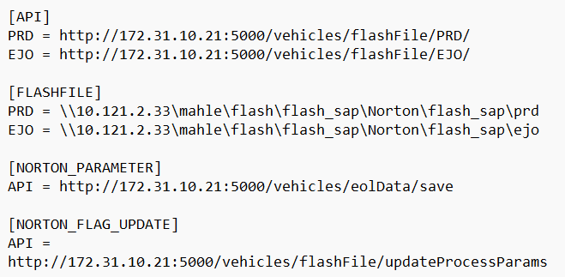

- API Address: It uses Norton updateProcessParams API, This address updates the flashing flag status as OK/NOK based on the result.
- Getting Data: Sends the VIN to the API based on PRD and EJO.
- Sending Results: Sends a simple message with the VIN and result (OK or NOK) in this format:

5.5 SKU MAPPING
- Vehicles have different SKU numbers accordingly. Here for the model B110 we have list of SKUs with ICCID1 and with ICCID2
- When we select the preferred active library for a vehicle, the corresponding SKU number is retrieved based on the VIN. This SKU number is then mapped to the appropriate table structure using the SKU details Excel file, allowing us to load the correct layout for models like B110

6. APPLICATION OVERVIEW
The TVS NIRIX Production Tool delivers a fully automated testing environment for vehicle production operations. Upon scanning the Vehicle Identification Number (VIN), the application automatically retrieves the corresponding vehicle SKU, loads the predefined production test sequence, and executes all required diagnostic, validation, and programming procedures without manual intervention. This streamlined approach ensures consistency, efficiency, and accuracy throughout the production testing process.

The operator is required only to establish the necessary hardware connections, launch the application, scan the Vehicle Identification Number (VIN), and initiate the test sequence. Once started, the application autonomously manages all subsequent diagnostic, validation, and programming activities, eliminating the need for further manual intervention and ensuring a seamless, efficient production workflow.
The primary functions of the application include:
- VIN acquisition using a barcode scanner or through manual entry.
- Automatic VIN validation before initiating the test sequence.
- Automatic SKU retrieval based on the validated VIN.
- Automatic selection and loading of the appropriate production test configuration.
- Automatic loading of the active test library is based on the retrieved SKU.
- CAN communication establishment and diagnostic session management.
- ECU identification and connectivity verification.
- ECU firmware flashing.
- Flashing progress monitoring with real-time status updates.
- ECU software version verification after flashing.
- Verification of flash programming success through post-programming validation.
- Execution of automated production test sequences.
- Automatic PASS/FAIL evaluation based on test results.
- Real-time display of test progress and execution status.
- Automatic generation of detailed execution logs.
- Storage of test results for traceability and quality records.
- Automatic error detection and reporting with diagnostic information.
- Automatic recovery or retry handling for supported communication failures.
- User guidance through on-screen instructions during the test process.
- Automatic cleanup and termination of the test session upon completion.

6.1 APPLICATION STARTUP
Before launching the application, verify that all hardware connections have been completed successfully.
Follow the steps below to start the application:
- Connect the PCAN USB adapter to the computer.
- Connect the CAN communication cable between the PCAN adapter and the vehicle.
- Connect the barcode scanner to the computer.
- Power up the ECU.
- Launch the TVS NIRIX Production Application.
- Wait until the application initializes all communication interfaces.
- Confirm that the application is ready for operation.
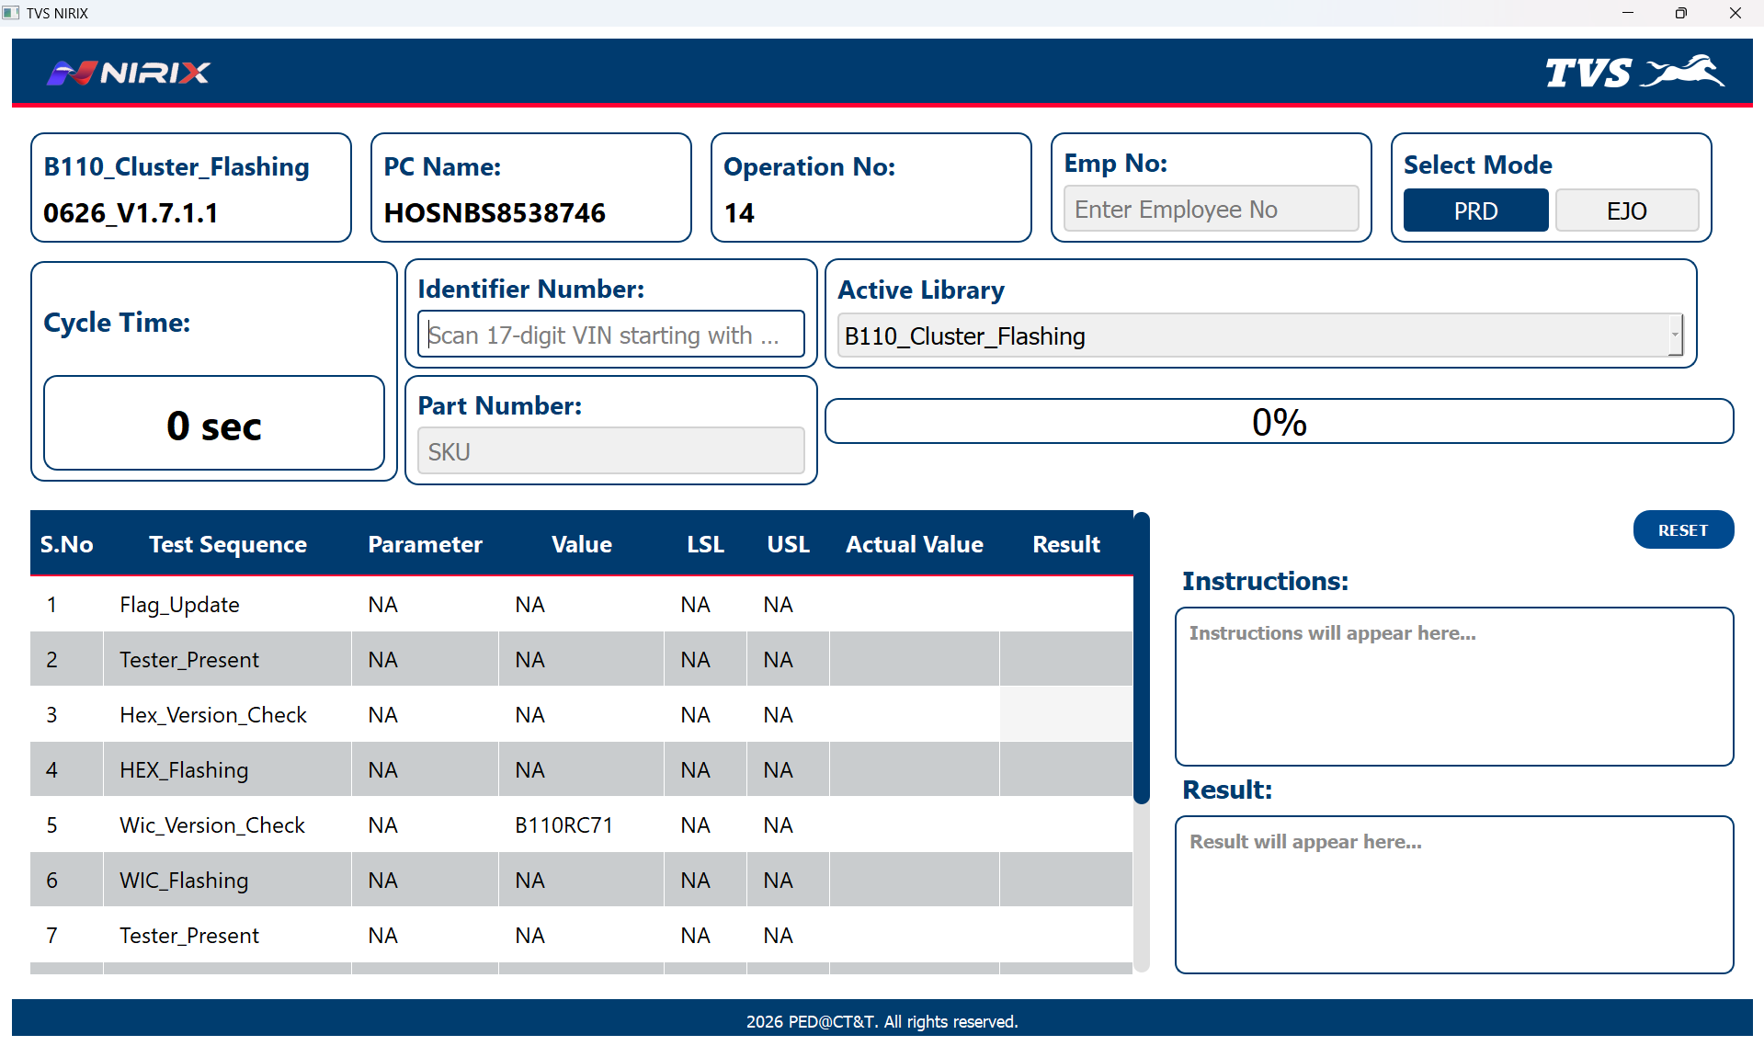

6.2 APPLICATION WORKFLOW
The workflow ensures the device is correctly identified, communication parameters are verified, and the required software (HEX/WIC) is flashed only when needed before completing the operation.
The overall workflow is as follows:
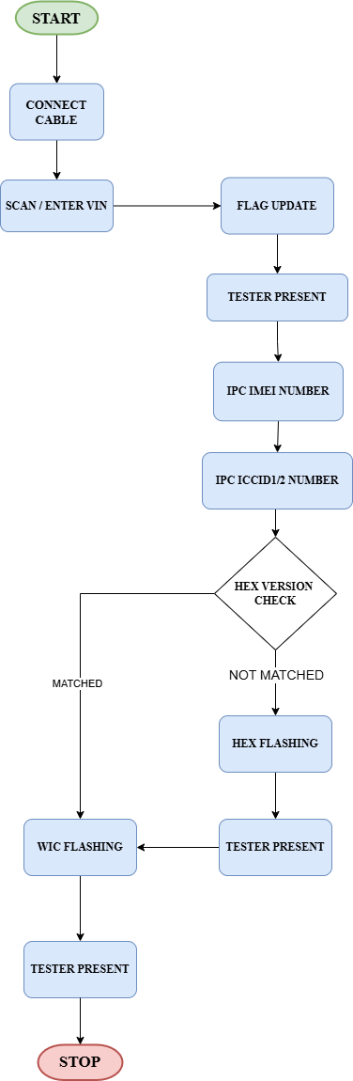

6.3 AUTOMATED TEST SEQUENCE
The application automatically executes the following production tests.
S.NO | TEST SEQUENCE | DESCRIPTION
1 | Flag Update | Updates the ECU/IPC configuration flags to enable the required features and ensure correct software settings.
2 | Tester Present | Sends a periodic diagnostic message to keep the communication session active and prevent ECU timeout during testing or flashing.
3 | IPC IMEI Number | Reads and verifies the IPC module's IMEI (International Mobile Equipment Identity) to ensure a valid and unique telematics device identity.
4 | IPC ICCID1 Number | Reads and verifies the primary SIM card ICCID (Integrated Circuit Card Identifier) stored in the IPC for network connectivity validation.
5 | Hex Version Check | Compares the currently installed firmware HEX version with the target version to determine whether a software update is required.
6 | HEX Flashing | Programs the IPC/ECU with the required HEX firmware file when the existing version is outdated or mismatched.
7 | Tester Present | Maintains the diagnostic session active during or after HEX flashing to ensure uninterrupted communication.
8 | WIC Flashing | Programs the WIC (Wireless Interface Controller) software/configuration to the specified version.
9 | Tester Present | Performs a final session maintenance check to keep communication active until all flashing and validation activities are completed successfully.

6.4 APPLICATION EXECUTION PROCEDURE
The following procedure shall be followed for every production vehicle.

Step 1 – Scan the VIN
Scan the vehicle's VIN barcode using the barcode scanner. The scanned Vehicle Identification Number (VIN) is automatically captured and displayed in the application.
Alternatively, manually enter the 17-character Vehicle Identification Number (VIN) into the Identifier Number field (e.g., SH123456789012345).
The application validates the scanned VIN before initiating the test sequence.

Step 2 – SKU Retrieval
After successful VIN validation, the application automatically retrieves the corresponding SKU information.
The retrieved SKU is used to identify and apply the appropriate test sequences for the vehicle.
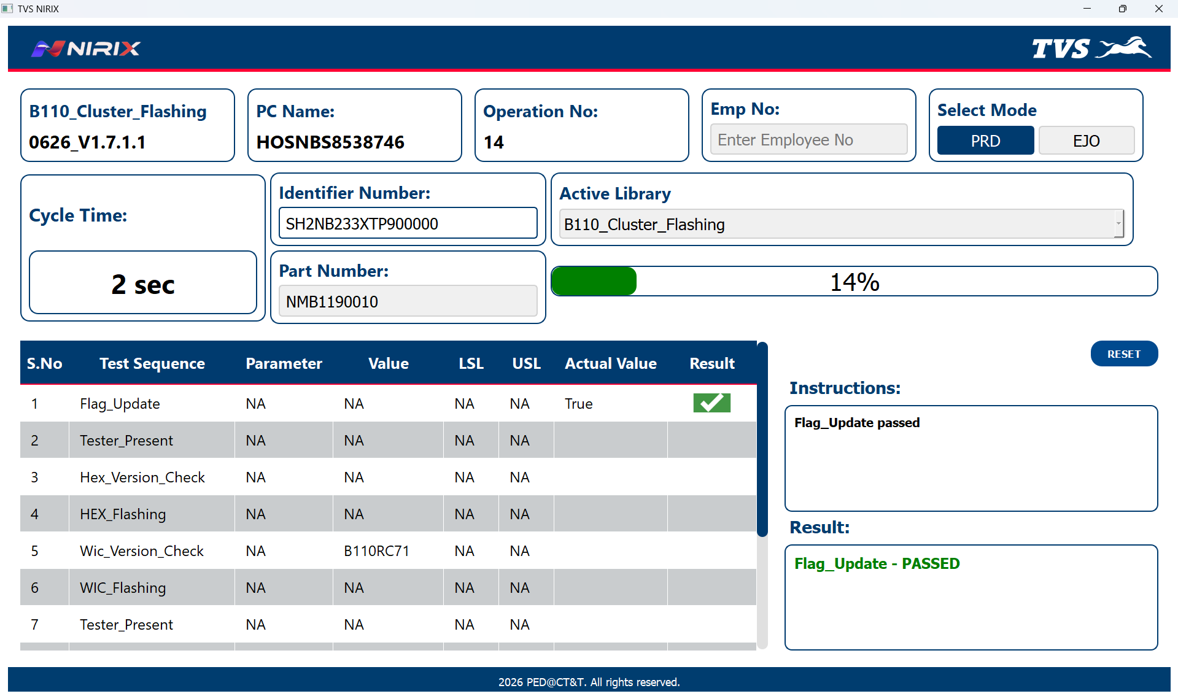

After SKU selection, we will fetch the flash file name based on the VIN Number and we will look for the local .zip file if it is there and not extracted, our application will extract as shown in the below figure,
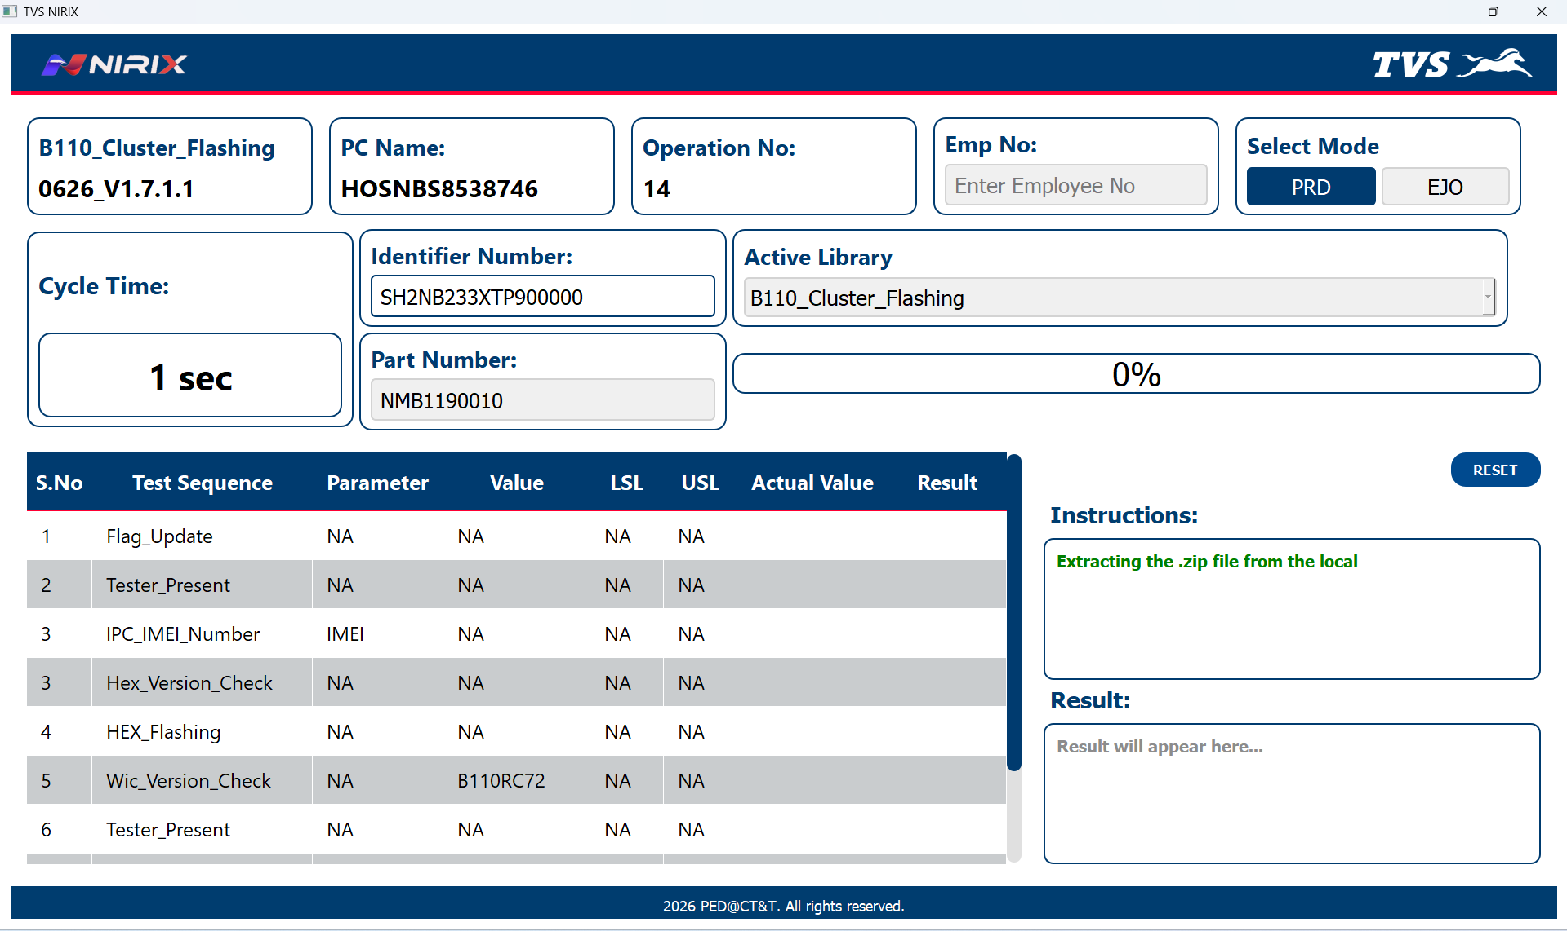

Step 3 – IPC IMEI and IPC ICCID Number
This test sequence reads the ECU IMEI and ICCID data from the ECU and compares with the API data. If ECU data and the API data is matched it will pass to the next test sequence and if it is not matched it will fail and show the not matched error description.
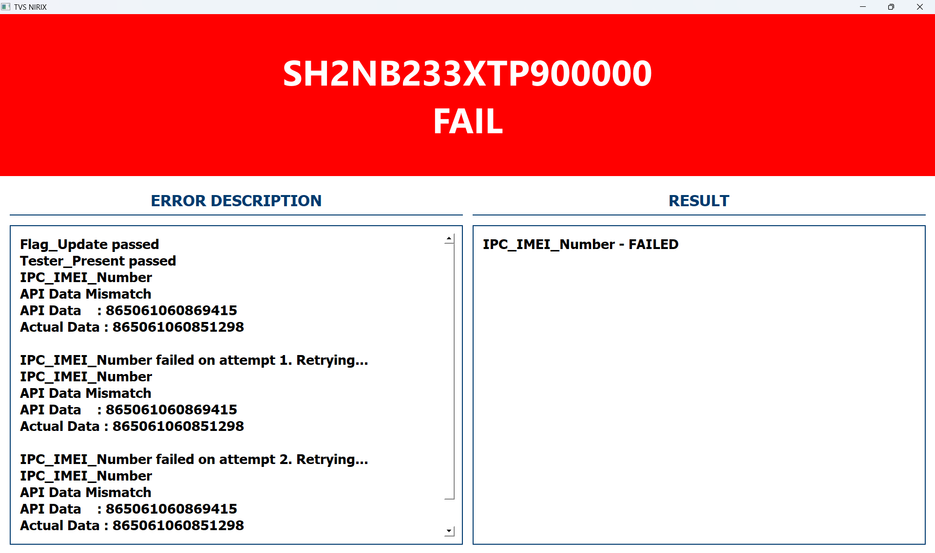

Step 4 – Hex_Version_Check

This test sequence reads the ECU software version and compares this data with the API data. If it is matches then the HEX Flashing is Skipped by showing this message in the instruction box as shown in the below figure,

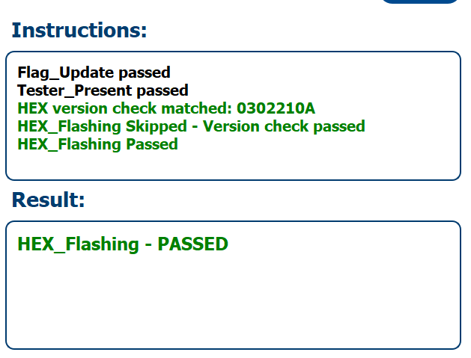

If the ECU data and the API data is not matched, then the Hex Flashing sequence will run by showing this message in the instruction box and the result box as shown in the figure,
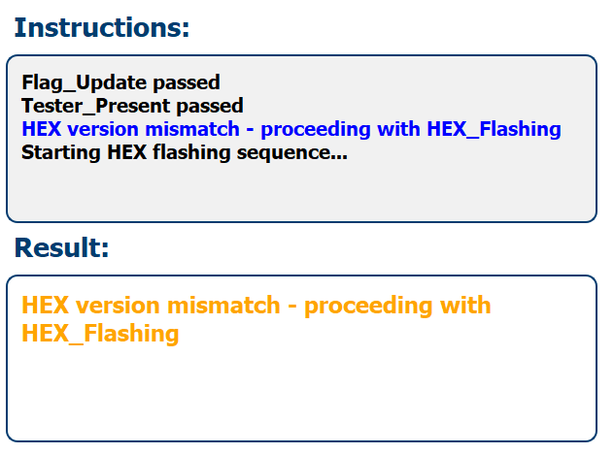

Step 5 – HEX Flashing
In this test sequence, if the Hex Version Check is matched this HEX Flashing test sequence will be skipped and if the Hex Version Check is not matched then the HEX Flashing test sequence will run by opening the popup Ui as shown in the figure,
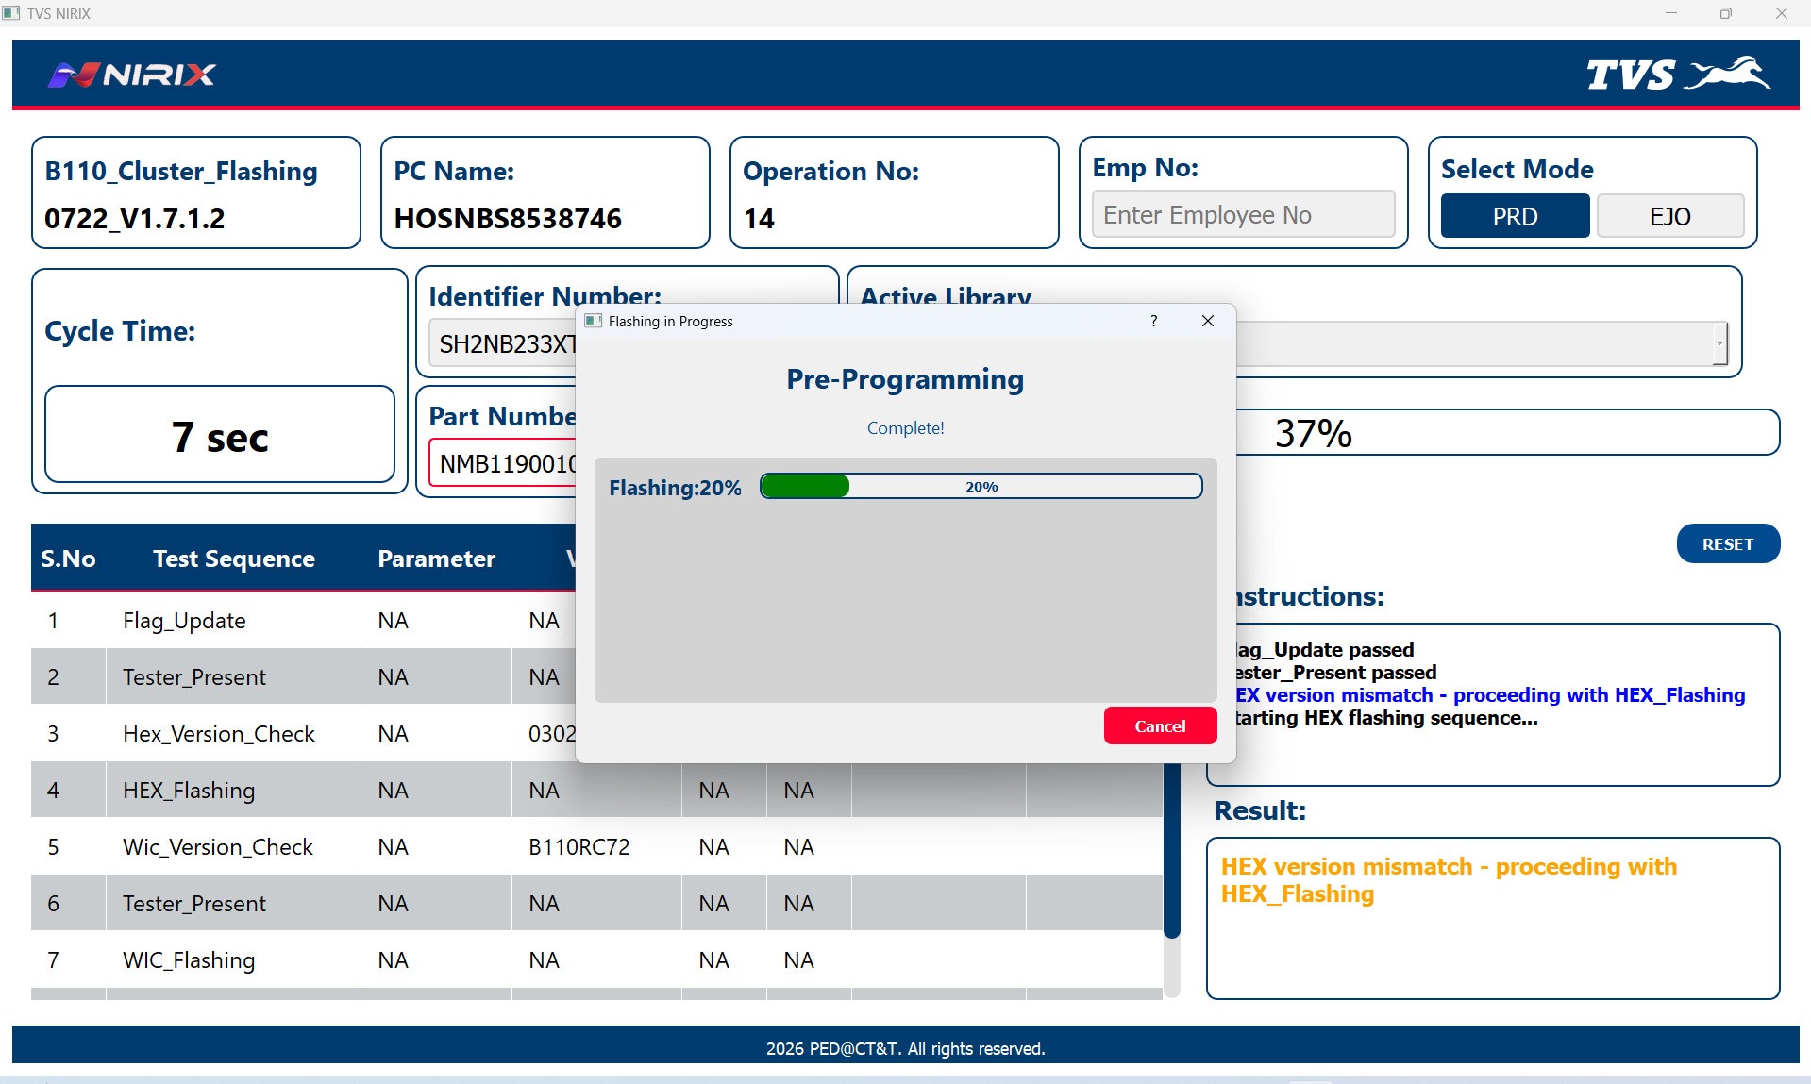

After Completion of the Data Transfer in the HEX Flashing, ECU Reset will happen so the ECU will be turned ON and ready for the next test sequence.

Step 6 – WIC Flashing
In this WIC Flashing test sequence, it will open the popup Ui just like the HEX Flashing and starts flashing using the uuu.exe with Shielded USB cable as shown in the below figure,

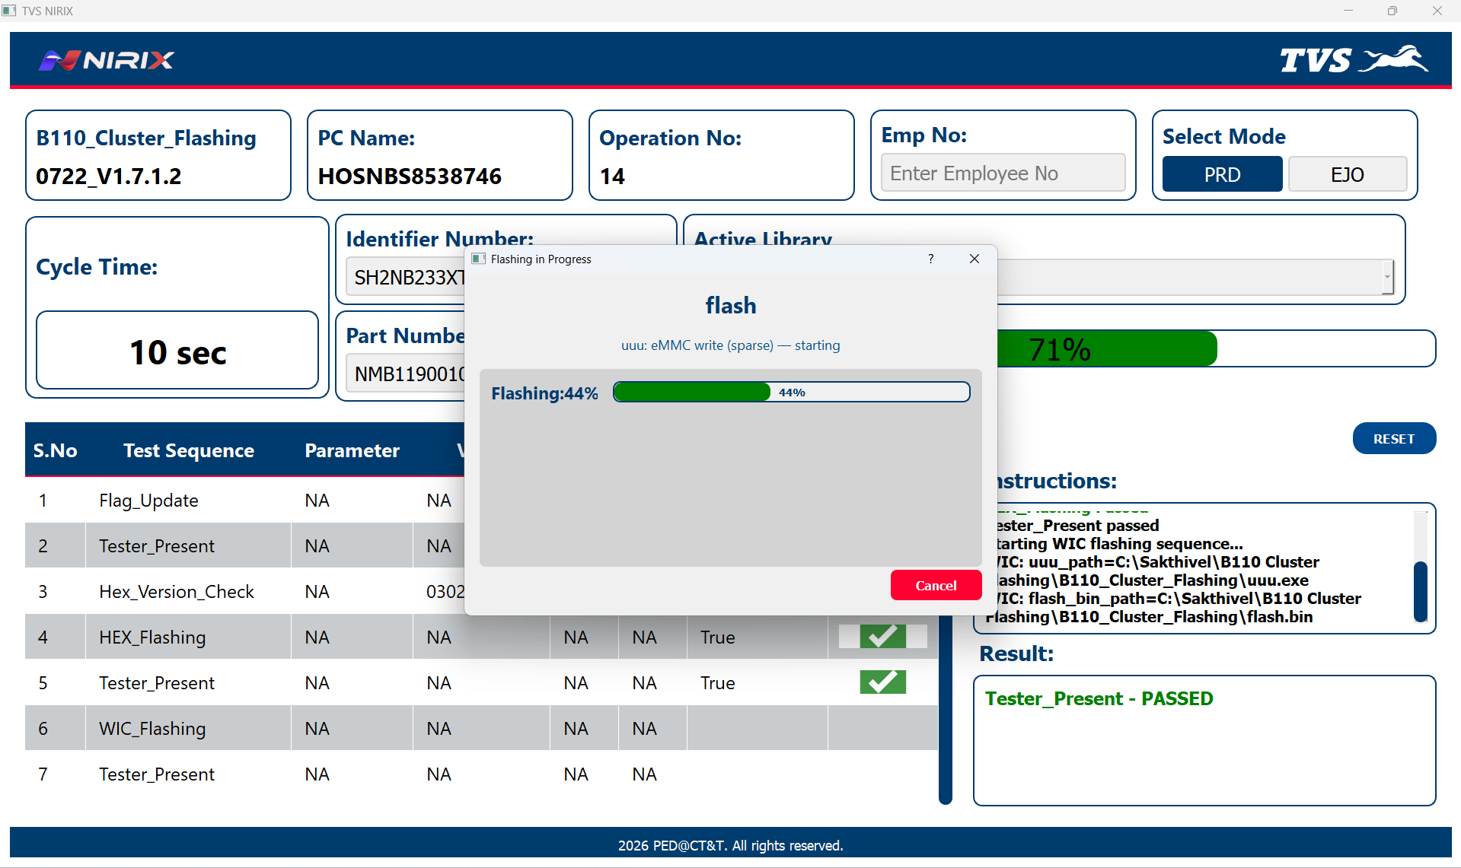

7. TEST COMPLETION

PASS
When all the test sequences are completed successfully, the application displays a PASS result.
A PASS result indicates that:
- ECU communication and the Flashing was successful.
- Production logs were generated successfully.
- Flags are updated for the param pairs and operation No in track and trace.
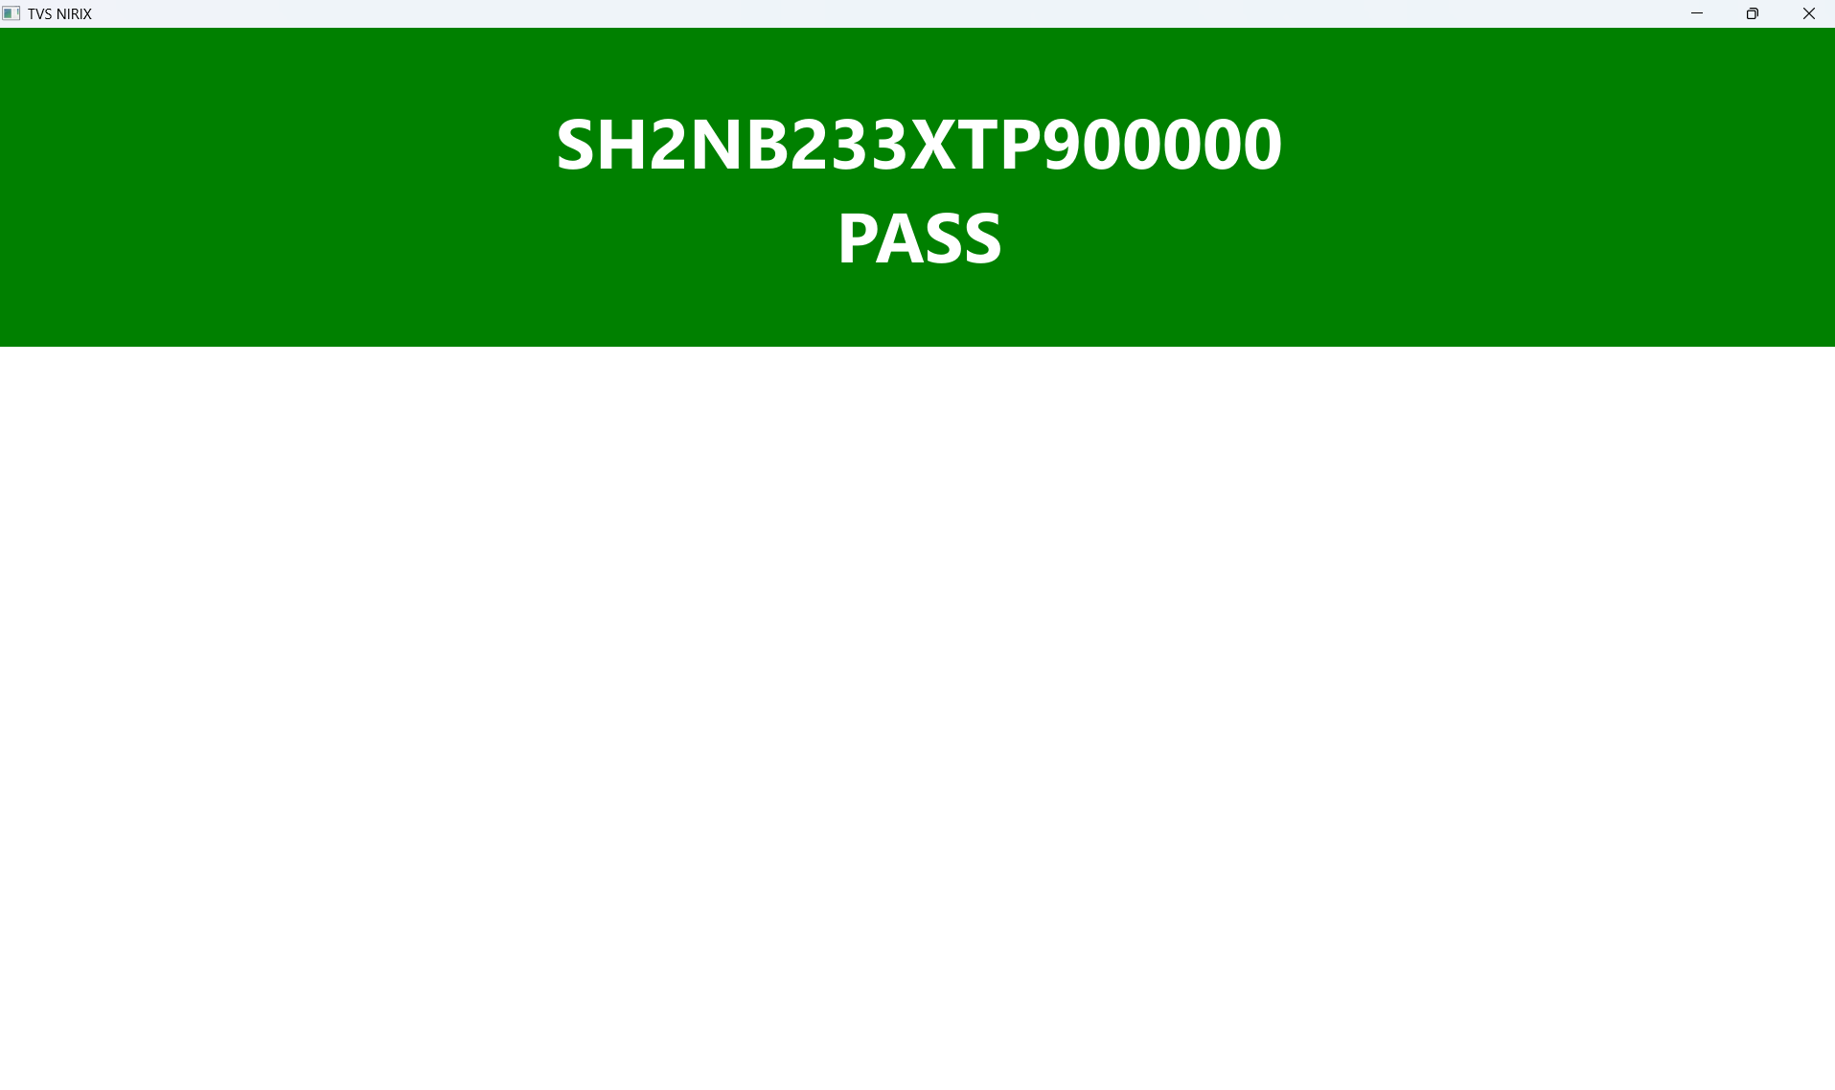

FAIL
If any production test fails, the application displays a FAIL result.
Possible reasons for FAIL include:
- ECU communication failure.
- Flash programming failure.
- Security authentication failure.
- VIN verification failure.
- SKU verification failure.
- CAN communication timeout.

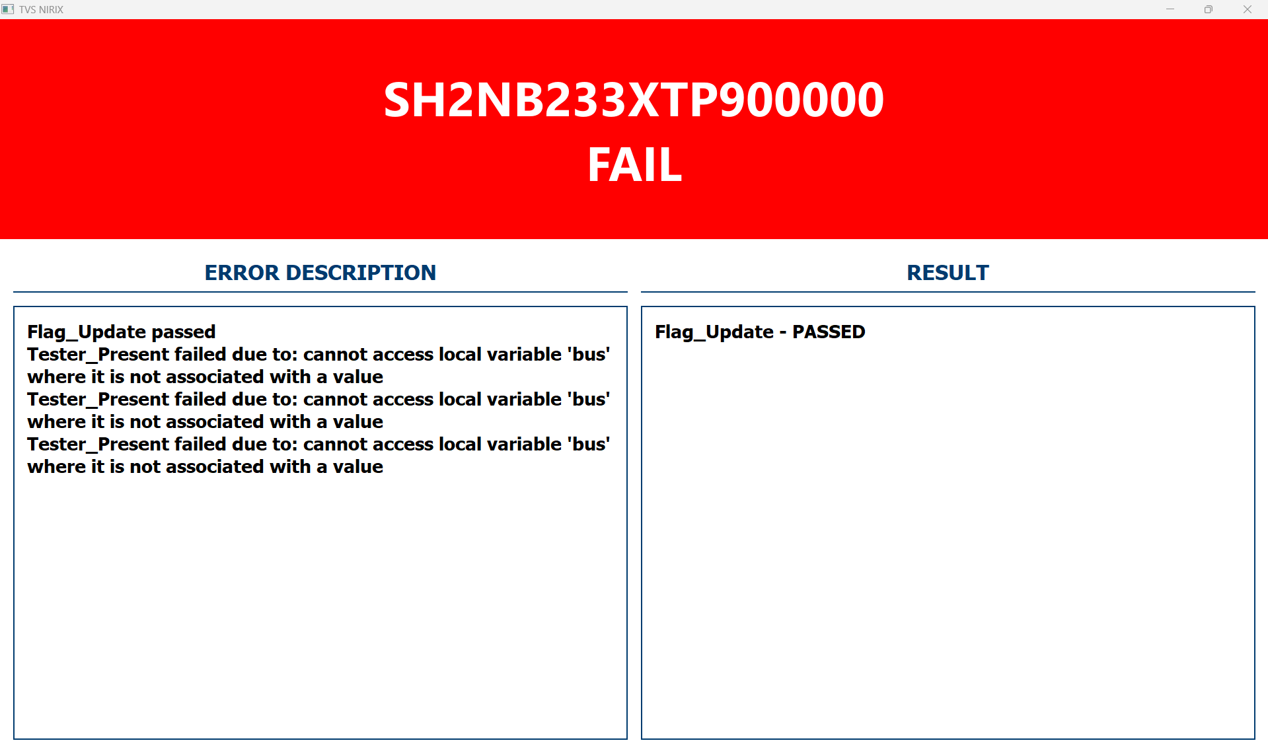

8. LOG FILES
The application automatically creates a log file for every production test.
Log Location: D:\Nirix\Trace
The log file contains:
- Date and time of execution.
- Vehicle VIN.
- SKU information.
- Test sequence details.
- UDS communication messages.
- ECU responses.
- Programming status.
- PASS or FAIL status.
The generated log should always be reviewed whenever a production test fails.

9. TROUBLESHOOTING

9.1 Application Fails to Launch:
- Verify all files are in C:\Nirix\Applicationfiles\.
- Check debug.log for errors like "Config file not found."
- Reinstall the package if files are corrupted.

9.2 Scanner Issues:
- Confirm COM port in scanner.ini matches Device Manager.
- Test scanner with same port and baud rate settings.
- Restart the computer if the port is locked.
- Ensure scanner drivers are installed and up to date.
- Check USB cable integrity and try a different USB port.

9.3 API Connection Problems:
- Confirm network connectivity using ip address.
- Check debug.log for HTTP status codes (e.g., 404, 500).
- Contact the API administrator if the endpoint is down.
- Verify firewall settings allow outbound connections to port 5000.
- Ensure api.ini has correct endpoint URL and authentication credentials.

9.4 Log Deletion Fails:
- Ensure valid log_deletion_days in station.ini.
- Check folder permissions.
- Verify log_cleanup.py is present and executable.
- Check for file locks by other processes; close TVS NIRIX before running cleanup.

9.5 Can Communication Error:
- Verify PCAN adapter is securely connected, and LED is on.
- Confirm bitrate (500 kbit/s) and clock frequency (8 MHz) in PCAN-View.
- Check CAN bus wiring and termination resistors for proper connection.
- Ensure vehicle ECU is powered and operational.
- Review debug.log for CAN timeout or bus-off errors

9.6 Test Sequence Failure:
- Check debug.log for specific test failure details (e.g., invalid Rx data).
- Verify VIN format (17 characters, starts with "SH2") and SKU mapping in SKU_File_Mapping.xls
- Ensure the correct active library is selected in station.ini.
- Retry test after resetting vehicle power and PCAN connection.

9.7 Incorrect API Address Retrieval:
- Confirm API endpoint Fetch API Details for fetching api data is correct.
- Confirm API endpoint Flag Update Parameter for updating Flag is correct.
- Check debug.log for API response errors or invalid JSON.
- Validate VIN input matches API database records.
- Ensure network stability during API call.

9.8 UI Freezing or Crashing:
- Check system resources (CPU, RAM) for high usage.
- Close other applications to free up memory.
- Update PyQt5 to the latest version (pip install –upgrade PyQt5).
- Review debug.log for UI-related exceptions.
- Restart the application and ensure no background instances are running.

10. SAFETY PRECAUTIONS
- Operate the application only on approved production systems.
- Use only authorized PCAN USB adapters and communication cables.
- Never disconnect the vehicle during firmware flashing.
- Ensure stable battery voltage throughout the testing process.
- Follow all production safety guidelines while operating the application.
- Disconnect hardware only after the application has completed the production test.

