SIMATS ENGINEERING
ASSESSMENT TOOL 3 – ASSIGNMENT 2

COURSE NAME: STATISTICS WITH R PROGRAMMING | COURSE CODE: ITA04

COURSE OUTCOME COVERED
CO3: Construct and manipulate data frames using reshaping, merging, and file I/O operations in R to prepare structured datasets for analysis. (BL3, BL5)
Assessment Tool Weightage: 20%

QUESTIONS: 5 | Total Marks: 100
Annexure
Assignment 2

Code of Conduct:
I, SAKTHIVEL S (Register Number: 192525368), certify that this submission is my original work and that I have adhered to the guidelines specified for this assessment. I understand that any violation of academic integrity rules will result in disciplinary action.
Signature of the student:
____________________________________________________________

Smart Electricity Consumption Analysis and Prediction Using R
Module 2 – Electricity Consumption Analysis
The following five questions demonstrate different statistical graph types using the sample electricity dataset. Each question includes a brief explanation, formula, R program, and the corresponding output graph immediately after the program. The supplied dataset contains synthetic illustrative values.
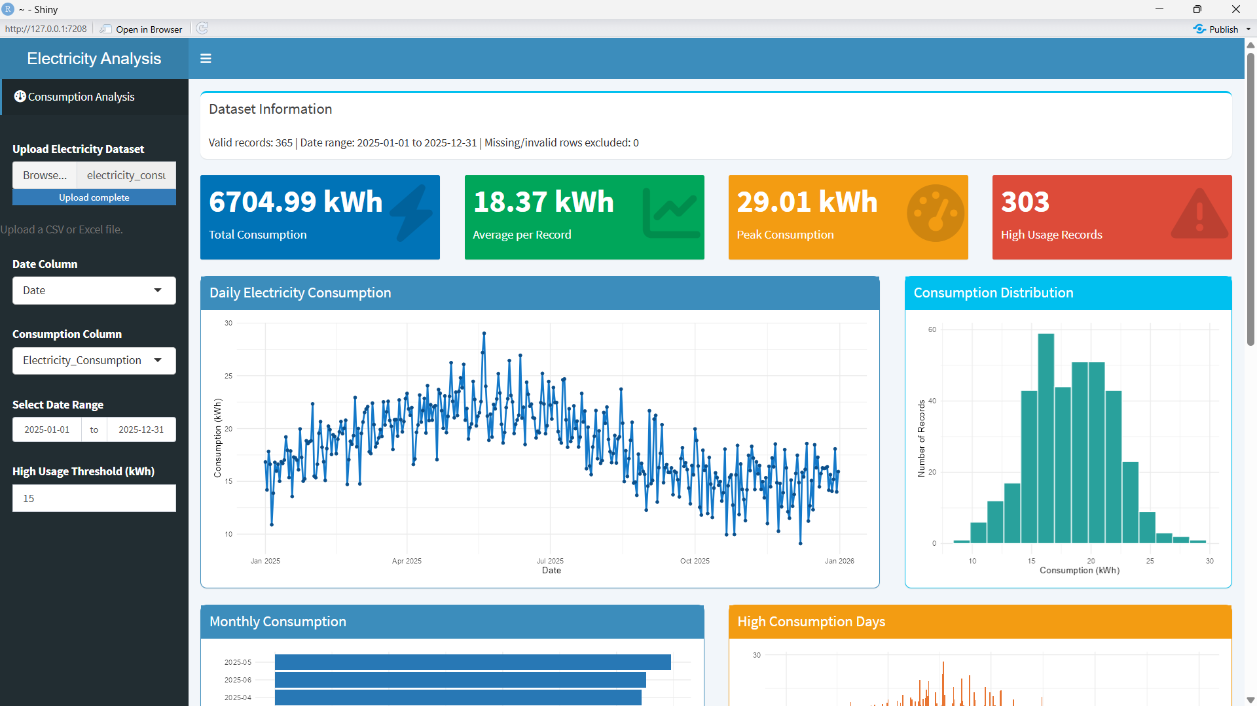
Figure: Electricity Consumption Analysis Dashboard

Question 1: Which household consumes the most electricity?
Formula: Formula: Total household consumption = Σ Eᵢ
Brief explanation: Add the consumption records for each household. The tallest bar represents the household category with the greatest total consumption.

R Program
# Question 1: Which household consumes the most electricity?
data <- read.csv(file.choose())
household_total <- aggregate(
Electricity_Consumption ~ Household,
data = data,
FUN = sum
)
print(household_total)
barplot(
household_total$Electricity_Consumption,
names.arg = household_total$Household,
col = "skyblue",
main = "Household Electricity Consumption",
xlab = "Household",
ylab = "Total Consumption (kWh)",
las = 2
)

Output Screenshot
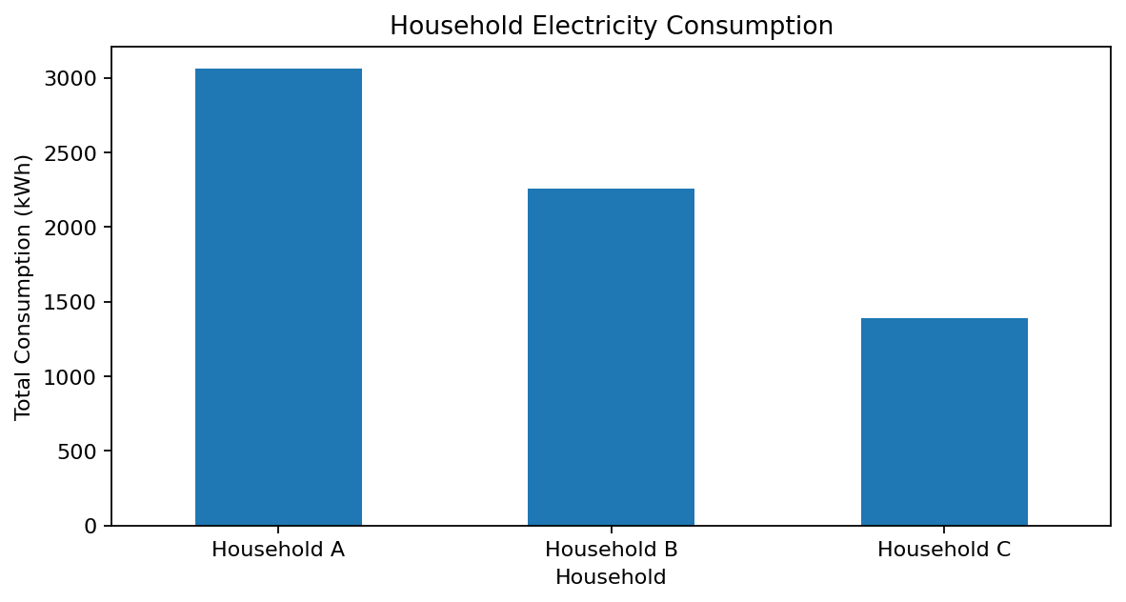

Question 2: How does electricity consumption change over time?
Formula: Formula: Change in consumption = Eₜ − Eₜ₋₁
Brief explanation: Subtract the previous day's consumption from the current day's consumption. The line graph shows daily changes and overall trends.

R Program
# Question 2: How does electricity consumption change over time?
data <- read.csv(file.choose())
data$Date <- as.Date(data$Date)
daily <- aggregate(
Electricity_Consumption ~ Date,
data = data,
FUN = sum
)
plot(
daily$Date,
daily$Electricity_Consumption,
type = "l",
col = "blue",
lwd = 2,
main = "Daily Electricity Consumption Trend",
xlab = "Date",
ylab = "Consumption (kWh)"
)

Output Screenshot
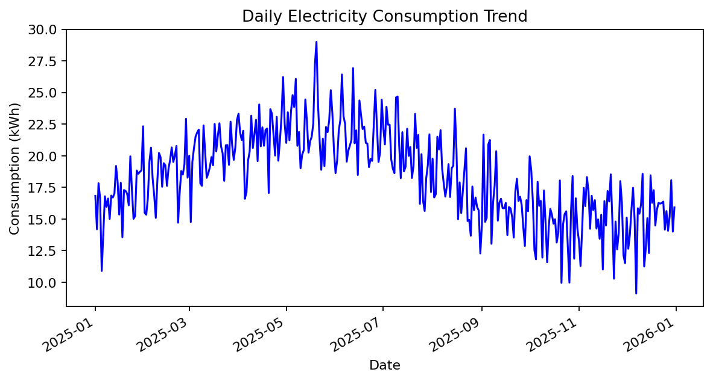

Question 3: Which consumption range occurs most frequently?
Formula: Formula: Mean consumption = (Σ Eᵢ) / n
Brief explanation: The histogram groups values into intervals and counts the records in each interval. The mean gives the average consumption across n records.

R Program
# Question 3: Which consumption range occurs most frequently?
data <- read.csv(file.choose())
hist(
data$Electricity_Consumption,
breaks = 15,
col = "lightgreen",
border = "white",
main = "Distribution of Electricity Consumption",
xlab = "Consumption (kWh)",
ylab = "Frequency"
)
# Calculate mean consumption
average_consumption <- mean(
data$Electricity_Consumption,
na.rm = TRUE
)
print(average_consumption)

Output Screenshot
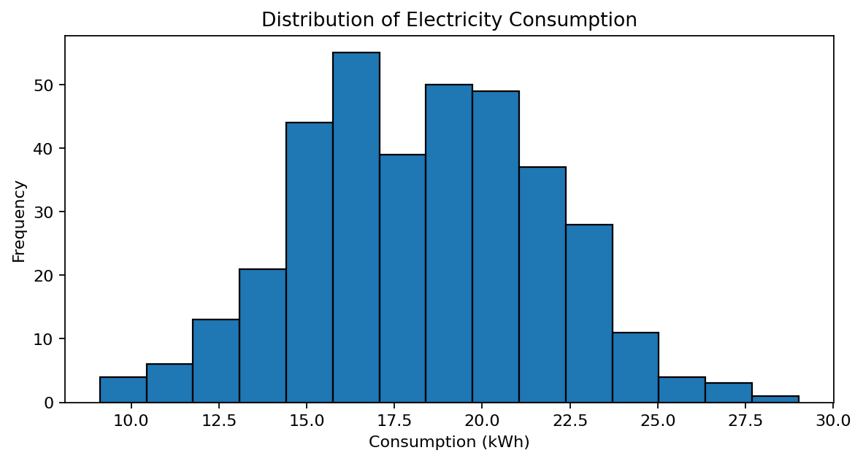

Question 4: Is temperature associated with electricity consumption?
Formula: Formula: Pearson correlation, r = Cov(T, E) / (σT × σE)
Brief explanation: The correlation coefficient ranges from −1 to +1. A positive value indicates a positive linear association; correlation does not prove causation.

R Program
# Question 4: Is temperature associated with electricity consumption?
data <- read.csv(file.choose())
correlation <- cor(
data$Temperature_C,
data$Electricity_Consumption,
use = "complete.obs"
)
print(correlation)
plot(
data$Temperature_C,
data$Electricity_Consumption,
pch = 19,
col = "darkorange",
main = "Temperature vs Electricity Consumption",
xlab = "Temperature (Celsius)",
ylab = "Consumption (kWh)"
)
abline(
lm(Electricity_Consumption ~ Temperature_C, data = data),
col = "red",
lwd = 2
)

Output Screenshot
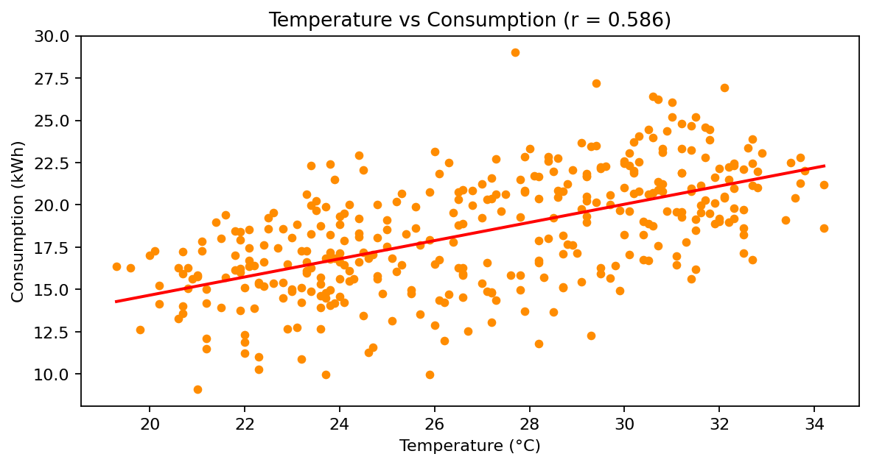

Question 5: How does daily electricity consumption vary by month?
Formula: Formula: Interquartile range (IQR) = Q₃ − Q₁
Brief explanation: The box plot compares the monthly median and spread. The IQR measures the range of the middle 50% of daily consumption values.

R Program
# Question 5: How does daily consumption vary by month?
data <- read.csv(file.choose())
data$Date <- as.Date(data$Date)
data$Month <- factor(
format(data$Date, "%b"),
levels = month.abb
)
boxplot(
Electricity_Consumption ~ Month,
data = data,
col = "plum",
main = "Monthly Consumption Variation",
xlab = "Month",
ylab = "Daily Consumption (kWh)",
outline = TRUE
)
# Calculate interquartile range
consumption_iqr <- IQR(
data$Electricity_Consumption,
na.rm = TRUE
)
print(consumption_iqr)

Output Screenshot
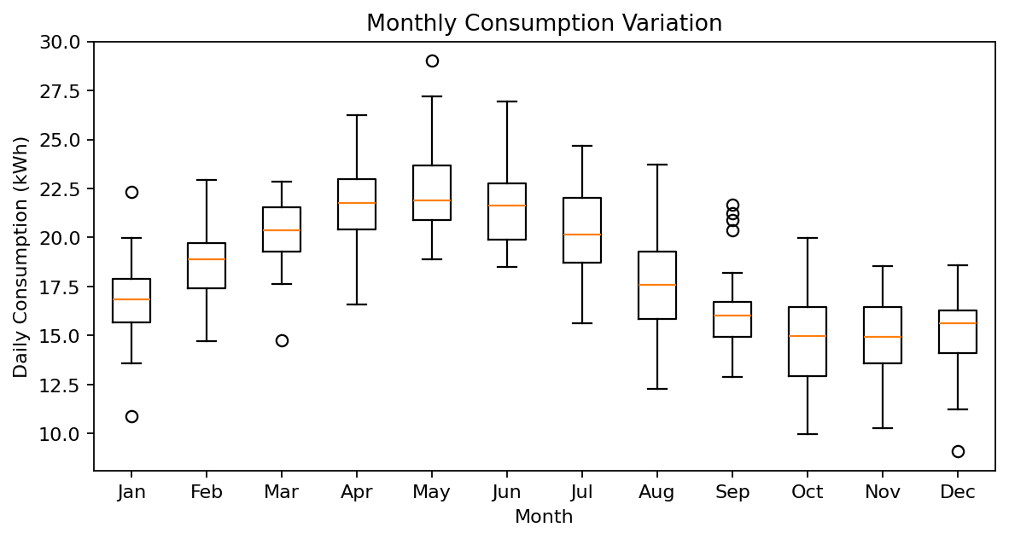

Dataset Notes
The sample dataset contains Date, Electricity_Consumption, Temperature_C, Day_Type, and Household. Electricity consumption is treated as kWh for this example. Results may differ when a different dataset is uploaded.

