**PRODUCT DEMAND PREDICTION WITH**

**MACHINE LEARNING**

**Dataset and its detail Explanation :**

**Product ID :**

**A product ID is a unique number or code assigned to a specific product to distinguish it from others, often used for inventory management, ordering, and product lookup.**

**Store ID :**

**A store ID is a unique number or code assigned to a specific retail location or online store to distinguish it from other stores within the same company or network.**

**Total Price at Which Product Was Sold :**

**The total price at which a product was sold refers to the complete amount of money for which a product was purchased, inclusive of any taxes, fees, or additional charges.**

**Base Price at Which Product Was Sold :**

**The base price at which a product was sold refers to the initial cost of the product before any additional charges, taxes, discounts, or fees are applied.**

**Units Sold (Quantity Demanded) :**

**Units sold refers to the total number of individual items or quantities of a product that have been purchased by customers over a specified period.**

**Begin building the project by load the dataset :**

**Importing the packages:**

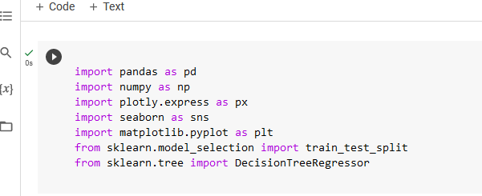

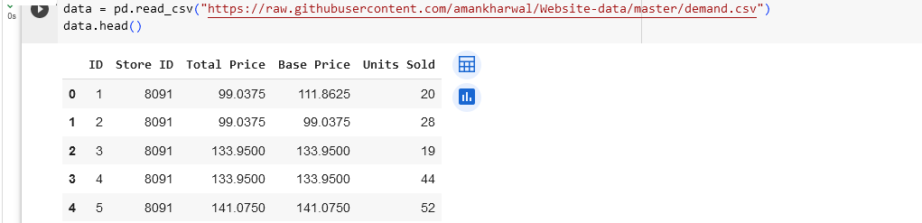

**Preprocess Dataset :**

**Now lets have a look at whether this dataset contains any null values or not.**

