**KGiSL MICROCOLLEGE, Coimbatore – 641035.**

**Software Programming**

**Git & GitHub practice**

Step 1: Git Download

<https://git-scm.com/downloads>

Choose windows

<https://git-scm.com/download/win>

[**64-bit Git for Windows Setup**](https://github.com/git-for-windows/git/releases/download/v2.40.1.windows.1/Git-2.40.1-64-bit.exe)**. – click**

**Step 2: Goto** <https://github.com/>

**For new registration: SignUp**

**Step 3: Click Sign in to GitHub**

**Step 4: Create a repository**

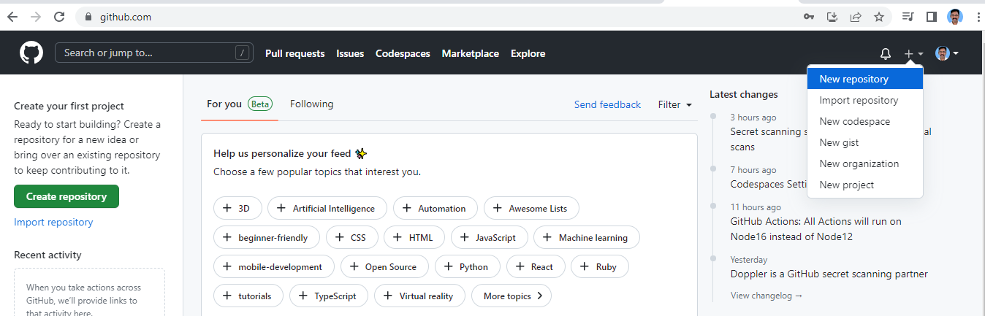

**Step 5: Give the name of the repository and make public accessible.**

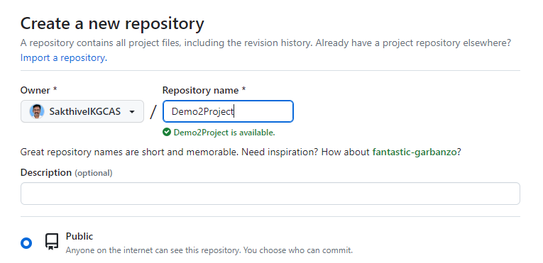

**Step 6: Open Windows PowerShell and check the git is installed or not.**

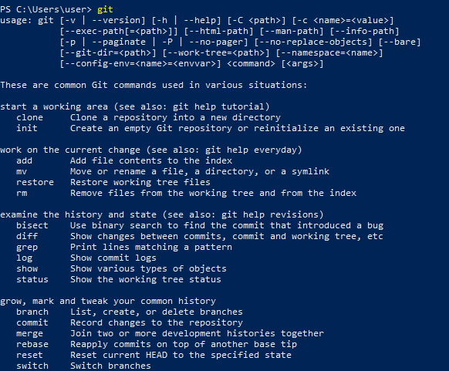

**Step 7: To use git clone command to clone your empty project to work in local.**

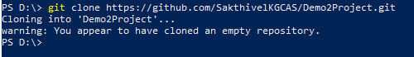

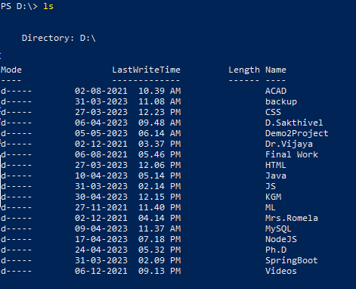

**Step 8: Get into the Demo2Project directory**

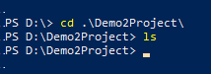

**Step 9: To open VS code editor in the same Demo2Project folder**



**Step 10: To add file to local Git local repository for tracking**

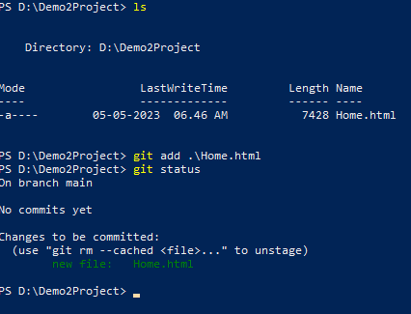

**Step 11: Set email and user name for git identification and apply for commit.**

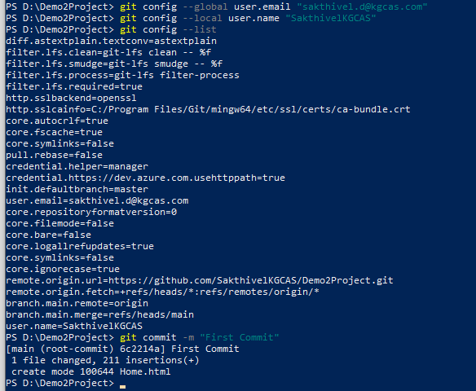

**Step 12: git push to global repository**

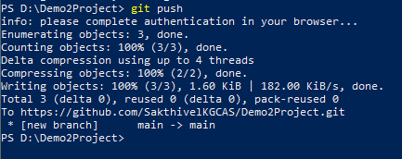

**Step 13: git pull command to bring your file from global repository to local repository**

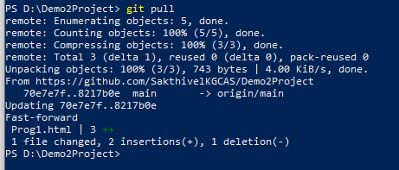

**Step 14: After updating all your necessary code to commit and push to global repository**

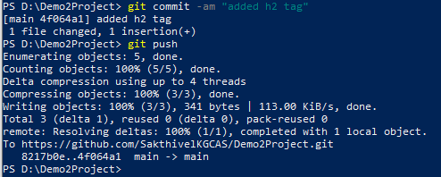

**You can see all your commits in the GitHub**

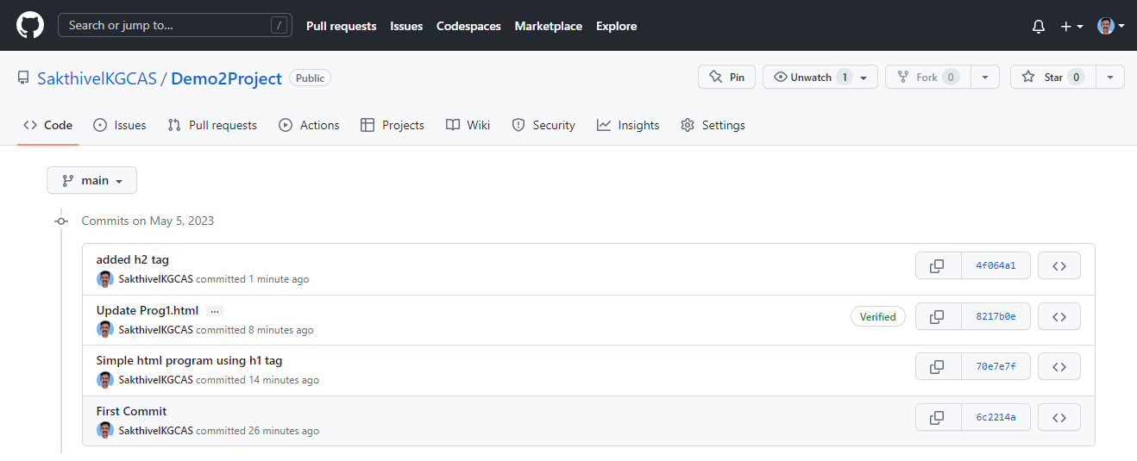

**Step 15: Working with branch * indicates you are in the current branch**



**Step 16: To create a new branch without affecting the main branch**

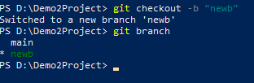

**Step 17: Apply any code and commit in new branch**



**Step 18: Come to main branch**



**Step 19: Do some changes in code if required and apply commit**



**Step 20: To get into newb (new branch)**



**Step 21: To switch to main branch then merge the newb (new branch) with it.**

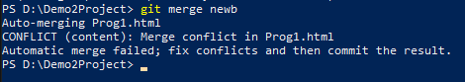

**It shows merge conflict, remove whichever the code not necessary within <<<< global and >> local commands**

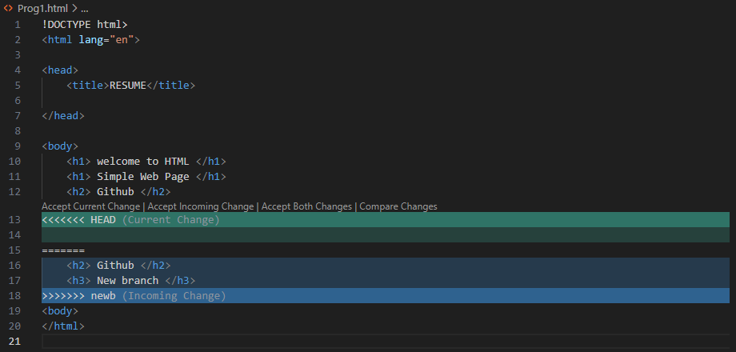

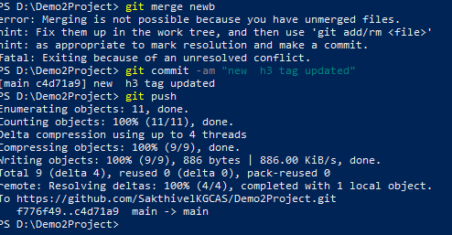

**Finally, open GitHub see all your commits.**

