KGiSL Microcollege,Coimbatore.

Software Programming

Linux Commands

The following are the top Linux commands:

Linux Directory Commands

**1. pwd Command**

The [pwd](https://www.javatpoint.com/linux-pwd) command is used to display the location of the current working directory.

**Syntax:**

1. pwd

**Output:**

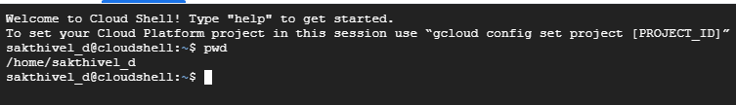

**2. mkdir Command**

The [mkdir](https://www.javatpoint.com/linux-mkdir) command is used to create a new directory under any directory.

**Syntax:**

1. mkdir **<directory** name**>**

**Output:**



**3. rmdir Command**

The [rmdir](https://www.javatpoint.com/linux-rmdir) command is used to delete a directory.

**Syntax:**

1. rmdir **<directory** name**>**

**Output:**



**4. ls Command**

The [ls](https://www.javatpoint.com/linux-ls) command is used to display a list of content of a directory.

**Syntax:**

1. ls

**Output:**



**5. cd Command**

The [cd](https://www.javatpoint.com/linux-cd) command is used to change the current directory.

**Syntax:**

1. cd **<directory** name**>**

**Output:**



Linux File commands

**6. touch Command**

The [touch](https://www.javatpoint.com/linux-touch) command is used to create empty files. We can create multiple empty files by executing it once.

**Syntax:**

1. touch **<file** name**>**
2. touch **<file1>**  **<file2>** ....

**Output:**

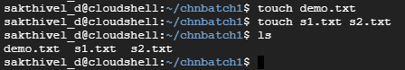

**7. cat Command**

The [cat](https://www.javatpoint.com/linux-cat) command is a multi-purpose utility in the Linux system. It can be used to create a file, display content of the file, copy the content of one file to another file, and more.

**Syntax:**

1. cat [OPTION]... [FILE]..

To create a file, execute it as follows:

1. cat **>** **<file** name**>**
2. // Enter file content

Press "**CTRL+ D**" keys to save the file. To display the content of the file, execute it as follows:

1. cat **<file** name**>**

**Output:**

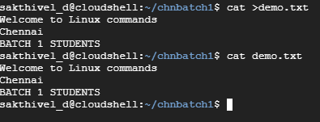

**8. rm Command**

The [rm](https://www.javatpoint.com/linux-rm) command is used to remove a file.

**Syntax:**

rm <file name>

**Output:**

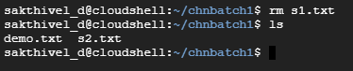

**9. cp Command**

The [cp](https://www.javatpoint.com/linux-cp) command is used to copy a file or directory.

**Syntax:**

To copy in the same directory:

1. cp **<existing** file name**>** **<new** file name**>**

To copy in a different directory:

**Output:**

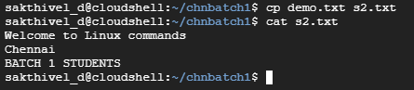

**10. mv Command**

The [mv](https://www.javatpoint.com/linux-mv) command is used to move a file or a directory form one location to another location.

**Syntax:**

1. mv **<file** name**>** **<directory** path**>**

**Output:**

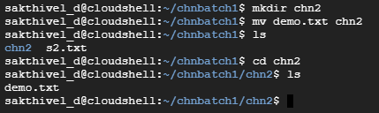

**11. rename Command**

The [rename](https://www.javatpoint.com/linux-rename) command is used to rename files. It is useful for renaming a large group of files.

**Syntax:**

1. rename 's/old-name/new-name/' files

For example, to convert all the text files into pdf files, execute the below command:

1. rename 's/\.txt$/\.pdf/' *.txt

**Output:**



**Exit from Directory**

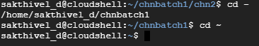

Linux File Content Commands

**12. head Command**

The [head](https://www.javatpoint.com/linux-head) command is used to display the content of a file. It displays the first 10 lines of a file.

**Syntax:**

1. head **<file** name**>**

**Output:**

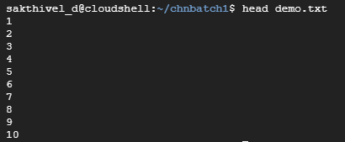

**13. tail Command**

The [tail](https://www.javatpoint.com/linux-tail) command is similar to the head command. The difference between both commands is that it displays the last ten lines of the file content. It is useful for reading the error message.

**Syntax:**

1. tail **<file** name**>**

**Output:**

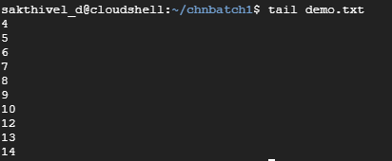

**14. tac Command**

The [tac](https://www.javatpoint.com/linux-tac) command is the reverse of cat command, as its name specified. It displays the file content in reverse order (from the last line).

**Syntax:**

1. tac **<file** name**>**

**Output:**

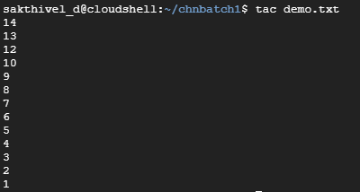

**15. more command**

The [more](https://www.javatpoint.com/linux-more) command is quite similar to the cat command, as it is used to display the file content in the same way that the cat command does. The only difference between both commands is that, in case of larger files, the more command displays screenful output at a time.

In more command, the following keys are used to scroll the page:

**ENTER key:** To scroll down page by line.

**Space bar:** To move to the next page.

**b key:** To move to the previous page.

**/ key:** To search the string.

**Syntax:**

1. more **<file** name**>**

**Output:**

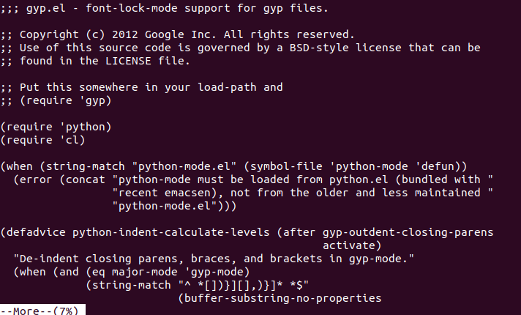

**16. less Command**

The [less](https://www.javatpoint.com/linux-less) command is similar to the more command. It also includes some extra features such as 'adjustment in width and height of the terminal.' Comparatively, the more command cuts the output in the width of the terminal.

**Syntax:**

1. less **<file** name**>**

**Output:**

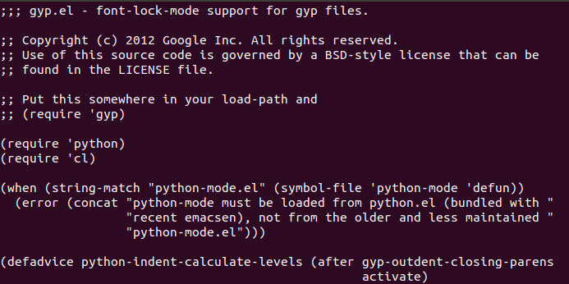

Linux User Commands

**17. su Command**

The [su](https://www.javatpoint.com/linux-su-commands) command provides administrative access to another user. In other words, it allows access of the Linux shell to another user.

**Syntax:**

1. su **<user** name**>**

**Output:**



**18. id Command**

The [id](https://www.javatpoint.com/linux-id-command) command is used to display the user ID (UID) and group ID (GID).

**Syntax:**

1. id

**Output:**



**19. useradd Command**

The [useradd](https://www.javatpoint.com/linux-create-user) command is used to add or remove a user on a Linux server.

**Syntax:**

1. useradd  username

**Output:**



**20. passwd Command**

The [passwd](https://www.javatpoint.com/linux-user-password) command is used to create and change the password for a user.

**Syntax:**

1. passwd **<username>**

**Output:**

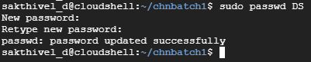

**21. groupadd Command**

The [groupadd](https://www.javatpoint.com/linux-add-user-to-group) command is used to create a user group.

**Syntax:**

1. groupadd **<group** name**>**

**Output:**



Linux Filter Commands

**22. cat Command**

The [cat](https://www.javatpoint.com/linux-cat-filters) command is also used as a filter. To filter a file, it is used inside pipes.

**Syntax:**

1. cat **<fileName>** | cat or tac | cat or tac |. . .

**Output:**

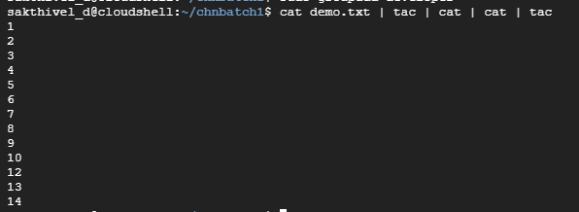

**23. cut Command**

The [cut](https://www.javatpoint.com/linux-cut) command is used to select a specific column of a file. The '-d' option is used as a delimiter, and it can be a space (' '), a slash (/), a hyphen (-), or anything else. And, the '-f' option is used to specify a column number.

**Syntax:**

1. cut -d(delimiter) -f(columnNumber) **<fileName>**

**Output:**

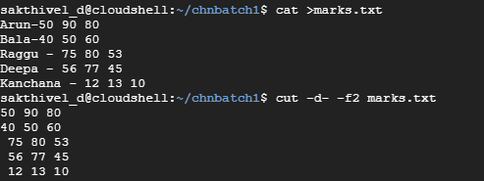

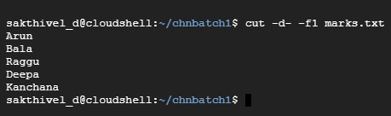

**24. grep Command**

The [grep](https://www.javatpoint.com/linux-grep) is the most powerful and used filter in a Linux system. The 'grep' stands for "**global regular expression print**." It is useful for searching the content from a file. Generally, it is used with the pipe.

**Syntax:**

1. command | grep **<searchWord>**

**Output:**

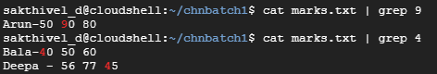

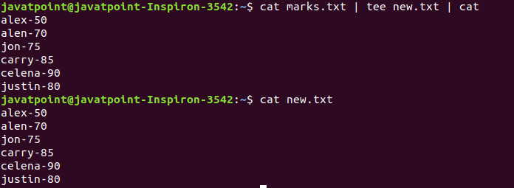

**25. tr Command**

The [tr](https://www.javatpoint.com/linux-tr) command is used to translate the file content like from lower case to upper case.

**Syntax:**

1. command | tr **<**'old'**>** **<**'new'**>**

**Output:**

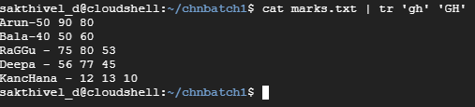

**26. uniq Command**

The [uniq](https://www.javatpoint.com/linux-uniq) command is used to form a sorted list in which every word will occur only once.

**Syntax:**

1. command **<fileName>** | uniq

**Output:**

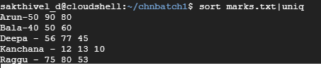

**27. wc Command**

The [wc](https://www.javatpoint.com/linux-wc) command is used to count the lines, words, and characters in a file.

**Syntax:**

1. wc **<file** name**>**

**Output:**



**28. od Command**

The [od](https://www.javatpoint.com/linux-od) command is used to display the content of a file in different s, such as hexadecimal, octal, and ASCII characters.

**Syntax:**

1. od -b **<fileName>**      // Octal format
2. od -t x1 **<fileName>**   // Hexa decimal format
3. od -c **<fileName>**     // ASCII character format

**Output:**

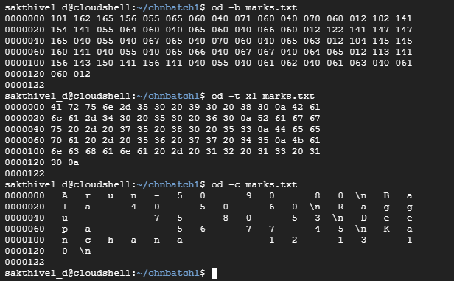

**29. sort Command**

The [sort](https://www.javatpoint.com/linux-sort) command is used to sort files in alphabetical order.

**Syntax:**

1. sort **<file** name**>**

**Output:**

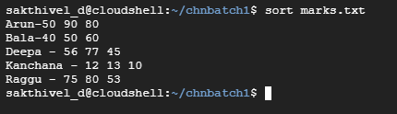

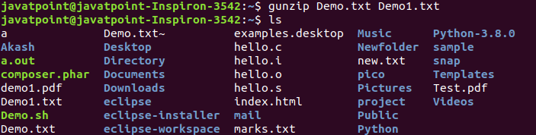

Linux Utility Commands

**30. find Command**

The [find](https://www.javatpoint.com/linux-find) command is used to find a particular file within a directory. It also supports various options to find a file such as byname, by type, by date, and more.

The following symbols are used after the find command:

(.) : For current directory name

(/) : For root

**Syntax:**

1. find . -name "*.pdf"

**Output:**

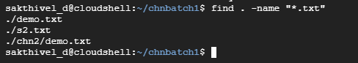

**31. date Command**

The [date](https://www.javatpoint.com/linux-date) command is used to display date, time, time zone, and more.

**Syntax:**

1. date

**Output:**



**32. sleep Command**

The [sleep](https://www.javatpoint.com/linux-sleep) command is used to hold the terminal by the specified amount of time. By default, it takes time in seconds.

**Syntax:**

1. sleep **<time>**

**Output:**



**33. time Command**

The [time](https://www.javatpoint.com/linux-time) command is used to display the time to execute a command.

**Syntax:**

1. time

**Output:**

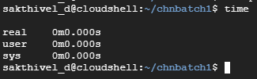

**34. zcat Command**

The zcat command is used to display the compressed files.

**Syntax:**

1. zcat **<file** name**>**

**Output:**

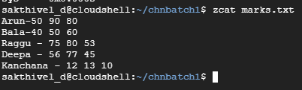

**35. df Command**

The [df](https://www.javatpoint.com/linux-df) command is used to display the disk space used in the file system. It displays the output as in the number of used blocks, available blocks, and the mounted directory.

**Syntax:**

1. df

**Output:**

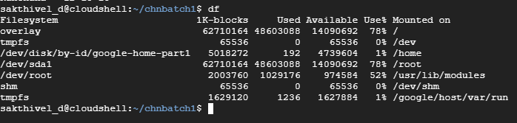

**46 exit Command**

Linux [exit](https://javatpoint.com/linux-exit-command) command is used to exit from the current shell. It takes a parameter as a number and exits the shell with a return of status number.

**Syntax:**

1. exit

After pressing the ENTER key, it will exit the terminal.

**37. clear Command**

Linux **clear** command is used to clear the terminal screen.

**Syntax:**

1. clear

**Output:**



After pressing the ENTER key, it will clear the terminal screen.

Linux Networking Commands

**38. ip Command**

Linux [ip](https://www.javatpoint.com/linux-ip) command is an updated version of the ipconfig command. It is used to assign an IP address, initialize an interface, disable an interface.

**Syntax:**

1. ip a or ip addr

**Output:**

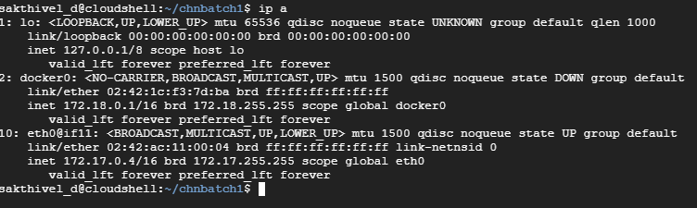

**39. ping Command**

The [ping](https://www.javatpoint.com/linux-ping) command is used to check the connectivity between two nodes, that is whether the server is connected. It is a short form of "Packet Internet Groper."

**Syntax:**

1. ping **<destination>**

**40. host Command**

The [host](https://www.javatpoint.com/linux-host) command is used to display the IP address for a given domain name and vice versa. It performs the DNS lookups for the DNS Query.

**Syntax:**

1. host **<domain** name**>** or **<ip** address**>**