**KGiSL Microcollege,Coimbatore.**

**Software Programming**

**Windows Commands**

The following are the top Windows commands:

### driverquery – Lists All Installed Drivers

It is important to have access to all drivers because they often cause problems.

That’s what this command does – it shows you even the drivers you won’t find in the device manager.  
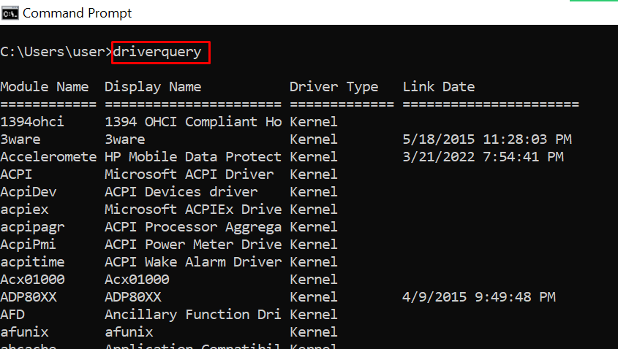

### chdir or cd – Changes the Current Working Directory to the Specified Directory

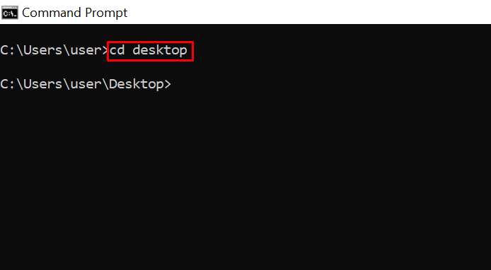

### systeminfo – Shows Your PC's Details

If you want to see more detailed information about your system you won’t see in the GUI, this is the command for you.  
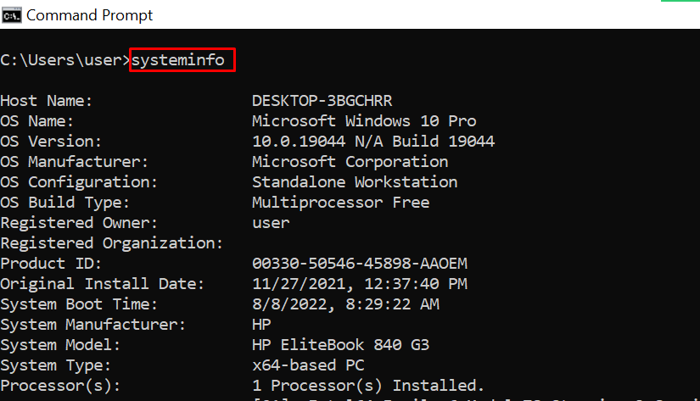

### set – Shows your PC’s Environment Variables

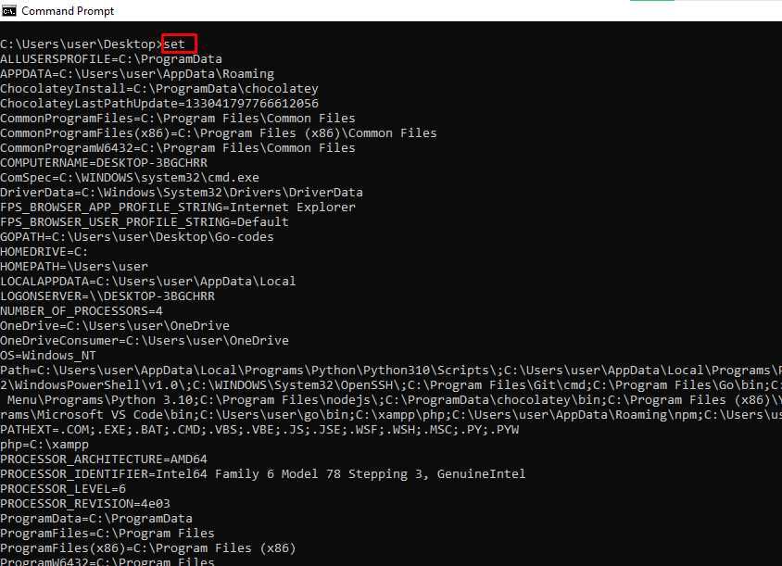

### prompt – Changes the Default Text Shown before Entering Commands

By default, the command prompt shows the C drive path to your user account.

You can use the prompt command to change that default text with the syntax prompt prompt_name $G:  
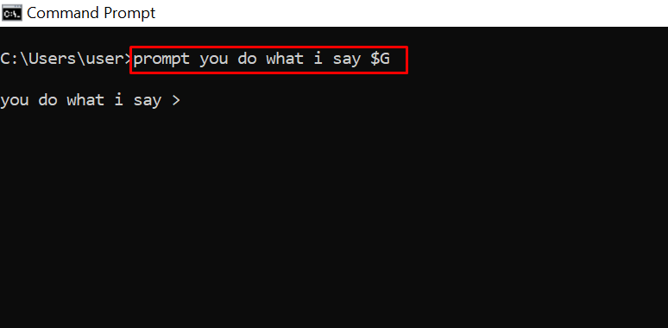

**N.B**: If you don’t append $G to the command, you won’t get the greater than symbol in front of the text.

### assoc – Lists Programs and the Extensions They are Associated With

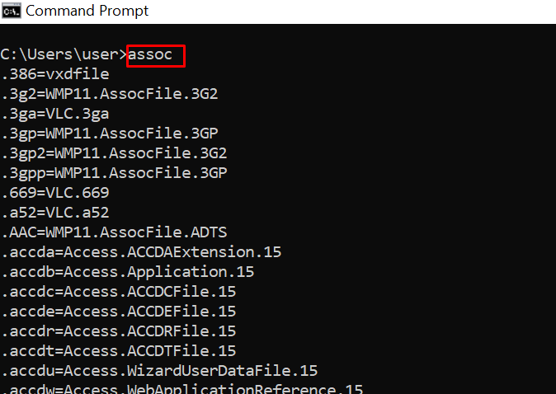

### title – Changes the Command Prompt Window Title Using the Format title window-title-name

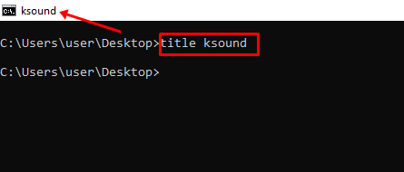

### fc – Compares Two Similar Files

If you are a programmer or writer and you want to quickly see what differs between two files, you can enter this command and then the full path to the two files. For example fc “file-1-path” “file-2-path”.  
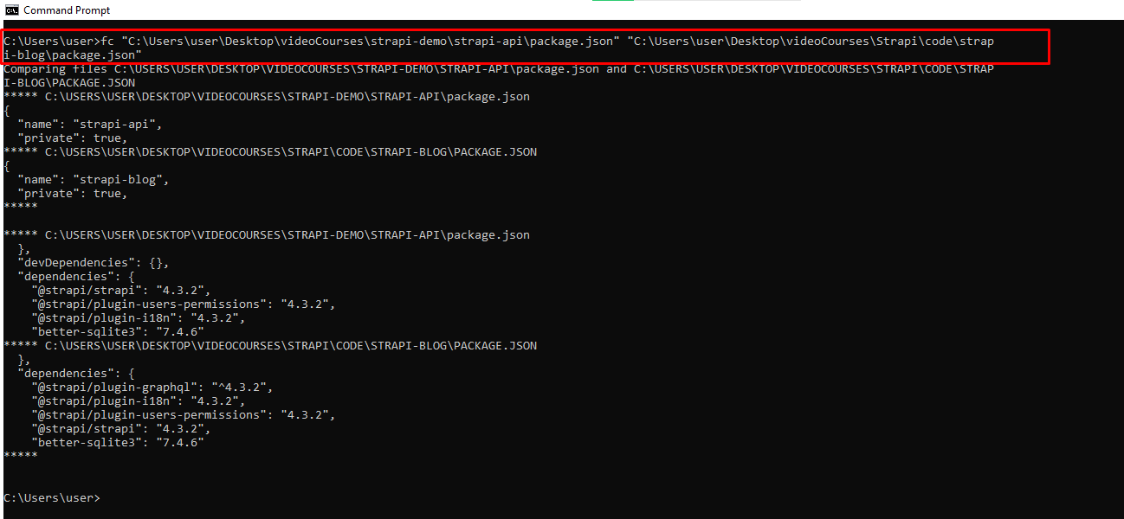

### cipher – Wipes Free Space and Encrypts Data

On a PC, deleted files remain accessible to you and other users. So, technically, they are not deleted under the hood.

You can use the cipher command to wipe the drive clean and encrypt such files.  
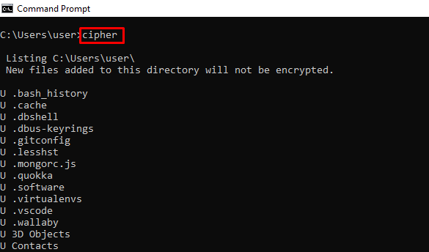

### netstat -an – Shows Open Ports, their IP Addresses and States

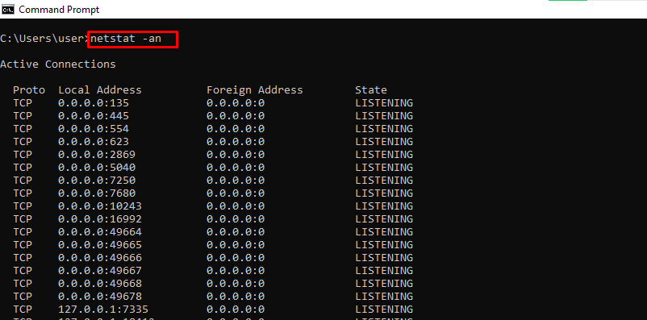

### ping – Shows a Website IP Address, Lets you Know How Long it Takes to Transmit Data and a Get Response

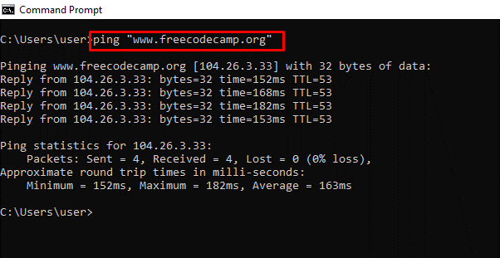

### color – Changes the Text Color of the Command Prompt

Enter color attr to see the colors you can change to:  
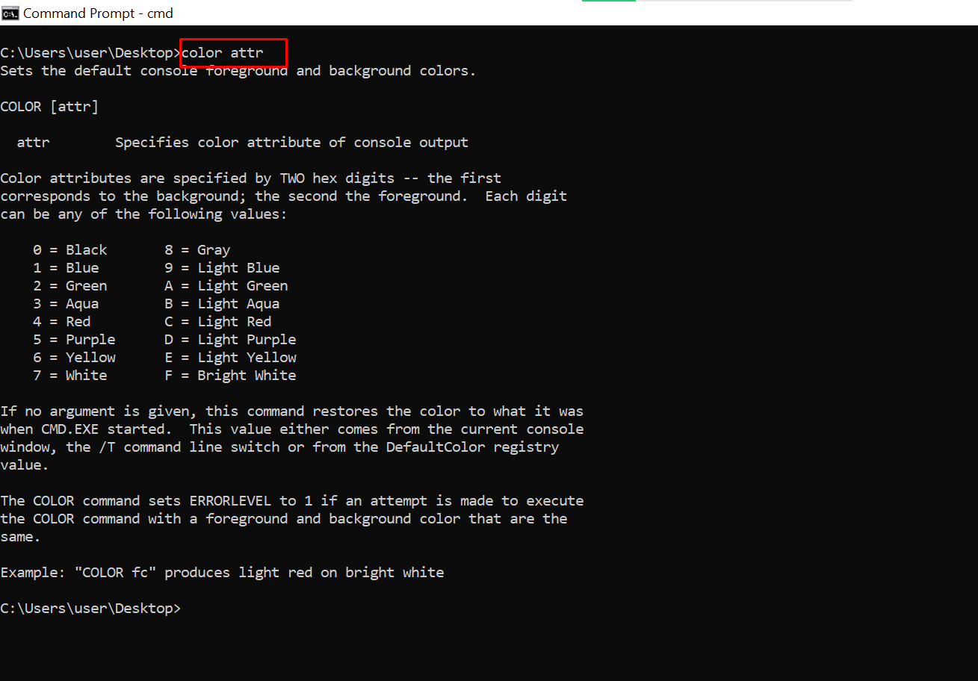

Entering color 2 changes the color of the terminal to green:  
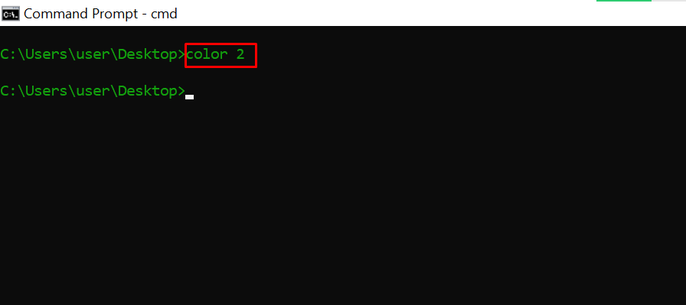

### ipconfig – Shows Information about PC IP Addresses and Connections

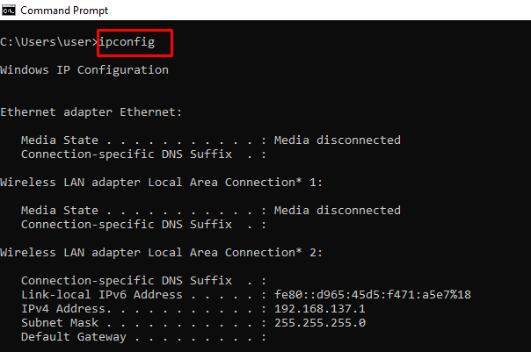

This command also has extensions such as ipconfig /release, ipconfig /renew, and ipconfig /flushdns which you can use to troubleshoot issues with internet connections.

### sfc – System File Checker

This command scans your computer for corrupt files and repairs them. The extension of the command you can use to run a scan is /scannow.  
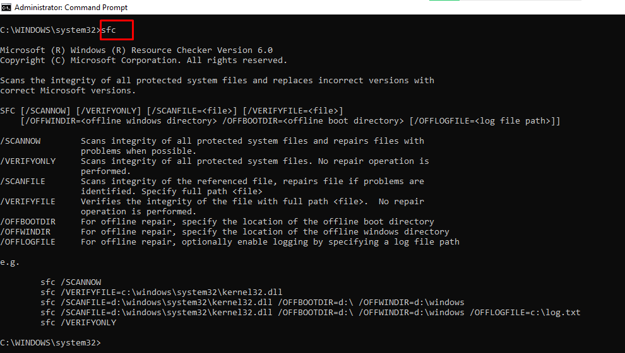

### powercfg – Controls Configurable Power Settings

You can use this command with its several extensions to show information about the power state of your PC.

You can enter powercfg help to show those extensions.  
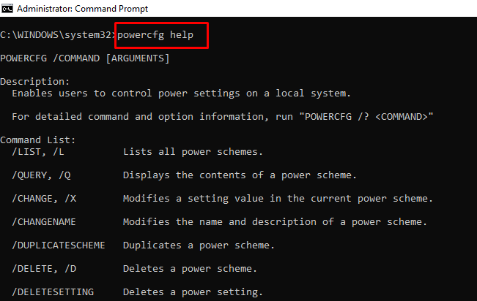

For example, you can use powercfg /energy to generate a battery health report.  
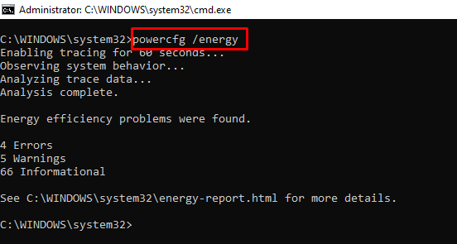

The powercfg /energy command will generate an HTML file containing the report. You can find the HTML file in C:\Windows\system32\energy-report.html.

### dir – Lists Items in a Directory

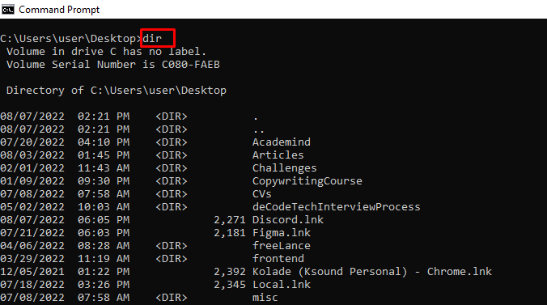

### del – Deletes a File

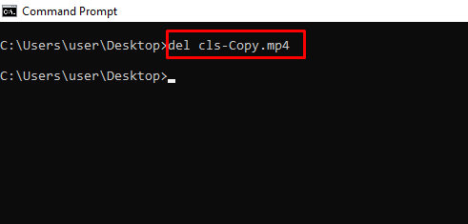

### attrib +h +s +r folder_name – Hides a Folder

You can hide a folder right from the command line by typing in attrib +h +s +r folder_name and then pressing ENTER.

To show the folder again, execute the command – attrib -h -s -r folder_name.  
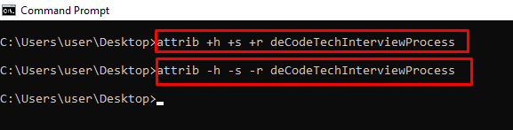

### start website-address – Logs on to a Website from the Command Line

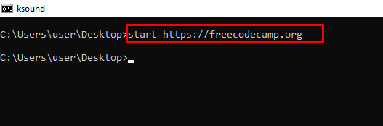  


### tree – Shows the Tree of the Current Directory or Specified Drive

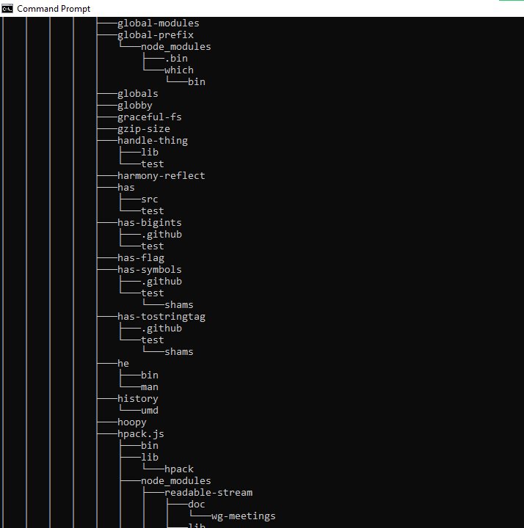

### ver – Shows the Version of the OS

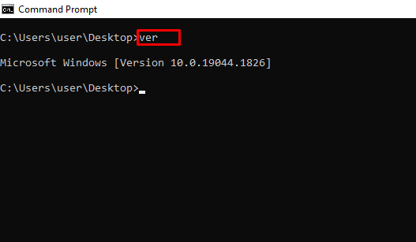

### tasklist – Shows Open Programs

You can do the same thing you do with the task manager with this command:  
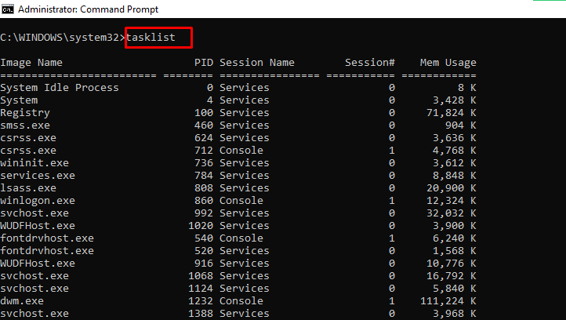  
The next command shows you how to close an open task.

### date – Shows and Changes the Current Date

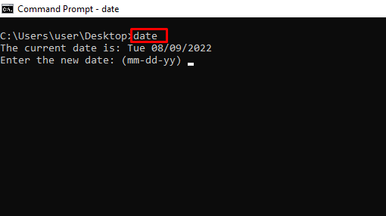

### time – Shows and Changes the Current Time

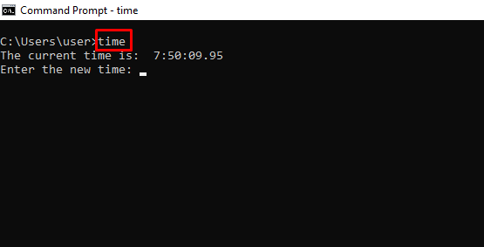

### vol – Shows the Serial Number and Label Info of the Current Drive

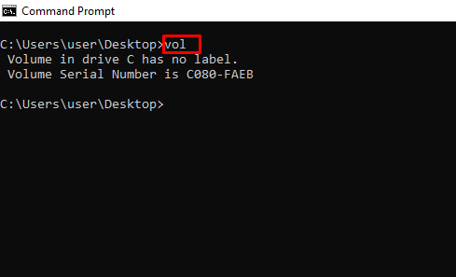

### dism – Runs the Deployment Image Service Management Tool

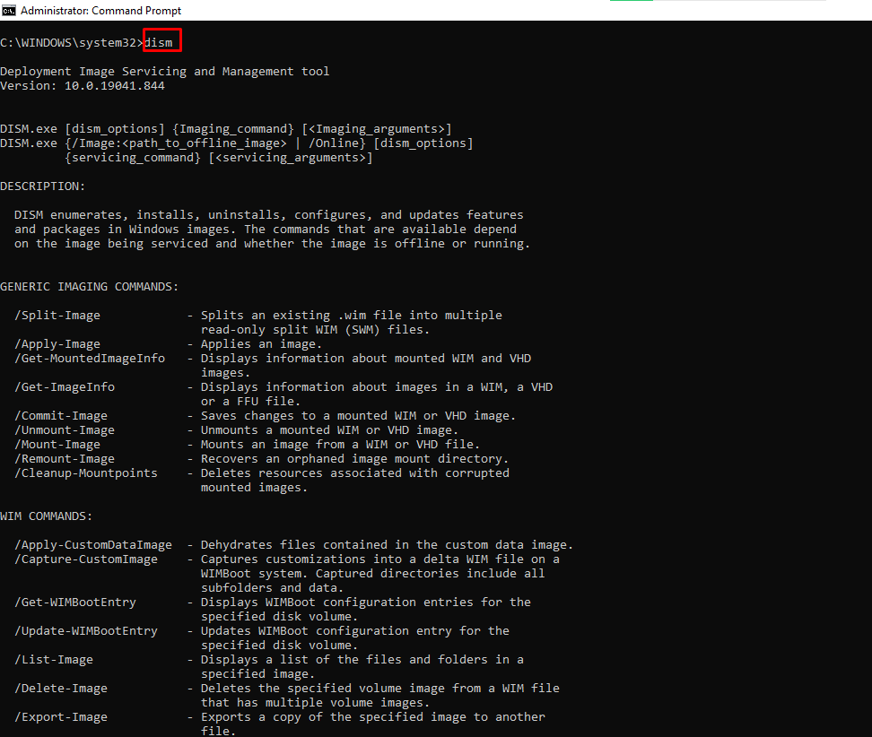

### mkdir – Creates a Folder

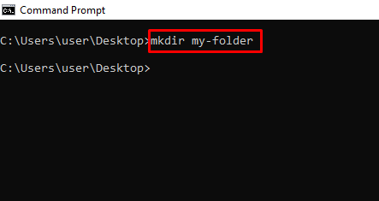

### rmdir – Deletes a Folder

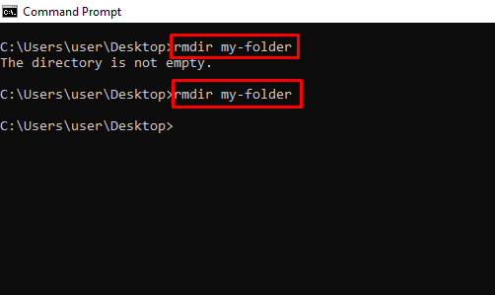

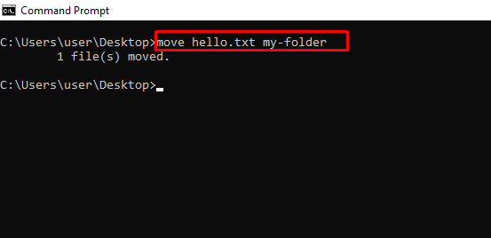

### ren – Renames a File with the Syntax ren filename.extension new-name.extension

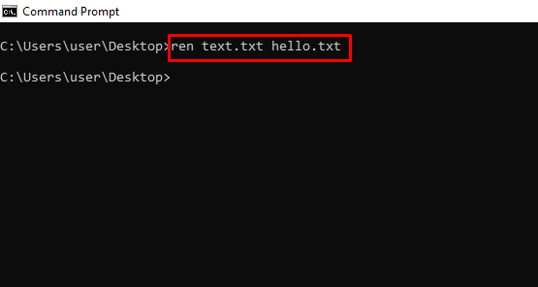

### cls – Clears the Command Line

In case you enter several commands and the command line gets clogged up, you can use cls to clear all entries and their outputs.  


### exit – Closes the Command Line

### shutdown – Shuts down, Restarts, Hibernates, Sleeps the Computer

You can shut down, restart, hibernate, and sleep your PC from the command line.

Enter shutdown in the command line so you can see the extensions you can use to perform the actions. For example, shutdown /r will restart your computer.