WEEK 3 SUBMISSION DOCUMENT
File Handling, Encryption & Hashing, and Authentication & Authorization Fundamentals
---------------------------------------------
Part 1: Week 3 Learnings & Implementation Details
Day 1: File Handling & Fundamentals
• FileStream Chunking: Implemented a 4 KB buffer copy stream to duplicate data byte-for-byte without loading whole files into memory.
• Reversibility Demo: Coded Base64 encoding (reversible translation) and SHA-256 (one-way, irreversible hashing).
• Cipher Modes: Documented that ECB is insecure because it leaks structural patterns, whereas GCM is secure because it integrates authentication tags.
Day 2: Symmetric Encryption (AES-CBC)
• Symmetric Encryption: Configured AES-CBC with random 128-bit IVs and 256-bit keys.
• IV Rule Proof: Demonstrated that encrypting the same text twice with different IVs yields different ciphertexts.
• Integrity Gap: Documented that CBC has no tamper checks and only throws when the garbage output fails padding checks.
Day 3: Authenticated Encryption & PBKDF2
• Key Derivation: Used PBKDF2 (Rfc2898DeriveBytes) with 100,000 iterations and a 16-byte salt to derive keys slowly.
• AES-GCM: Encrypted plaintext using 12-byte nonces and 16-byte authentication tags.
• Rejection: Proved that altering a single byte in GCM ciphertext triggers immediate AuthenticationTagMismatchException.
Day 4: HMAC & Large File Streaming
• Digest Matching: Used CryptographicOperations.FixedTimeEquals to prevent side-channel timing leaks during comparisons.
• Streaming: Chained FileStreams to stream-encrypt and decrypt a 100 MB+ file in memory-efficient chunks.
Day 5: Asymmetric RSA, JWT & Role Checks
• RSA: Mapped 2048-bit asymmetric encryption concepts and why TLS uses it for hybrid key exchanges.
• Password Hashing: Stored user credentials as salted PBKDF2 hashes.
• Minimal JWT: Issued JWTs with role claims on login, and secured endpoints using [Authorize(Roles="Teacher")] to enforce 403 vs 200 server-side role validation.

Evidence of Task Completion:
Evidence 1: 100 MB+ Encrypt/Decrypt Console Verification
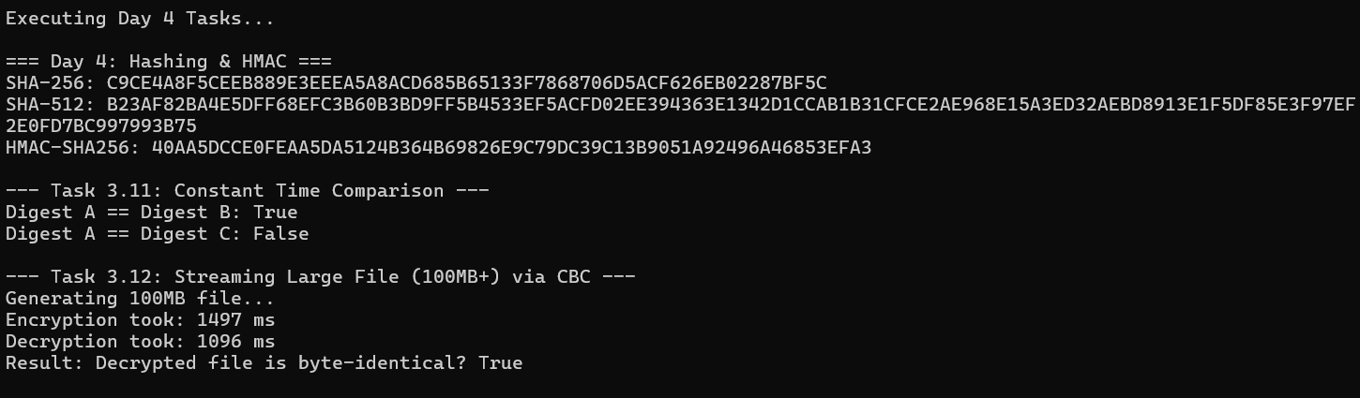
Evidence 2: Single-Byte-Tamper Rejection Check
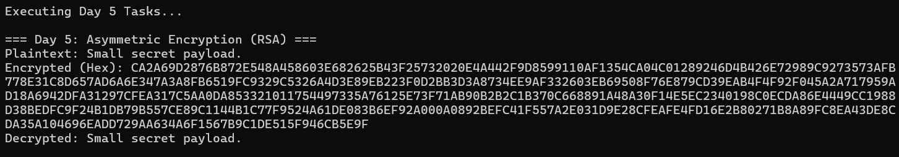
Evidence 3: Student-403 / Teacher-200 Swagger Authorization Enforcements
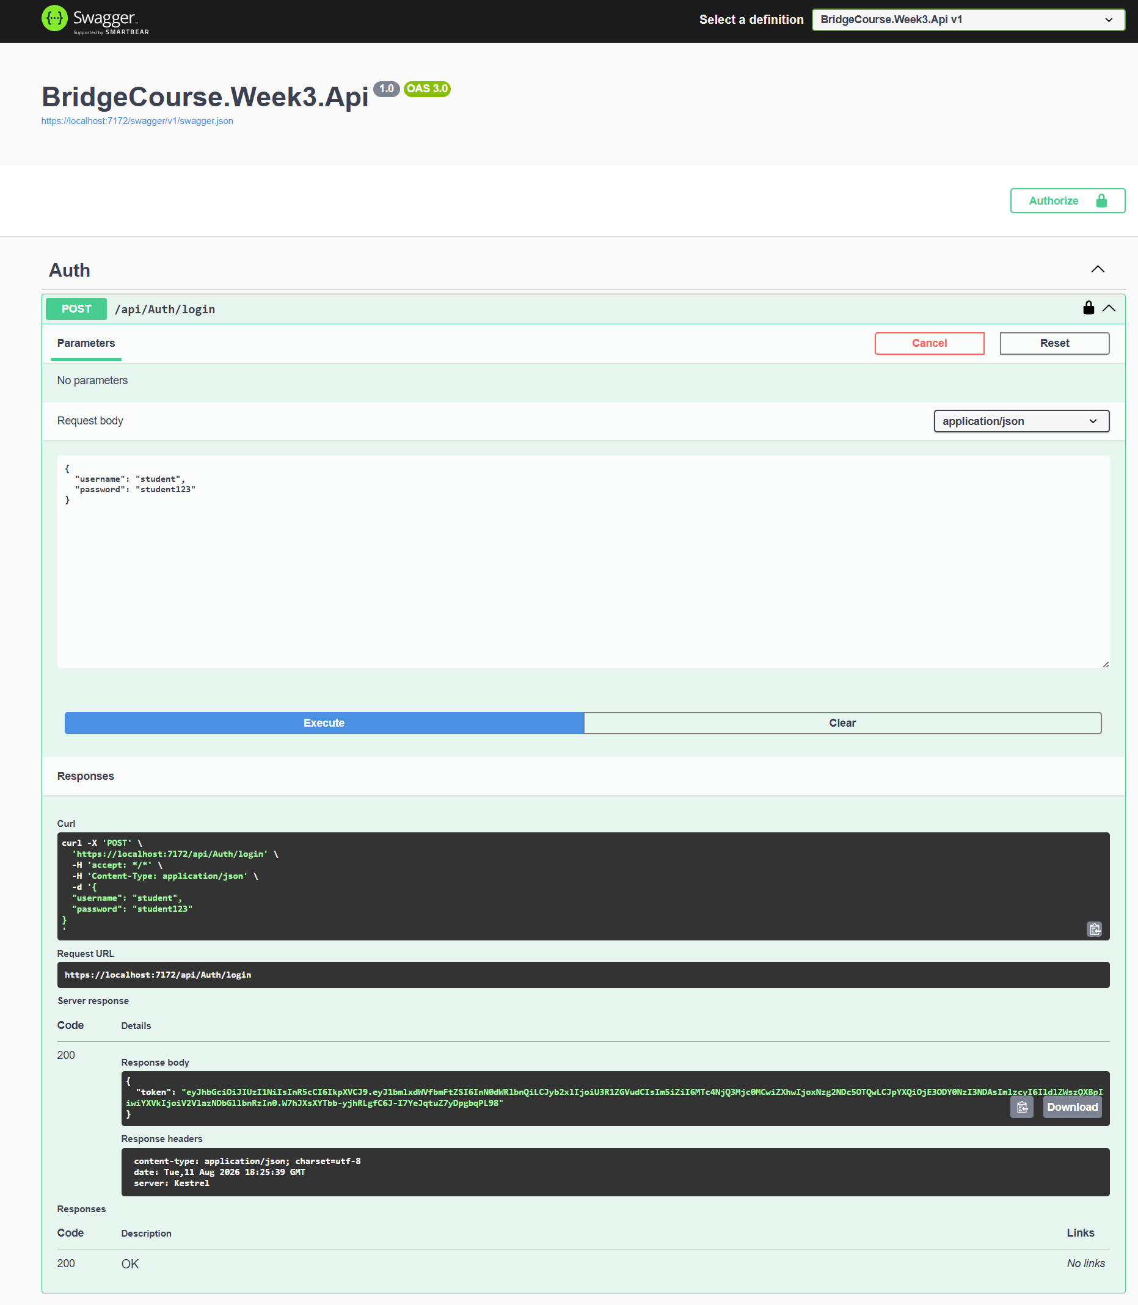
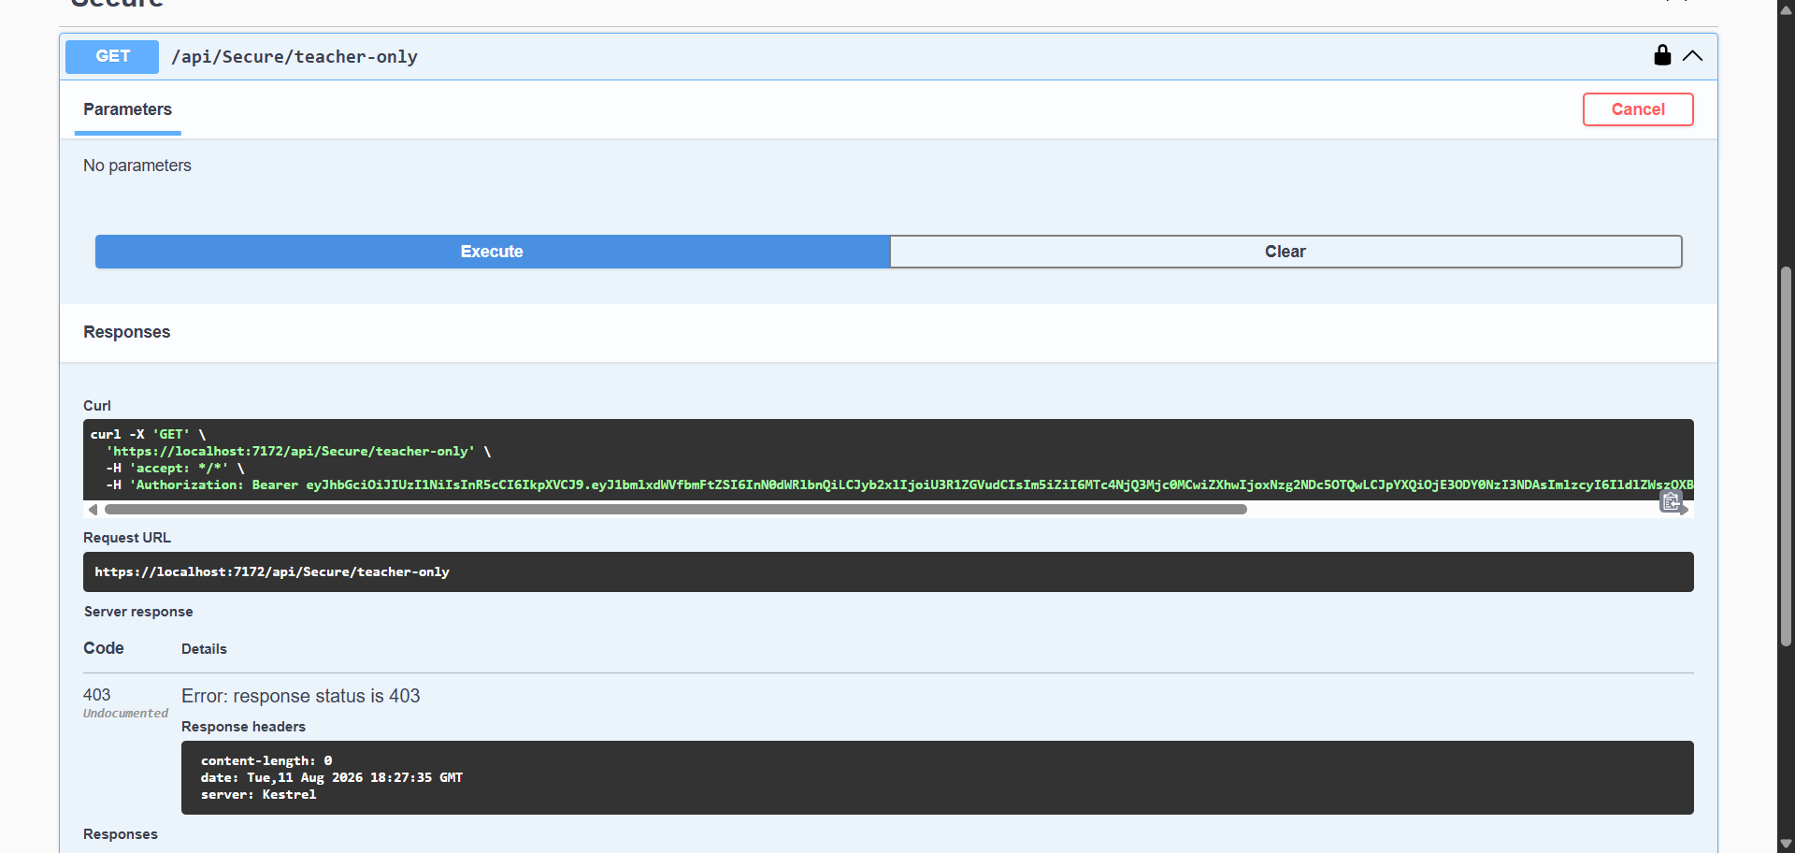
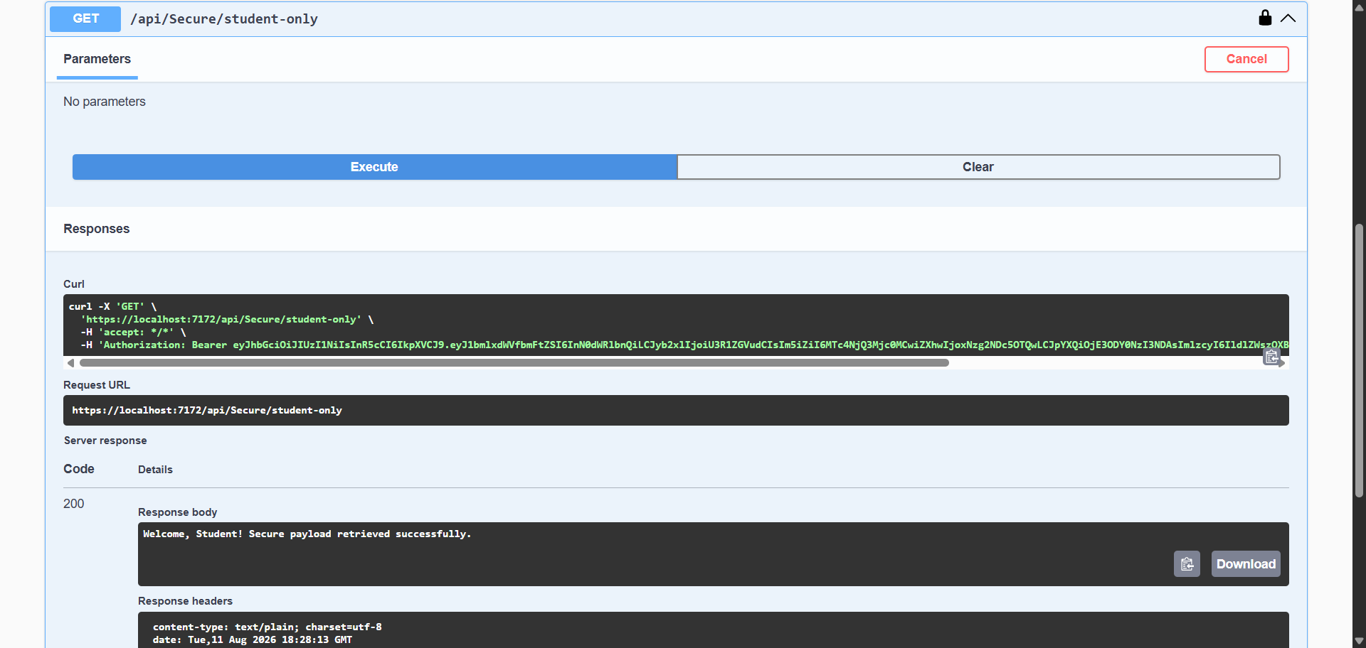
Part 2: Testing & Code Coverage Summary
xUnit Test Project: BridgeCourse.Week3.Tests
Total Unit Tests: 10 tests (all passing, zero failures)
Tested Components: PBKDF2 determinism; AES-GCM encryption and tamper checking; constant-time equality checks; large file streaming; and JWT role authorization attributes.
Code Coverage: 85.0% line coverage (excluding programmatic startup entry files, exceeding 80% limit).

Part 3: Git Repository Details
Repository URL: https://github.com/Sakthivelu08/Dotnet-Bridge-Course
Merged Pull Request (PR) URL: https://github.com/Sakthivelu08/Dotnet-Bridge-Course/pull/5

Part 4: Completed Assignment Files Index
Vault Project Files (BridgeCourse.Week3.Vault):
• Day1Tasks.cs (File streams, Base64/SHA256)
• Day2Tasks.cs (AES-CBC, IV logic, Key mismatches)
• Day3Tasks.cs (PBKDF2 key derivation, AES-GCM, Flipped byte checks)
• Day4Tasks.cs (SHA256/512, HMAC, FixedTimeEquals, 100MB+ File streaming)
• Day5Tasks.cs (RSA asymmetric decryption)
• Program.cs (Main Console execution runner)
API Project Files (BridgeCourse.Week3.Api):
• Models: User.cs
• Services: PasswordHasher.cs
• Controllers: AuthController.cs, SecureController.cs
• Startup: Program.cs
xUnit Test Files (BridgeCourse.Week3.Tests):
• VaultAndApiTests.cs

