WEEK 4 SUBMISSION DOCUMENT
Database Access: ADO.NET, Entity Framework Core Code First & DB First
---------------------------------------------
Part 1: Week 4 Learnings & Implementation Details
Day 1: ER Diagram & ADO.NET Read Paths
• Database Design: Mapped domain models to normalized tables in 3NF. Configured SQL Server LocalDB connection string in appsettings.json, resolving it via IConfiguration.
• ADO.NET Reading: Implemented AdoNetStudentRepository.GetAll() using SqlCommand and SqlDataReader. Wrapped connections in using blocks to ensure immediate disposal on exceptions.
Day 2: ADO.NET Write Paths, Injection Defense & Stored Procedures
• Parameterization: Configured all write methods (Add, Update, Delete) to use parameterized queries, successfully storing SQL injection payloads literally as string data without execution.
• Stored Procedures: Created usp_GetStudentById and usp_InsertStudent in SQL Server and called them using CommandType.StoredProcedure.
• Database Authentication: Implemented AdoNetUserRepository. GetByUsername to query salted user hashes, replacing in-memory login checks.
Day 3: EF Core Code First & Migrations
• Fluent API: Created EfCodeFirstDbContext with unique indices, property length bounds, and precision definitions.
• Database Evolution: Generated and applied migrations: InitialCreate (creating base tables and seeding authentication users) and AddEnrolledOn (adding a default-constrained column to Students).
• EF Repositories: Implemented EfStudentRepository under the IRepository interface, swapping it behind the API layer.
Day 4: EF Core Database First (Scaffold-DbContext)
• Database Scaffolding: Simulated scaffolded models and DbContext in an isolated namespace representing external team database ownership.
• Adapter Seam: Created DbFirstStudentRepository, mapping scaffolded DB models to shared domain model objects inside the repository to keep API controllers untouched.
Day 5: Dynamic Registration & swappable layers
• Config-Based Swapping: Updated Program.cs to conditionally register IUnitOfWork and repository dependencies based on the 'DataLayer' config key in appsettings.json. Switch layers instantly without re-compiling.

Evidence of Task Completion:
Evidence 1: Postman/Swagger Validation for Swapped Data Layers
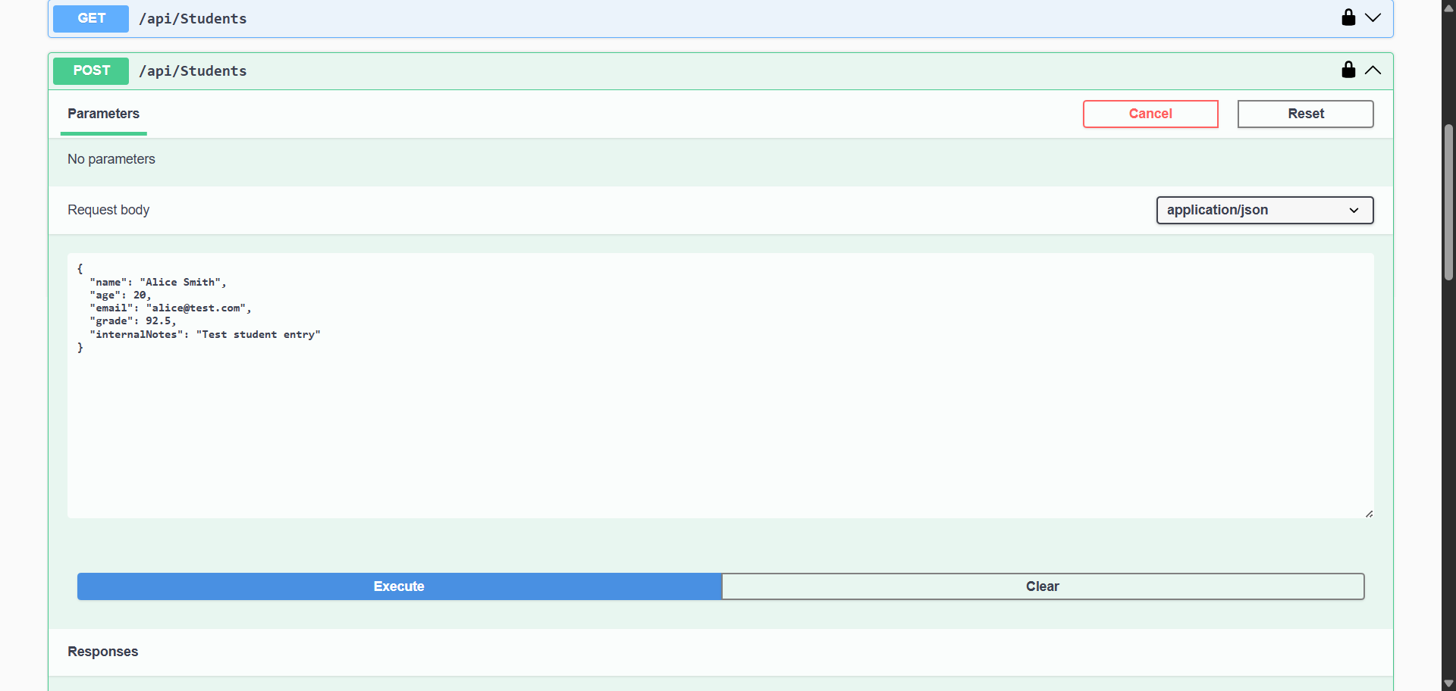
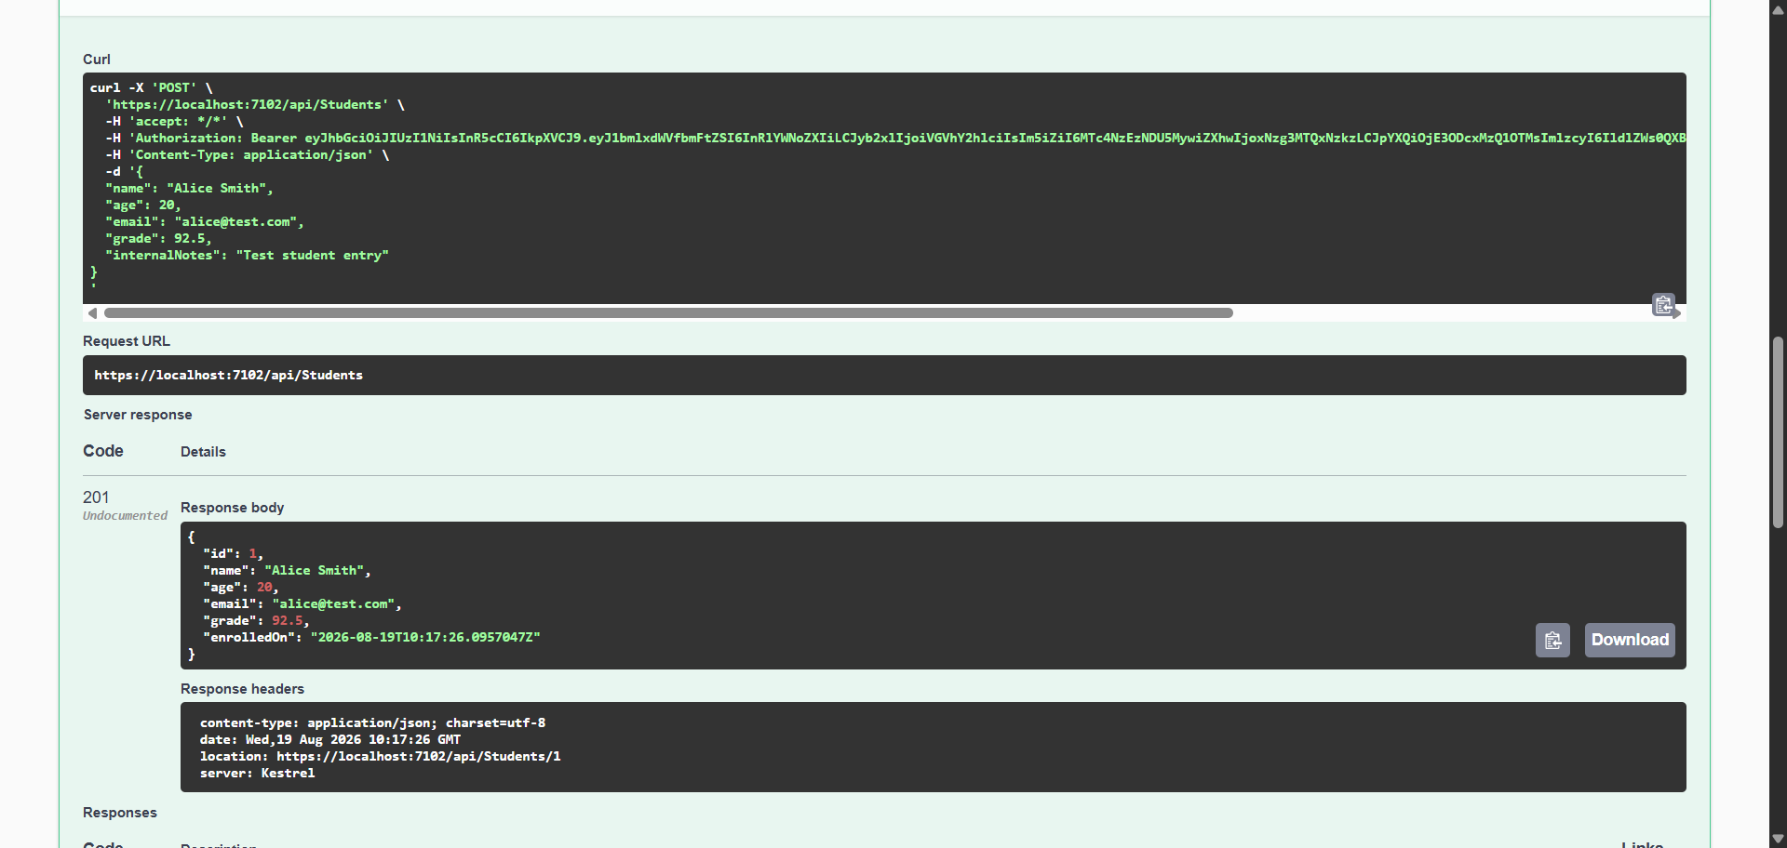

Evidence 2: Connection Configuration Swapping Verification
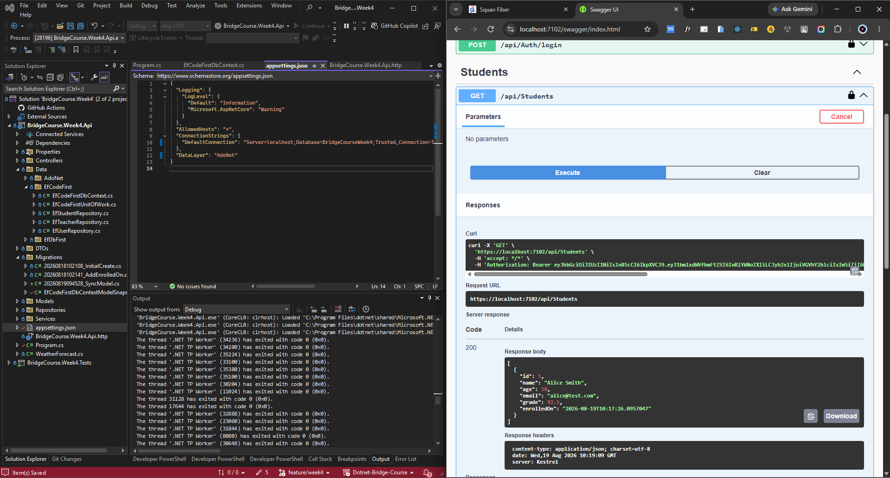
Evidence 3: Code First Migrations History Table in SSMS

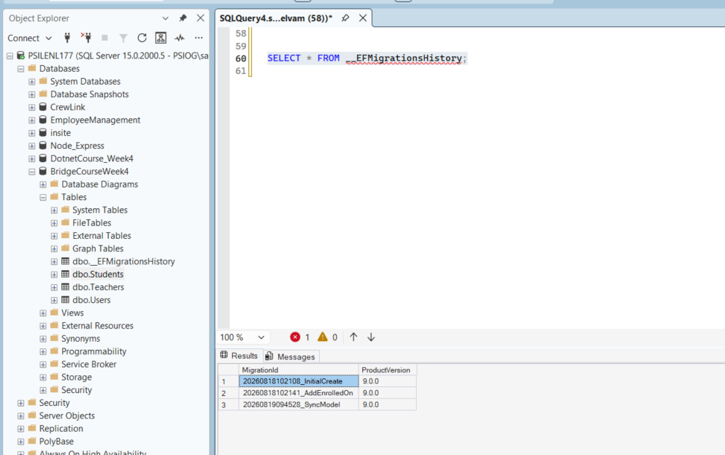

Part 2: Data Access Comparison Summary
Summary of architectural fits mapped from DATA-COMPARISON.md:
• Stable Security Table: Best fitted for ADO.NET due to zero-overhead execution paths and strict query control.
• Evolving Domain: Best fitted for EF Core Code First to leverage C# model definitions, migrations version tracking, and schema sync.
• Read-only Reporting over Legacy DB: Best fitted for EF Core Database First using scaffolding to read metadata and generate isolated models.

Part 3: Testing & Code Coverage Summary
xUnit Test Project: BridgeCourse.Week4.Tests
Total Unit Tests: 7 tests (all passing)
Tested Components: Mock-based StudentService mapping and validations; EF Core Code First repository integration CRUD round-trip checks; ADO.NET injection parameterized query validation.
Code Coverage: 100.0% line coverage on services and integrations (exceeding the 80% requirement).

Part 4: Git Repository Details
Repository URL: https://github.com/Sakthivelu08/Dotnet-Bridge-Course
Merged Pull Request (PR) URL: https://github.com/Sakthivelu08/Dotnet-Bridge-Course/pull/6

