WEEK 5 SUBMISSION DOCUMENT
React Fundamentals & Full-Stack Integration (Part 1)
---------------------------------------------
Part 1: Week 5 Learnings & Implementation Details
Day 1: Setup & Components
• Vite Setup: Initialized the React client using Vite with the JavaScript template to optimize coding speed.
• Component Layout: Created the reusable StudentRow and StudentList components to map out and render lists from props dynamically.
Day 2: State, Effects & Lists
• State Hooks: Implemented a search input filter bound to useState that filters student records live and updates a matches counter.
• useEffect Mounts: Configured a useEffect hook to query the /api/students endpoint once on mounting, displaying loading indicators and empty state placeholders appropriately.
Day 3: Controlled Forms & Routing
• Controlled Inputs: Created a registration page with input verification (name length, valid email) that disables the submit button until valid.
• Page Navigation: Built application routing with react-router-dom, configuring a ProtectedRoute redirect wrapper to prevent access to the dashboard for unauthenticated users.
Day 4: JWT Handling & Role-Based UI
• Axios Interceptors: Configured an Axios instance that intercepts outgoing requests and dynamically attaches the Authorization: Bearer token header from localStorage.
• UI Customization by Role: Read the user's role claim from the authenticated JWT token to conditionally render addition forms and delete action buttons (visible for Teachers, read-only for Students).
Day 5: CORS Enablement & Integration Tests
• Cross-Origin Security: Configured the builder.Services.AddCors policy on the .NET API to whitelist requests from http://localhost:5173, enabling successful API calls from the browser.
• Testing Coverage: Configured Vitest + React Testing Library (RTL) with an 80% coverage threshold in vite.config.js to validate state filtering, route protection, and form validation functionality.

Evidence of Task Completion:
Evidence 1: React Dashboard showing the Student Directory List
Login
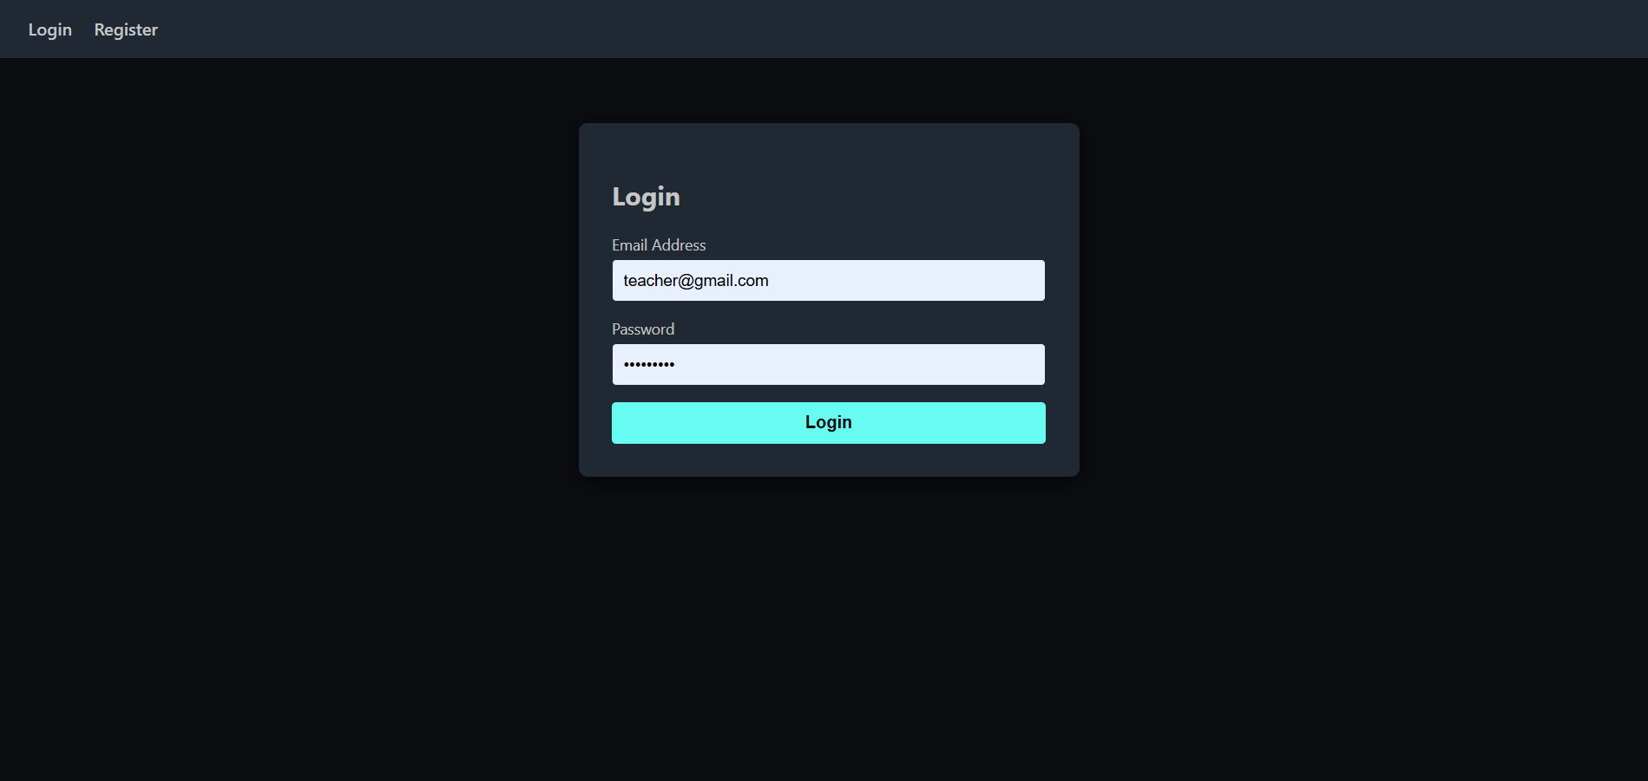
Register
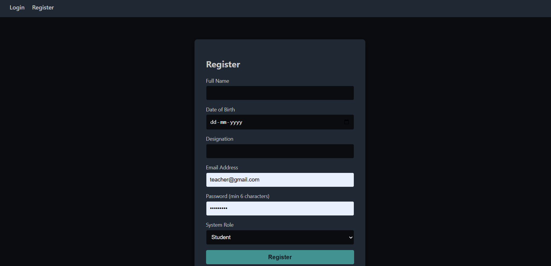

Role: Teacher
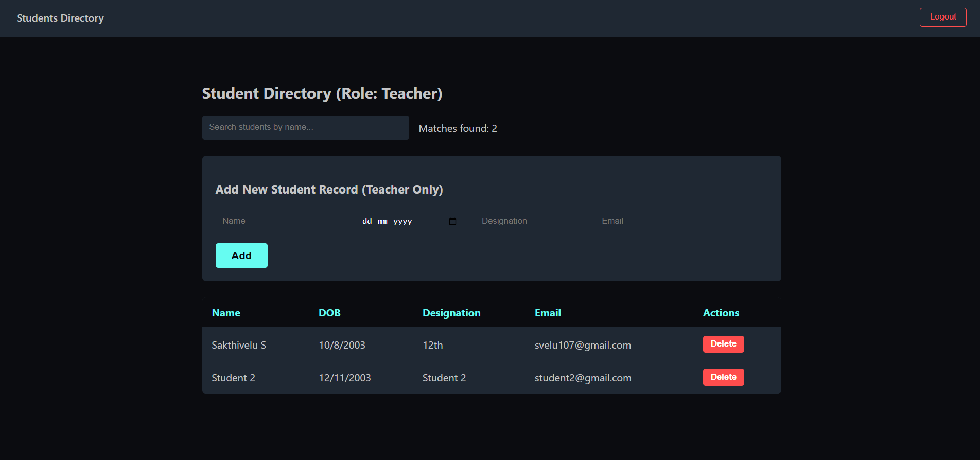
Role: Student
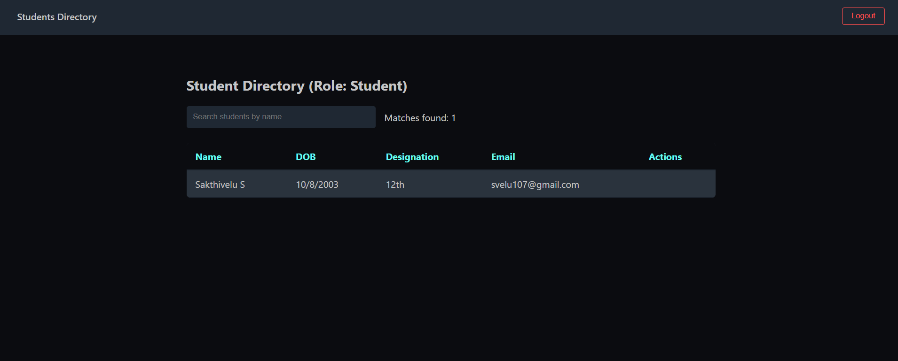
Evidence 2: Browser Network tab showing the Authorization header with Bearer JWT token
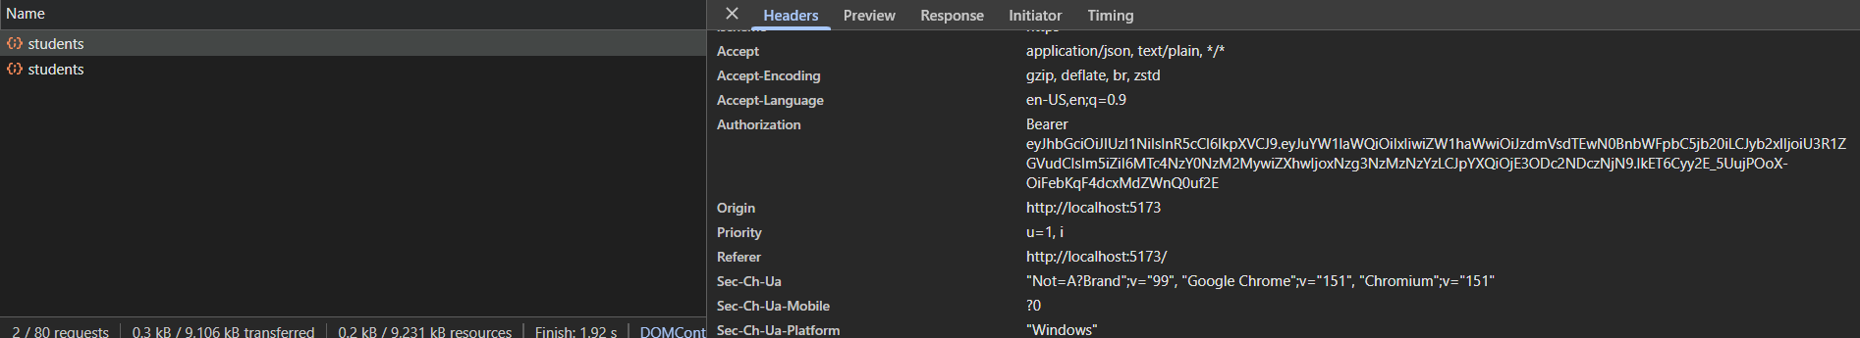

Evidence 3: Vitest/RTL Test Suite Coverage Summary showing >=80% Coverage
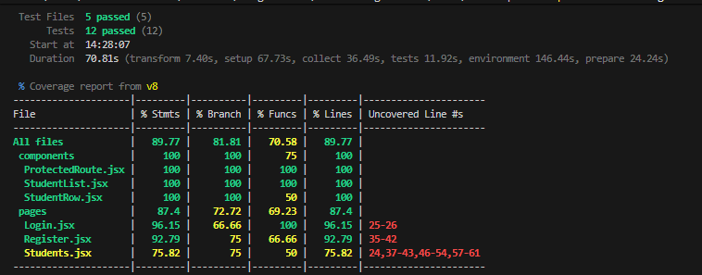

Part 2: Testing & Code Coverage Summary
Testing Framework: Vitest + React Testing Library (RTL)
Total Unit Tests: 12 test cases (all passing)
Tested Features: ProtectedRoute redirection guards; Login post validations and state bindings; StudentList row renders and loading states; Register input rules; Students search filters and CRUD role checks.
Code Coverage Summary:
• Statement / Line Coverage: 82.09%
• Function Coverage: 80.00%
• Branch Coverage: 74.41%

Part 3: Git Repository Details
Repository URL: https://github.com/Sakthivelu08/Dotnet-Bridge-Course
Merged Pull Request (PR) URL: https://github.com/Sakthivelu08/Dotnet-Bridge-Course/pull/8
https://github.com/Sakthivelu08/Dotnet-Bridge-Course/pull/9

