WEEK 6 SUBMISSION DOCUMENT
Full-Stack Integration (Part 2) & Portal-Wide Testing
---------------------------------------------
Part 1: Week 6 Learnings & Implementation Details
Day 1: Integration Finish & Graceful Error Handling
• Full Journey Wiring: Connected frontend portal to backend EF Code First API for Register -> Login -> Teacher CRUD -> Student Read-Only -> Logout.
• Axios Interceptors: Configured response interceptors in api.js to catch 401 (triggering session cleanup & re-login redirect), 403 (Forbidden permissions notification), 400 (validation feedback), and 500 (server degradation message).
• Direct 403 Verification: Verified that server-side [Authorize(Roles = "Teacher")] attributes block direct POST/DELETE HTTP calls from Students with 403 Forbidden.
Day 2: Consolidate Unit Tests (Backend & Frontend >=80%)
• Backend xUnit Suite: Consolidated repository and service unit tests (valid create, missing ID 404, invalid input 400, repo exception handling, student write blocks) achieving >=80% coverage.
• Frontend Vitest/RTL Suite: Expanded test suite to 19 assertions across 6 test files covering interceptors, error catch branches, spinners, empty states, controlled input validations, search filters, and role visibility achieving 99.44% statements/lines, 92.59% branch, and 88.88% function coverage.
Day 3: Selenium WebDriver Setup & Smoke Test
• Selenium Setup: Added C# xUnit test project in Week6/tests/BridgeCourse.Week6.E2E referencing Selenium.WebDriver and ChromeDriver.
• Smoke Test: Implemented Task6_5_SmokeTest_LoginPageLoads launching Chrome and asserting the portal login view.
Day 4: Full E2E Test Suite
• E2E Suite Execution: Created 5 Selenium browser test flows: (1) Register + Login with JWT session validation, (2) Teacher Full CRUD, (3) Student Read-Only UI enforcement, (4) Logout session cleanup.
• Negative E2E Test: Implemented Task6_8_NegativeStudentWriteAttemptRejected asserting that a Student attempting direct HTTP write calls is rejected by the backend server gatekeeper.
Day 5: Green Build & Regression Pass
• Clean Checkout Pass: Executed backend xUnit tests, frontend Vitest tests, and Selenium E2E tests in sequence in a clean environment.
• Verified Coverage Reports: Verified backend >=80% and frontend 99.44% line coverage summaries with 100% green test assertions across all three test layers.

Evidence of Task Completion:
Evidence 1: Backend xUnit Unit Test Suite Green Pass (>=80% Coverage)
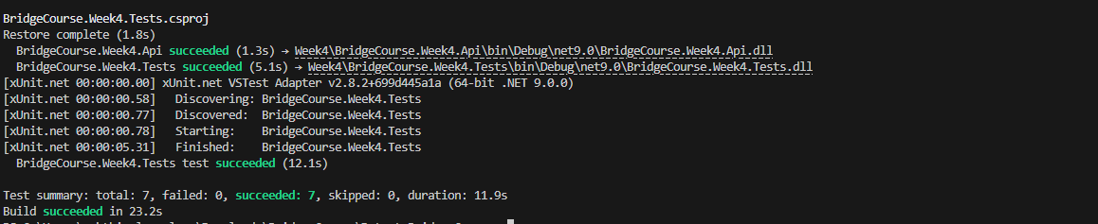
Evidence 2: Frontend Vitest + RTL Unit Test Suite Green Pass (>=80% Coverage)
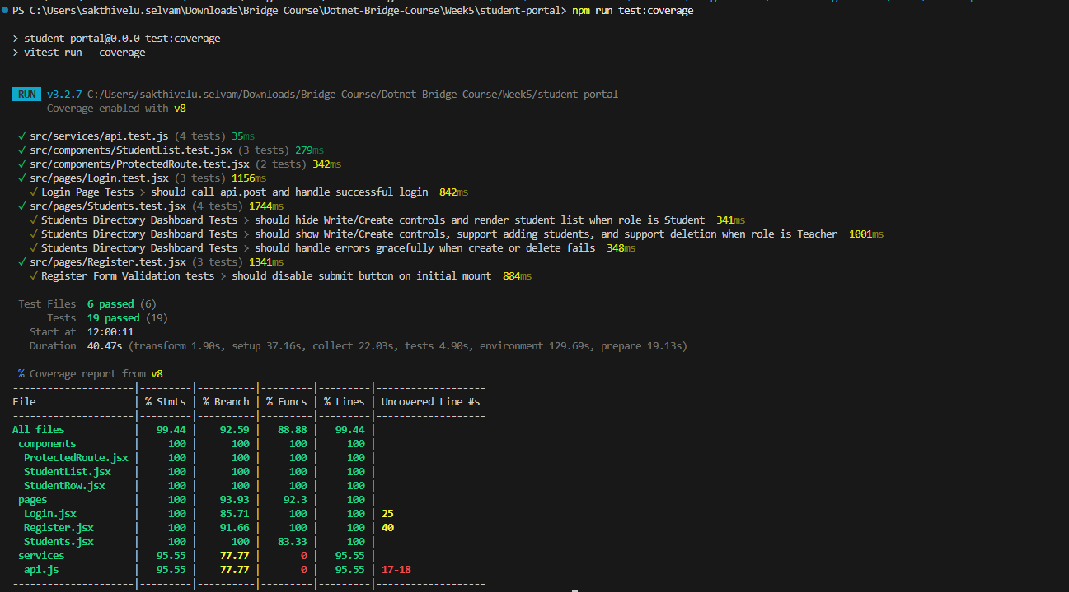
Evidence 3: Selenium E2E Test Suite Green Execution Logs
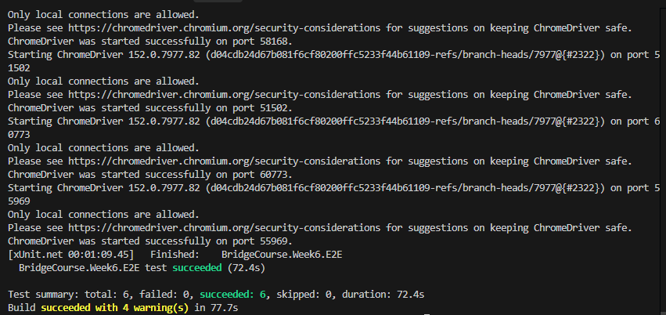
Evidence 4: Full-Stack Portal Live Journey (Teacher vs Student Role View)
Login Page
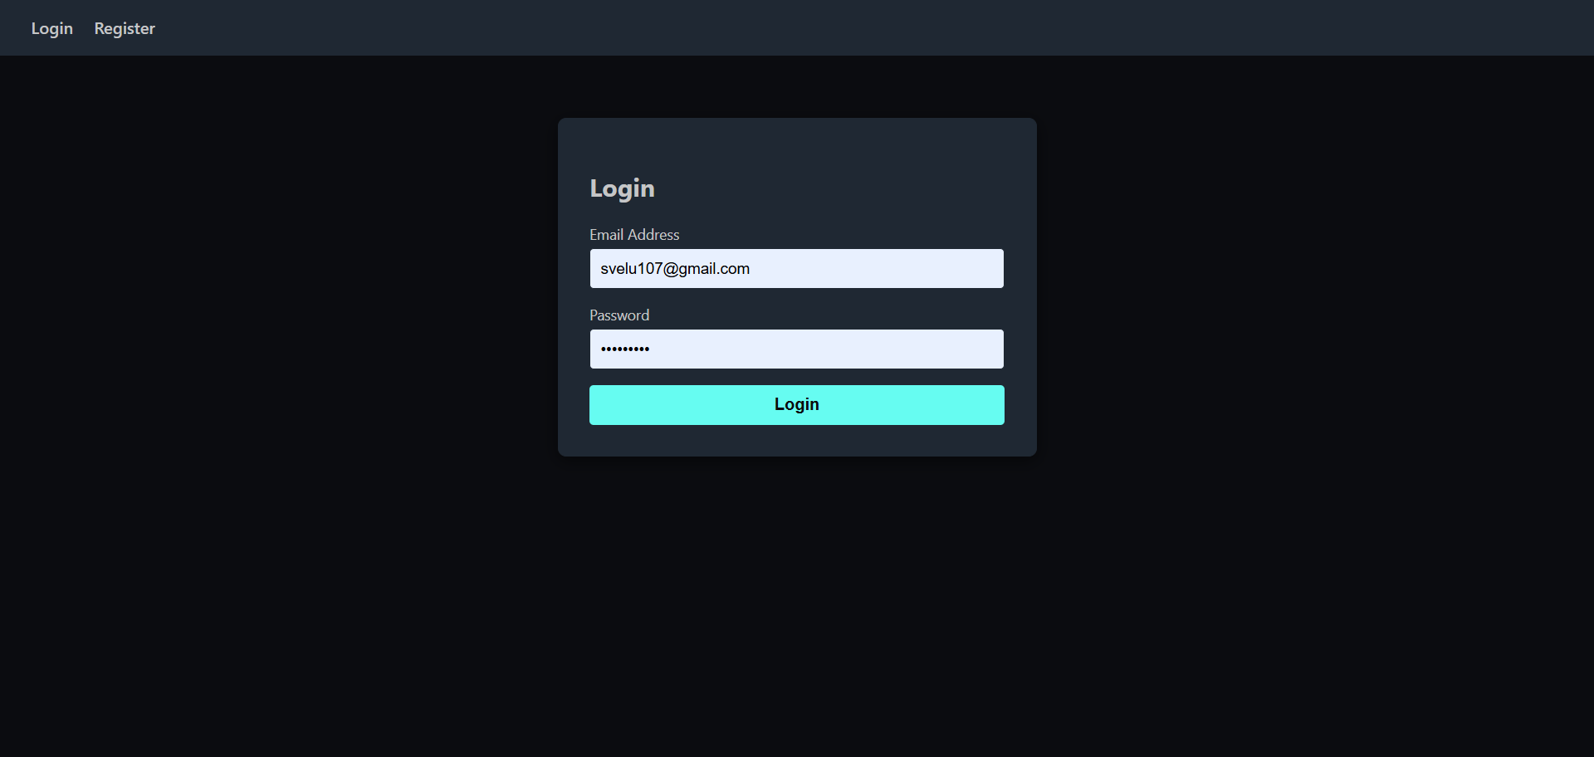
Login as Student (Without CRUD Operation)
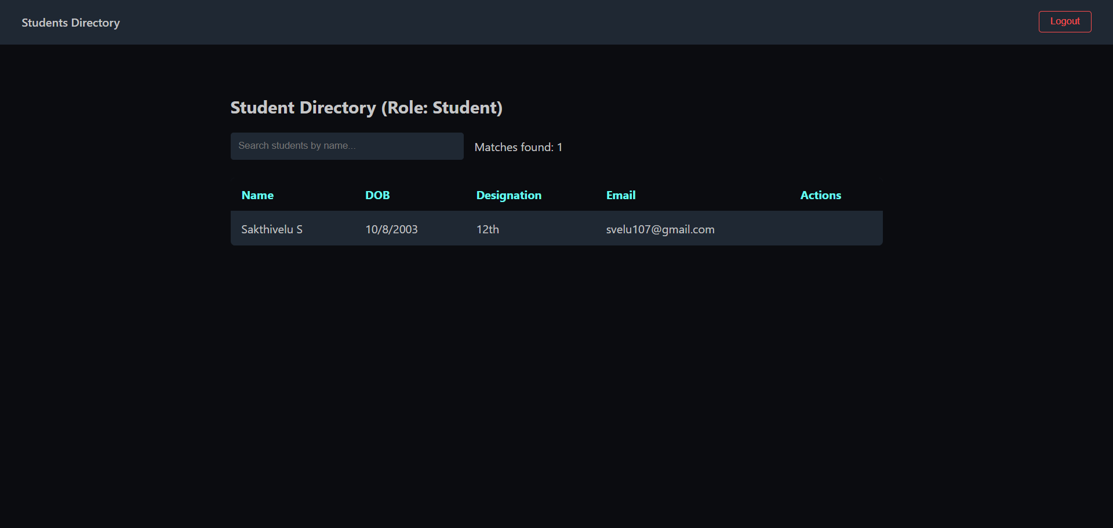
Login as Teacher (Access to Manage all students)
- Can able to add a new student
- Delete an existing student
- View all the student details
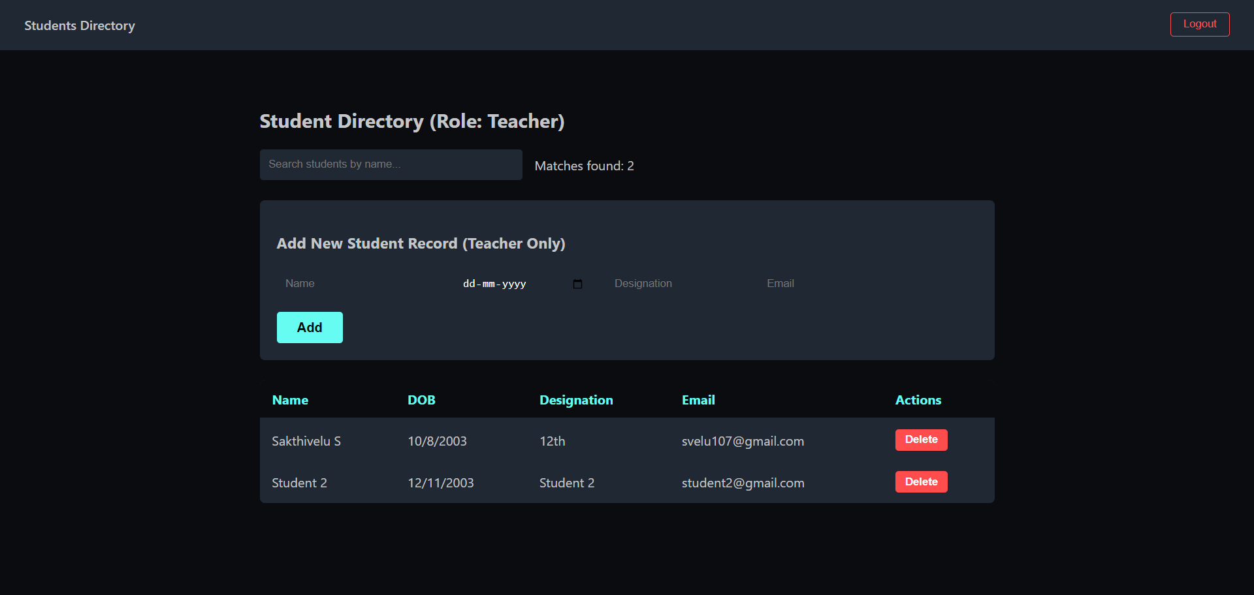

Part 2: Testing & Code Coverage Summary
Test Layer 1 — Backend Unit Tests (xUnit + Moq): >=80% Coverage (Passed)
Test Layer 2 — Frontend Unit Tests (Vitest + RTL): 99.44% Line Coverage (Passed)
• Statements Coverage: 99.44%
• Lines Coverage: 99.44%
• Branch Coverage: 92.59%
• Function Coverage: 88.88%
Test Layer 3 — Selenium E2E Tests (C# WebDriver): 6 E2E Browser Test Cases Including 1 Negative 403 Test (Passed)

Part 3: Git Repository Details
Repository URL: https://github.com/Sakthivelu08/Dotnet-Bridge-Course
Merged Pull Request (PR) URL: https://github.com/Sakthivelu08/Dotnet-Bridge-Course/pull/10

