NAAN MUDHALVAN

BLOCKCHAIN TECHNOLOGY

ASSIGNMENT -01

• Create a program to return your String

Program:

// SPDX-License-Identifier: MIT pragma solidity^0.8.0; contract zonename{

function blockchainTechnology() public pure returns(string memory){ return "blockchainTechnology";

 }

}

ABI CODE:

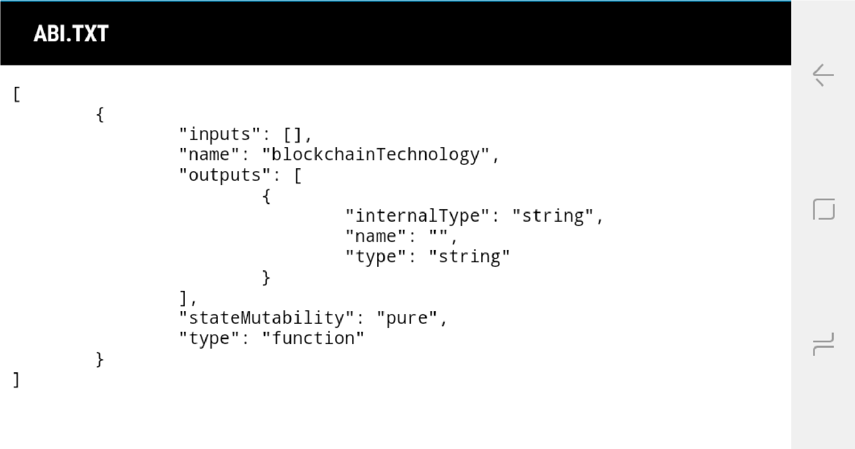

BYTE CODE:

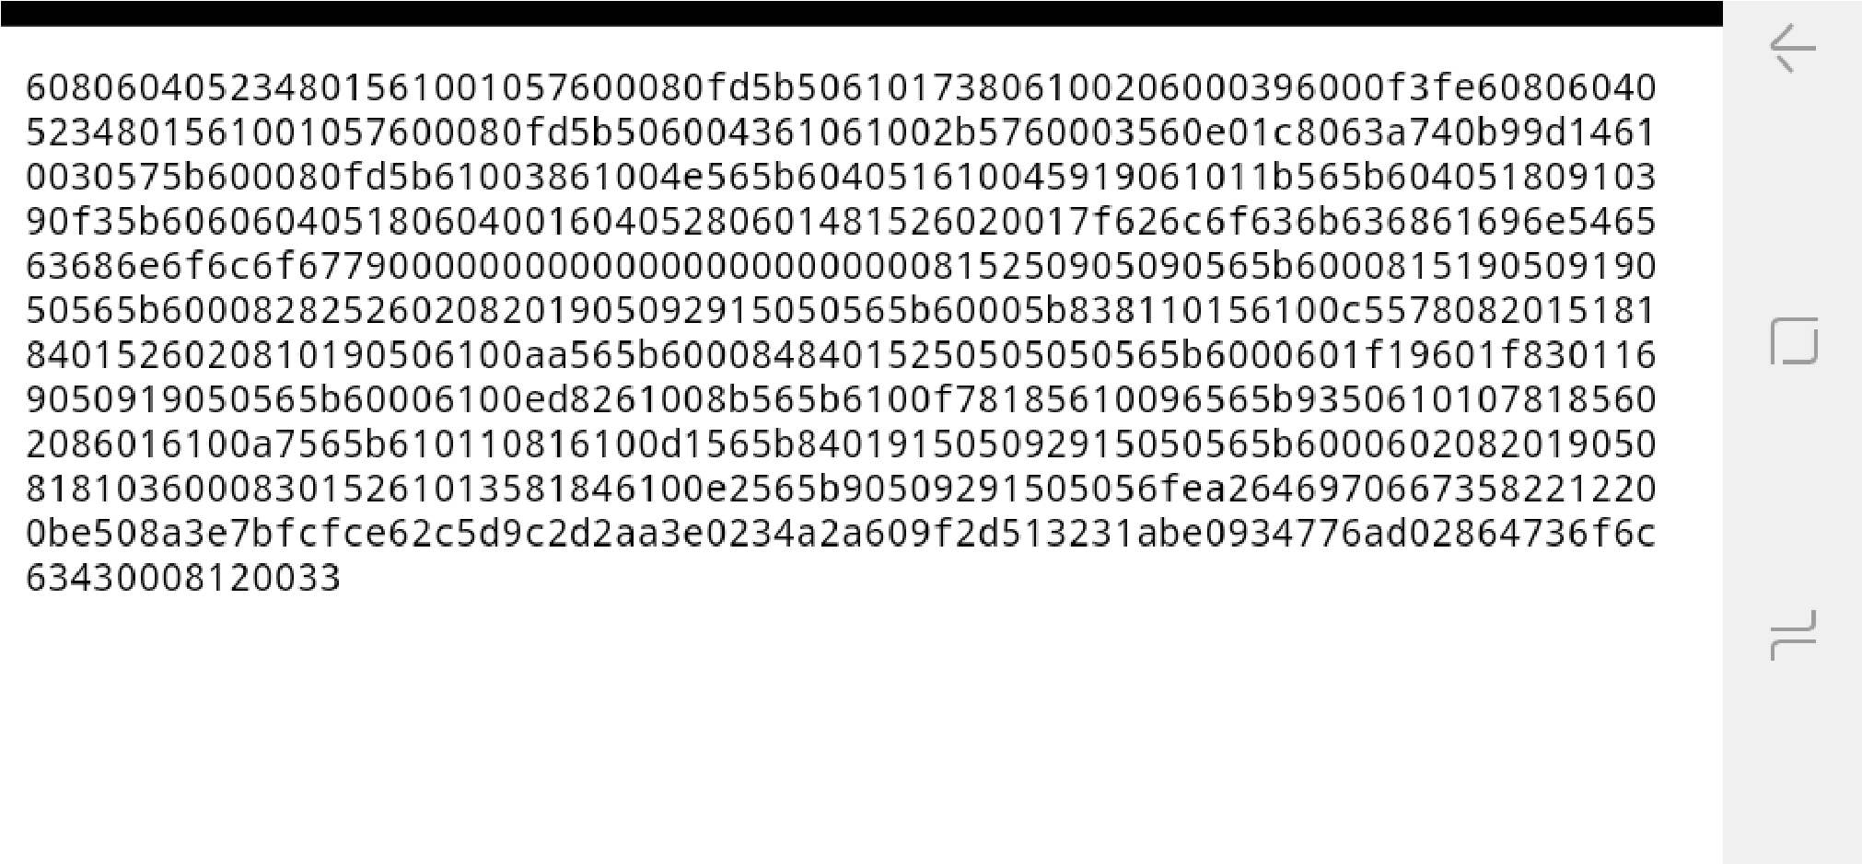

OUTPUT:

