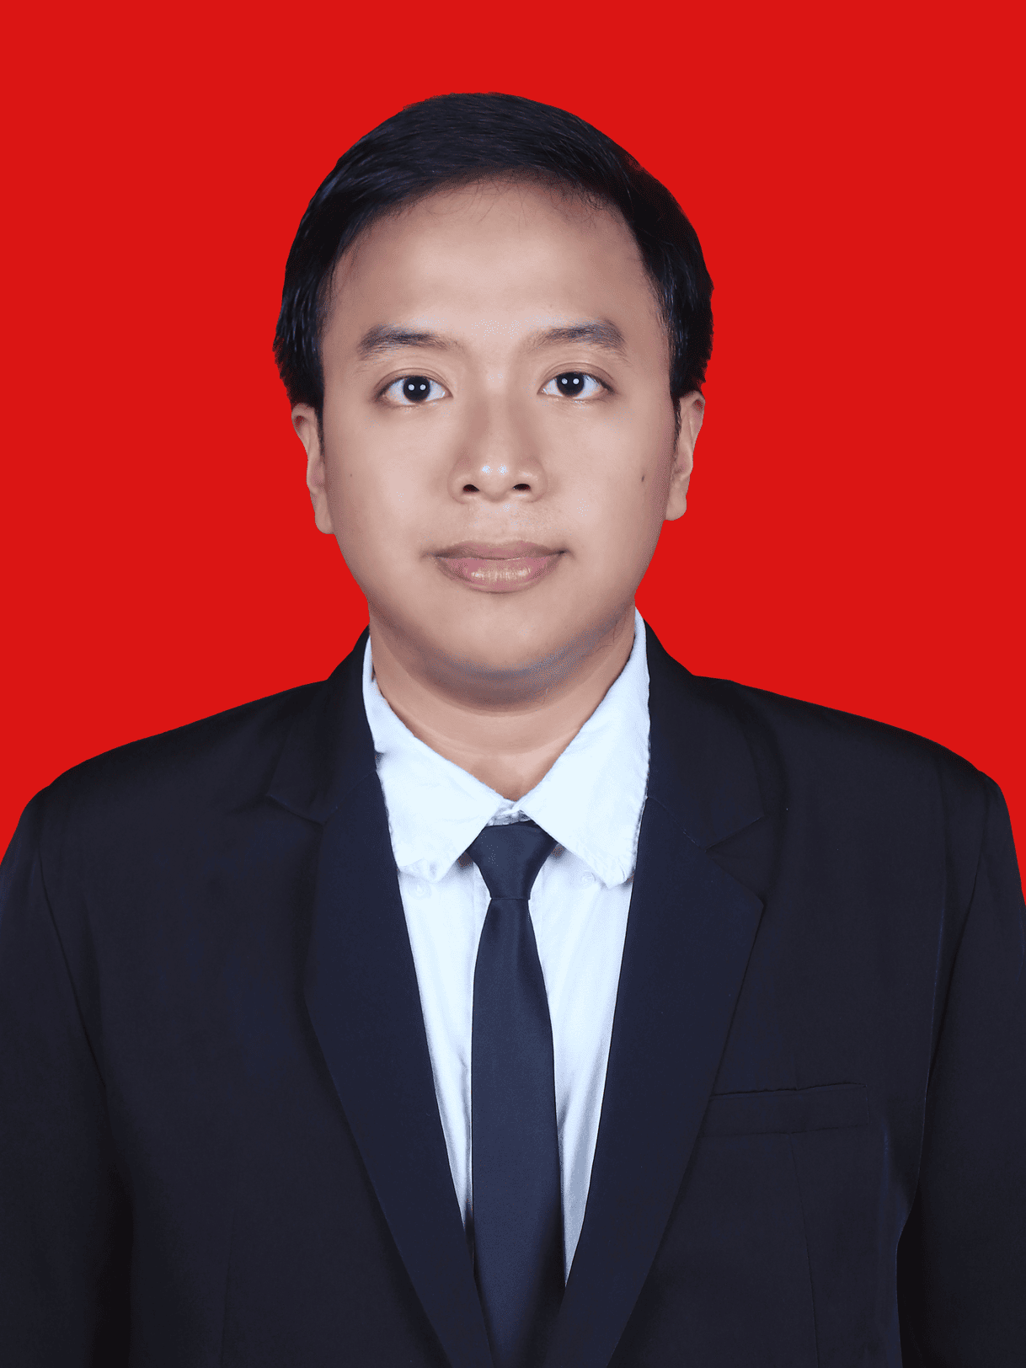

SAKTI MUJAHID IMANI
Junior Manual QA | Software Testing | Black-Box & UAT
saktimujahid.9b@gmail.com | 081298056550
linkedin.com/in/saktimujahid | sakti-mujahid.vercel.app

PROFILE
Recent Computer Science graduate from Institut Teknologi Sumatera (GPA 3.56/4.00, Cum Laude) with hands-on experience in black-box testing, UAT execution, and structured test documentation through web system development projects. Achieved 100% black-box test pass rate and 88.57% UAT score on a campus correspondence system. Proficient in test case design, bug reporting with clear reproduction steps, and cross-functional collaboration with developers and stakeholders. Seeking a Junior Manual QA role at NTT Data to contribute to software quality assurance.

EDUCATION
Institut Teknologi Sumatera - South Lampung, Indonesia 2022 - 2026
Bachelor of Computer Science, GPA 3.56/4.00 - Graduated Cum Laude
- Thesis: "Development of the Student Affairs Subsystem on the Harmony FTI ITERA Website Using the RUP Method with Kanban Tools."
- URI: repo.itera.ac.id/depan/submission/SB2606220028
- Relevant coursework: Software Engineering, Software Testing, Database Systems, Web Development, Data Structures, Object-Oriented Programming.

WORK AND PROGRAM EXPERIENCE
Faculty of Industrial Technology, ITERA - South Lampung, Indonesia 2025 - 2026
Full Stack Developer, Harmony FTI Website (Internship / MBKM)
- Developed a campus correspondence administration subsystem using React, Laravel, and MySQL with RUP methodology and Kanban-based task tracking.
- Designed and executed black-box test cases covering functional validation, edge cases, and user workflow scenarios — achieving 100% test pass rate.
- Conducted User Acceptance Testing (UAT) with faculty stakeholders, reaching 88.57% UAT score and ensuring feature alignment with requirements.
- Documented test results, bug reports with clear reproduction steps, and structured technical documentation for developer handoff.
Department of Communication and Informatics, Bandar Lampung City 2025
Web Developer & Information Security/Cybersecurity Staff
- Contributed to 2 government digital systems, SIMAS and SIMAMANG, covering letter validation, data recapitulation, internship registration, document upload, and status tracking.
- Performed functional testing on feature flows including account creation, document upload, and status tracking to validate system behavior.
DBS Foundation x Dicoding - Indonesia 2025
Machine Learning Engineer Cohort, Coding Camp 2025 (Independent Study / MBKM)
- Completed the Machine Learning Engineer learning track and delivered 1 accessibility-oriented computer vision product through the CashEye project.
- Worked on Python, data analysis, machine learning, deep learning fundamentals, MLOps, technical documentation, and model evaluation submissions.
Institut Teknologi Sumatera - South Lampung, Indonesia 2023 - 2025
Academic Assistant / Laboratory Assistant / Assistant Coordinator
- Handled 17 assistant and coordinator assignments across 10+ courses/practicums, including Basic Physics, Software Engineering, and Formal Language and Automata Theory.
- Managed schedules, task allocation, grade recaps, student evaluation, and academic documentation — developing structured documentation habits.

TESTING & QUALITY ASSURANCE EXPERIENCE
- Black-Box Testing: Designed and executed test cases for web-based systems, validating functional requirements, edge cases, and user workflows.
- User Acceptance Testing (UAT): Coordinated UAT sessions with stakeholders, collected feedback, and verified feature alignment with business requirements.
- Bug Reporting: Documented bugs with clear steps to reproduce, expected vs. actual results, severity classification, and screenshots.
- Test Documentation: Maintained structured test plans, test case matrices, and test summary reports throughout development cycles.
- SDLC Knowledge: Familiar with both Waterfall and Agile methodologies; experience with RUP stages and Kanban-based task tracking.

ORGANIZATION AND LEADERSHIP EXPERIENCE
Computer Science Student Association (HMIF) ITERA 2024 - 2025
Member Development Expert Staff; Professional Training Staff; MBKM Sharing Session Speaker
- Held 3 organizational roles in member development, professional training, and MBKM knowledge-sharing to support Computer Science students' academic and career readiness.
- Supported activity planning, material preparation, member communication, program documentation, and collaborative event execution.

SELECTED PROJECTS
Web Harmony - Campus Correspondence Subsystem React, Laravel, MySQL
- Built a student affairs correspondence workflow that reduced processing time from 7-10 days to 2-5 days, validated by 100% Black Box Testing and 88.57% UAT.
- Designed test cases for role-based access, document upload, status tracking, and multi-tenant data workflows.
SIMAS and SIMAMANG - Government Digital Systems Laravel, Inertia.js, React.js
- Supported 2 government applications for letter validation, data recapitulation, internship registration, document upload, and registration status tracking.
- Performed functional testing on feature flows and documented test results for developer verification.
End-to-End ETL Pipeline Python, Pytest, PostgreSQL
- Extracted 50 web pages, transformed the data, and loaded outputs into 3 destinations with Pytest-based validation tests.
"Access by KAI" Sentiment Analysis Python, TF-IDF, XGBoost
- Compared 3 sentiment classification models; XGBoost achieved the best performance with 97% accuracy.

SKILLS AND CERTIFICATIONS
Testing: Black-box testing, UAT, test case design, bug reporting, test documentation, regression testing, functional testing, edge case analysis.
Tools & Collaboration: JIRA (basic), Google Workspace, Microsoft Office, Git/GitHub, VS Code, Postman (basic API testing).
Technical: React.js, Laravel, MySQL, JavaScript, PHP, Python, HTML/CSS, RESTful APIs, SQL.
Professional: Requirements gathering, analytical skills, attention to detail, cross-functional communication, time management, documentation.
Certifications: 30+ training certificates in machine learning, data analysis, SQL, version control, project management, back-end JavaScript, cloud, AI, and prompt engineering.
Certificate folder: drive.google.com/drive/folders/certificates
Achievements: Graduated Cum Laude from ITERA (2026); recipient of PHMW 2024 funding for the proposal "Burger With Ramen Noodle Bun".

LANGUAGES
Indonesian: Native. English: Limited Working Proficiency.

