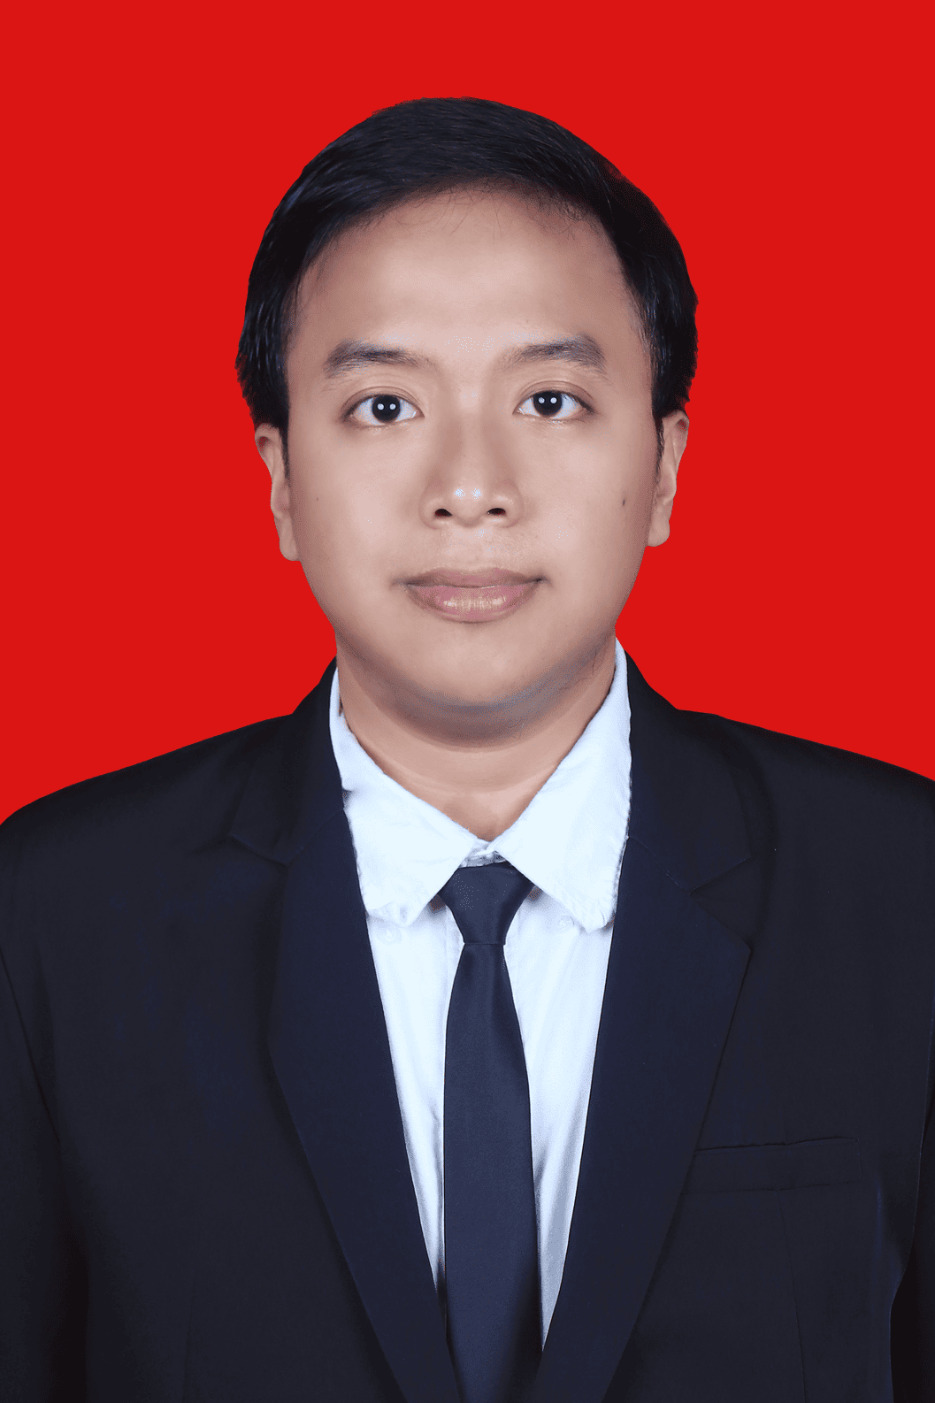

SAKTI MUJAHID IMANI
Fresh Graduate in Informatics Engineering | Web Development | Data & Project Coordination
Jakarta, Indonesia | saktimujahid.9b@gmail.com | 081298056550 | linkedin.com/in/saktimujahid

PROFILE
Recent Informatics Engineering graduate from Institut Teknologi Sumatera (GPA 3.56/4.00, Cumlaude) with hands-on experience in institutional web systems, data processing, and project coordination. Skilled in React, Laravel, MySQL, Python, and machine learning, including a correspondence system that reduced processing time from 7-10 business days to 2-5 business days with 100% Black Box Testing and 88.57% UAT results. Interested in contributing to Meratus through digital solutions, process automation, data analysis, and structured documentation that support operational efficiency.

EDUCATION
Institut Teknologi Sumatera - South Lampung, Indonesia 2022 - 2026
Bachelor of Informatics Engineering, GPA 3.56/4.00 - Graduated Cum Laude
- Thesis: "Development of the Student Affairs Subsystem on the Harmony FTI ITERA Website Using the RUP Method with Kanban Tools."
- URI: repo.itera.ac.id/depan/submission/SB2606220028

WORK AND PROGRAM EXPERIENCE
Faculty of Industrial Technology, ITERA - South Lampung, Indonesia 2025 - 2026
Full Stack Developer, Harmony FTI Website (Internship / MBKM)
- Developed a campus correspondence administration subsystem using React, Laravel, and MySQL with RUP methodology and Kanban-based task tracking.
- Reduced correspondence processing time from 7-10 business days to 2-5 business days, with 100% Black Box Testing and 88.57% UAT results.
Department of Communication and Informatics, Bandar Lampung City 2025
Web Developer & Information Security/Cybersecurity Staff
- Contributed to 2 government digital systems, SIMAS and SIMAMANG, covering letter validation, data recapitulation, internship registration, document upload, and status tracking.
- Translated internal user needs into system workflows and progress documentation to improve coordination with supervisors and stakeholders.
DBS Foundation x Dicoding - Indonesia 2025
Machine Learning Engineer Cohort, Coding Camp 2025 (Independent Study / MBKM)
- Completed the Machine Learning Engineer learning track and delivered 1 accessibility-oriented computer vision product through the CashEye project.
- Worked on Python, data analysis, machine learning, deep learning fundamentals, MLOps, technical documentation, and model evaluation submissions.
Institut Teknologi Sumatera - South Lampung, Indonesia 2023 - 2025
Academic Assistant / Laboratory Assistant / Assistant Coordinator
- Handled 17 assistant and coordinator assignments across 10+ courses/practicums, including Basic Physics, Computer and Software Introduction, Software Engineering, Entrepreneurship, TBFO, and MRV.
- Managed schedules, task allocation, grade recaps, student evaluation, and academic documentation with lecturers, laboratory staff, and assistant teams.

ORGANIZATION AND LEADERSHIP EXPERIENCE
Informatics Student Association (HMIF) ITERA 2024 - 2025
Member Development Expert Staff; Professional Training Staff; MBKM Sharing Session Speaker
- Held 3 organizational roles in member development, professional training, and MBKM knowledge-sharing to support Informatics students' academic and career readiness.
- Supported activity planning, material preparation, member communication, program documentation, and collaborative event execution.

SELECTED PROJECTS
Web Harmony - Campus Correspondence Subsystem React, Laravel, MySQL
- Built a student affairs correspondence workflow that reduced processing time from 7-10 days to 2-5 days, validated by 100% Black Box Testing and 88.57% UAT.
SIMAS and SIMAMANG - Government Digital Systems Laravel, Inertia.js, React.js
- Supported 2 government applications for letter validation, data recapitulation, internship registration, document upload, and registration status tracking.
End-to-End ETL Pipeline Python, Pytest, PostgreSQL
- Extracted 50 web pages, transformed the data, and loaded outputs into 3 destinations: CSV, Google Sheets API, and PostgreSQL, with Pytest-based validation.
"Access by KAI" Sentiment Analysis Python, TF-IDF, XGBoost
- Compared 3 sentiment classification models; XGBoost achieved the best performance with 97% accuracy.
Afenter_PCD - Motorcycle Parking Area Detection Python, Streamlit, OpenCV
- Built a computer vision app with 11 image-processing stages to analyze motorcycle parking slot availability from datasets and user-uploaded images.
Book Recommendation System Python, TF-IDF, Cosine Similarity
- Compared Content-Based Filtering and Collaborative Filtering on the 1M+ row Book-Crossing dataset; Precision@5 improved from 0.04 to 0.42.
Medical Insurance Cost Prediction Python, Regression, GridSearchCV
- Compared Linear Regression and Decision Tree models; Linear Regression reached an MSE of 33,596,915, outperforming Decision Tree at 40,153,988.
Kyuubi-MML - Multimodal Music Emotion Recognition PyTorch, DeBERTa, PANN
- Classified music emotion into 5 clusters using 3 modalities, audio, lyrics, and MIDI, through a late fusion approach.
Bike Sharing Analysis Dashboard Pandas, Streamlit, Seaborn
- Analyzed the 2011-2012 Washington D.C. Bike Sharing dataset and built an interactive dashboard with date, weather, and season filters.

SKILLS AND ACHIEVEMENTS
Technical: React.js, Laravel, Inertia.js, RESTful API, MySQL, SQL, JavaScript, PHP, Python, Git, CI/CD automation, Docker.
Data and Machine Learning: Pandas, Scikit-learn, TensorFlow, OpenCV, TF-IDF, XGBoost, MLflow, Pytest, Streamlit, data visualization.
Professional: Requirements gathering, technical documentation, stakeholder communication, progress tracking, UAT support, black-box testing, Kanban, teamwork.
Certifications: 30+ training certificates in machine learning, data analysis, SQL, version control, project management, back-end JavaScript, cloud, AI, and prompt engineering.
Certificate folder: drive.google.com/drive/folders/certificates
Achievements: Graduated Cum Laude from ITERA (2026); recipient of PHMW 2024 funding for the proposal "Burger With Ramen Noodle Bun".

LANGUAGES
Indonesian: Native. English: Limited Working Proficiency.

